Zofia Warzycha

Day 2 – Advent of Code
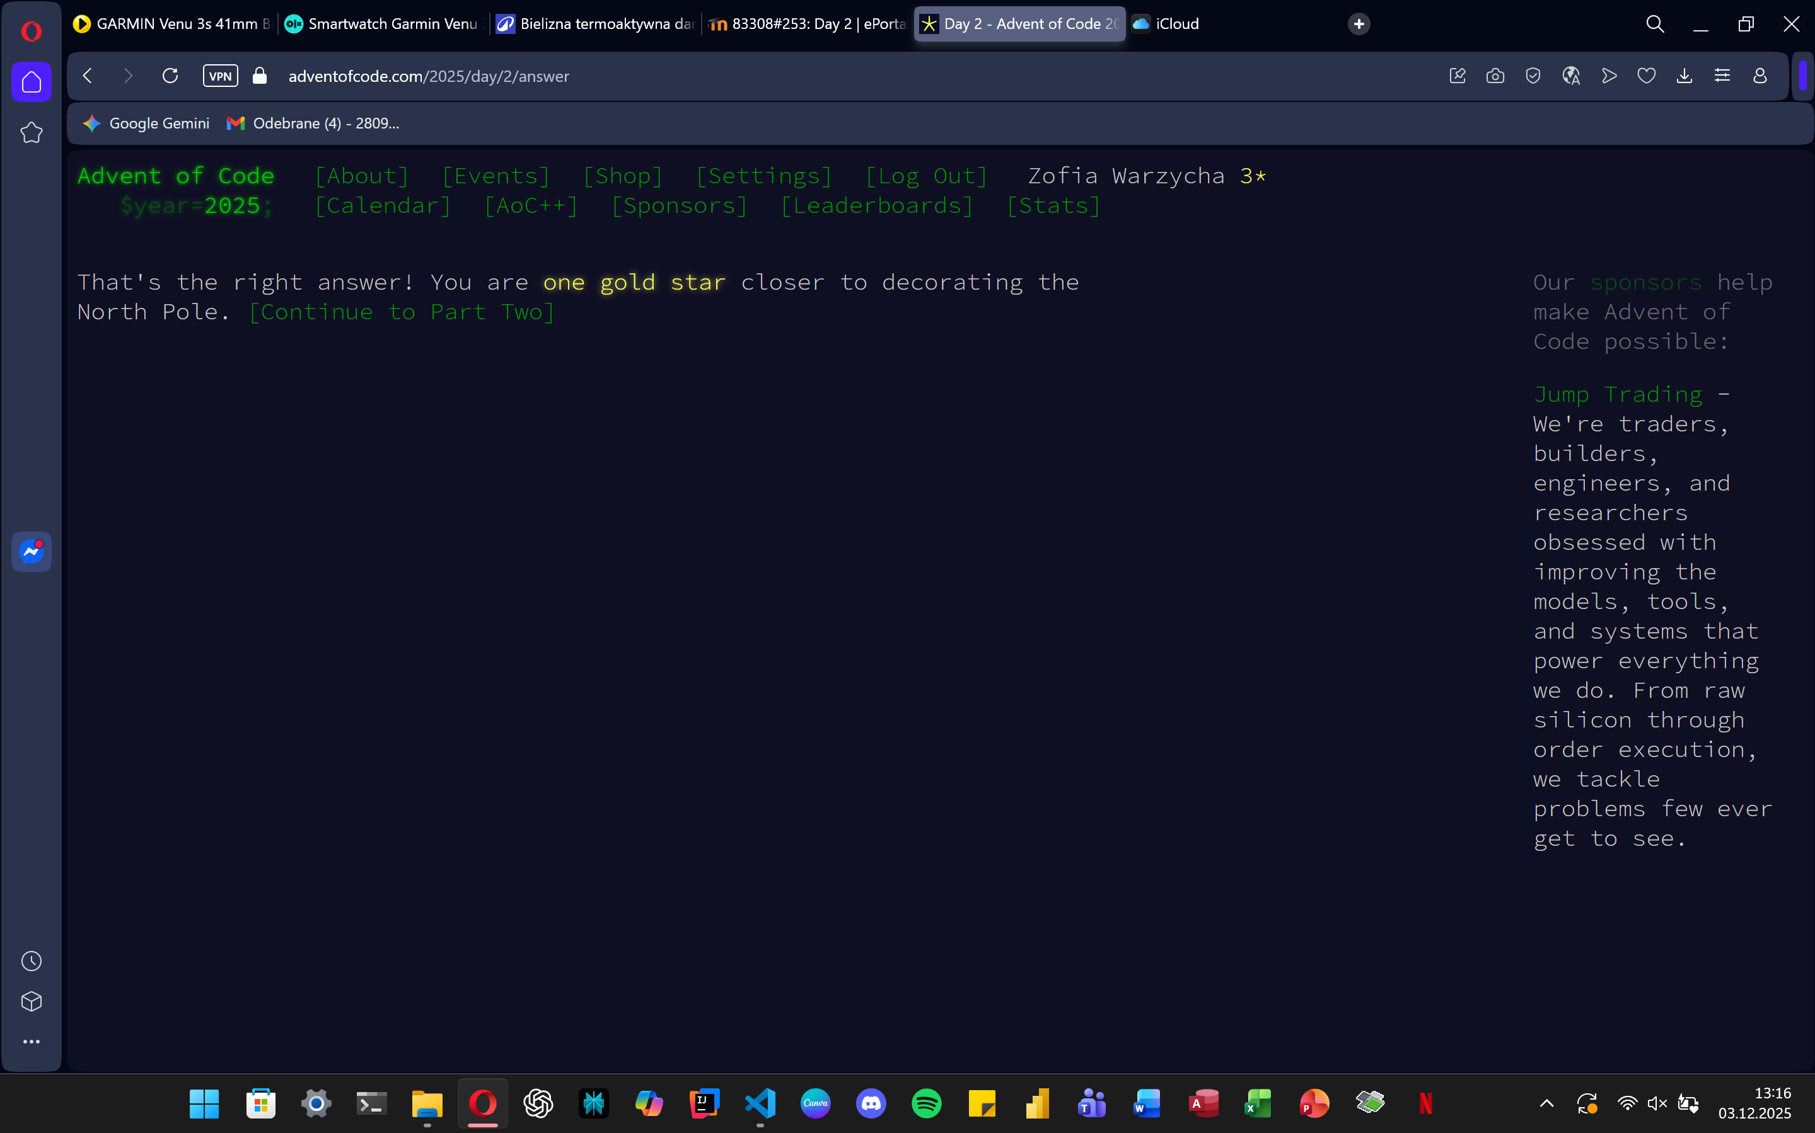
path = "C:/Users/zosia/OneDrive/Pulpit/day2.txt"

def is_invalid_id(n):
s = str(n)
l = len(s)
if l % 2 != 0:
return False
half = l // 2
return s[:half] == s[half:]

with open(path) as f:
line = f.read().strip()
ranges = line.split(',')

invalid_ids = []

for r in ranges:
if '-' not in r:
continue
start, end = map(int, r.split('-'))
for num in range(start, end + 1):
if is_invalid_id(num):
invalid_ids.append(num)

print(sum(invalid_ids))
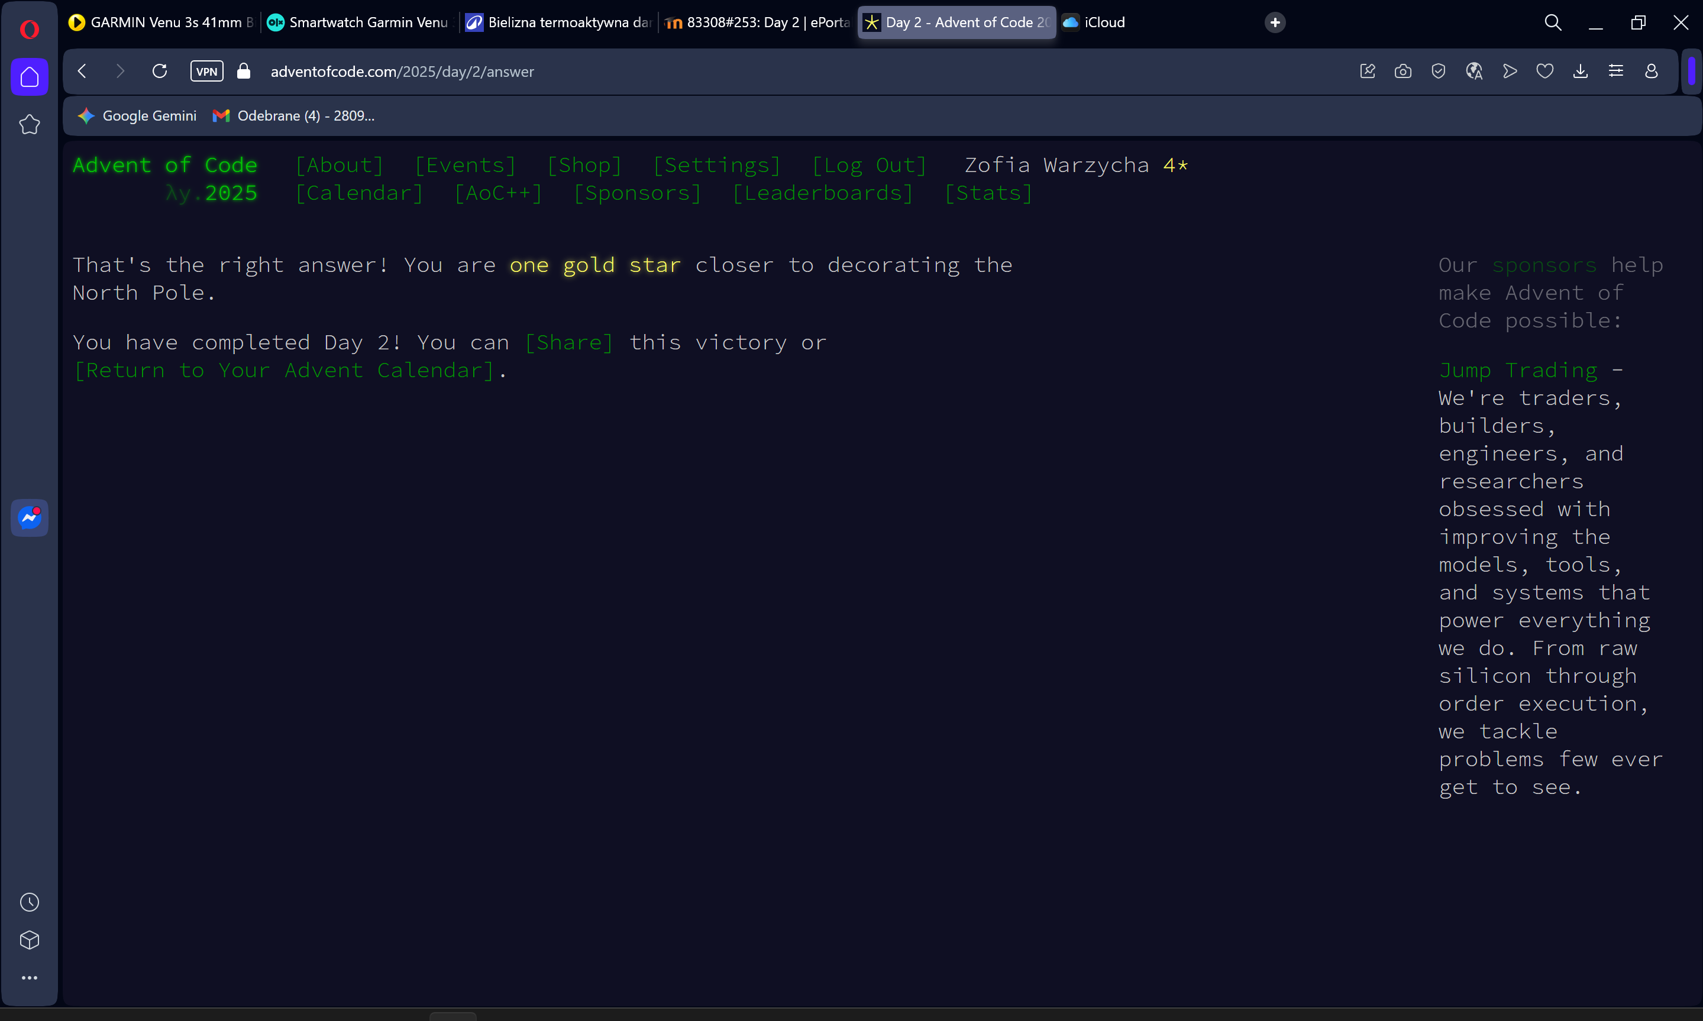
def is_invalid_id_part2(n):
s = str(n)
length = len(s)
for sub_len in range(1, length // 2 + 1):
if length % sub_len == 0:
sub = s[:sub_len]
if sub * (length // sub_len) == s:
return True
return False

with open(path) as f:
line = f.read().strip()
ranges = line.split(',')

invalid_ids = []

for r in ranges:
if '-' not in r:
continue
start, end = map(int, r.split('-'))
for num in range(start, end + 1):
if is_invalid_id_part2(num):
invalid_ids.append(num)

print(sum(invalid_ids))

