Zofia Warzycha

Day 3 – Advent of Code
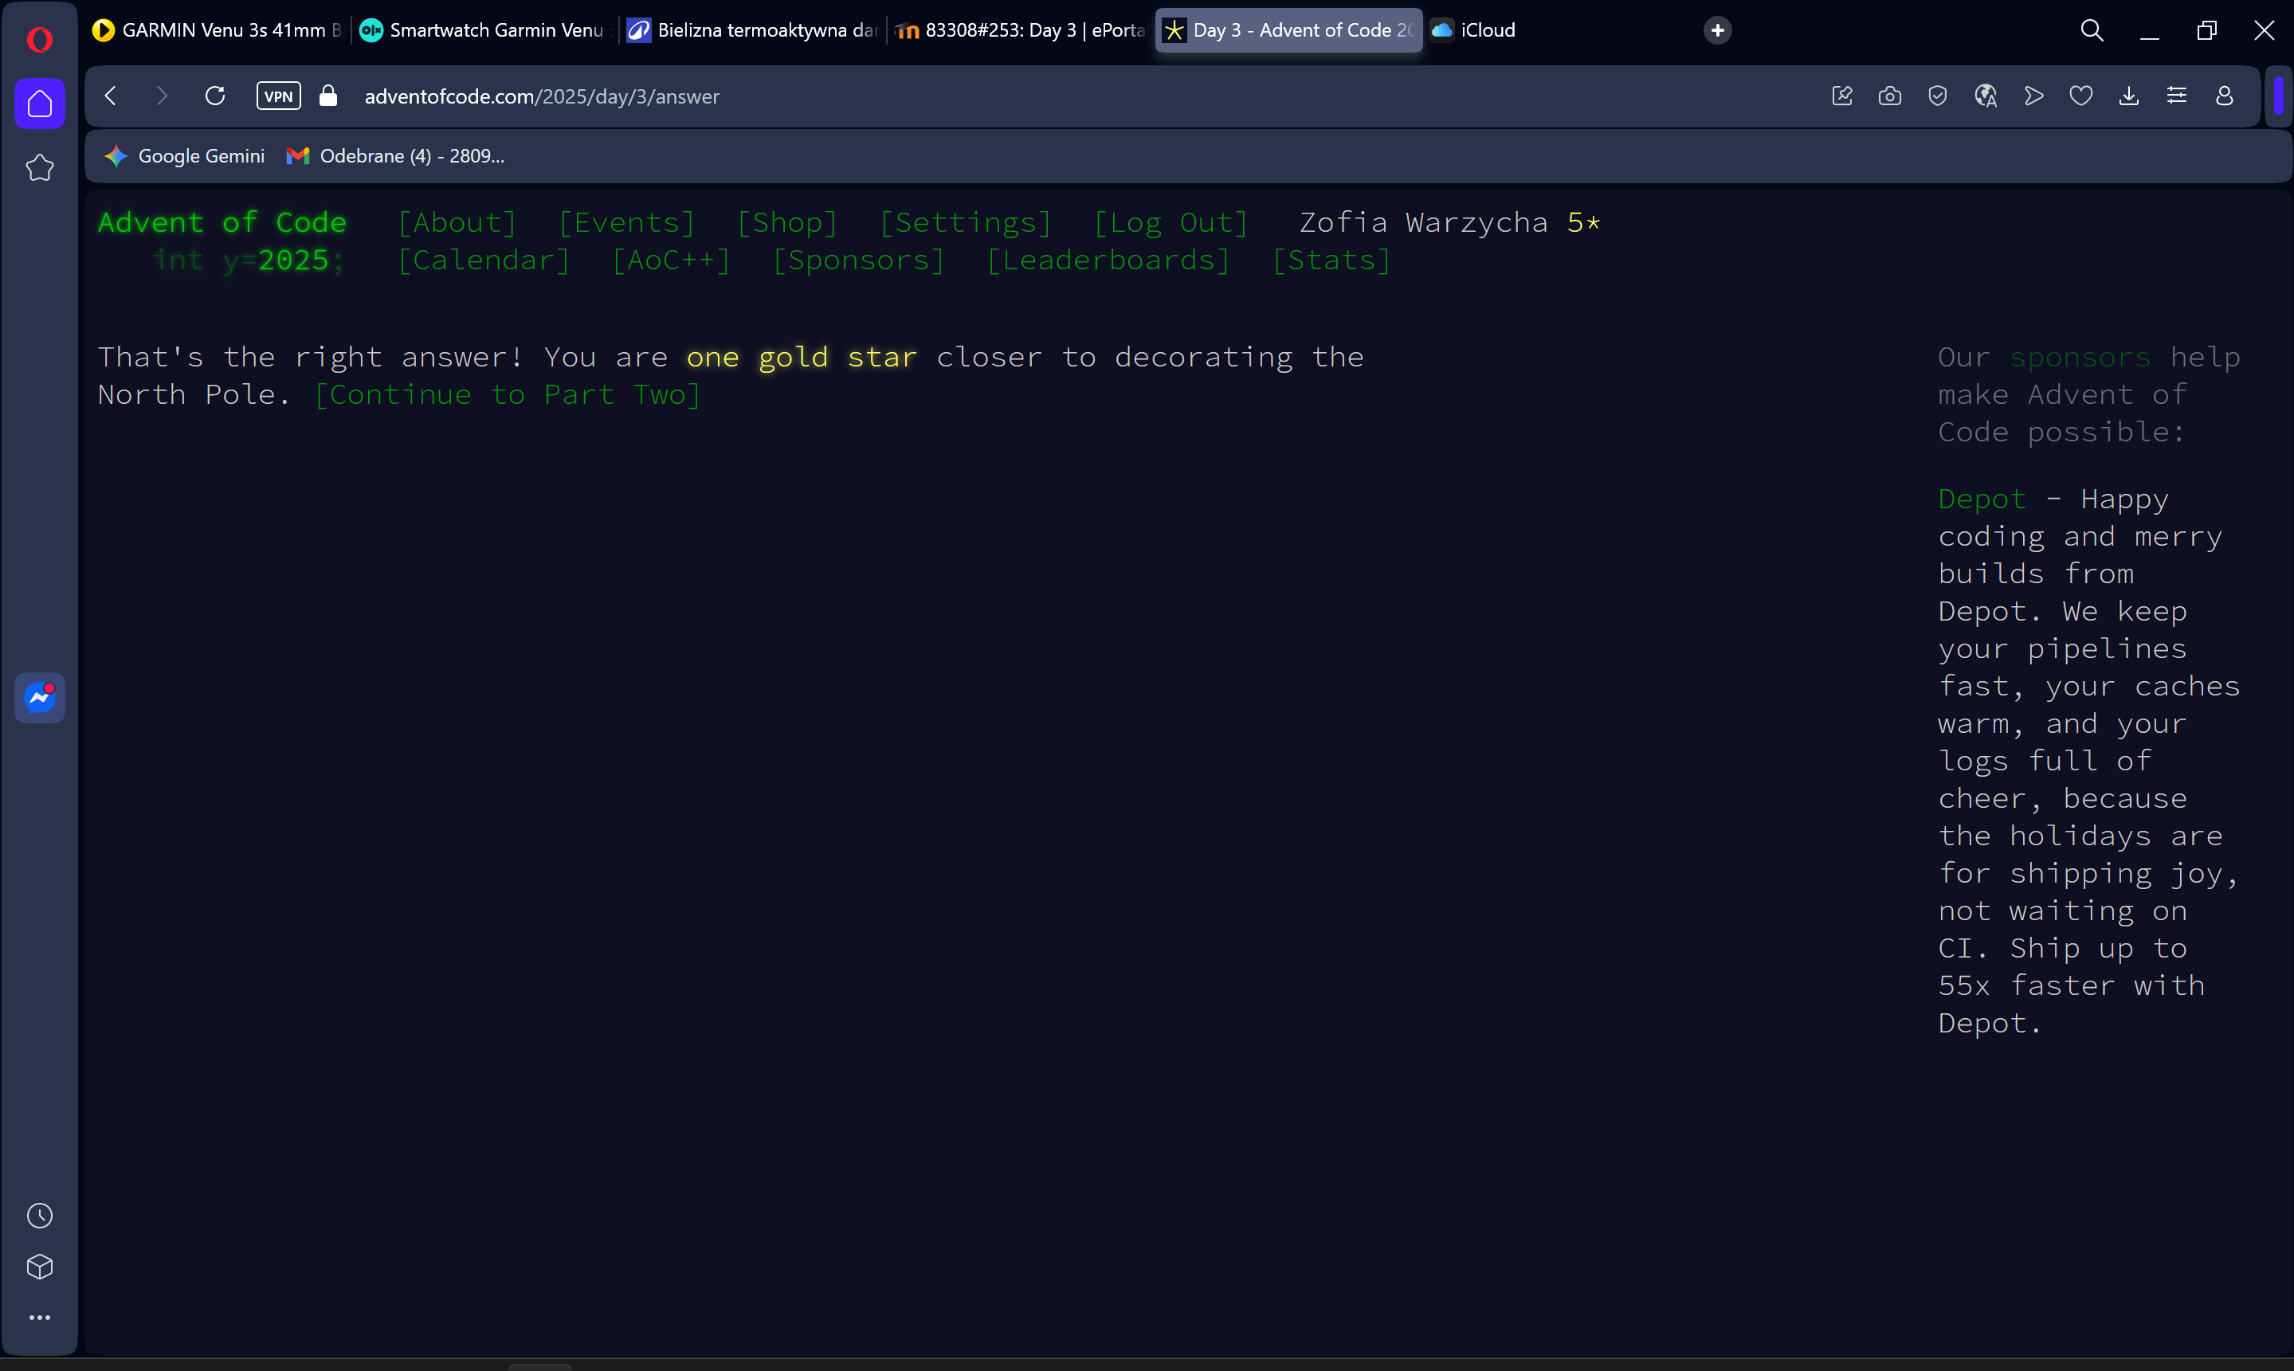
path = "C:/Users/zosia/OneDrive/Pulpit/day3.txt"

total = 0
with open(path, 'r') as f:
for line in f:
bank = line.strip()
if not bank:
continue

max_joltage = 0

for i in range(len(bank)):
for j in range(i + 1, len(bank)):
digit1 = bank[i]
digit2 = bank[j]
joltage = int(digit1 + digit2)
if joltage > max_joltage:
max_joltage = joltage

total += max_joltage

print(total)
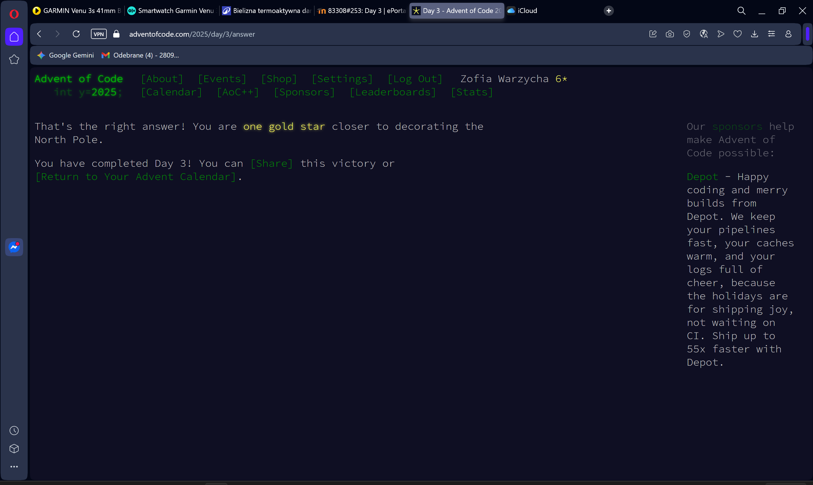
def find_max_12_digit_number(bank):
n = len(bank)
need = 12
result = []
start = 0

for pos in range(12):
positions_left = n - start
can_skip = positions_left - need

max_digit = -1
max_pos = -1

for i in range(start, start + can_skip + 1):
if int(bank[i]) > max_digit:
max_digit = int(bank[i])
max_pos = i

result.append(str(max_digit))
start = max_pos + 1
need -= 1

return int(''.join(result))

total = 0
with open(path, 'r') as f:
for line in f:
bank = line.strip()
if not bank or len(bank) < 12:
continue

max_joltage = find_max_12_digit_number(bank)
total += max_joltage

print(total)

