Zofia Warzycha (280971)

Day 4 – Advent of Code
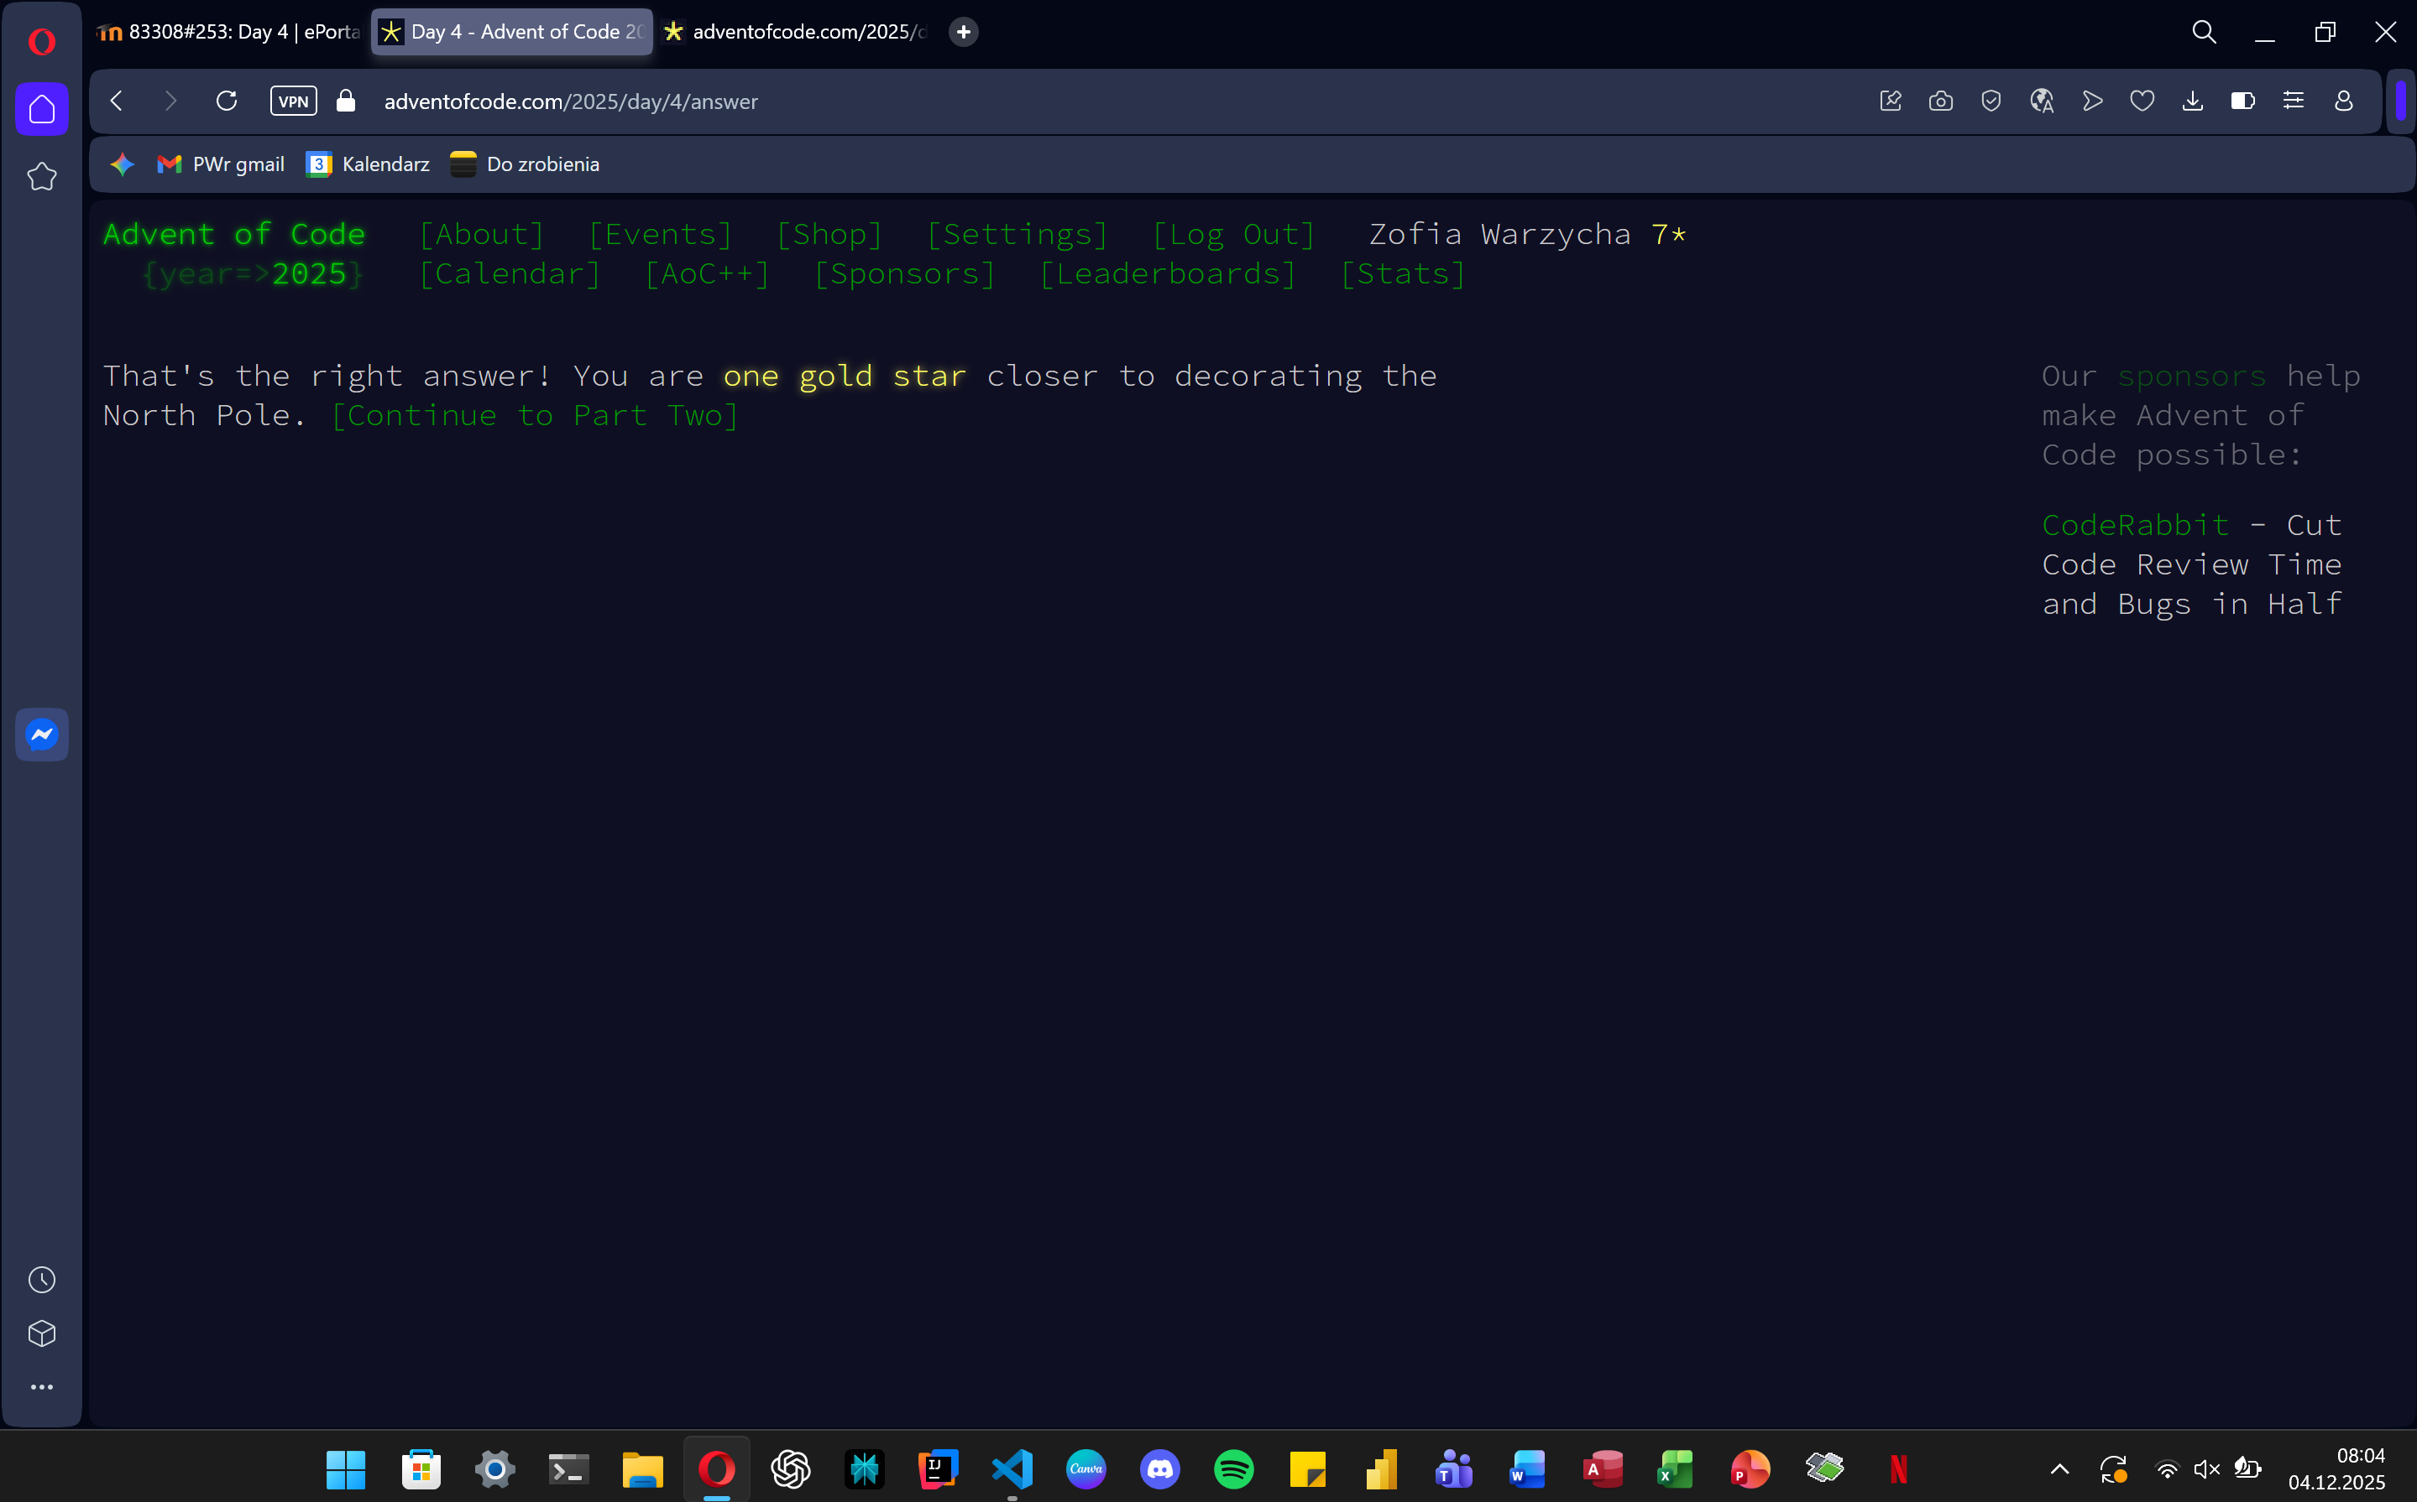
path = "C:/Users/zosia/OneDrive/Pulpit/day4.txt"

def solve_day4(path):
try:
with open(path, 'r') as f:
grid = [line.strip() for line in f.readlines()]
except FileNotFoundError:
print(f"Błąd: Nie znaleziono pliku pod ścieżką: {path}")
return None

if not grid:
return 0

rows = len(grid)
cols = len(grid[0])
accessible_rolls = 0

neighbor_offsets = [
(-1, -1), (-1, 0), (-1, 1),
(0, -1), (0, 1),
(1, -1), (1, 0), (1, 1)
]

for r in range(rows):
current_cols = len(grid[r])

for c in range(current_cols):
if grid[r][c] == '@':
neighbor_count = 0

for dr, dc in neighbor_offsets:
nr, nc = r + dr, c + dc

if 0 <= nr < rows and 0 <= nc < len(grid[nr]):
if grid[nr][nc] == '@':
neighbor_count += 1

if neighbor_count < 4:
accessible_rolls += 1

return accessible_rolls

result = solve_day4(path)

if result is not None:
print(f"Rolls of paper: {result}")
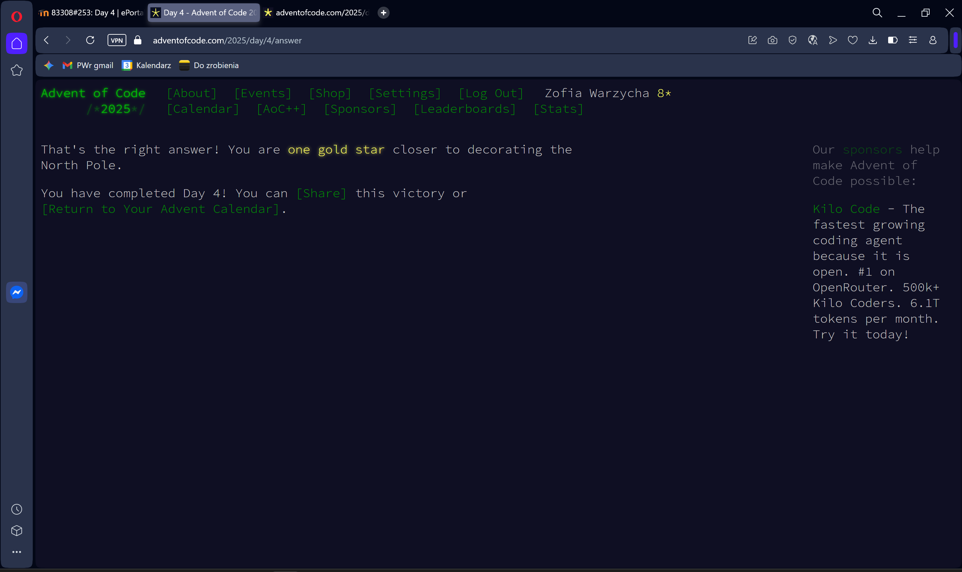
def solve_day4_part2(path):
try:
with open(path, 'r') as f:
grid = [list(line.strip()) for line in f.readlines()]
except FileNotFoundError:
print(f"Błąd: Nie znaleziono pliku pod ścieżką: {path}")
return None

if not grid:
return 0

rows = len(grid)
cols = len(grid[0])
total_removed = 0

neighbor_offsets = [
(-1, -1), (-1, 0), (-1, 1),
(0, -1), (0, 1),
(1, -1), (1, 0), (1, 1)
]

while True:
to_remove = []

for r in range(rows):
current_cols = len(grid[r])
for c in range(current_cols):
if grid[r][c] == '@':
neighbor_count = 0

for dr, dc in neighbor_offsets:
nr, nc = r + dr, c + dc

if 0 <= nr < rows and 0 <= nc < len(grid[nr]):
if grid[nr][nc] == '@':
neighbor_count += 1

if neighbor_count < 4:
to_remove.append((r, c))

if not to_remove:
break

for r, c in to_remove:
grid[r][c] = '.'

total_removed += len(to_remove)

return total_removed

result = solve_day4_part2(path)

if result is not None:
print(f"Part 2: {result}")

