Zofia Warzycha 280971

Day 5 – Advent of Code
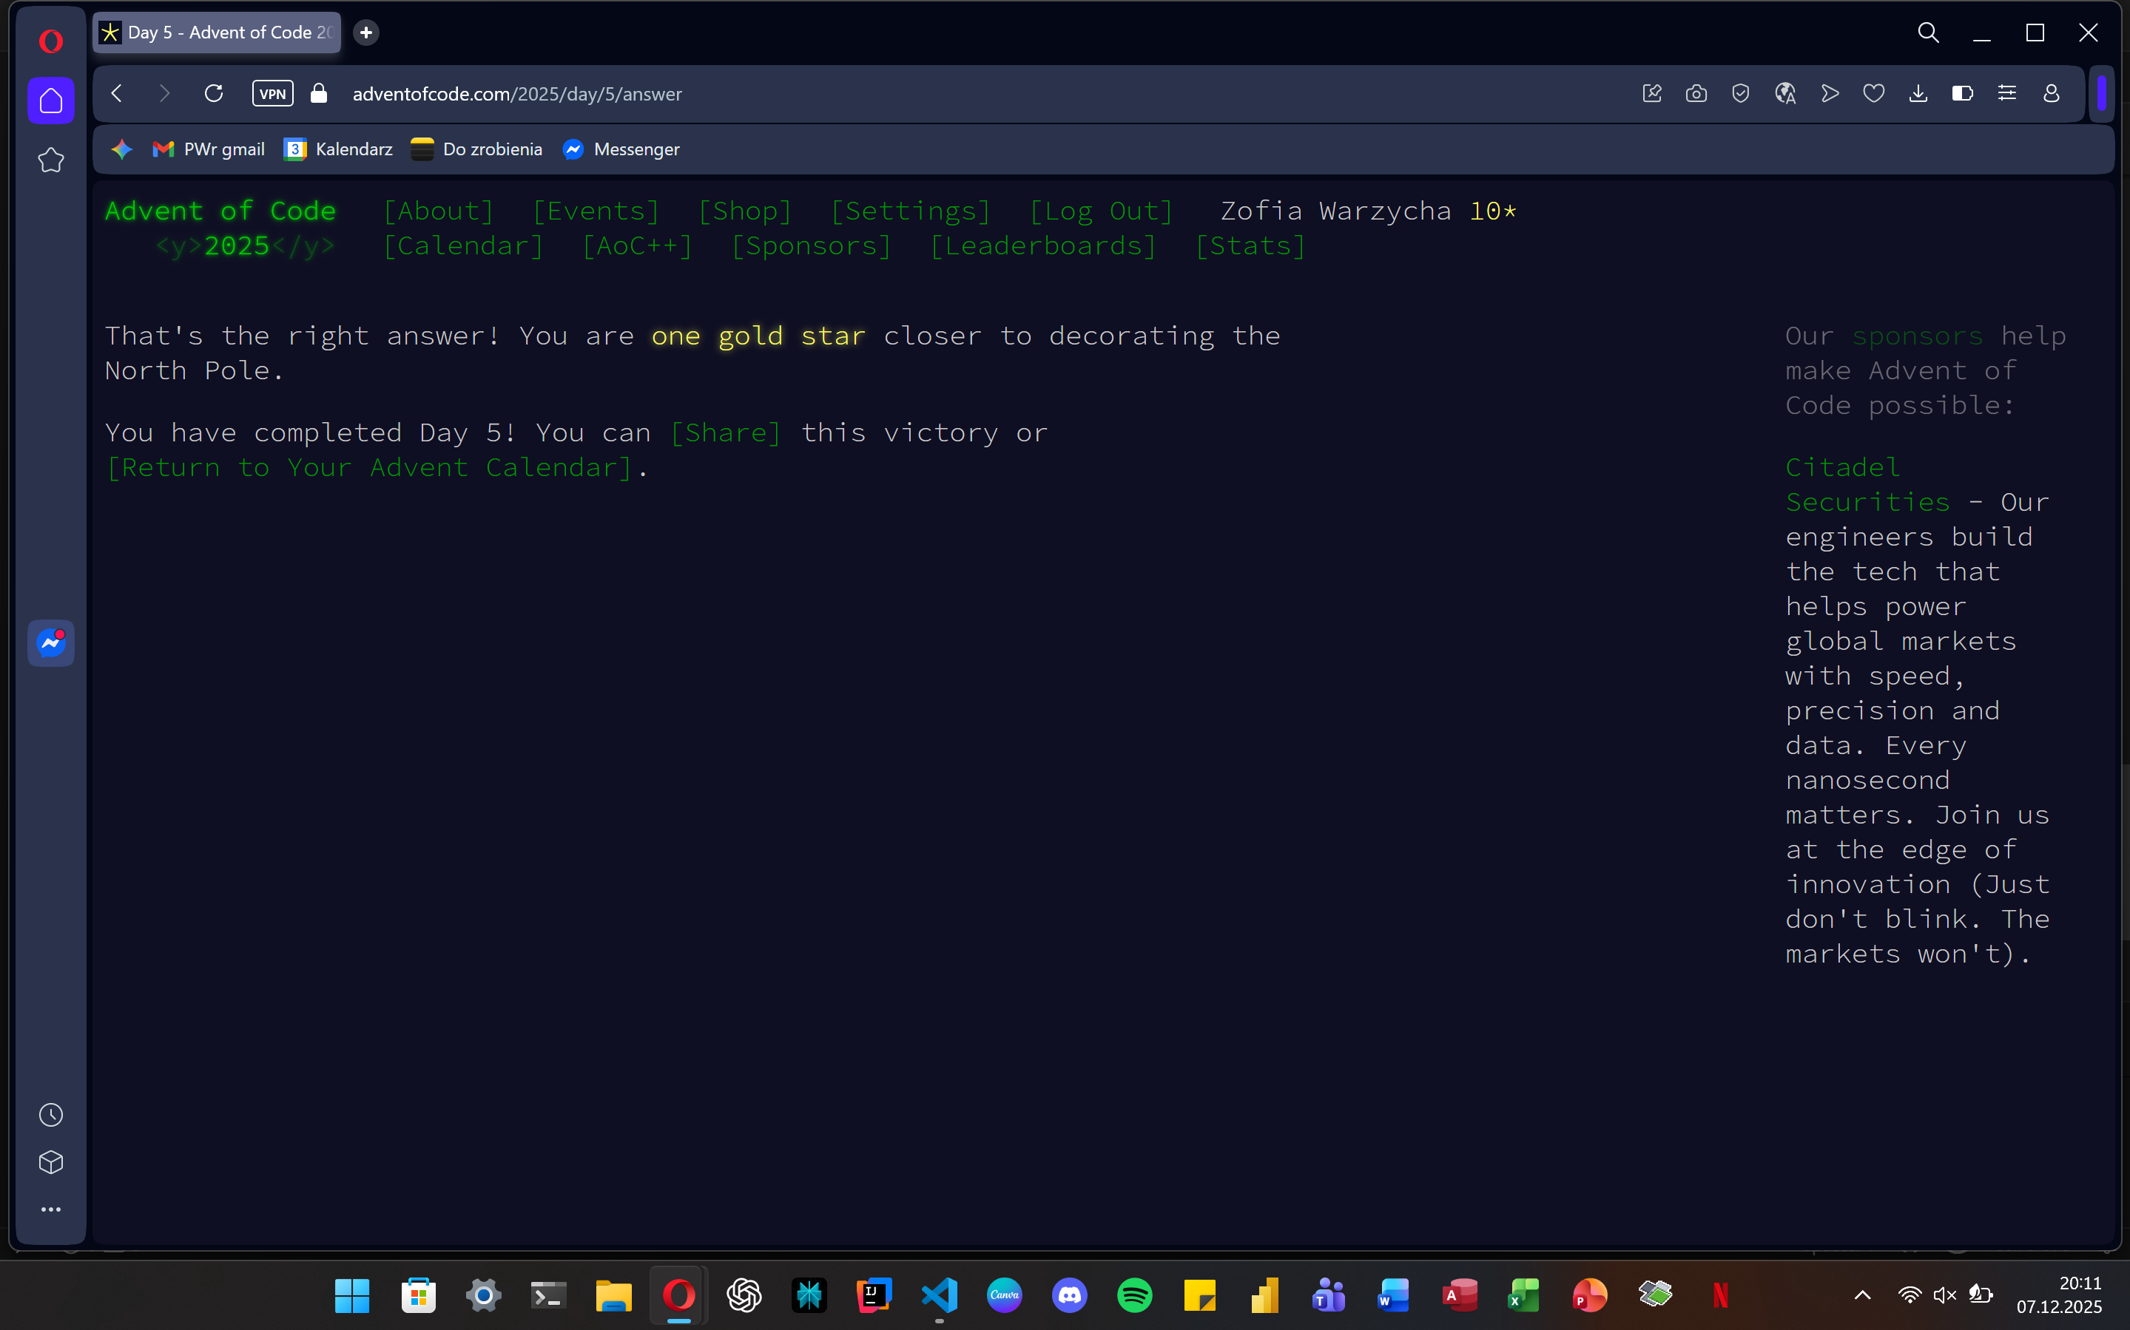

Part 1
def solve_cafeteria_puzzle():
file_path = "C:/Users/zosia/OneDrive/Pulpit/day5.txt"
ranges = []
ids = []
parsing_ranges = True

try:
with open(file_path, 'r') as f:
for line in f:
line = line.strip()

if line.startswith('[source'):
line = line.split(']')[-1].strip()

if not line:
if parsing_ranges and len(ranges) > 0:
parsing_ranges = False
continue

if parsing_ranges:
if '-' in line:
parts = line.split('-')
ranges.append((int(parts[0]), int(parts[1])))
else:
parsing_ranges = False
ids.append(int(line))
else:
ids.append(int(line))

fresh_count = 0

for ingredient_id in ids:
for start, end in ranges:
if start <= ingredient_id <= end:
fresh_count += 1
break

print(fresh_count)

except FileNotFoundError:
print("File not found.")

if __name__ == "__main__":
solve_cafeteria_puzzle()

Part 2
def solve_cafeteria_part_two():
file_path = "C:/Users/zosia/OneDrive/Pulpit/day5.txt"
ranges = []

try:
with open(file_path, 'r') as f:
for line in f:
line = line.strip()
if line.startswith('[source'):
line = line.split(']')[-1].strip()

if not line:
break

if '-' in line:
parts = line.split('-')
start, end = int(parts[0]), int(parts[1])
ranges.append((start, end))

if not ranges:
print(0)
return

ranges.sort(key=lambda x: x[0])

merged_ranges = []
curr_start, curr_end = ranges[0]

for i in range(1, len(ranges)):
next_start, next_end = ranges[i]

if next_start <= curr_end + 1:
curr_end = max(curr_end, next_end)
else:
merged_ranges.append((curr_start, curr_end))
curr_start, curr_end = next_start, next_end

merged_ranges.append((curr_start, curr_end))

total_fresh = 0
for start, end in merged_ranges:
total_fresh += (end - start + 1)

print(total_fresh)

except FileNotFoundError:
print("File not found.")

if __name__ == "__main__":
solve_cafeteria_part_two()

