Zofia Warzycha 280971

Day 6 – Advent of Code
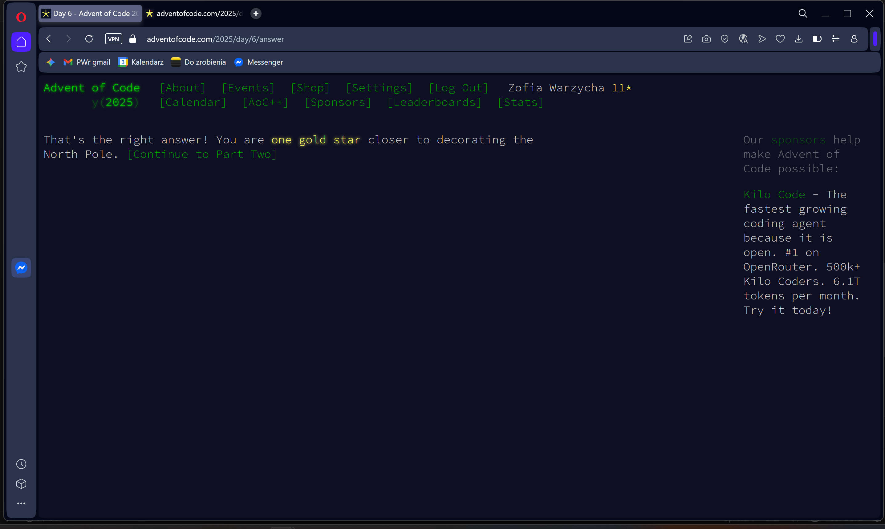
import sys

def solve():
file_path = "C:/Users/zosia/OneDrive/Pulpit/day6.txt"

try:
with open(file_path, 'r') as f:
lines = f.read().splitlines()
except FileNotFoundError:
print(f"Error: Could not find file at {file_path}")
return

if not lines:
print(0)
return

max_width = max(len(line) for line in lines)
grid = [line.ljust(max_width) for line in lines]
height = len(grid)

grand_total = 0
col = 0

while col < max_width:
is_empty = True
for row in range(height):
if grid[row][col] != ' ':
is_empty = False
break

if is_empty:
col += 1
continue

start_col = col

while col < max_width:
col_is_separator = True
for row in range(height):
if grid[row][col] != ' ':
col_is_separator = False
break

if col_is_separator:
break
col += 1

end_col = col

numbers = []
operator = None

for row in range(height):
segment = grid[row][start_col:end_col].strip()
if not segment:
continue

if segment.isdigit():
numbers.append(int(segment))
elif segment in ('+', '*'):
operator = segment

if operator == '+':
result = sum(numbers)
elif operator == '*':
result = 1
for n in numbers:
result *= n
else:
result = 0

grand_total += result

print(grand_total)

if __name__ == "__main__":
solve()
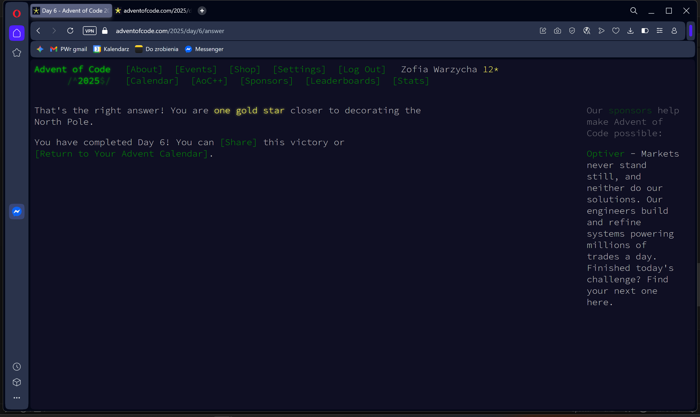
import sys

def solve():
file_path = "C:/Users/zosia/OneDrive/Pulpit/day6.txt"

try:
with open(file_path, 'r') as f:
lines = f.read().splitlines()
except FileNotFoundError:
print(f"Error: Could not find file at {file_path}")
return

if not lines:
print(0)
return

max_width = max(len(line) for line in lines)
grid = [line.ljust(max_width) for line in lines]
height = len(grid)

grand_total = 0
col = 0

while col < max_width:
is_empty = True
for row in range(height):
if grid[row][col] != ' ':
is_empty = False
break

if is_empty:
col += 1
continue

start_col = col
while col < max_width:
col_is_separator = True
for row in range(height):
if grid[row][col] != ' ':
col_is_separator = False
break

if col_is_separator:
break
col += 1

end_col = col

problem_numbers = []
operator = None

for c in range(end_col - 1, start_col - 1, -1):
num_str = ""
for r in range(height):
char = grid[r][c]
if char.isdigit():
num_str += char
elif char in ('+', '*'):
operator = char

if num_str:
problem_numbers.append(int(num_str))

if operator == '+':
result = sum(problem_numbers)
elif operator == '*':
result = 1
for n in problem_numbers:
result *= n
else:
result = 0

grand_total += result

print(grand_total)

if __name__ == "__main__":
solve()

