Zofia Warzycha 280971

Day 7 – Advent of Code
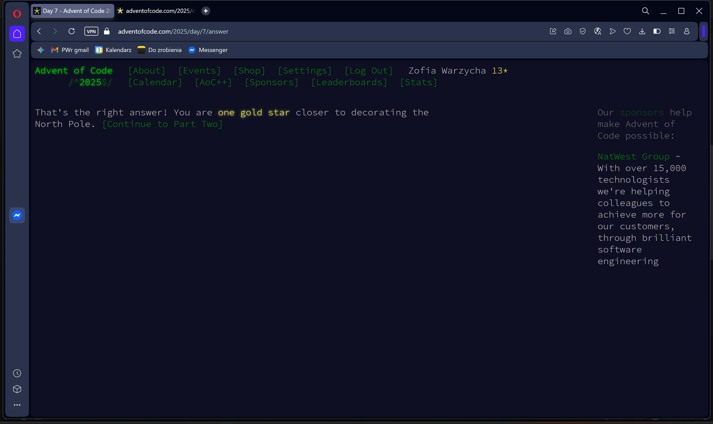
def solve():
path = "C:/Users/zosia/OneDrive/Pulpit/day7.txt"
with open(path, 'r') as f:
grid = [line.rstrip('\n') for line in f]

active_beams = set()
for col, char in enumerate(grid[0]):
if char == 'S':
active_beams.add(col)
break

total_splits = 0
height = len(grid)
width = max(len(row) for row in grid)

for r in range(height):
next_beams = set()
for c in active_beams:
if 0 <= c < width:
char = grid[r][c] if c < len(grid[r]) else '.'

if char == '^':
total_splits += 1
next_beams.add(c - 1)
next_beams.add(c + 1)
else:
next_beams.add(c)
active_beams = next_beams

print(total_splits)

if __name__ == "__main__":
solve()
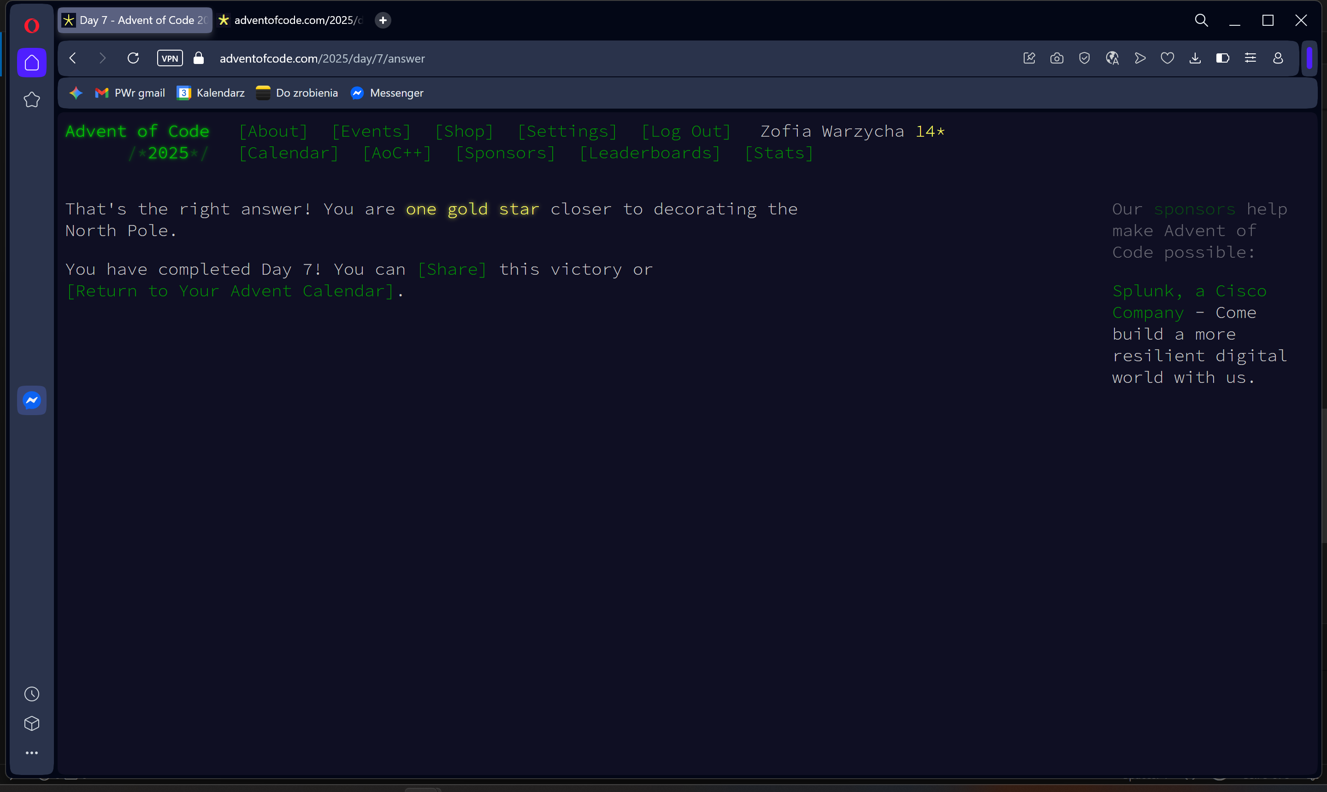
from collections import defaultdict

def solve():
path = "C:/Users/zosia/OneDrive/Pulpit/day7.txt"
with open(path, 'r') as f:
grid = [line.rstrip('\n') for line in f]

current_timelines = defaultdict(int)
for col, char in enumerate(grid[0]):
if char == 'S':
current_timelines[col] = 1
break

height = len(grid)
width = max(len(row) for row in grid)

for r in range(height):
next_timelines = defaultdict(int)
for c, count in current_timelines.items():
if 0 <= c < width:
char = grid[r][c] if c < len(grid[r]) else '.'

if char == '^':
if 0 <= c - 1 < width:
next_timelines[c - 1] += count
if 0 <= c + 1 < width:
next_timelines[c + 1] += count
else:
next_timelines[c] += count

current_timelines = next_timelines

print(sum(current_timelines.values()))

if __name__ == "__main__":
solve()

