Small Computer Monitor

Installation

Monitor version 1.0 for the Z80 CPU

Software and Documentation by Stephen C Cousins Edition 1.0.0

CONTENTS
Overview 2
Installation Options 3
LiNC80, 16k EPROM 27C128, Monitor L1 4
LiNC80, 32k EPROM 27C256, Monitor L1 4
LiNC80, 64k EPROM 27C512, Monitor L1 5
LiNC80, 32k EEPROM 28C256, Monitor L1 5
RC2014 Mini, 8k EPROM 27C64, Monitor R1 6
RC2014 Mini, 16k EPROM 27C128, Monitor R1 6
RC2014 Mini, 32k EPROM 27C256, Monitor R1 7
RC2014 Mini, 64k EPROM 27C512, Monitor R1 7
RC2014 Mini, 8k EEPROM 28C64, Monitor R1 8
RC2014 Mini, 32k EEPROM 28C256, Monitor R1 8
RC2014 Classic, 8k EPROM 27C64, Monitor R1 9
RC2014 Classic, 64k EPROM 27C512, Monitor R1 9
RC2014, 8k EPROM 27C64, Monitor R1 10
RC2014, 16k EPROM 27C128, Monitor R1 11
RC2014, 64k EPROM 27C512, Monitor R1 12
RC2014, 32k EEPROM 28C256, Monitor R1 13
RC2014, 16k EPROM 27C128, Monitor R2 14
RC2014, 32k EPROM 27C256, Monitor R2 15
RC2014, 64k EPROM 27C512, Monitor R2 16
RC2014, 32k EEPROM 28C256, Monitor R2 17
RC2014, 32k EPROM 27C256, Monitor R3 18
RC2014, 64k EPROM 27C512, Monitor R3 19
RC2014, 32k EEPROM 28C256, Monitor R3 20
Fault Finding 21
Parts and Suppliers 22
PROM Pin-outs 24
Contact Information 25

The Small Computer Monitor is a classic machine code monitor enabling debugging of programs and general tinkering with hardware and software. It can also act as a boot ROM, so no other software is required on the target computer system.

To install the Monitor you need to know the type of hardware you are using and the type of PROM containing Monitor program. Then look up, in the following pages, the correct jumper settings for this combination.

If you want to program your own PROM, then you need to know the hardware you are using, the type of PROM you have and which configuration of the Monitor you wish to use. The following tables give a summary of the popular combinations.

The Monitor requires a PROM of at least 8k bytes (8k by 8-bit, often called 64k bit memory). The Monitor on its own fits in 8k bytes, but can also contain software like BASIC and a CP/M loader, which requires a larger PROM.

In order to support a range of hardware and optional features, there are a number of different configurations of the Monitor. These are identified by a two character configuration code. The first character is usually a letter indicating the hardware family, such as “L” for LiNC80 and “R” for RC2014, and the second is usually a number indicating the variant within that family. The variants usually indicate what optional software is included in the PROM.

Optional software in the PROM is integrated with the Monitor and provides extra commands, such as BASIC and CPM. These two commands launch BASIC and CPM respectively. Systems that allow software to page different parts (or banks) of the ROM into the memory map, such as the LiNC80, enable additional monitor functions to be added without making changes to the Monitor code or even recompiling it.

The following configurations are described in this document.

LiNC80 | Config | Contains | PROMs
SBC1 | L1  (16k) | SCMonitor  BASIC (47k free)  CP/M loader | 27C128
SBC1 | L1  (32k) | SCMonitor  BASIC (47k free)  CP/M loader  GSL monitor/loader | 27C256  27C512  28C256

RC2014 | Config | Contains | PROMs
RC2014 Mini | R1  (8k) | SCMonitor (only) | 27C64  27C128  27C256  27C512  28C64  28C256
8k ROM board | R1  (8k) | SCMonitor (only) | 27C64  28C64
Switchable ROM board | R1  (8k) | SCMonitor (only) | 27C64  27C512
Pageable ROM board  and 32k/64k RAM board | R1  (8k) | SCMonitor (only) | 27C64  27C128  27C512  28C256
Pageable ROM board  and 64k RAM board | R2 (16k) | SCMonitor  BASIC (47k free) | 27C128  27C256  27C512  28C256
Pageable ROM board  and 64k RAM board | R3  (32k) | SCMonitor  BASIC (31k free)  CP/M loader | 27C256  27C512  28C256

LiNC80, 16k EPROM 27C128, Monitor L1

Monitor configuration L1 | 16k EPROM 27C128
SCMonitor  BASIC (47k free)  CP/M loader | 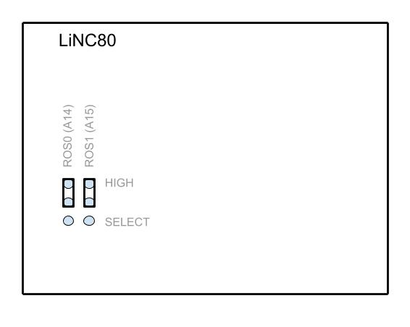
16k page size (ROM)
1 page available

LiNC80, 32k EPROM 27C256, Monitor L1

Monitor configuration L1 | 32k EPROM 27C256
SCMonitor  BASIC (47k free)  CP/M loader  GSL monitor (optional) | 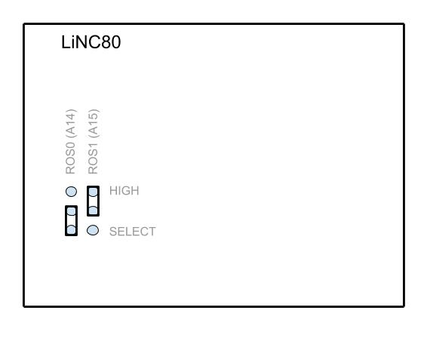
16k page size (ROM)
2 pages available

Shown with Monitor in first ROM page

LiNC80, 64k EPROM 27C512, Monitor L1

Monitor configuration L1 | 64k EPROM 27C512
SCMonitor  BASIC (47k free)  CP/M loader  GSL monitor (optional) | 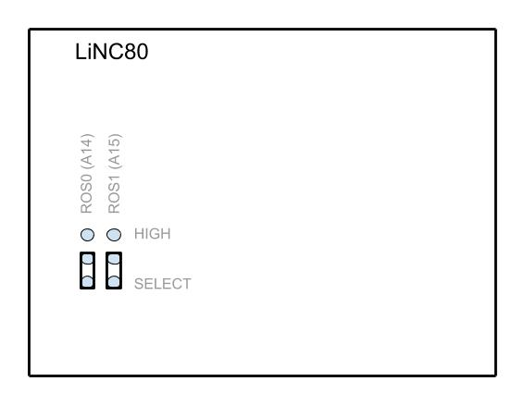
16k page size (ROM)
4 pages available

Shown with Monitor in first ROM page

LiNC80, 32k EEPROM 28C256, Monitor L1

Monitor configuration L1 | 32k EEPROM 28C256
SCMonitor  BASIC (47k free)  CP/M loader  GSL monitor (optional) | 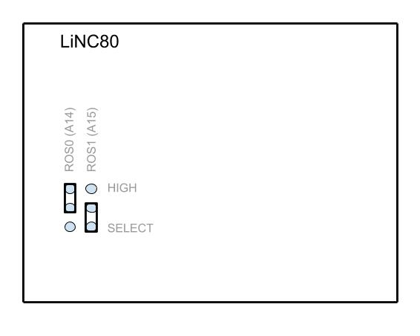
16k page size (ROM)
2 pages available

Shown with Monitor in first ROM page

RC2014 Mini, 8k EPROM 27C64, Monitor R1

Monitor configuration R1 | 8k EPROM 27C64
SCMonitor (only) | 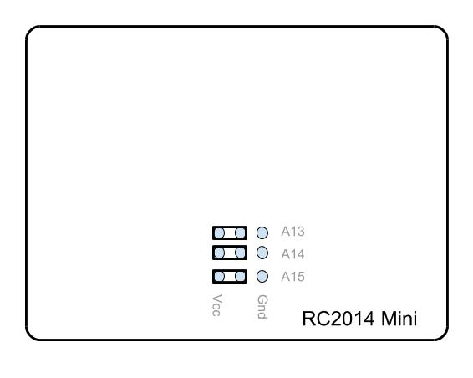
8k page size (ROM)
1 pages available

RC2014 Mini, 16k EPROM 27C128, Monitor R1

Monitor configuration R1 | 16k EPROM 27C128
SCMonitor (only) | 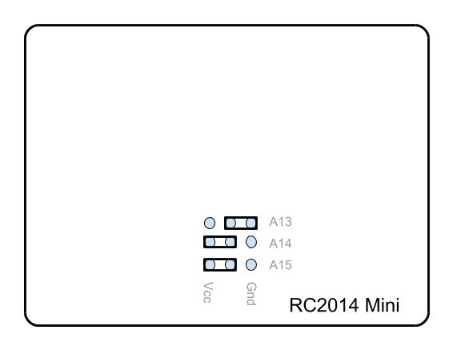
8k page size (ROM)
2 pages available

Shown with Monitor in first ROM page

RC2014 Mini, 32k EPROM 27C256, Monitor R1

Monitor configuration R1 | 32k EPROM 27C256
SCMonitor (only) | 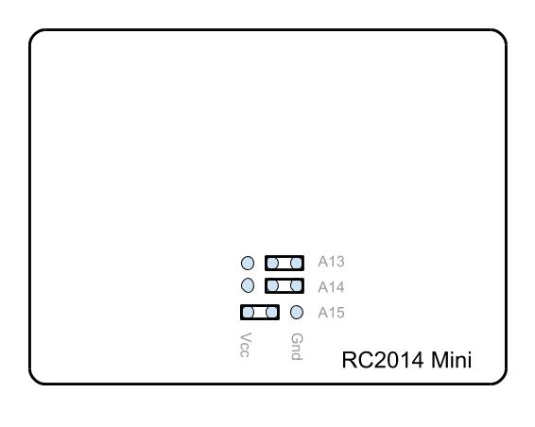
8k page size (ROM)
4 pages available

Shown with Monitor in first ROM page

RC2014 Mini, 64k EPROM 27C512, Monitor R1

Monitor configuration R1 | 64k EPROM 27C512
SCMonitor (only) | 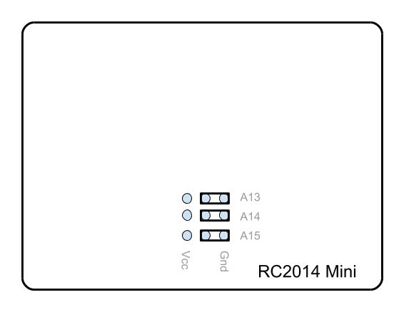
8k page size (ROM)
8 pages available

Shown with Monitor in first ROM page

RC2014 Mini, 8k EEPROM 28C64, Monitor R1

Monitor configuration R1 | 8k EEPROM 28C64
SCMonitor (only)

8k page size (ROM)
1 page available

RC2014 Mini, 32k EEPROM 28C256, Monitor R1

Monitor configuration R1 | 32k EEPROM 28C256
SCMonitor (only) | 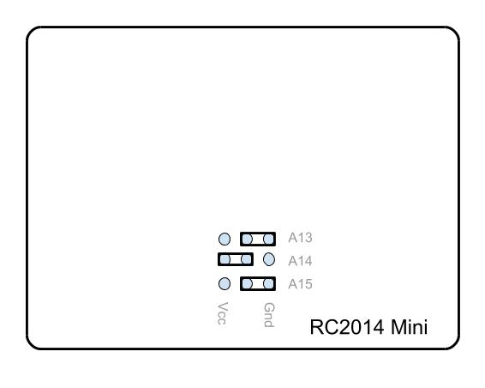
8k page size (ROM)
4 pages available

Shown with Monitor in first ROM page

RC2014 Classic, 8k EPROM 27C64, Monitor R1

Monitor configuration R1 | 8k EPROM 27C64
SCMonitor (only) | 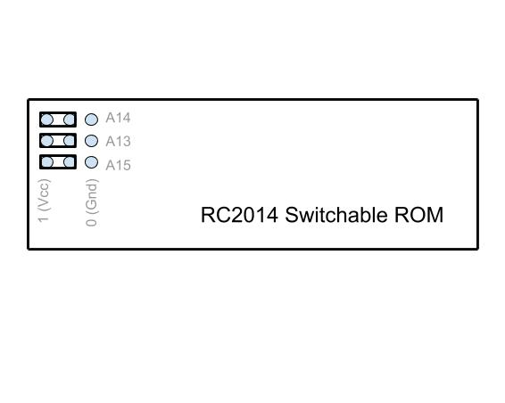
8k page size (ROM)
1 page available

This configuration of Monitor and EPROM can also be used in the
original 8k ROM board.

RC2014 Classic, 64k EPROM 27C512, Monitor R1

Monitor configuration R1 | 64k EPROM 27C512
SCMonitor (only) | 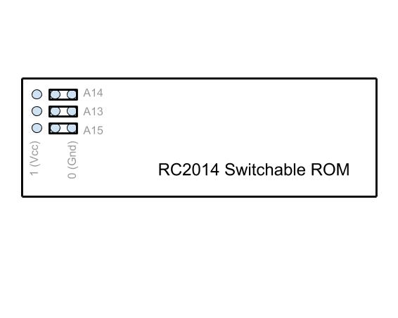
8k page size (ROM)
8 pages available

Shown with Monitor in first ROM page

This configuration of Monitor and EPROM can also be used in the
original 8k ROM board.
RC2014, 8k EPROM 27C64, Monitor R1

RC2014 configuration R1 | 8k EPROM 27C64
SCMonitor only | 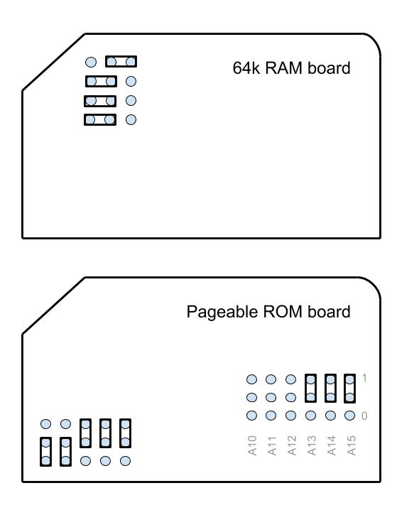
8k page size (ROM)
1 page available

This configuration of Monitor and jumpers is also suitable for the 28C64
EEPROM.

RC2014, 16k EPROM 27C128, Monitor R1

RC2014 configuration R1 | 16k EPROM 27C128
SCMonitor only | 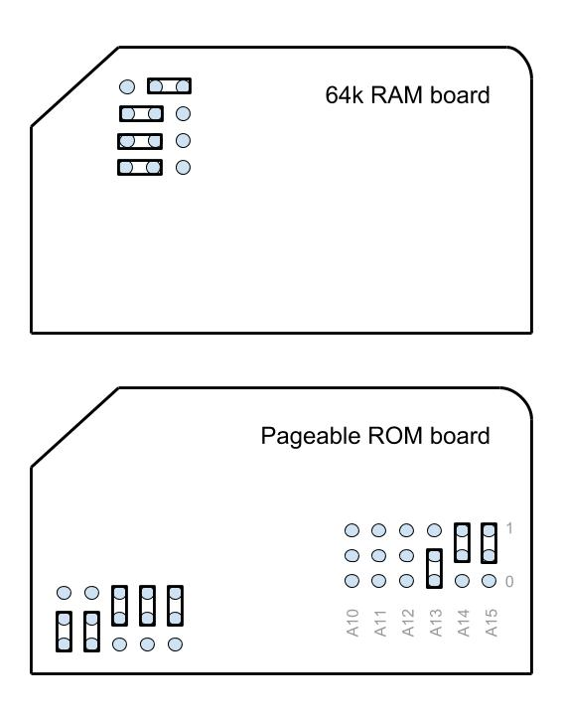
8k page size (ROM)
2 pages available

Shown with Monitor in first ROM page

RC2014, 64k EPROM 27C512, Monitor R1

RC2014 configuration R1 | 64k EPROM 27C512
SCMonitor only | 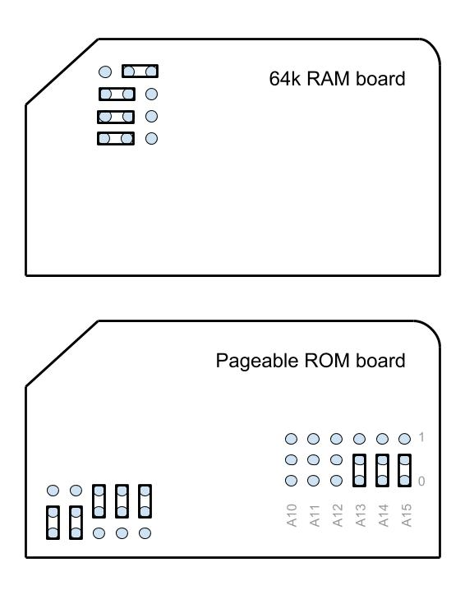
8k page size (ROM)
8 pages available

Shown with Monitor in first ROM page

RC2014, 32k EEPROM 28C256, Monitor R1

RC2014 configuration R1 | 32k EEPROM 28C256
SCMonitor only | 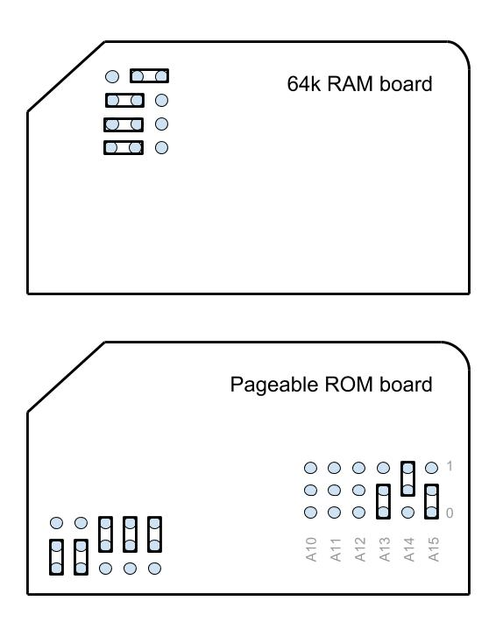
8k page size (ROM)
4 pages available

Shown with Monitor in first ROM page

RC2014, 16k EPROM 27C128, Monitor R2

RC2014 configuration R2 | 16k EPROM 27C128
Small Computer Monitor  BASIC (47k free) | 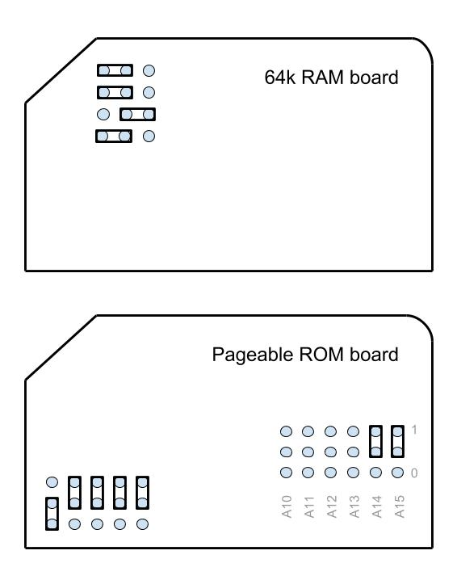
16k page size (ROM)
1 page available

RC2014, 32k EPROM 27C256, Monitor R2

RC2014 configuration R2 | 32k EPROM 27C256
Small Computer Monitor  BASIC (47k free) | 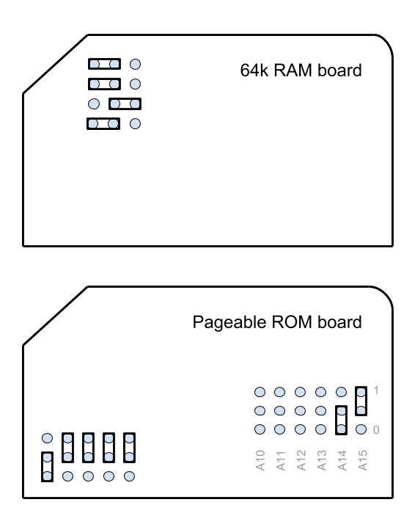
16k page size (ROM)
2 pages available

Shown with Monitor in first ROM page

RC2014, 64k EPROM 27C512, Monitor R2

RC2014 configuration R2 | 64k EPROM 27C512
Small Computer Monitor  BASIC (47k free) | 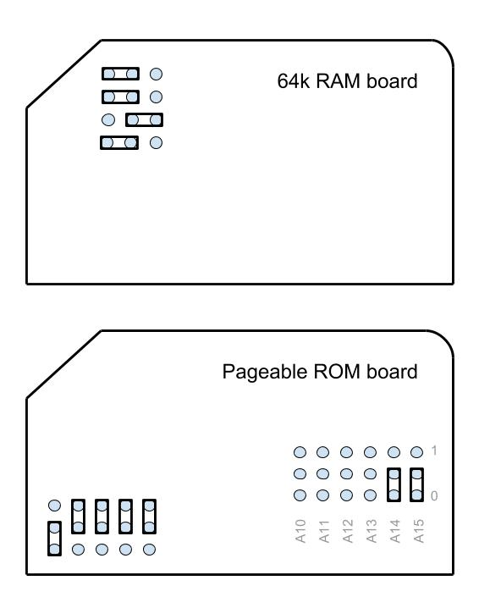
16k page size (ROM)
4 pages available

Shown with Monitor in first ROM page

RC2014, 32k EEPROM 28C256, Monitor R2

RC2014 configuration R2 | 32k EEPROM 28C256
Small Computer Monitor  BASIC (47k free) | 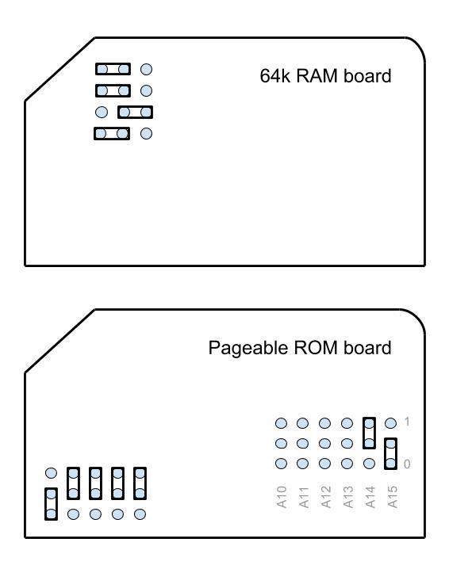
16k page size (ROM)
2 pages available

Shown with Monitor in first ROM page

RC2014, 32k EPROM 27C256, Monitor R3

RC2014 configuration R3 | 32k EPROM 27C256
Small Computer Monitor  BASIC (31k free)  CP/M loader | 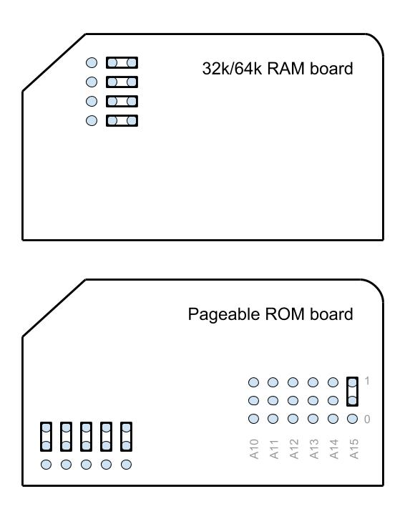
32k page size (ROM)
1 page available

Requires paging signal between RAM and ROM boards.

RC2014, 64k EPROM 27C512, Monitor R3

RC2014 configuration R3 | 64k EPROM 27C512
Small Computer Monitor  BASIC (31k free)  CP/M loader | 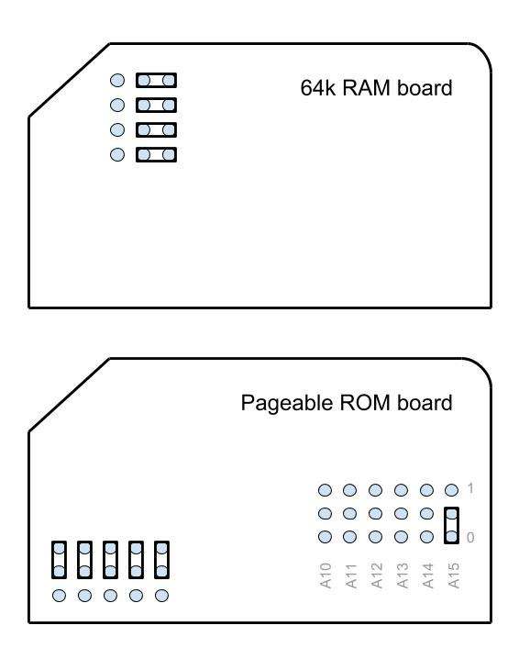
32k page size (ROM)
2 pages available

Shown with Monitor in first ROM page

Requires paging signal between RAM and ROM boards.

RC2014, 32k EEPROM 28C256, Monitor R3

RC2014 configuration R3 | 32k EEPROM 28C256
Small Computer Monitor  BASIC (31k free)  CP/M loader | 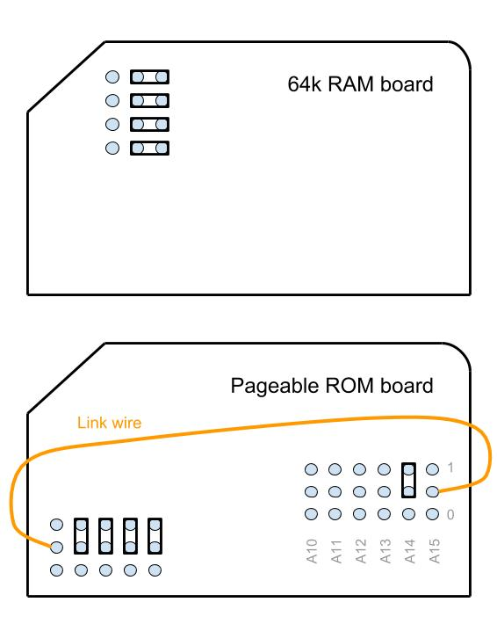
32k page size (ROM)
2 pages available

Shown with Monitor in first ROM page

Requires paging signal between RAM and ROM boards.

Fault Finding
If you do not see the monitor’s sign on message on the terminal when you switch the system on, then here are some things to try:

Press the system’s reset button.

Check the power supply is providing 4.75 to 5.25 volts, measured on the circuit board with the system turned on. Everything should be fine with a supply voltage of 4.5 to 5.5 volts, but better to play safe.

Check all links and jumpers, check no chips have bent legs and thus not making contact with their socket, carefully inspect all soldering, check all the chips are inserted the right way round, check all the components are in the right place. Check your serial connection looks right and that the terminal is correctly set. Then cry!

Don’t forget to follow any troubleshooting guide provided by the manufacturer.

LiNC80
Double check the jumpers for ROM signals A14 and A15, particularly if you are using a chip like the 28C256 which has unusual pin-outs for these signals. Also double check the serial jumpers as the clock source determines the initial baud rate.

RC2014
If your RC2014 was not previously tested with the supplied BASIC ROM, then if possible check it does work with the BASIC ROM. If that is not possible then you’ll need to go through all the usual fault finding processes, described here.

If your RC2014 was known to be working with the supplied BASIC ROM, then verify the Small Computer Monitor ROM contains the correct code and check the links related to addressing the ROM (especially if the chip has a different capacity to the one containing BASIC). Other than that you would appear to have an odd problem as the Monitor ROM should, in theory, work if the RC2014 standard BASIC ROM works.

It should be noted that there are a number of different serial modules available for the RC2014 and they are not all compatible. Currently the Small Computer Monitor only works with official RC2014 serial modules or modules totally compatible with these, and also SIO/2 modules following Grant Searle’s register addressing order.

Parts and Suppliers
The following is a list of parts and suppliers used during development of the Small Computer Monitor.

LiNC80 official modules
Information about the LiNC80 and its accessories, and links to the store page where kits can be purchased can be found at http://linc.no/go/linc80.

RC2014 official modules
Information at www.rc2014.co.uk
Parts purchased through Tindie:
https://www.tindie.com/stores/Semachthemonkey/?ref=offsite_badges&utm_source=sellers_Semachthemonkey&utm_medium=badges&utm_campaign=badge_medium

Chip programmer
WINGONEER TL866CS Universal USB MiniPro EEPROM FLASH BIOS Programmer AVR GAL PIC SPI
Amazon ASIN: B071H5XGR7
https://www.amazon.co.uk/gp/product/B071H5XGR7/ref=oh_aui_detailpage_o00_s00?ie=UTF8&psc=1

EEPROM 8k x 8 bit
Microchip Technology AT28C64B-15PU Parallel EEPROM Memory, 64kbit, 150ns, 4.5 → 5.5 V PDIP 28-Pin
RS part number: 127-6572
http://uk.rs-online.com/web/p/eeprom-memory-chips/1276572/

EEPROM 32k x 8 bit
Microchip Technology AT28C256-15PU Parallel EEPROM Memory, 256kbit, 150ns, 4.5 → 5.5 V PDIP 28-Pin
RS part number: 127-6570
https://uk.rs-online.com/web/p/eeprom-memory-chips/1276570/

FTDI cable
TTL-232R-5V - USB to Serial Converter Cable, 5V, 6Way, 1.8m
Farnell order code: 2419945
http://uk.farnell.com/ftdi/ttl-232r-5v/usb-to-serial-converter-cable/dp/2419945?ost=2419945&iscrfnonsku=false&ddkey=http%3Aen-GB%2FElement14_United_Kingdom%2Fsearch

FTDI 'cable'
HALJIA FT232RL FTDI USB to TTL Serial Converter Adapter Module Mini USB 3.3V 5.5V Board for Arduino
Amazon ASIN: B06XDH2VK9
https://www.amazon.co.uk/gp/product/B06XDH2VK9/ref=oh_aui_detailpage_o00_s00?ie=UTF8&psc=1

USB-RS232 cable
UGREEN 20210 USB Serial Cable, USB to RS232 DB9 9 pin Converter Cable
Amazon ASIN: B00QUZY4UG
https://www.amazon.co.uk/gp/product/B00QUZY4UG/ref=oh_aui_search_detailpage?ie=UTF8&psc=1
Note, you still need a null modem lead between this and the LiNC80 or RC2014.

PROM Pin-outs
Common PROM pin-outs are shown below, together with LiNC80 and RC2014 jumper options.

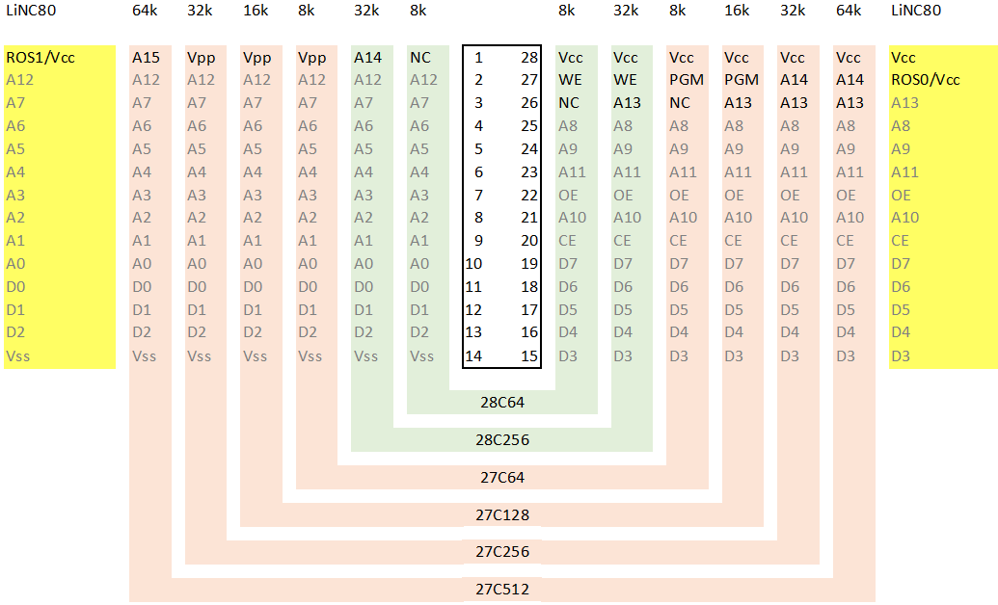

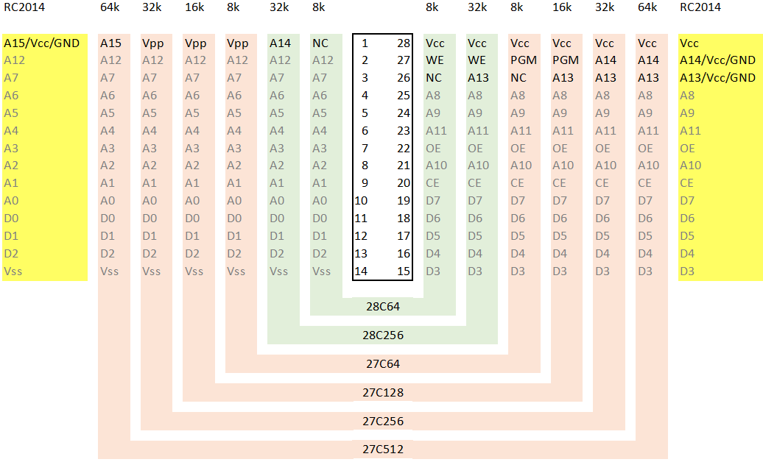
If you wish to contact me regarding the Small Computer Monitor please use the contact page at www.scc.me.uk.

Stephen C Cousins, Chelmsford, Essex, United Kingdom.

LiNC80
Issues related to the LiNC80 can be posted on the google group “LiNC80”.
Information about the LiNC80 and its accessories, and links to the store page where kits can be purchased can be found at http://linc.no/go/linc80

RC2014
Issues related to the RC2014 can be posted on the google group “RC2014-Z80”.
Information about the RC2014 can be found at www.rc2014.co.uk
Kits are available from www.tindie.com

