SIMATS ENGINEERING (SAVEETHA SCHOOL OF ENGINEERING)
Department of Computer Science and Engineering

ASSESSMENT TOOL 3 – Comparative Analysis

Course Code: | CSA06 | Course Title: | Design and Analysis of Algorithms
CO Assessed: | CO4: Articulation (BL4, BL5) | Assessment: | Assessment Tool 3 – Comparative Analysis
Weightage: | 10% of CIA | Total Marks: | 100
CO4 Statement: | Solve optimization problems using dynamic programming and greedy strategies.
Student Name: | Dinesh Karthick R | Reg. No.: | 192524121
Section / Batch: | 02 | Date: | 21-08-2026
Instructions to Students

- Answer the following question. Total Marks: 100.
- Analyze the given questions thoroughly before answering.
- Compare multiple aspects such as methods, results, advantages, and limitations clearly.
- Critically evaluate the strengths, weaknesses, and implications with proper justification.
- Present meaningful insights, interpretations, and well-supported conclusions from the comparisons.

Question Type | Focus Area | Questions
Comparative Analysis | Comparative analysis of Dynamic Programming and Greedy algorithms for optimization problems. | Q1

SECTION A – Comparative Analysis

Q1. Advantages and Disadvantages of DP vs Greedy (Comparative Analysis)

Analyze a problem solved using both DP and Greedy techniques. Compare advantages such as optimality vs efficiency. Identify disadvantages like high memory usage in DP and suboptimal solutions in greedy. Evaluate computational complexity. Discuss scalability. Generate insights on selecting appropriate paradigms.

(Solution implemented and executed in the SIMATS Online Programming Lab – DAA Programming module – 0/1 Knapsack solved using Dynamic Programming and Greedy approach; screenshots of the code and output are attached below.)
Code of Conduct
I Dinesh Karthick R / 192524121 (Name / Reg No) certify that this submission is my original work and that I have adhered to the guidelines specified for this assessment. I understand that any violation of academic integrity rules will result in disciplinary action.
Signature of the Student:

RUBRICS FOR CALCULATION

Comparative Analysis
Criteria | Weightage | Level 4 (Exemplary) | Level 3 (Proficient) | Level 2 (Developing) | Level 1 (Beginning)
Selection of Studies/Parameters | 20% | Selects highly relevant and diverse studies with well-defined comparison parameters | Selects relevant studies with minor gaps in parameter definition | Limited or partially relevant selection | Poor or inappropriate selection of studies
Comparison & Differentiation | 25% | Clearly compares multiple aspects (methods, results, limitations) with strong  differentiation | Good comparison with minor gaps | Basic comparison  with limited depth | No clear comparison;  mostly descriptive
Critical Evaluation | 25% | Critically evaluates strengths, weaknesses, and implications with  strong justification | Provides evaluation with  some justification | Limited evaluation;  lacks depth | No critical evaluation  provided
Synthesis & Insight Generation | 20% | Generates meaningful insights and conclusions  from comparisons | Some insights derived from  comparison | Limited or unclear insights | No insights generated
Clarity | 10% | Information is clearly presented (tables/figures) with  logical structure | Generally clear with minor issues | Presentation lacks clarity or  structure | Poor presentation and difficult to  understand

Marks Evaluation:
Criteria | Wt. | Level 4 – Exemplary | Level 3 – Proficient | Level 2 – Developing | Level 1 – Beginning
Selection of Studies/Parameters | 20%
Comparison & Differentiation | 25%
Critical Evaluation | 25%
Synthesis & Insight Generation | 20%
Clarity | 10%
Total Marks (100):

Faculty In-charge | Course Coordinator | Head of Department
Name: | Name: | Name:
Signature: | Signature: | Signature:
Date: | Date: | Date:
Screenshots – Code Execution Proof (SIMATS Online Programming Lab)
Screenshot 1: Problem statement and C code (DP setup) for the DP vs Greedy comparative analysis
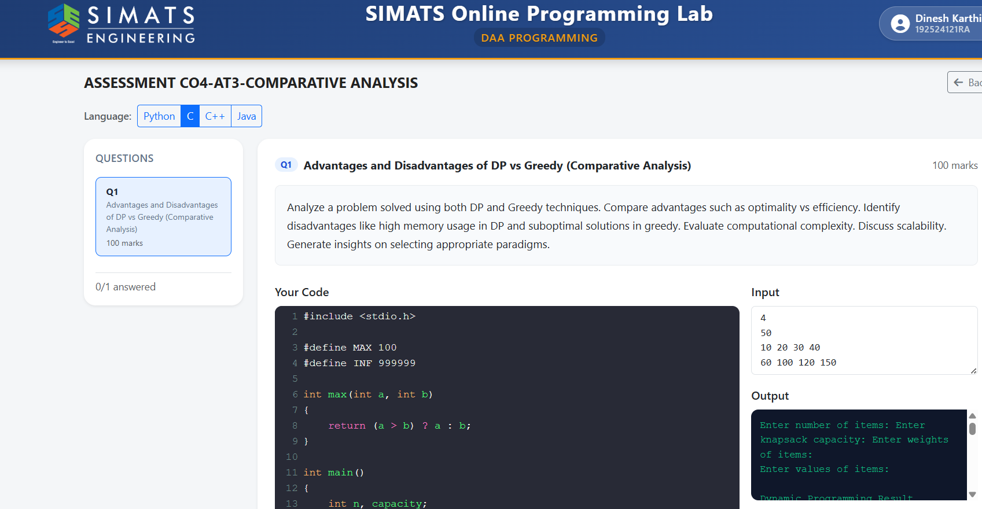
Screenshot 2: Dynamic Programming (0/1 Knapsack) implementation
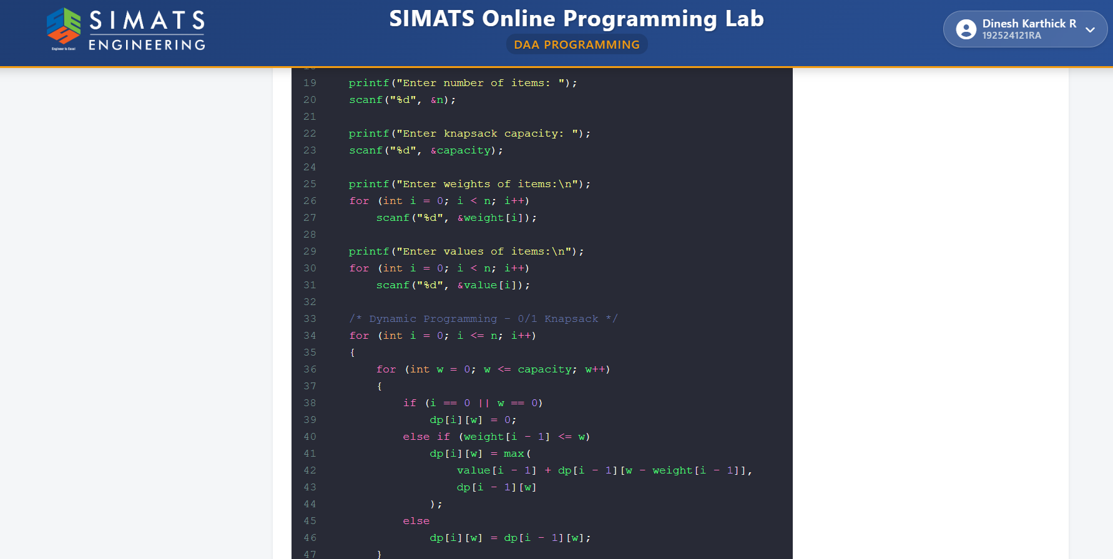
Screenshot 3: Greedy approach implementation
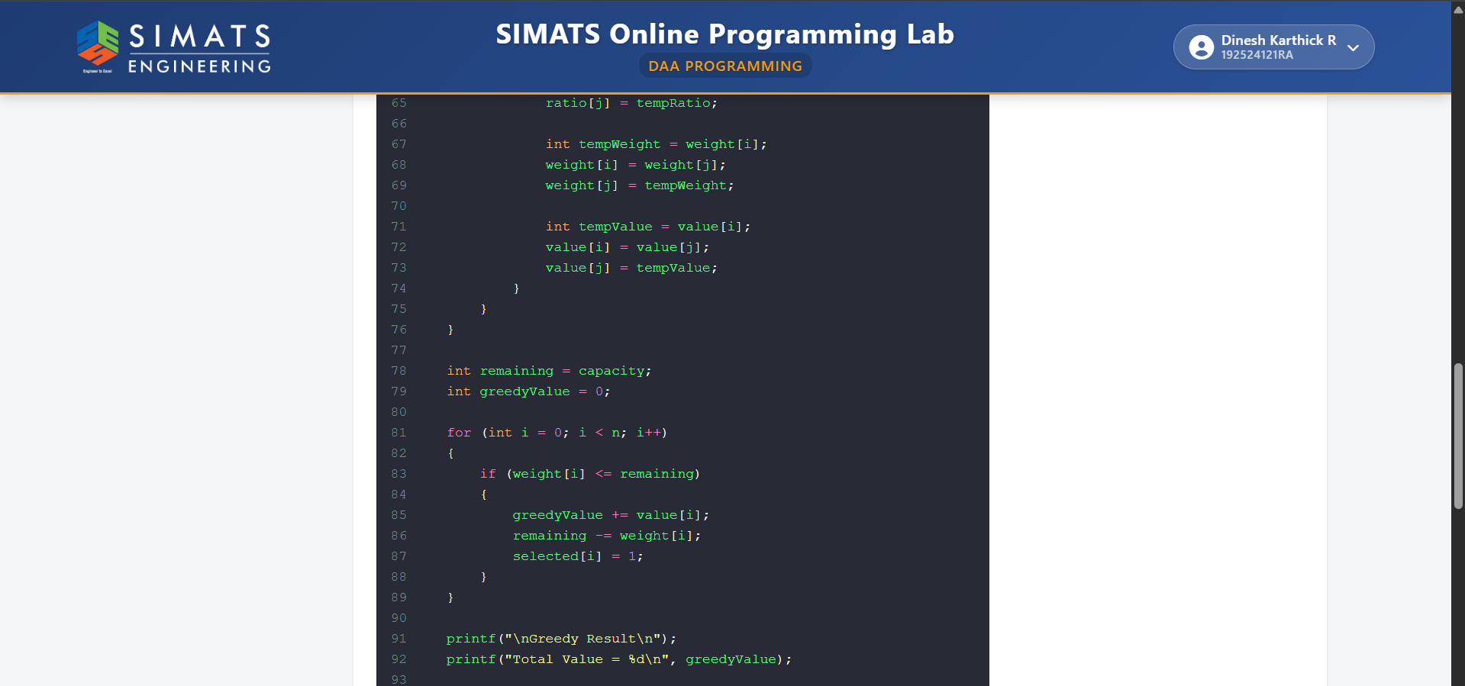
Screenshot 4: Comparison, scalability analysis, and final insights output
