 **NUST SCHOOL OF ELECTRICAL ENGINEERING AND COMPUTER SCIENCE**

Submitted by: Zoha Ahmed

213901

Submitted to: **Ma’am Sidra Sultana**

Class: BSCS7A

Date: 9/16/19

Advance Programming

Assignmnet1

Prestashop

About the Software

It is a software where one can design free e commerce websites. It is easy to install and configure hence can be used by laymen users too. Being a web based application it makes use of the language PHP. Since it is an e shopping center a database is to be managed too in mysql database. The database and the website an be accessed using xampp local host.

Configuring the Software

* Go on the prestashop official website and download the code files

(link for download: <https://www.prestashop.com/en/download>)

* Install a local host like XAMPP
* Paste all prestashop files to the htdocs folder in xampp
* Install prestashop on your pc. This involves the kind of store you want, the language the website will be in and several other specifications to customize your store/ website
* Create database for prestashop (giving it any name you like). Database can be created using phpMyAdmin or mysql (if already present in the pc).
* Login to prestashop on local host (type in the url: Localhost/Prestashop/admin)

User’s Perspective

Once installed, the website is pretty easy to use. On the website’s home page the top ribbon has contact information link, language option, sign in option and cart viewing option.

The next ribbon has home page option, options of different categories of goods and a search bar. Below that is a slide show of different offers or products that can attract user attention. Below that is a list of some popular items with their pictures, concluded by a view all items option. Below it is another customizable box that can either be removed or can have more offers or products to keep the user interested.

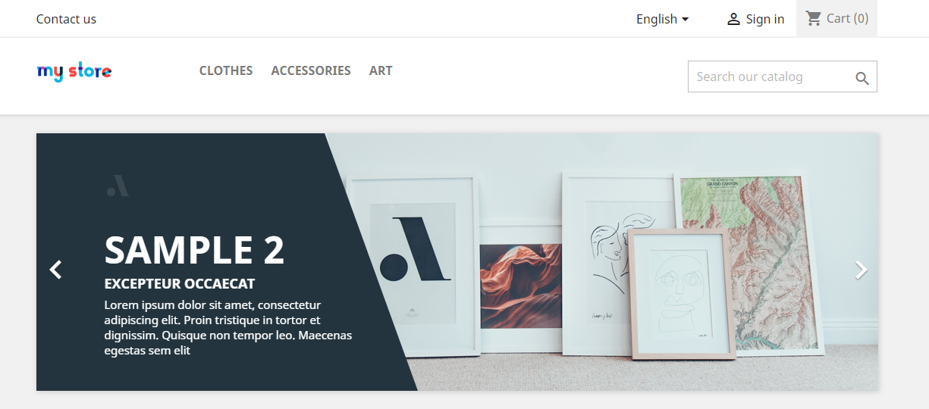

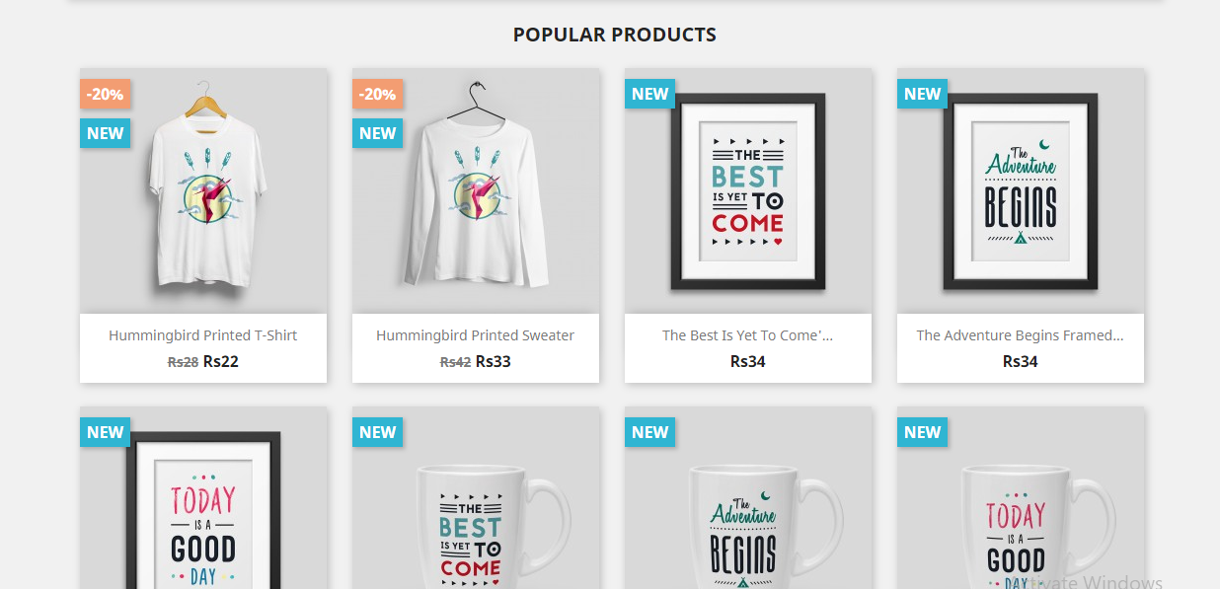

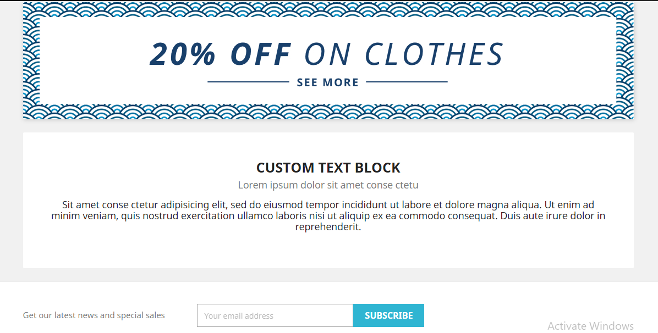

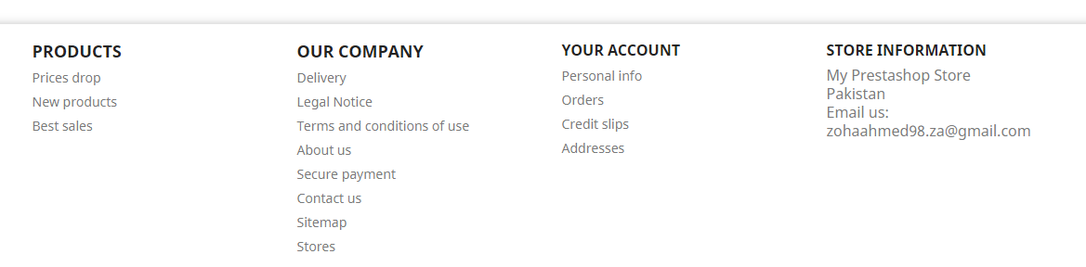

On the view all items page the top two ribbons as the home page are the same. There is a side bar having options of different classifications like item category, sizes, colors, material type, brand, etc. The end of the page is also same as the home page having the subscription bar and site information. Just before this is the page change button. The items are listed such that there is a picture and the price on each item displayed.

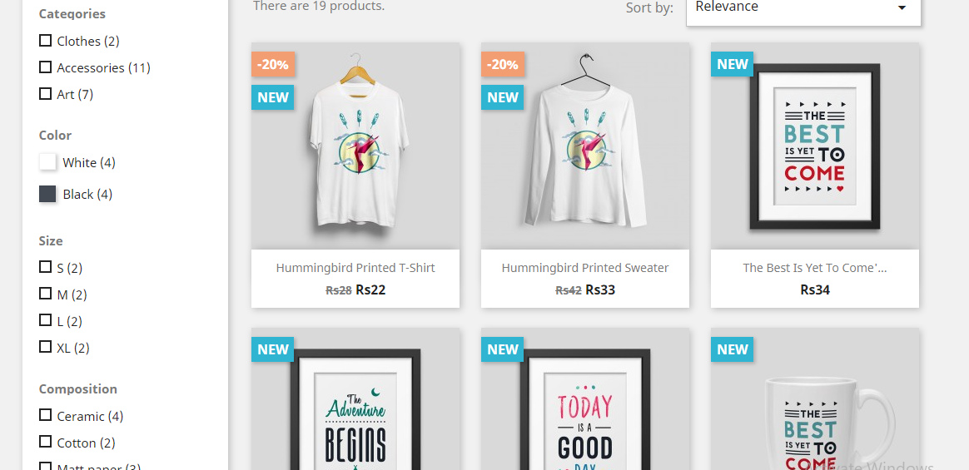

Any item’s picture when clicked enlarges the picture and displays details about the item along with an add to cart option.

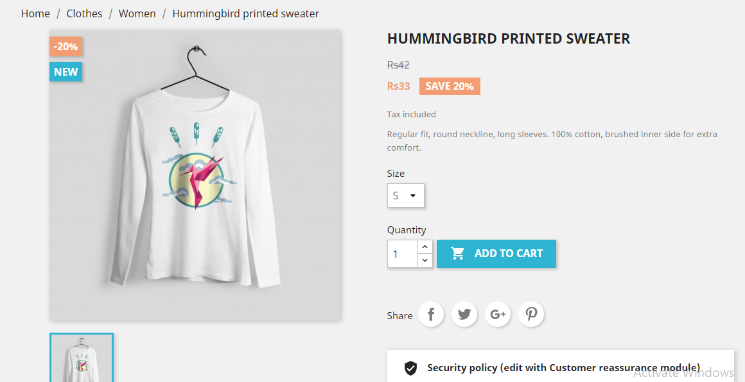

Once successfully added to the cart, the following display occurs.

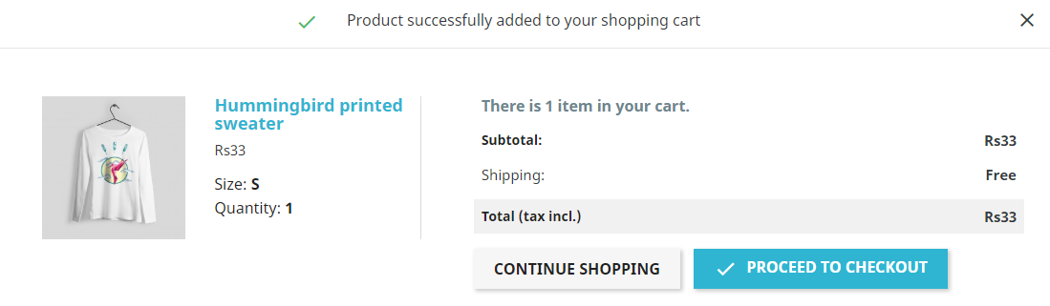

The proceed to checkout option takes us to the view my cart option which looks like following.

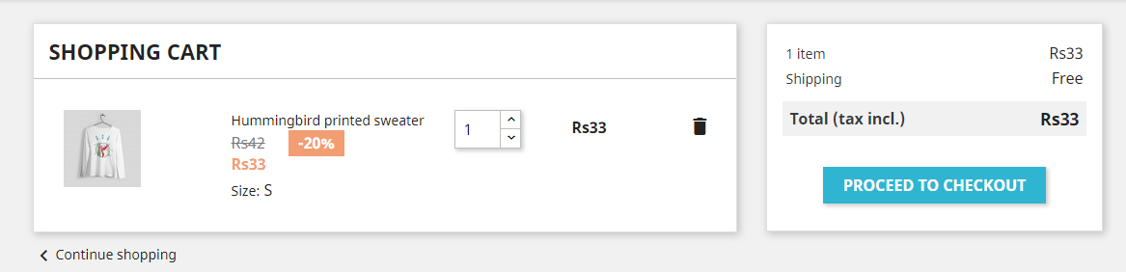

The continue shopping option takes us back to the last items page that was being viewed.

The contact us option when clicked, opens up a form where the user enters their email address, subject and the message they want to deliver. At the side of the for is the store’s contact information.

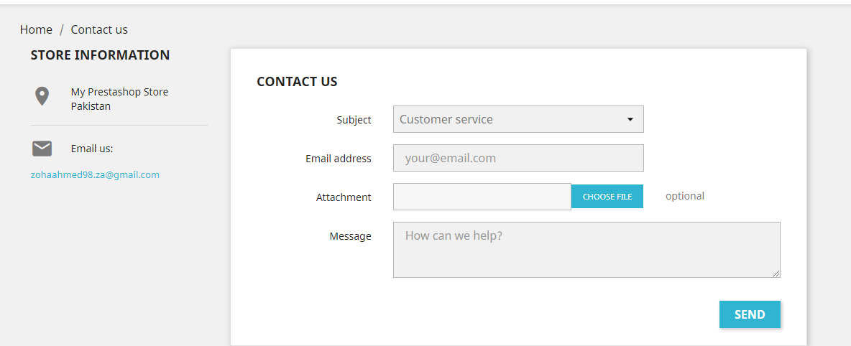

The activity on the website created can be monitored from the dashboard that looks like the following.

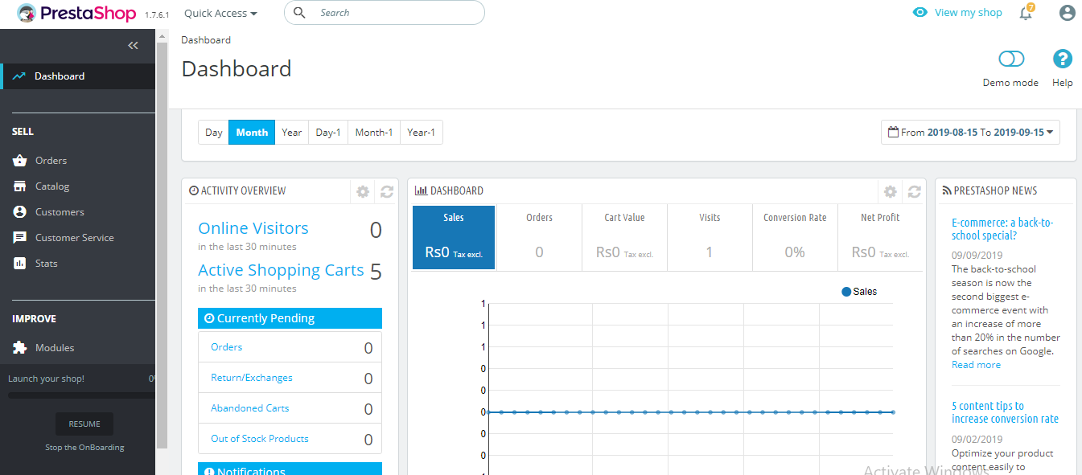

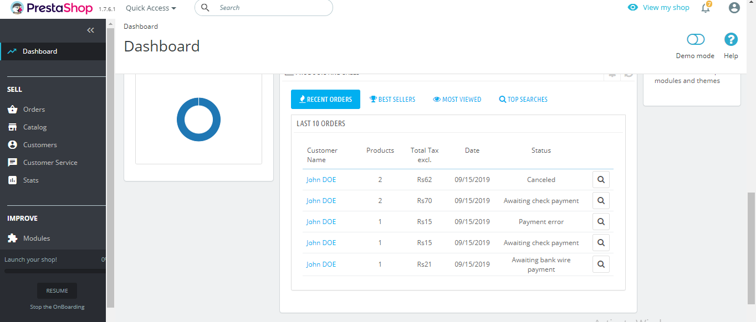

The customer service module displays customer stats, order messages displays the customer messages along with their information and the merchandise tab has details of the product id, order id, its status and date issued.

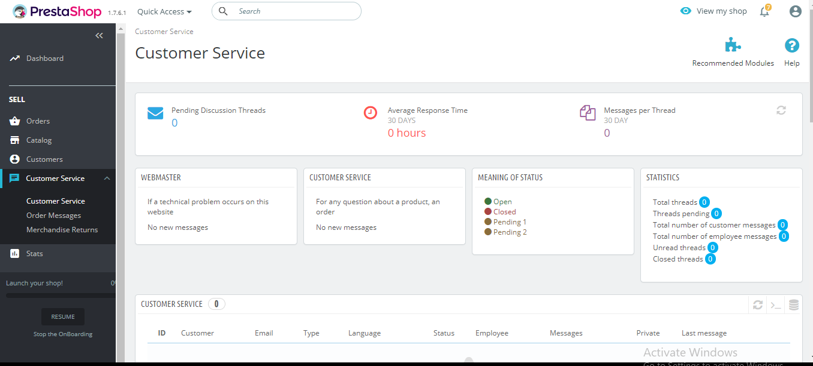

The catalogue tab has options like products (displaying all products’ list and their details), attributes and features (filtering items based on various attributes), brands and suppliers (filtering items based on their brands), discounts, stocks, etc.

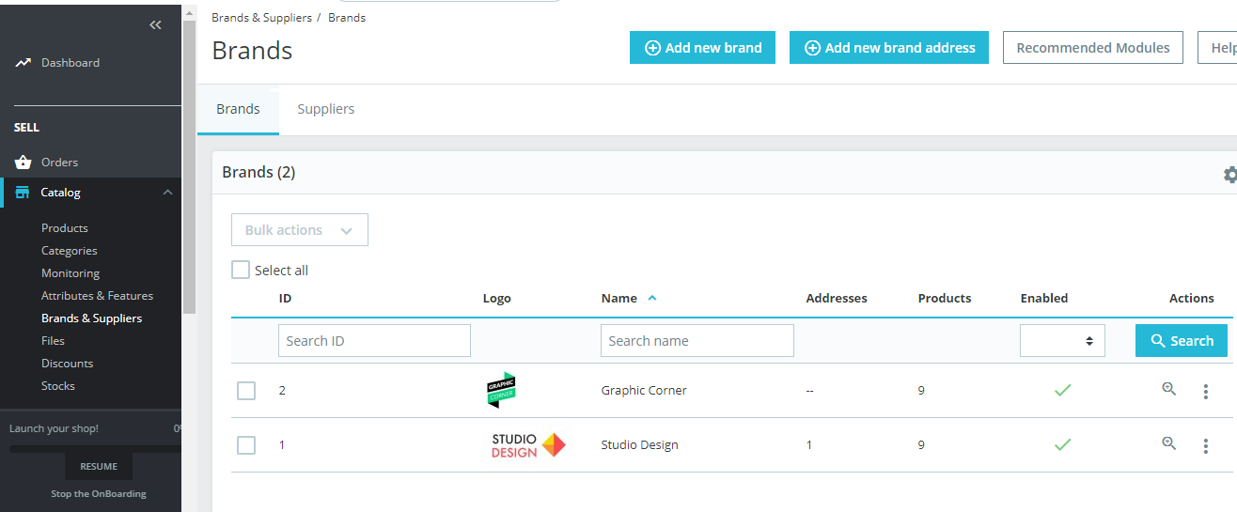

The orders tab has list of all orders currently placed. Options like invoices, credit slips, delivery slips, shopping carts filter the orders accordingly.

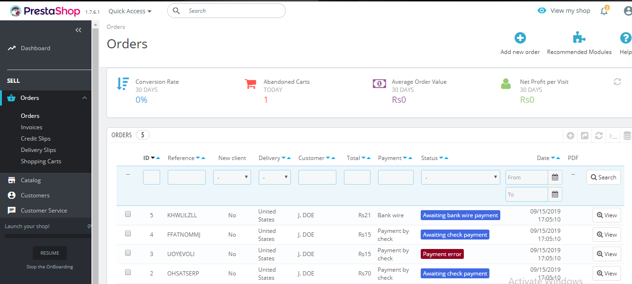

Data base

The data base has several tables in the database. Some are related to user information and authorization. Some tables have product ids and details. An address table has information about the user’s complete address and the manufacturers complete address. The two addresses are linked by the customer id and the product id that comes as foreign keys in this table from the customer tab le and the items table. There is an admin table too with the primary key id and attributes like shop (where the employee works in), employee (their name), controller, etc. another table named attachment is in the database where primary key is id_attachment and has other attributes like file_name, file_size, file, etc. Another table “attribute” has primary key id_attribute, foreign key id_attribute_group and other attributes like color, position, etc. more tables like manufacturer, meta, log, link_book, module, operating_system, order_history, order_invoice, order_return, order_carrier, product, product_carrier, product_country_tax, product_supplier, product_shop, product_tag, order_state, etc exist alongside many more tables all dealing with different data needed for smooth user login to checkout counter. Tables dealing with supplier information, tax information, stock availability, warehouse, webservice, cms, cart products- their addition or removal, their payment, etc are also present. All in all the database has a lot of tables each dealing with a very precise set of data. Some tables even have just one attribute (their primary key that refers to data in another table). Most tables have several foreign keys pointing from several tables to link the data together. In most tables, the “id” attribute plays the primary key role.

Developer’s Perspective

The coding language used in prestashop is PHP and the programming paradigm is object oriented. This means that it has a main class alongside other classes that it needs. Each module has the same name as its class and inherits the module class or any child class of module. Each class has a predefined constructor to initialize all its variables.

There is a multi- store feature in prestashop which makes use of attributes such as id_shop (the id of any particular shop and id_shop_group (telling about the group that particular store belongs to). Several external values can be returned using the getters in the ps_configuration class for instance

Configuration :: get(‘PS_SHOP_EMAIL’) to get shop email address

Configuration :: get(‘PS_TIMEZONE’) to return th current time zone

There is a views folder in the prestashop folder which contains .tpl or .html.twig files (that is multimedia data). Templates folder in this views folder has several other folders like admin having templates used by admin, front folder having files used by front office etc. the controllers folder has files that define the actions taken by parts of the website. Another folder by the name translations has files fr.php and es.php. These dea with the international language translation part of the website. Upgrade folder’s contents make sure that if any change has been made in the code (that is a new version has been released) the older files get modified too. The file config.xml optimizes the loading on the back office. Folder named vendor has all external libraries used.

Plugin

This plugin displays on the home page the list of brands whose items are available in the store. This feature was not already present in the website but can be incorporated after successfully configuring the plugin.

