Zoha Ahmed

213901

BSCS7A

LAB8

TASK1

Code

import React from 'react';

class App extends React.Component{

constructor(){

super();

this.state={message:"welcome visitor"};

}

changeMessage(){

this.setState({ message: "Thank you for subscribing" })

}

render(){

return (

<div>

<h1>{this.state.message}</h1>

<button onClick={()=>this.changeMessage()}>Subscribe</button>

</div>

);

}

}

export default App;

Output



TASK2

Code

import React from 'react';

class App extends React.Component{

constructor(props){

super(props);

this.state={ count:0 };

}

Increment(){

let c= this.state.count + 1;

this.setState({count: c});

}

render(){

return (

<div>

<h1>counter - {this.state.count}</h1>

<button onClick={()=>this. Increment()}>Increment</button>

</div>

)

}

}

export default App;

Output

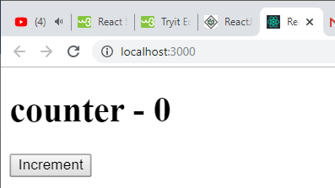

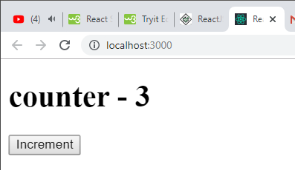

TASK3

Code

import React, { Component } from 'react';

class App extends Component {

constructor() {

super();

this.state = {minutes: 0 };

this.state = {seconds: 0 };

this.startTimer = this.startTimer.bind(this);

this.countDown = this.countDown.bind(this);

}

startTimer(event) {

this.setState({

minutes:event.target.value

});

}

start= (event)=>{

event.preventDefault();

if (this.state.minutes > 0) {

setInterval(this.countDown, 1000);

}

}

countDown() {

if(this.state.seconds==0){

let min= this.state.minutes -1;

this.setState({

minutes: min,

seconds: 59,

});

}

else{

let sec= this.state.seconds -1;

this.setState({

seconds: sec,

});

}

}

render() {

return(

<div align="center">

<h1> Timer </h1>

<h3> Enter Number of minutes: </h3>

<form onSubmit={this.start}>

<input type='text' name='num' onChange={this.startTimer}/>

<input type="submit"/> <br/> <br/>

</form>

<h1>m:{this.state.minutes} s:{this.state.seconds} </h1>

</div>

);

}

}

export default App;

Output

