September 16, 2019.

Exploring Open Source Software

Assignment 1

Zohaa Ali (212856)

Submitted to: Dr. sidra sultana

**Vanilla**

Vanilla is a PHP based forum software. It is both an open source and cloud-based software. A variety of custom themes and plugins are available for Vanilla that are being added till date. The software is also being improved and new versions are released frequently.

Following are the aspects that I explored this software from along with my observations and a few tasks that I performed:

* **Configuration:**

I installed the version 2.8.3 of Vanilla which was released in April, 2019. The zipped source file of the software was downloaded from their [website](https://open.vanillaforums.com). I used Wampp local server to setup and backup the software. The source content was extracted in the “www” folder of wamp64 folder for it to be accessed.

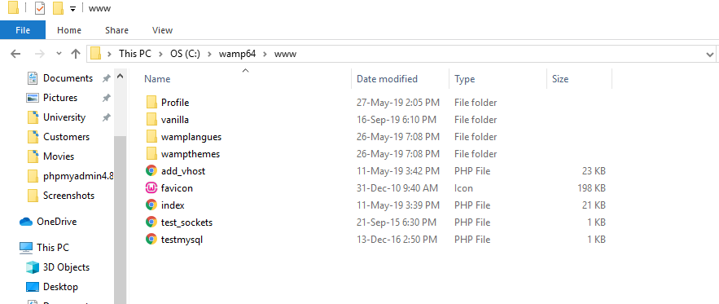

The server could be accessed from browser (chrome in my case) as localhost. The Vanilla software project was visible in server.

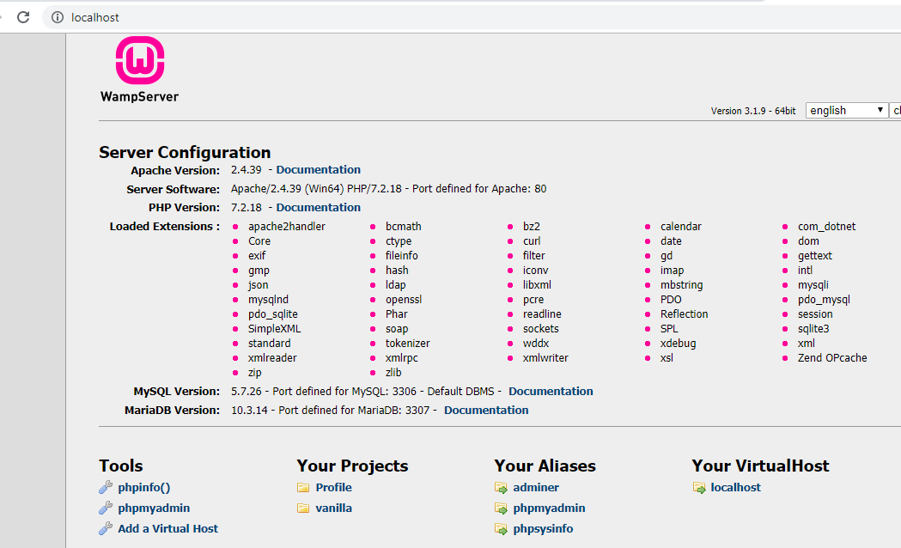

Next, a database was created to accommodate the database of the software in phpMyAdmin. The database was named vanilla.

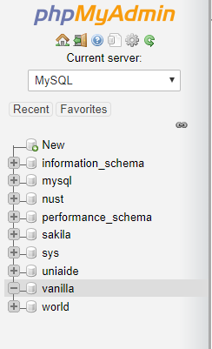

After running the software from the server and entering the details of database created and the server connection details in software, the database of software was setup in the server and the software was ready to use.

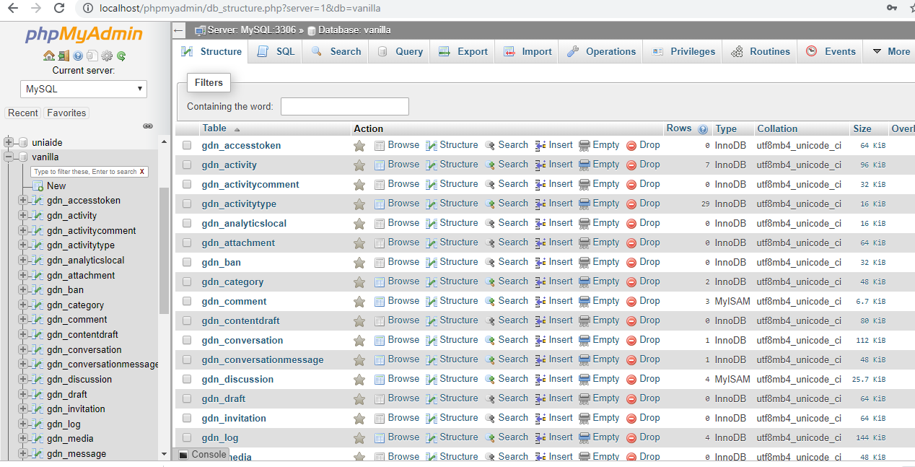

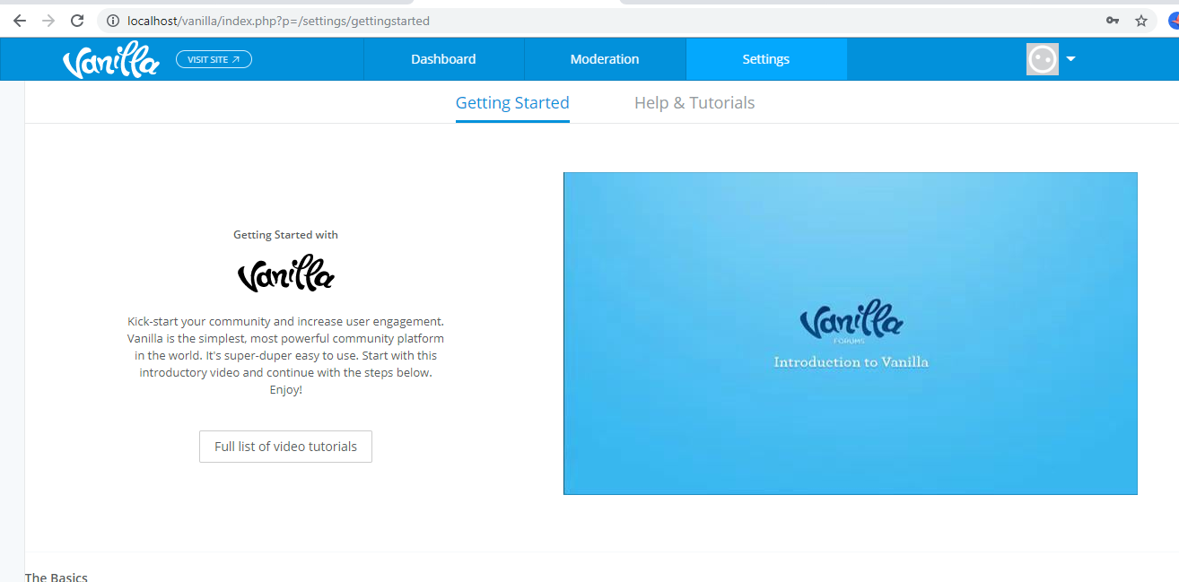

* **User Mode:**

The user mode of software is quite easy to understand and self-guiding. I did not find much difficulty in navigating through the options. I explored the users, posts and comments that were created by default and also created a post by myself.

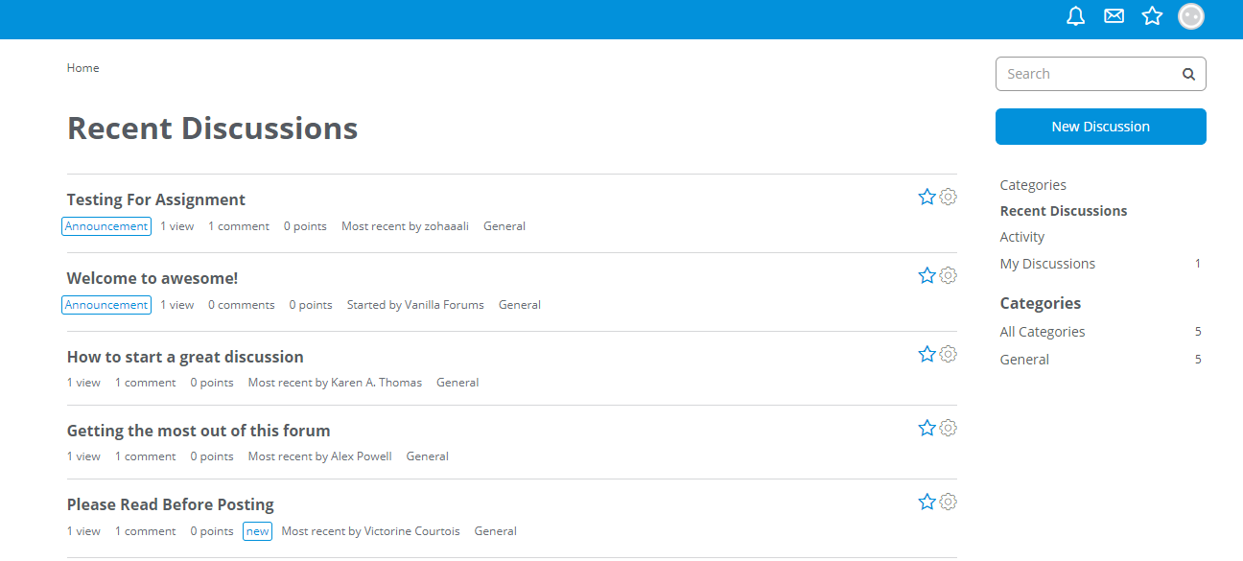

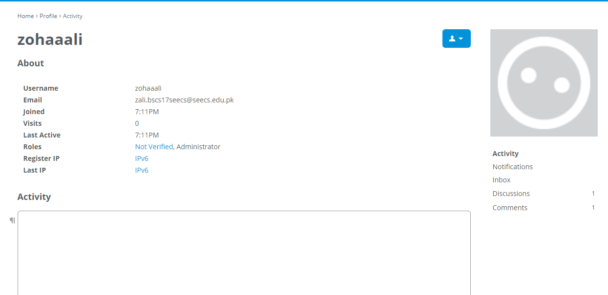

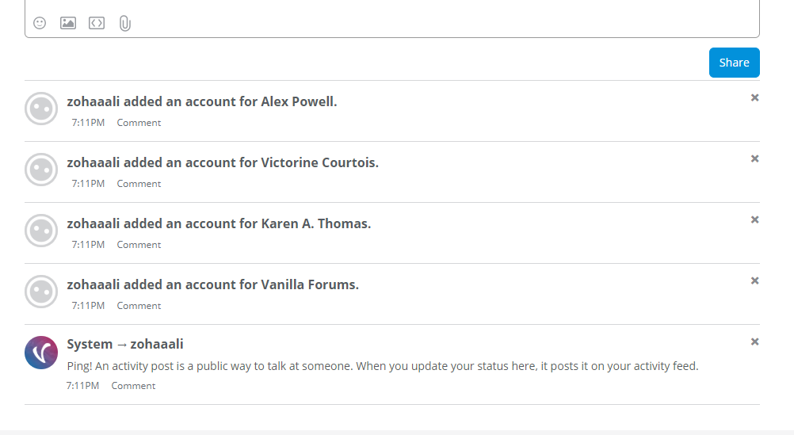

This is the discussion post created by me.

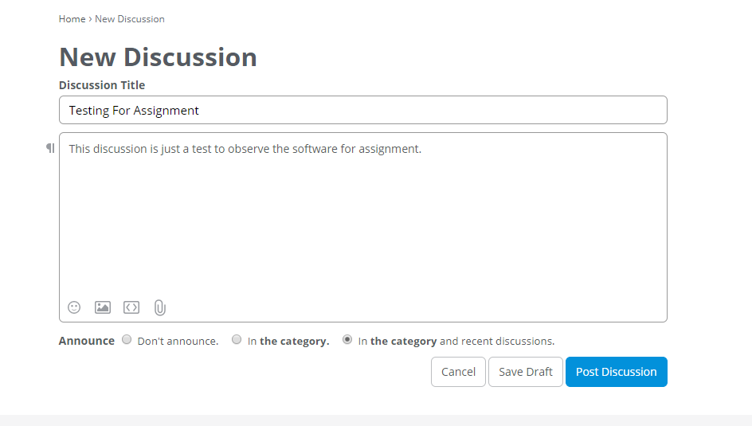

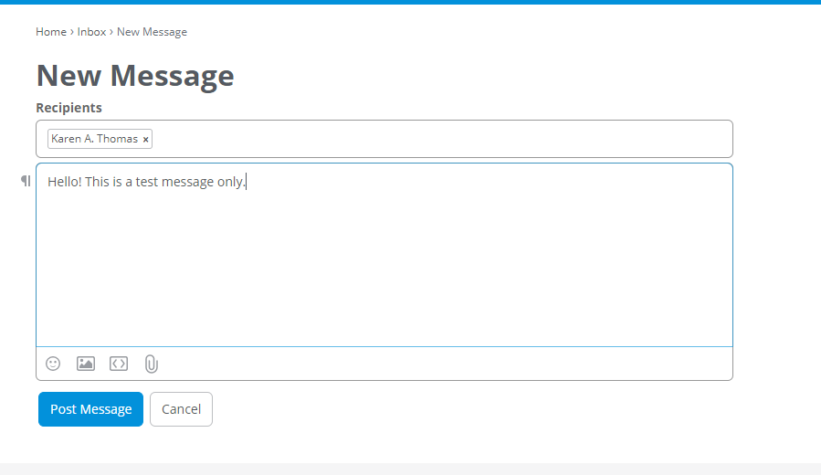

The forum also includes features for messaging. Users can message other users that are present on the forum and also create group chats.

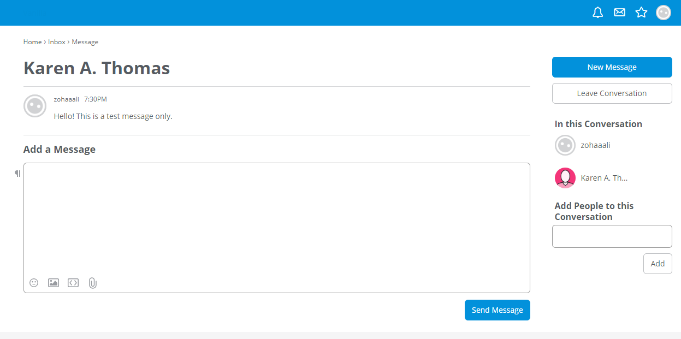

The dashboard of the software offers admin control options for managing discussions, users, forum settings and more. It is only visible to the users with admin access.

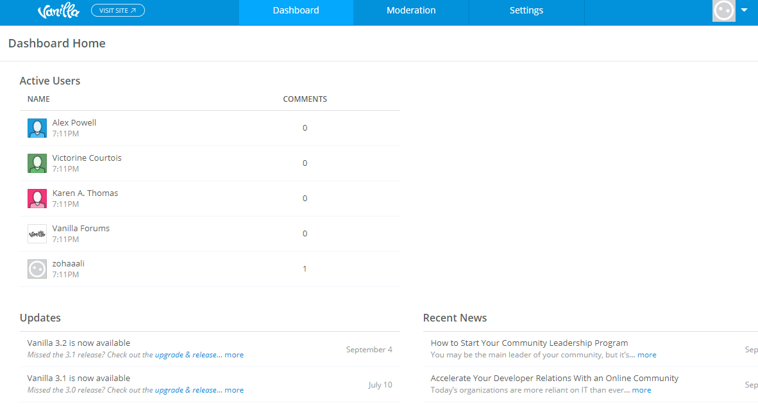

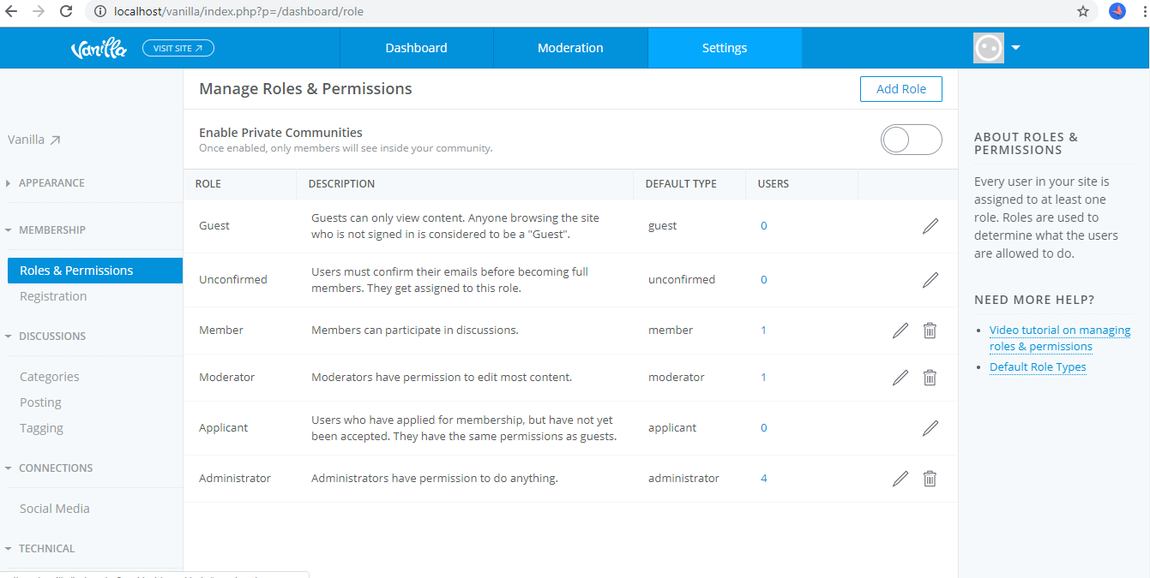

* **Database and Coding Structure:**

Vanilla has a well structured and well linked database. The tables and columns are named so that it is easy to understand relations between entities. Each type of data is separated into tables and relevant entities have a common id to form link.

As the software wasn’t used much, some of the tables returned empty data. The populated ones also have lesser number of rows that made it easy to comprehend the data present.

There were around 15 tables that were dedicated to the storing the user information. User’s roles, hashed passwords, signup details, authentication status, discussion and messaging history and login session details were stored.

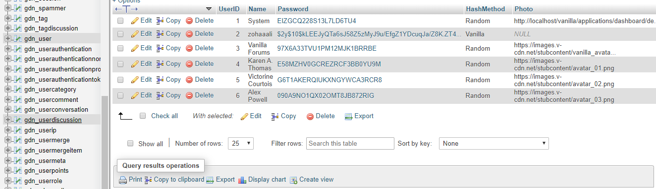

Similarly, all discussion details were stored in separate tables. Private and discussions messages have different identities. Comments have their own ids and the discussion id referring to the discussion they belong to. The discussions have category id and user id indicating the category of discussion they belong to and the user that posted the discussion.

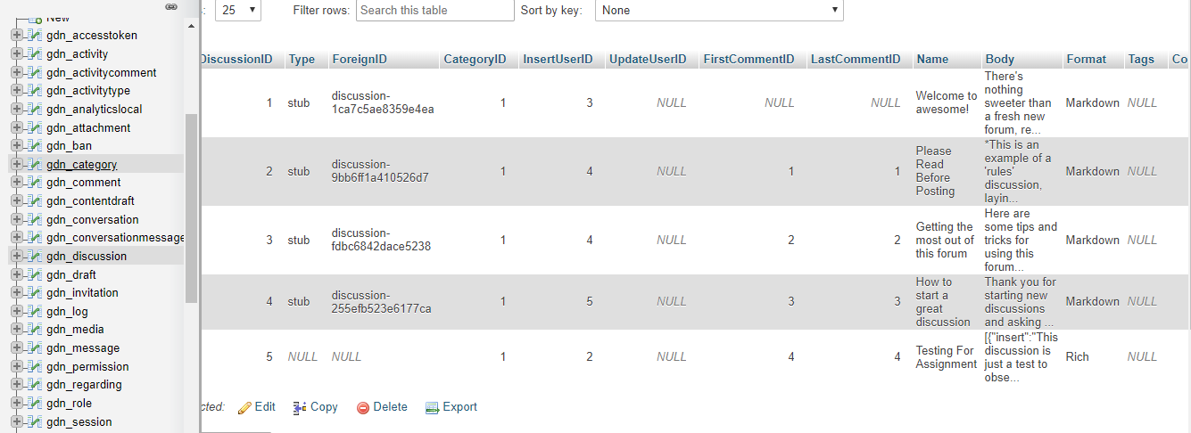

Another table is present that holds brief detail of the permissions that number of users are entitled to.

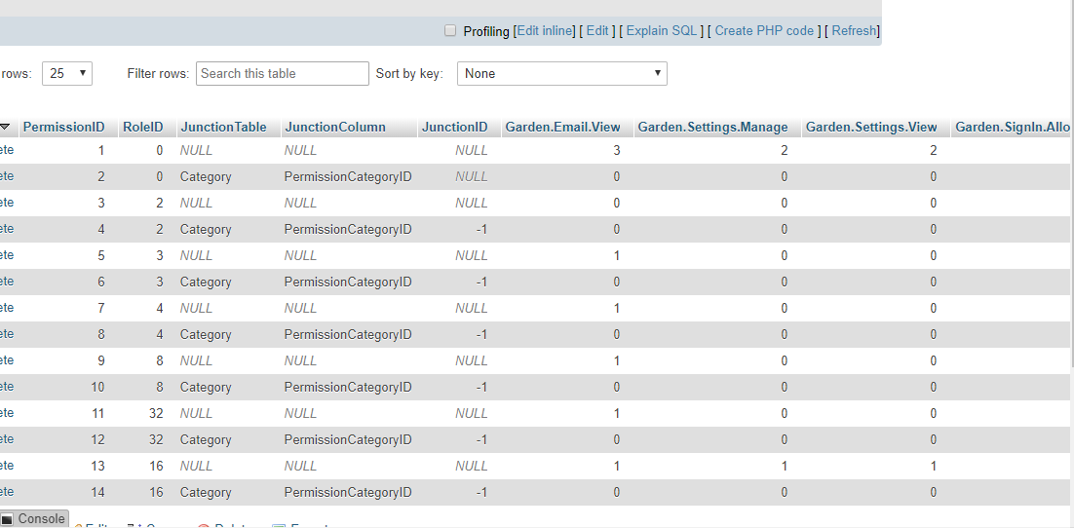

The database of this software contains detailed information of every little activity and session that is being executed and is easy to locate in the tables, given their self-explanatory names and structure.

* **Addons (Plugins and Themes):**

To customize the theme of my forum, I downloaded an open source Vanilla theme from the internet named “GreenGlass” and copied its contents into …/wampp64/www/vanilla/themes. Upon copying, the theme was accessible from the dashboard of Vanilla and was applied.

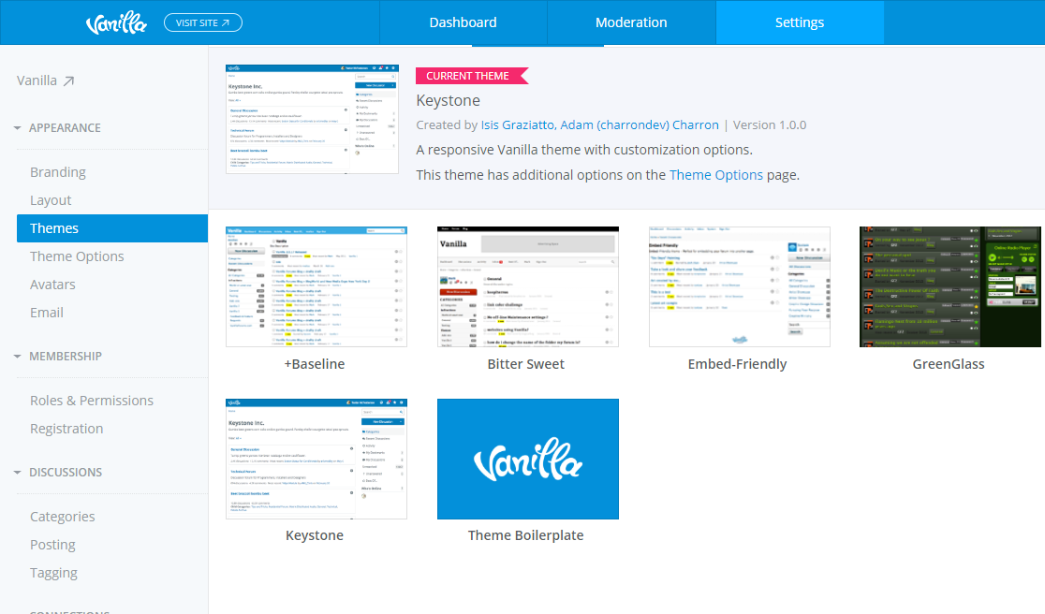

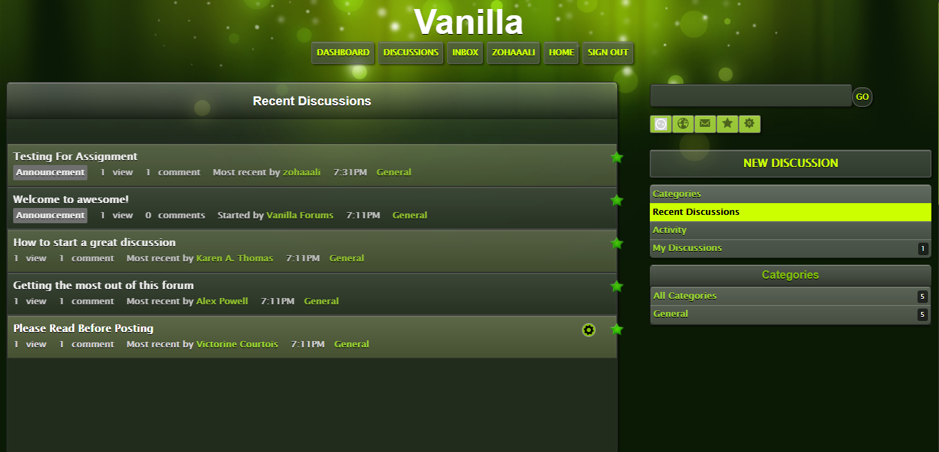

To add functionalities, I searched for a variety of plugins. There were many pre-installed plugins in the software too; most of them inactive. The one that I implemented was “WhosOnline”. It is created by Vanilla developers and adds a section in sidebar of the forum and lists the users that are active i.e. are visiting the forum. Its configuration was similar to that of themes. I downloaded the source folder and copied it in …/wampp64/www/vanilla/plugins. The plugin was then activated from the plugin section of dashboard. Adding the plugin also created a table in the database of vanilla that stores the data of the users that are online and timestamp.

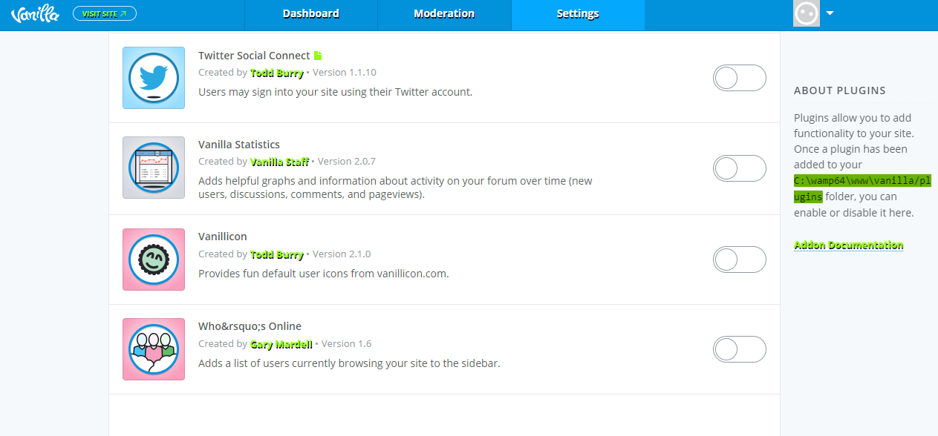

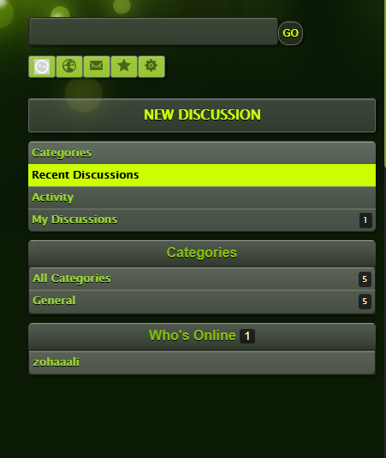

**Conclusion:**

This assignment made be understand different components of a software and the ways to configure/customize it according to requirements. It also made me aware of some real life coding conventions and how multiple modules of software are integrated with each other.