**Department of Computing**

**CS-213: Advanced Programming**

**Class: BSCS 7AB**

**Lab 08: React JS**

**Date: 07 November, 2019**

**Time: 10:00-01:00pm & 02:00-05:00pm**

**Instructor: Dr. Sidra Sultana**

**Lab Engineer: Ms. Ayesha Asif**

**Lab 08: ReactJS States**

**Lab Tasks:**

You have to practice the states codes covered in class lecture

**Index.js:**

import React from 'react';

import ReactDOM from 'react-dom';

import App from './App';

ReactDOM.render(<App />, document.getElementById('root'));

**Index.html:**

<!DOCTYPE html>

<html lang="en">

<head>

<meta charset="utf-8" />

<title>React App</title>

</head>

<body>

<div id="root"></div>

</body>

</html>

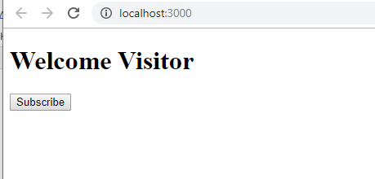

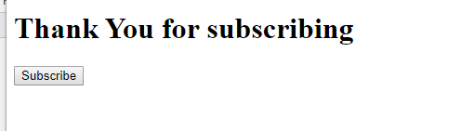

**App.js:**

import React from 'react';

import './App.css';

class App extends React.Component {

constructor(){

super();

this.state = {message: 'Welcome Visitor'};

}

changeMessage(){

this.setState({

message: 'Thank You for subscribing'

});

}

render(){

return(

<div>

<h1>{this.state.message}</h1>

<button onClick = {()=>this.changeMessage()}>Subscribe</button>

</div>

);

}

}

export default App;

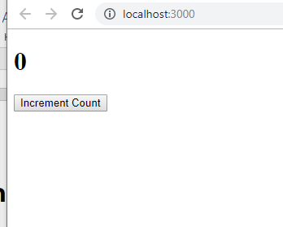

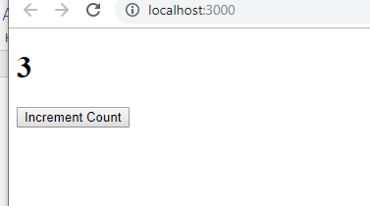

**App.js:**

import React from 'react';

import './App.css';

class App extends React.Component {

constructor() {

super();

this.state = { count: 0 };

}

Increment() {

this.setState({

count: this.state.count + 1

});

}

render() {

return (

<div>

<h1>{this.state.count}</h1>

<button onClick={() => this.Increment()}>Increment Count</button>

</div>

);

}

}

export default App;

1. Create a timer application which asks the user for minutes. The user then click Start button and starts the timer count down. Preview @ <https://7zyz2y4p5j.csb.app/>

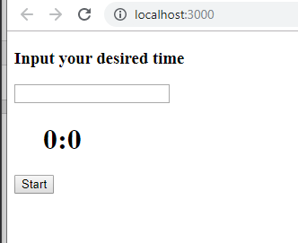

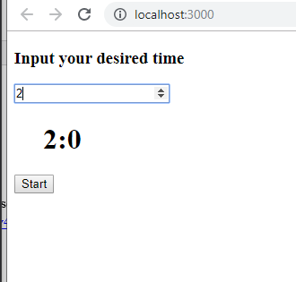

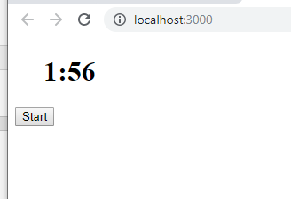

**App.js Code:**

import React from 'react';

import './App.css';

class App extends React.Component {

constructor() {

super();

this.state = { sec: 0 , min : 0};

this.myRef = React.createRef();

}

Increment() {

this.setState({

count: this.state.count + 1

});

}

changeTime = (event) =>

{

this.setState({

min : event.target.value

});

}

counter = (event) =>

{

this.myRef.current.style.display = 'none';

this.update = setInterval(() => {

var sec = this.state.sec;

var min = this.state.min;

if(sec == 0 && min > 0)

{

this.setState({

sec: 60,

min : this.state.min - 1

});

}

else if (sec == 1 && min == 0)

{

clearInterval(this.update);

}

this.setState({

sec: this.state.sec -1

});

}, 1000);

}

render= () => {

return (

<div>

<div ref = {this.myRef}>

<h3> Input your desired time </h3>

<form>

<input type = "number" onChange = {this.changeTime}/>

</form>

</div>

<h1>&emsp;{this.state.min}:{this.state.sec}</h1>

<button onClick={this.counter}>Start</button>

</div>

);

}

}

export default App;

**Deliverables**

Compile the Lab Submission File (Uploaded on LMS) by filling in the solution part with your source code and screenshots and submit it on LMS. The lab grading policy is as follows:

The lab is graded between 0 to 10 marks. At the end of each lab or in the next lab, there will be a viva related to the tasks. The viva has a weightage of 5 marks. Insert the solution/answer in this document. You must show the implementation of the tasks in the designing tool, along with your complete Word document to get maximum grade. In case of any problems with submissions on LMS, Email to Mr. Ahsan Gul: [ahsan.gul@seecs.edu.pk](mailto:ahsan.gul@seecs.edu.pk)