Data Cleaning and Preparation Using Python (Pandas) in Google Colab

1. Dataset Preview (df.head())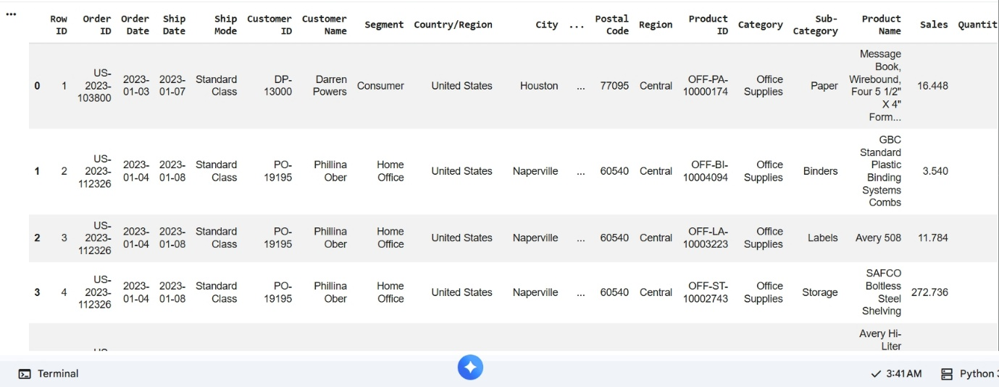

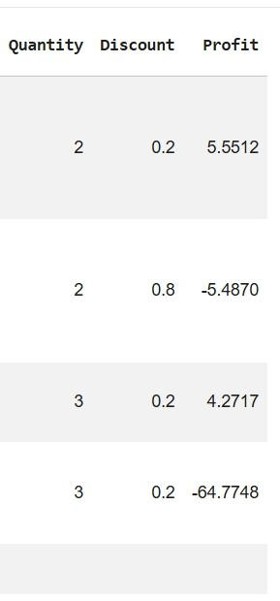

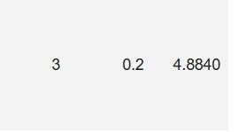

2.Dataset Information(df.info())
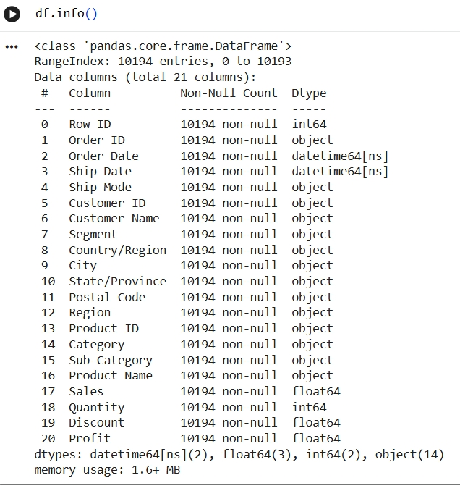

3. Missing Values Check (df.isnull().sum())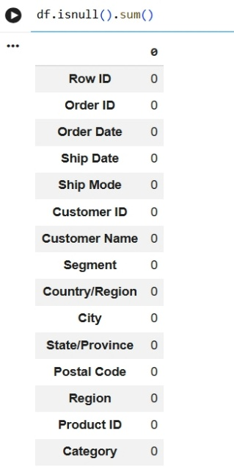
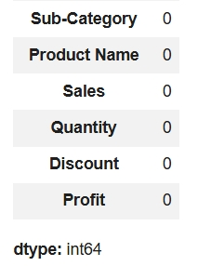

4. Duplicate Check (df.duplicated().sum())
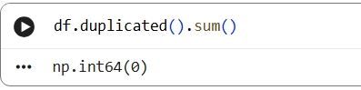

5. Date Conversion Verification

Conclusion:
The Superstore dataset was successfully loaded into Python using the Pandas library. Missing values and duplicate records were checked and none were found. The Order Date and Ship Date columns were converted to datetime format. Finally, the cleaned dataset was exported and saved as Cleaned_Superstore.csv.

