Final Design Specifications
Project Title: Al-Nur Mosque Lajna Management System

CMIS-4900-400 – CAPSTONE I
DATE: November 24, 2025
Prof.: Dr. Menon
ZSJK

Prepared By:
Zoha Khan
Shannon Katolsky
JJ Gilbert
Kah Guan Ong

Table of Contents

1. Introduction 3
2. Project Charter 4
3. Project Scope 6
4. Topology Diagram 8
5. Context Diagram 10
6. Data Flow Diagrams (DFD) 11
7. Entity Relationship Diagram (ERD) and Data Dictionary 13
8. Screen Sequences 21
9. Work Breakdown Structure (WBS)/Project Management Plan 22
10. Conclusion 23

1. Introduction
The Al-Nur Mosque Lajna Management System is a centralized web-based platform designed to streamline reporting, attendance tracking, announcement dissemination, document management, and calendar coordination for the Lajna department at Al-Nur Mosque. The system replaces scattered tools, such as paper records, group chats, and emails, with a unified application that enhances communication, transparency, and organizational efficiency for its members, department heads, the President, and system administrators.
This Final Design Specification consolidates the system’s planning and design artifacts, including the Project Charter, Scope, Topology Diagram, Context and Data Flow Diagrams (DFDs), the Entity Relationship Diagram (ERD), and Data Dictionary. These components establish a clear blueprint for development and implementation during Senior Capstone II.

2. Project Charter
Project Name
Al-Nur Mosque Lajna Management Reporting System
Project Abstract
The Management Reporting System is a centralized web application that supports the reporting and communication needs of the Lajna department at Al-Nur Mosque. Its core purpose is to consolidate scattered processes monthly reports, attendance tracking, announcements, reminders, and documentation into one secure and accessible platform. The system authenticates users via server-side validation. Member accounts are pre-created, and new members may request account creation subject to presidential approval. Department Heads gain access to departmental report submissions and tools for aggregation. The President has overarching visibility into all accounts and submissions. The unified system reduces confusion caused by disparate platforms and ensures timely, organized information flow. fileciteturn1file1
Project Purpose
The project meets the organizational need for an integrated system that reduces administrative workload, improves communication consistency, and centralizes resources. By bringing reporting, attendance, and calendar functions into one interface, the system resolves existing inefficiencies caused by reliance on multiple disconnected tools.
Stakeholders
- General Members (≈50) – Submit reports, view announcements, track events.
- Department Heads – View and aggregate member submissions, manage attendance.
- President – Manage users, approve account requests, oversee departmental data.
- Admin/Maintenance Team – Development team responsible for deployment and bug fixes during project duration.
User Stories & Critical Success Factors
Success will be measured by:
- ≥80% of monthly reports submitted through the system within 3 months of launch.
- ≥50% reduction in administrative preparation time for monthly reporting.
- ≥70% of members logging in at least once per quarter.
Full user stories detailing functional expectations for all roles (President, Department Heads, Members, Admin) are documented separately
Project Gates / Milestones
Gate 1 – MVP Core: Authentication, RBAC, Attendance CRUD, Google Sheet report ingestion, Calendar read.
Gate 2 – Reporting & Document Repository: Aggregated reports, CSV/PDF export, secure file repository.
Gate 3 – Communication & Hardening: Announcements, email notifications, audit logs, backups, admin guide. fileciteturn1file1
Anticipated Completion
End of Senior Capstone II semester.
Budget
No current expenses; system hosted using the University VM. Possible future sponsorship from the mosque may be explored.
Project Team
- Zoha – Project Lead; HTML/CSS Developer
- Shannon – PHP/SQL Developer
- JJ – JavaScript Developer
- Kah Guan – JavaScript Developer

3. Project Scope
Problem Description
The Lajna department struggles with fragmented reporting, attendance, and communication processes spread across group chats, email threads, paper logs, and multiple online tools. These inefficiencies make coordination difficult, increase administrative burden, and cause frequent loss of critical information.
Anticipated Business Benefits
- Centralized access to reports, reminders, events, and documents.
- Reduced admin time by more than half.
- Stronger communication consistency.
- Fewer missed messages and incomplete records.
- Improved member engagement and attendance.
- Protection against data loss through structured digital storage.
System Capabilities
- Attendance Tracking (with historical visibility)
- Member Management & Permissions
- Centralized Calendar with Recurring Events
- Document Repository & Visibility Controls
- Announcement Publishing (Email + In-app)
- Integrated Monthly Reporting via Google Forms API
- Authentication & Secure Password Reset
- Audit Logging
Technical Requirements
- Platform: Web-based, accessible via standard browsers
- Integration: Google Forms → SQL Database ingestion
- Security: Username/password authentication, role approval workflow
- User Roles: Member, Department Head, President, Admin/Maintenance
- Hosting: University VM (PHP, JS, SQL Stack)

4. Topology Diagram
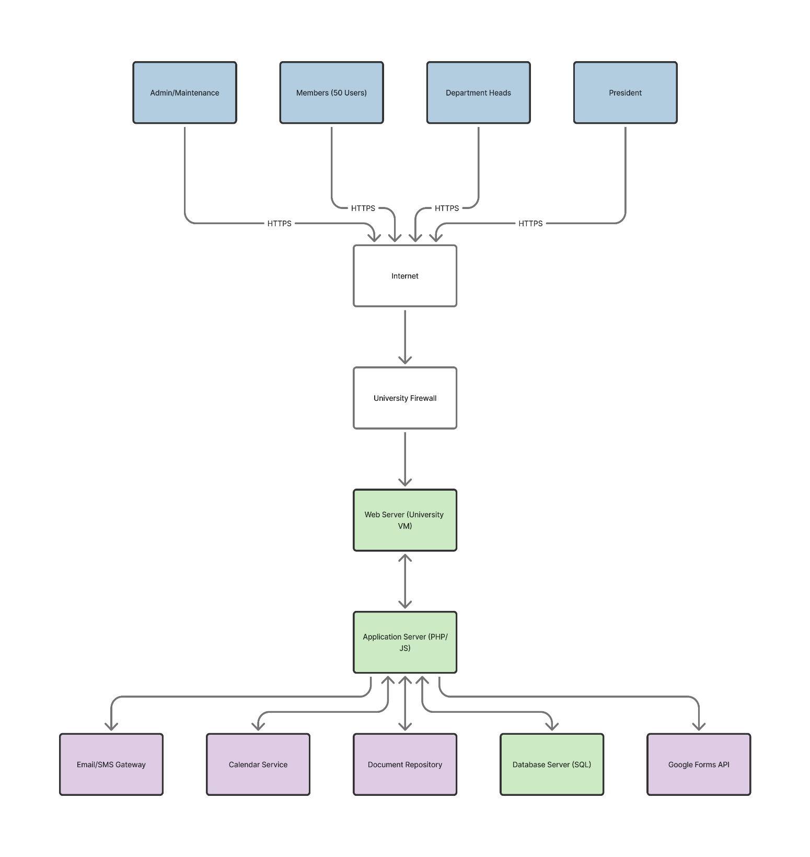

The system’s topology shows how users securely access the platform through HTTPS and interact with backend services.
Diagram Summary:
- Four user groups (Admin, Members, Department Heads, President) connect via HTTPS over the internet.
- All traffic passes through the University Firewall.
- The Web Server (University VM) hosts the frontend.
- The Application Server (PHP/JS) handles server-side logic.
- Supporting services include Email/SMS gateway, Calendar service, Document repository, SQL database server, and Google Forms API.

5. Context Diagram
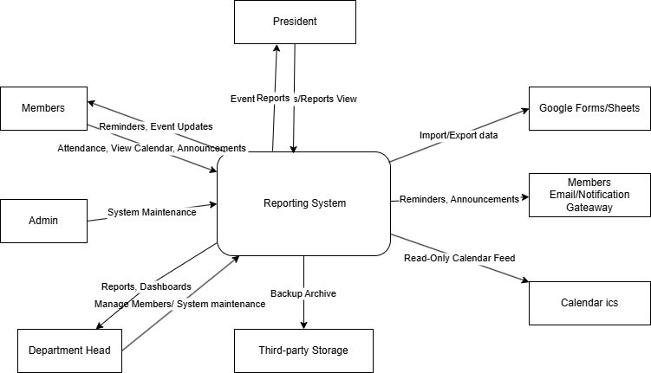

The context diagram illustrates high-level interactions between system entities:
- Users (Members, Heads, President, Admin) send requests such as logins, attendance submissions, report submissions, announcements, or document uploads.
- The Mosque Management System processes requests and returns responses (e.g., dashboards, notifications, data views).
- External systems include the Google Forms API, Email/SMS gateways, and Calendar Service.
This diagram represents how all external actors interface with the application, establishing clear system boundaries.

6. Data Flow Diagrams (DFD)
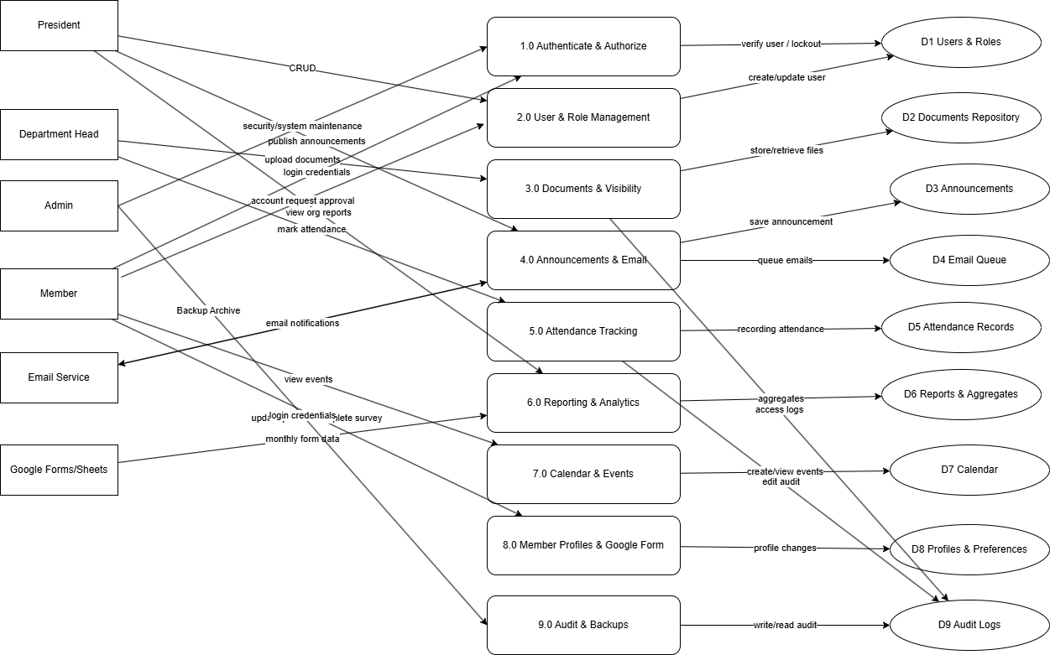
DFD Level 1 – Modular Breakdown
Breaks major processes into functional subsystems:
- User Management – Authentication, role-based routing, password reset.
- Attendance Management – Logging, viewing, exporting.
- Reporting Engine – Google Form import, aggregation, submission history.
- Document Repository – Upload, visibility, archiving.
- Announcements – Creation, expiry, email dispatch.
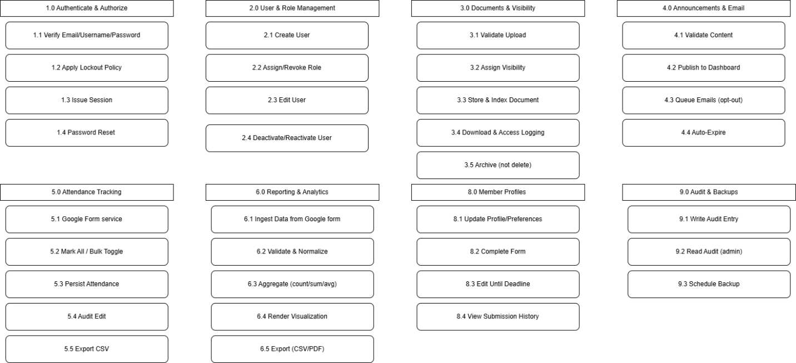

DFD Level 2 – Process Expansion
Provides deeper logic layers:
- Form submission → validation → storage → review workflow.
- Attendance events → audit logging → summary generation.
- Announcement creation → email queue → expiry handling.

7. Entity Relationship Diagram (ERD) and Data Dictionary
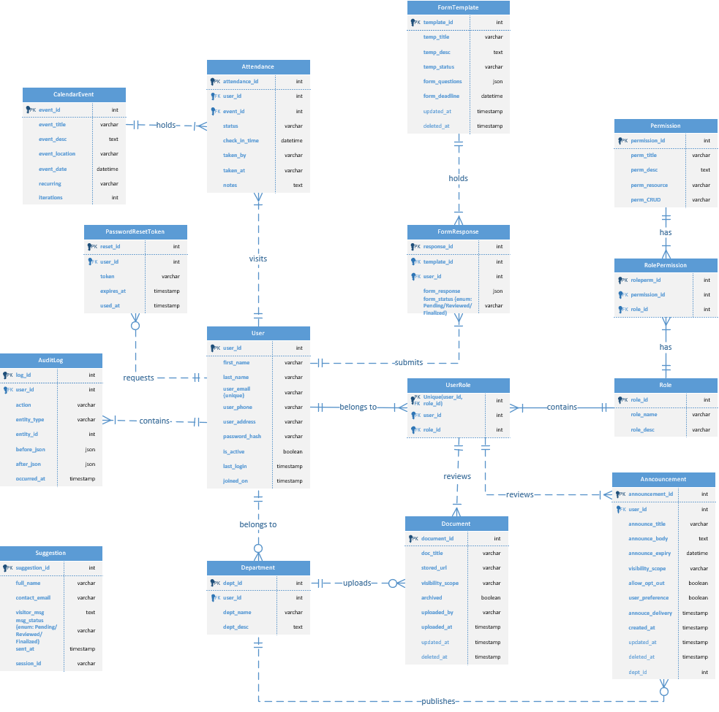
7.1 ERD Overview
The Entity Relationship Diagram (ERD) defines the logical data model for the Al-Nur Mosque Lajna Management System. It captures the system’s core entities, attributes, and relationships, forming the foundation for the SQL database schema.
At a high level, the ERD supports:
- Secure user identity and role-based access control.
- Attendance records tied to calendar events.
- Structured form templates and responses for reporting.
- A department structure to organize members.
- Document and announcement publishing with visibility scopes.
- Permissions and audit logging for governance and troubleshooting.
Key entities include:
- User – Stores member identity, contact details, authentication data, status flags, and timestamps.
- Role and UserRole – Implements many-to-many mapping of users to roles (President, Dept Head, Member, Admin) through a linking table.
- Permission and RolePermission – Defines fine-grained access (CRUD) per resource and links them to roles.
- Department – Groups users into departments and records department metadata.
- CalendarEvent and Attendance – Represents events and associated attendance (who attended which event and when).
- FormTemplate and FormResponse – Stores monthly report templates and user-submitted responses in JSON format.
- Announcement – Publishes announcements with title, body, expiry, and visibility scope.
- Document – Tracks stored documents (e.g., reports, meeting minutes) via URLs, metadata, and visibility constraints.
- Suggestion – Captures visitor/member suggestions or join requests.
- AuditLog – Records actions taken in the system, including before/after JSON snapshots, actor, and timestamps.
- PasswordResetToken – Manages password reset flows via time-bound tokens.
The ERD enforces data integrity using primary keys, foreign keys, unique constraints (e.g., unique user email), and composite keys (e.g., UserRole uniqueness per user/role pair).
7.2 Major Entities and Attributes
Below is a summarized data dictionary for the most critical entities.
User
Holds core account and profile information for each system participant.
- user_id (PK, int) – Unique identifier for each user.
- first_name, last_name (varchar) – User’s legal name.
- user_email (varchar, unique) – Primary login credential; must be unique.
- user_phone, user_address (varchar) – Contact details.
- password_hash (varchar) – Securely hashed password.
- is_active (boolean) – Whether the account is active or frozen.
- user_preference (boolean) – Email/announcement opt-in preferences.
- last_login, joined_on (timestamp) – Audit timestamps.
Role and UserRole
Implements role-based access control.
- Role
  - role_id (PK, int) – Unique identifier for each role.
  - role_name (varchar) – Role label (President, Dept Head, Member, Admin).
  - role_desc (text) – Description of responsibilities.
- UserRole
  - linking_id (PK, int) – Surrogate key.
  - user_id (FK, int) – References User.
  - role_id (FK, int) – References Role.
  - Unique(user_id, role_id) ensures a user cannot have duplicate entries for the same role.
Permission and RolePermission
Controls resource-level actions for each role.
- Permission
  - permission_id (PK, int) – Unique permission identifier.
  - perm_title (varchar) – Short code/name of the permission.
  - perm_desc (text) – Detailed description of what the permission allows.
  - perm_resource (varchar) – Target resource (e.g., "Announcement", "Document").
  - perm_CRUD (varchar) – Allowed operations (Create/Read/Update/Delete).
- RolePermission
  - roleperm_id (PK, int) – Unique mapping identifier.
  - permission_id (FK, int) – References Permission.
  - role_id (FK, int) – References Role.
Department
Represents organizational units within the Lajna.
- dept_id (PK, int) – Department identifier.
- user_id (FK, int) – Typically the department head or owner.
- dept_name (varchar) – Department name.
- dept_desc (text) – Department description.
CalendarEvent and Attendance
Tracks activities and attendance.
- CalendarEvent
  - event_id (PK, int) – Unique event identifier.
  - event_title (varchar) – Name of the event.
  - event_desc (text) – Description/agenda.
  - event_date (datetime) – Scheduled date/time.
  - event_location (varchar) – Location.
  - recurring (varchar) – Recurrence pattern (e.g., daily/weekly/monthly/yearly).
  - iterations (int) – Number of repetitions (or supports end date logic).
  - allow_opt_out (boolean) – Whether members can opt out.
  - created_at, updated_at, deleted_at (timestamp) – Lifecycle tracking.
- Attendance
  - attendance_id (PK, int) – Unique attendance record.
  - user_id (FK, int) – Attending member.
  - event_id (FK, int) – Event attended.
  - status (varchar) – Present/Absent.
  - check_in_time (datetime) – When attendance was recorded.
  - taken_by (varchar) – Actor who recorded the attendance.
  - taken_at (varchar) – Method/location of capture.
  - notes (text) – Additional comments.
FormTemplate and FormResponse
Supports dynamic forms for monthly reporting and surveys.
- FormTemplate
  - template_id (PK, int) – Identifier for each template.
  - temp_title (varchar) – Template name.
  - temp_desc (text) – Description/purpose.
  - temp_status (varchar) – Status (e.g., Active/Archived).
  - form_deadline (datetime) – Due date for responses.
  - form_questions (json) – JSON structure for questions.
  - updated_at, deleted_at (timestamp) – Maintenance fields.
- FormResponse
  - response_id (PK, int) – Response identifier.
  - template_id (FK, int) – Associated template.
  - user_id (FK, int) – Responding user.
  - form_response (json) – JSON payload of answers.
  - form_status (varchar) – Pending/Reviewed/Finalized.
Announcement
Publishes time-bound messages to members.
- announcement_id (PK, int) – Announcement identifier.
- user_id (FK, int) – Author of the announcement.
- dept_id (FK, int) – Department scope, if applicable.
- announce_title (varchar) – Title.
- announce_body (text) – Message content.
- announce_expiry (datetime) – Expiration date/time.
- visibility_scope (int/ FK) – Visibility group (All/Heads/President).
- annouce_delivery (timestamp) – When notifications were sent.
- archived (boolean) – Logical archive flag.
- created_at, updated_at (timestamp) – Lifecycle fields.
Document
Stores references to uploaded files.
- document_id (PK, int) – Document identifier.
- uploaded_by (FK, int) – User who uploaded the file.
- visibility_scope (int/ FK) – Access control scope.
- doc_title (varchar) – Document title.
- stored_url (varchar) – Storage location/URL.
- archived (boolean) – Whether file is archived.
- created_at, updated_at, deleted_at (timestamp) – Lifecycle tracking.
Suggestion
Captures visitor/member suggestions and join requests.
- suggestion_id (PK, int) – Suggestion identifier.
- full_name (varchar) – Name of submitter.
- contact_email (varchar) – Contact email.
- visitor_msg (text) – Message body.
- msg_status (varchar, enum) – Pending/Reviewed/Finalized.
- session_id (varchar) – Session reference.
- created_at (timestamp) – Submission time.
AuditLog
Provides a full audit trail for key actions.
- log_id (PK, int) – Log record identifier.
- user_id (FK, int) – Actor.
- action (varchar) – Action type.
- entity_type (varchar) – Target entity type.
- entity_id (int) – Target entity ID.
- before_json, after_json (json) – Snapshots before/after change.
- occurred_at (timestamp) – Time of action.
PasswordResetToken
Supports secure password resets.
- reset_id (PK, int) – Token record identifier.
- user_id (FK, int) – User requesting reset.
- token (varchar) – Secure token string.
- expires_at (timestamp) – Expiration time.
- used_at (timestamp) – When token was consumed.
- 7.3 Normalization and Integrity
- The schema is normalized to at least Third Normal Form (3NF):
- Repeated data (e.g., roles, permissions) is moved into separate tables.
- Many-to-many relationships (User–Role, Role–Permission) use linking tables.
- Foreign keys maintain referential integrity among core entities.
- This model supports scalable reporting, secure access control, and detailed auditing while remaining flexible enough to support future enhancements such as additional roles, new form types, or expanded logging.

8. Screen Sequences

9. Work Breakdown Structure (WBS)/Project Management Plan

10. Conclusion

