Problems I faced when making Kazeem’s Kloud website:
- Problem #1: The first issue I ran into was with my database. I originally planned on splitting up each activity into its own table. Originally, I thought this would be easier since everything was separate; however, once I started creating the website, I ended up changing this to have all activities in one table and split them up by category. I found that using one activity table was easier to keep track of and kept the code neater.
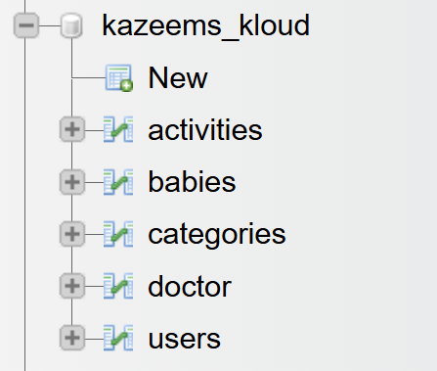

- Problem #2: The second issue I ran into was an issue I caused myself. I started mixing up variable names like category_id and catergoryID or activity_id and activityID. This created an issue that was not easy for me to solve because I didn't realize this small mistake. After very carefully reviewing my code, I was able to pinpoint the issue and then change the variable names so they matched where they should.

- Problem #3: This problem was a problem that existed because of problem #2. Since I had the wrong variable names (user_id vs userID), some of my variables weren't being passed correctly. This issue resolved itself once I fixed the variable naming throughout the website code.

- Problem #4: When I first made the baby dropdown, it had the babyID not the name. Since the user might not automatically know which ID number is associated with which baby, I changed this so that the dropdown shows the baby’s names, making it easy for the user to select right child.

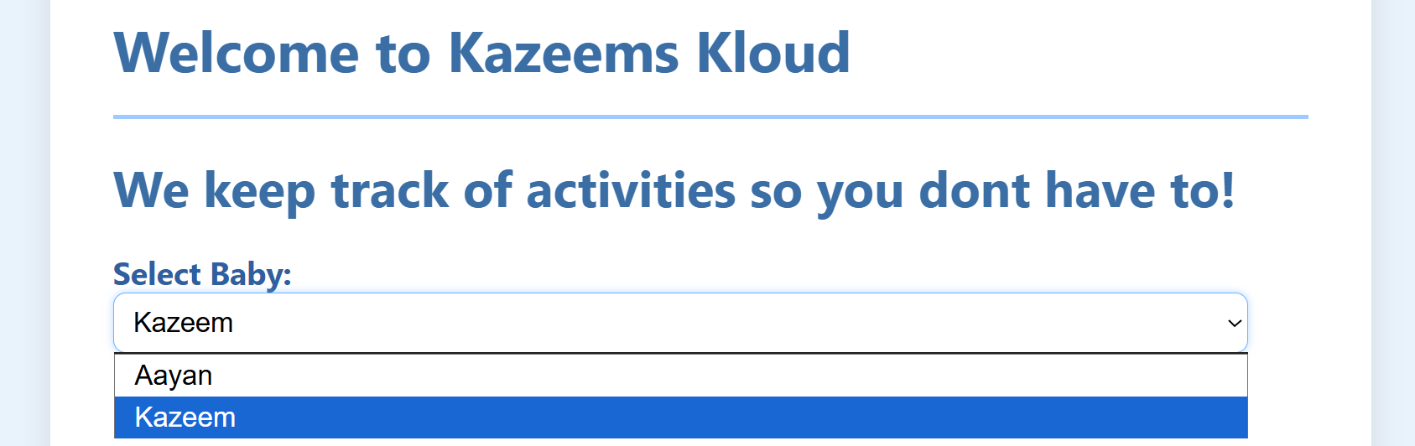

- Problem #5: An issue I ran into creating this website, was that I wasn’t sure how to create the reports page. After searching online, I found help to create the type of page in the style I was looking for. At first, I was going to split it up by category, but then decided to just show the number of activities in each category and then one large list of them. The code for this part was tricky for me.
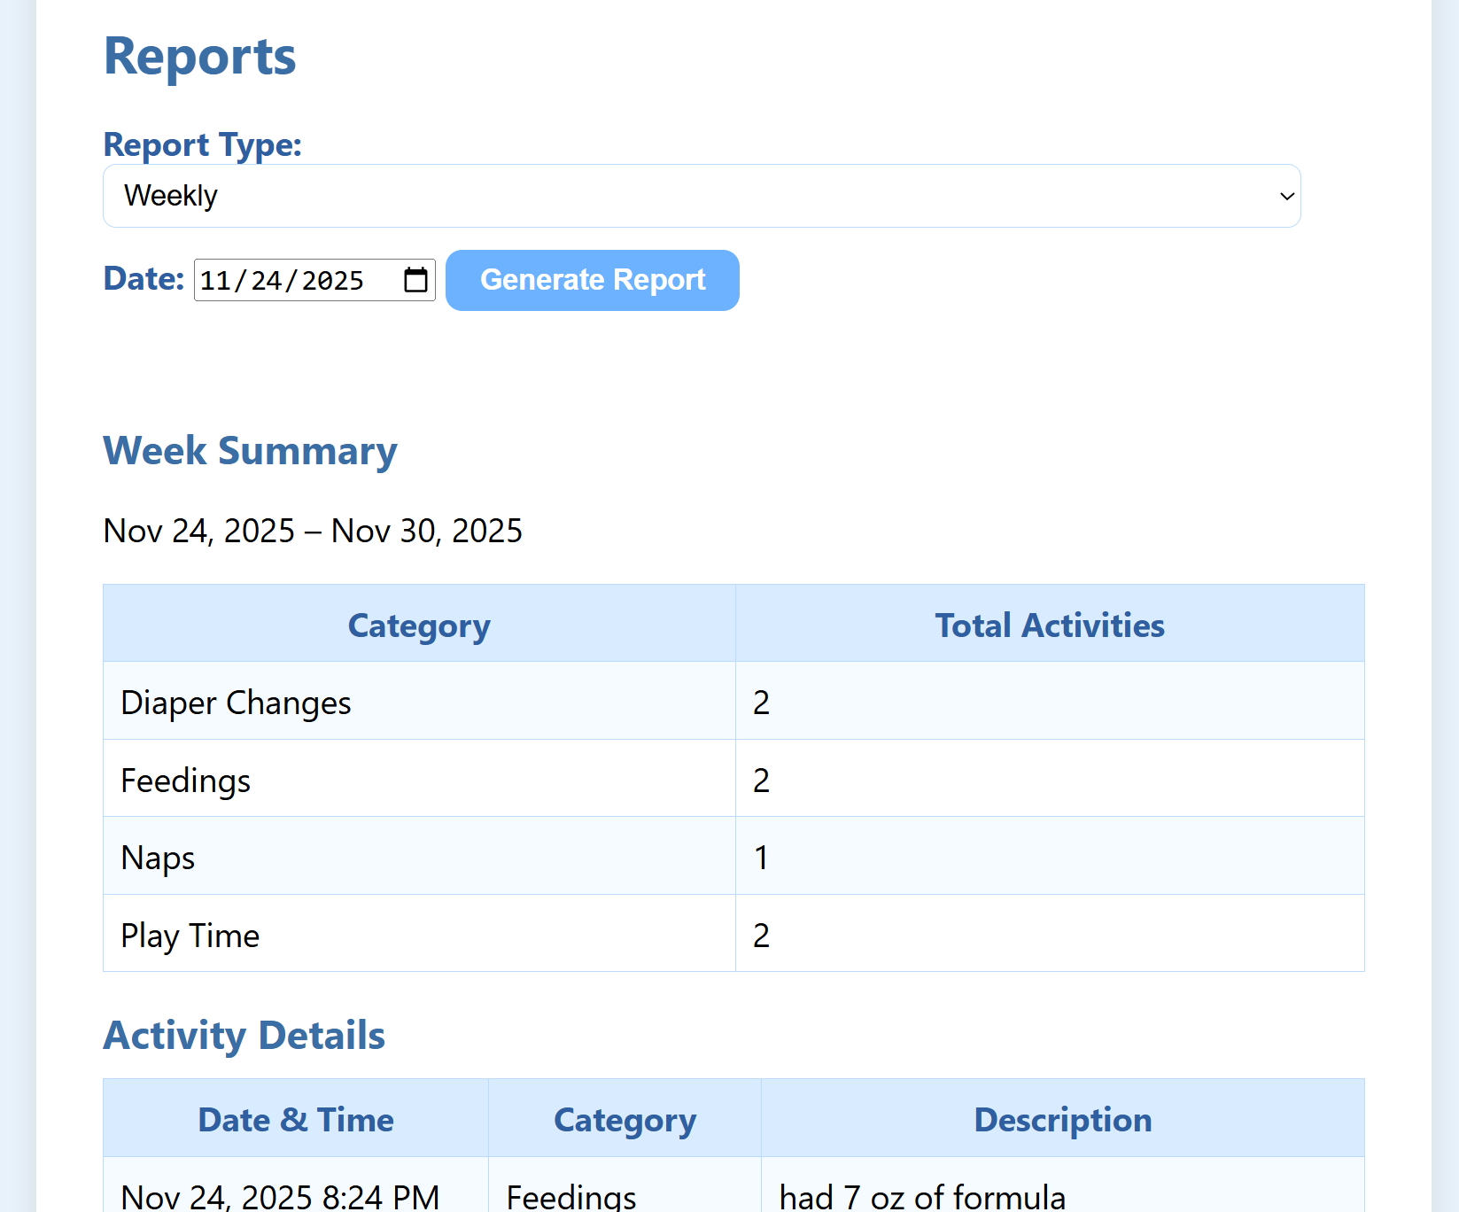

- Problem #6: I ran into an issue in the middle of creating the Kazeems Kloud website, when I tried to launch the XAMPP Control Panel and start ‘MySQL’, it would not start. I was able to resolve this using the document you provided in d2l and had to get rid of my current data folder and use the backup. Once I changed the folder, ‘MySQL’ started back up.
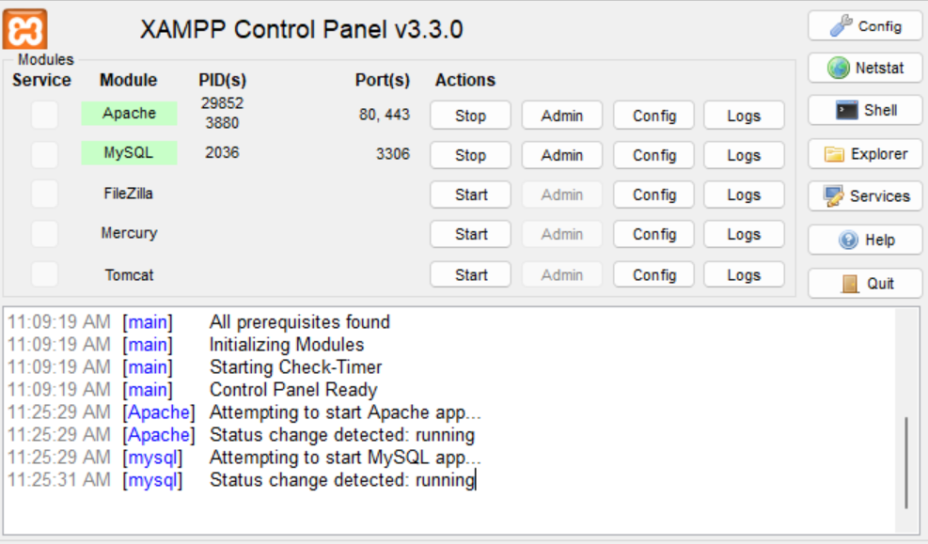

- Problem $7: When I tried to add an activity, the date would be correct, but the time was always wrong. I found out it was because of the timezone so I added this line of code in the addActivities page:
date_default_timezone_set('America/New_York');
This set the timezone to EST so the time recorded was accurate.

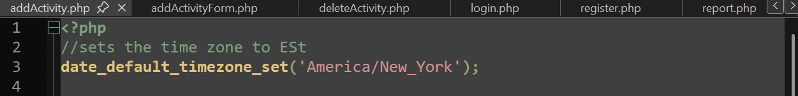

- At first, I didn't add any way to create an account, which I realized was an issue since accounts had to be made. I ended up adding two options, one for users and one for doctors. I created the register, registerDoctor.php and registerDoctorForm.php for this.

