PaperSonar

Phase 1 Design Baseline v2
Research & Innovation Intelligence Warehouse | Expanded source strategy and target architecture | 10 November 2026
Status: design only. Phase 2 and Phase 3 implementation has not started.

Executive summary
PaperSonar is a source-neutral Research & Innovation Intelligence Warehouse design. It aims to connect publications, preprints, datasets, research software, creators, institutions, citations and explicit relationships. It supports research-direction comparison with transparent counts, dated observations, provenance and caveats. A sparse topic intersection is a review lead, not proof of novelty.

Phase status
This update is a Phase 1 design expansion. Phase 2 ingestion, staging, physical warehouse loading and ETL have not started. Phase 3 analytical SQL, OLAP, query optimization and Power BI have not started. The current pilot contains 20 OpenAlex works and is not an analysis-ready corpus.

Business problem and users
Researchers and supervisors need repeatable comparisons of activity, citation cohorts, topic intersections, access, creators, institutions and related research artifacts. PaperSonar should show the evidence and limits behind each metric rather than output an unexplained novelty score.

Broader scope
The target canonical object includes publication, preprint, dataset, research software, report and other research output. The first domain remains software engineering and adjacent computing. Cross-source coverage must be measured; a larger source list does not automatically mean a larger unique corpus.

Five sources
OpenAlex supplies scholarly graph metadata. Crossref supports DOI metadata and reindex updates. arXiv contributes preprints and versions. DataCite contributes dataset/software and other registered outputs. Zenodo contributes datasets, software, reports and version relationships. Each source has its own identity, historical extraction and incremental strategy. See docs/sources.md.
Source | Role | Incremental approach
OpenAlex | Scholarly graph and metadata | Bounded re-fetch, overlap, periodic reconciliation
Crossref | DOI metadata and reindex changes | Fixed index-date windows + cursor
arXiv | Preprints and versions | OAI-PMH datestamp windows
DataCite | Datasets/software/research outputs | Updated-date query or OAI-PMH; validate
Zenodo | Research artifacts and versions | OAI-PMH windows + API detail/backfill

Incremental strategy
Keep separate per-source watermarks, fixed window start/end, overlap, cursor/token, run state and payload hashes. Persist raw pages and checksums before checkpointing. Use upsert by source-native ID and preserve raw history. Watermarks advance only after a complete validated run. Missing from one response does not mean deleted. OpenAlex remains bounded-re-fetch/periodic reconciliation under the free-only plan; Crossref supports index-date windows; arXiv and Zenodo can use OAI-PMH datestamps; DataCite updated-date query/OAI-PMH must be validated.

Architecture
Five sources feed independent harvest controls, immutable raw landing, staging and quality checks, source identity crosswalk, canonical research-output warehouse, analytics mart, reporting views, local Power BI and later optional web/API. Full diagram is docs/architecture/diagrams/07_Target_architecture_v2.pdf.
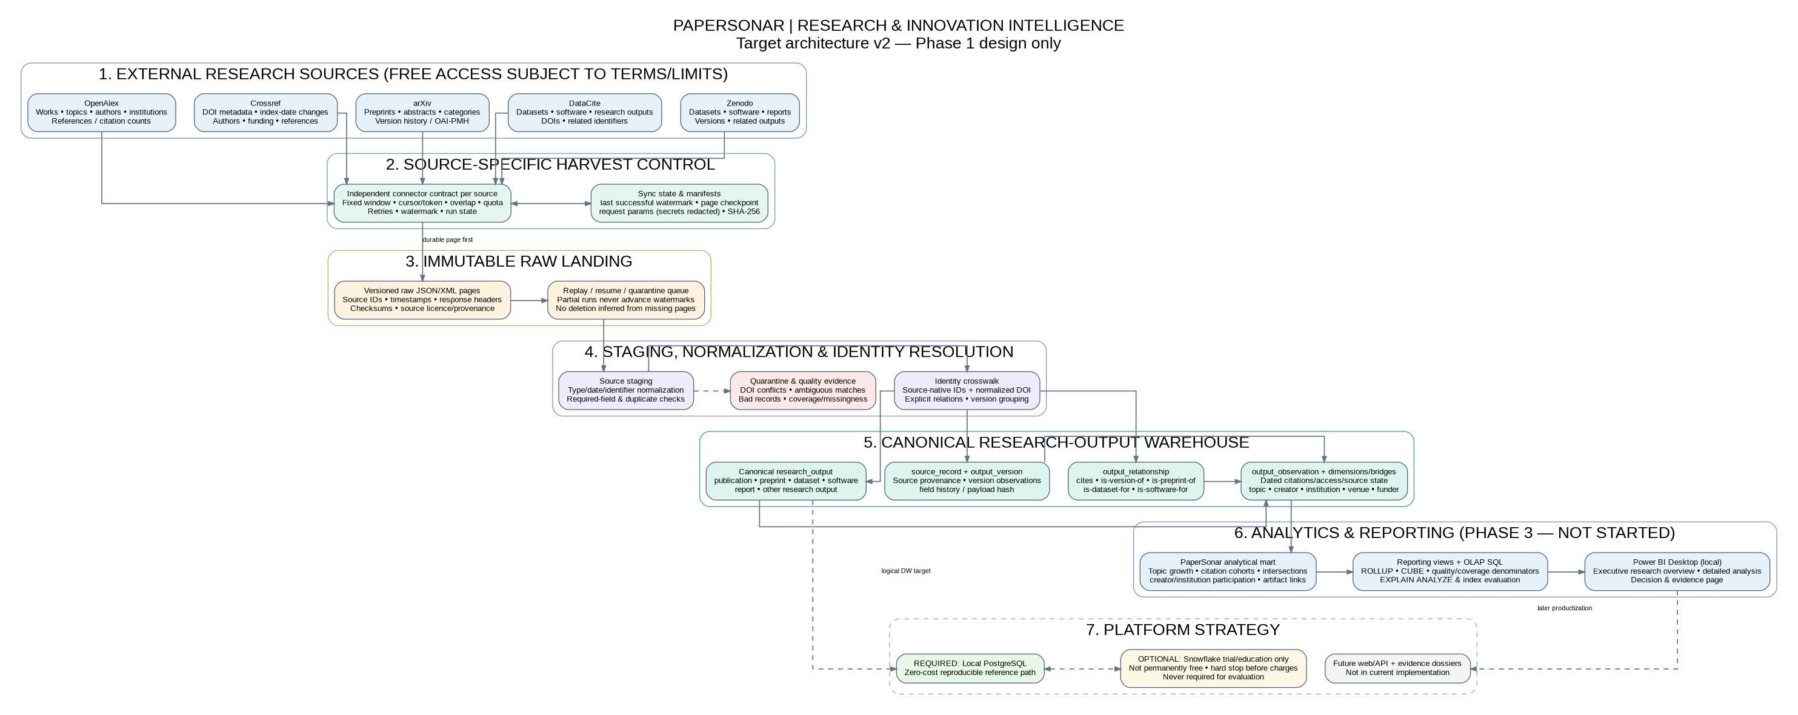

Logical entities
Proposed entities include etl_run, source_sync_state, source_record, research_output, output_version, output_relationship, output_observation, dimensions for date/output type/topic/person/institution/venue-repository/access/funder, and bridges for topic/creator/institution/funder. Publication activity and citation relationships are separate analytical facts. Exact physical keys/grains require final model review before Phase 2.

Key and deduplication rules
Preserve source-native IDs. Normalize DOI but keep the original value. Matching DOI is a candidate match, not blind permission to merge. Compare title, type and dates; quarantine conflicts. Never automatically merge on title alone. Keep explicit source relationships and version history.

Corpus and scale
Candidate OpenAlex topic IDs T10743, T12423 and T12479 remain unfinalized. Proposed baseline is 2016–2025, with 2026 partial and common-cutoff comparisons. The 30,000–60,000 output target is a profiling-dependent engineering target, not a verified count or hard truncation cap. Include preflight counts, resource-type mapping, overlap, and source coverage in the frozen corpus definition.

Free-only Snowflake decision
Local PostgreSQL is the required reproducible baseline. Snowflake is optional only if a no-cost trial or educational credits are available. Do not assume a permanent free tier or make Snowflake necessary to pass evaluation. Stop before any charge. Keep SQL portable where reasonable and isolate platform-specific syntax.

Analytical questions
The v2 dictionary contains 18 candidate questions: the original 14 plus research artifact links, cross-source match rate, preprint/version evolution and funding participation. They remain planned questions, not implemented queries. Validate definitions and coverage before finalizing.

Course requirement alignment
Phase 1 requires business understanding, 10+ questions, processes, grain, fact types, dimensions, hierarchies, keys, conceptual/logical/physical diagrams and dictionary. Phase 2 requires staging/DW/reporting schemas, cleaning, surrogate-key mapping, 100+ dimension records, 10,000+ facts and quality reports. Phase 3 requires analytical SQL, ROLLUP, CUBE, reporting views, EXPLAIN ANALYZE before/after indexes, Power BI pages, screenshots, insights and presentation. Retail examples must be translated to research metrics.

Known limitations
Source coverage is uneven; source APIs overlap and change; free quotas constrain refresh; OpenAlex lacks a guaranteed free change feed; DOI matching can conflict; author/institution identity can be incomplete; citation history begins only at local observation; source taxonomies change; topic co-assignment does not prove semantic connection; free cloud trials expire; full-text is out of scope.

Phase 2 readiness gates
Before implementation, profile topic/year/type partitions, confirm source-specific API semantics, estimate storage, finalize the source-neutral model and dictionary, approve source-specific watermarks/cadences, document licences and freeze a versioned corpus configuration. Then implement and test one connector at a time.

Status summary
Designed: scope, source strategy, target architecture, data dictionary v2 and course traceability. Existing: 20-record OpenAlex pilot and original publication-centered schema/design. Not started: all five connectors, raw landing, incremental ETL, canonical warehouse loading, quality reports, SQL analytics, Power BI and public application.
Primary references: docs/sources.md, docs/architecture/README.md, docs/requirements/incremental-ingestion-design.md, docs/requirements/course-requirements-matrix.md, docs/decisions/002-free-first-warehouse-and-snowflake.md.

