PaperSonar
Model design
Design baseline 1.0 / 25 October 2026
PaperSonar uses a dimensional fact constellation. Publication, work observation and citation relationship facts share conformed dimensions. Multivalued topics, authors and institutions are represented by bridges. The physical definitions are supplied in the Excel data dictionary, PostgreSQL DDL and editable DBML.

Conceptual model
A scholarly work can be written by several authors, be affiliated with several institutions and be assigned several topics. It has at most one indexed primary source. A work may cite many other works and be observed repeatedly. Publication output and later observations therefore require separate facts.
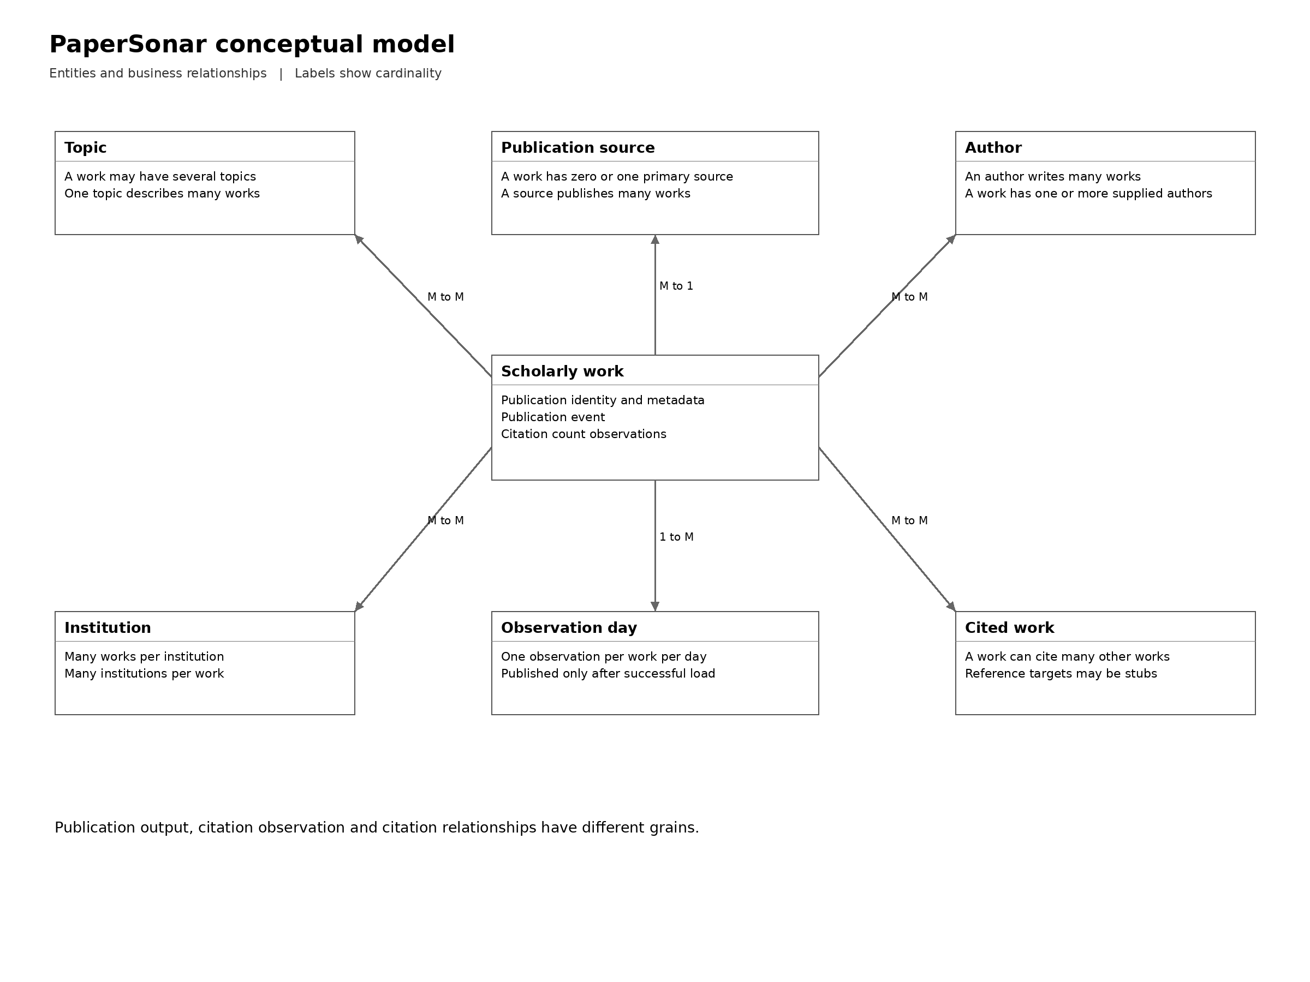
Conceptual relationships are optional when metadata is absent. A source affiliation is a relationship observed on a work, not proof of an author's current employment.

Logical dimensional model
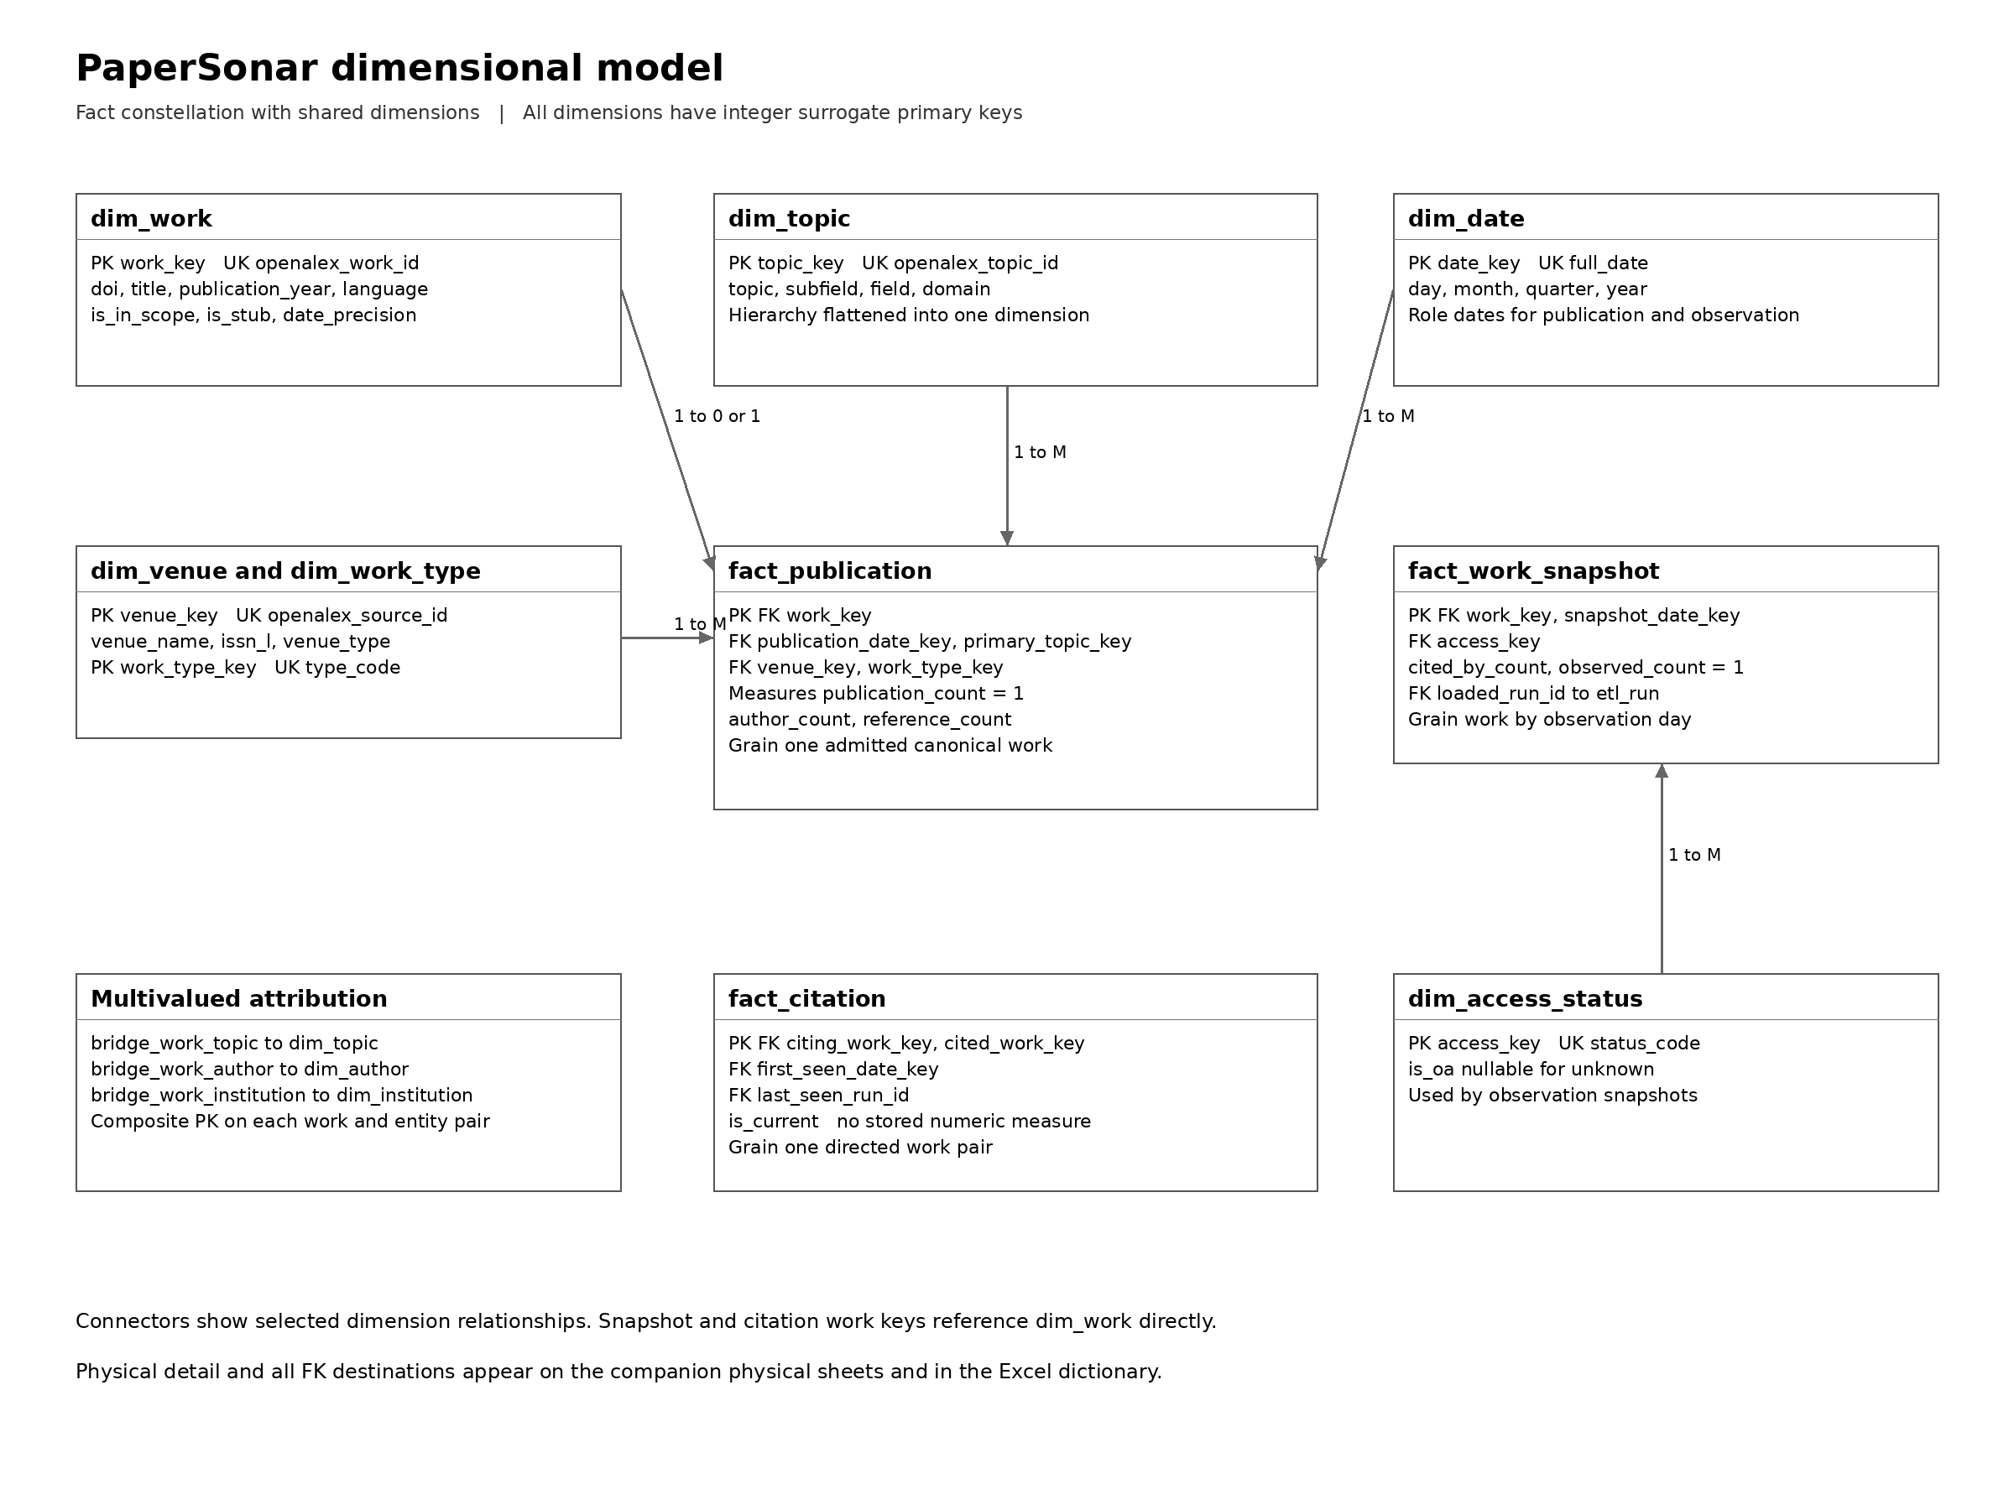
Each analytical fact has a declared grain and PK. Integer FKs connect facts to dimensions. The topic hierarchy is flattened, so the core model remains a set of stars. Bridges handle multivalued attributes without forcing one row per author or topic into the publication fact. Citation references use two roles of dim_work.

Fact key constraints
Table | Primary key | Foreign key groups
fact_publication | work_key | work, publication date, primary topic, venue, work type, run
fact_work_snapshot | work_key + snapshot_date_key | work, observation date, access status, run
fact_citation | citing_work_key + cited_work_key | citing work, cited work, first-seen date, last-seen run

Physical dimension definitions
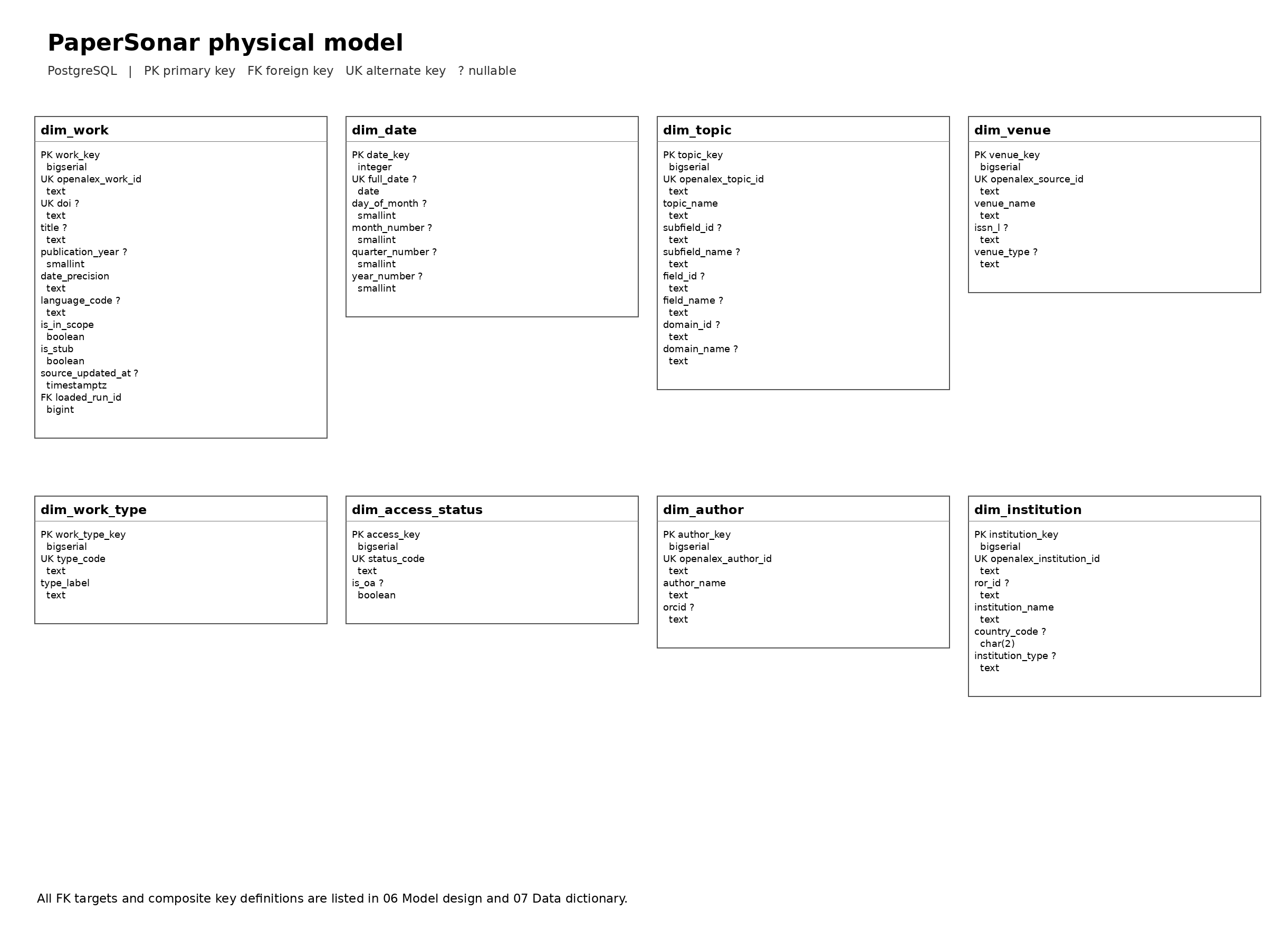
Physical sheet 1 lists every dimension attribute and data type. The full-size PNG and PDF retain readable field labels. All column descriptions, nullable flags, natural identifiers and source mappings are in 07_PaperSonar_Data_dictionary.xlsx.

Unknown members and dates
Reserve key 0 for unknown members of date, topic, venue, work type, access, author and institution dimensions. The current bridge policy stores only actual supplied memberships, so it normally uses no unknown author or institution row. Full-date attributes for the unknown day are null. Work stubs retain actual source work IDs and do not use key 0.

Physical facts and relationships
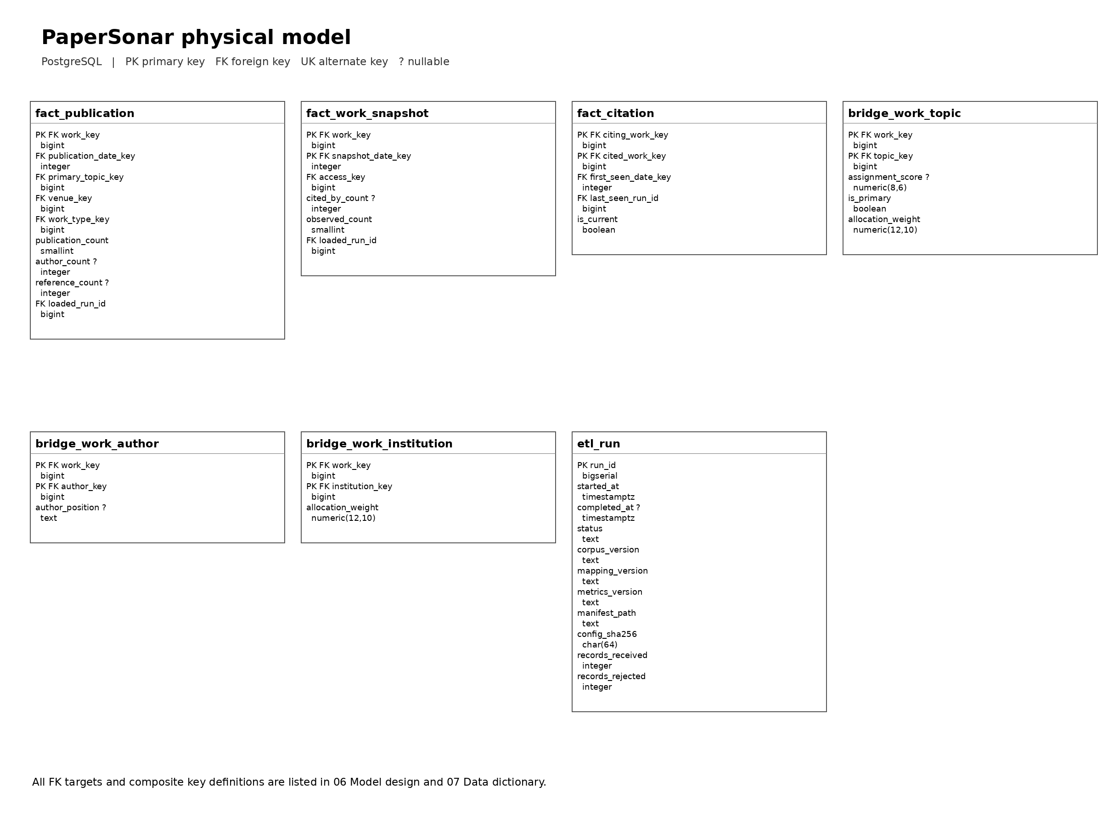
Physical sheet 2 lists fact, bridge and run-log fields. PostgreSQL DDL defines all PKs, FKs, alternate identifiers and basic constraints. It also creates indices for topic and date analysis, snapshot dates and reference targets. Source-dependent validation and reconciliation remain ETL responsibilities.

Physical integrity rules
publication_count and observed_count equal 1. Citation counts and supplied source counts cannot be negative. Citation endpoints must differ. Allocation weights are positive and no greater than 1. The ETL checks per-work weight totals and a single primary-topic membership where a primary topic exists. DOI identity conflicts are quarantined before a unique DOI can be loaded.

Relationship register
Foreign key | Referenced primary key
dim_work.loaded_run_id | etl_run.run_id
fact_publication.work_key | dim_work.work_key
fact_publication.publication_date_key | dim_date.date_key
fact_publication.primary_topic_key | dim_topic.topic_key
fact_publication.venue_key | dim_venue.venue_key
fact_publication.work_type_key | dim_work_type.work_type_key
fact_publication.loaded_run_id | etl_run.run_id
fact_work_snapshot.work_key | dim_work.work_key
fact_work_snapshot.snapshot_date_key | dim_date.date_key
fact_work_snapshot.access_key | dim_access_status.access_key
fact_work_snapshot.loaded_run_id | etl_run.run_id
fact_citation.citing_work_key | dim_work.work_key
fact_citation.cited_work_key | dim_work.work_key
fact_citation.first_seen_date_key | dim_date.date_key
fact_citation.last_seen_run_id | etl_run.run_id
bridge_work_topic.work_key | dim_work.work_key
bridge_work_topic.topic_key | dim_topic.topic_key
bridge_work_author.work_key | dim_work.work_key
bridge_work_author.author_key | dim_author.author_key
bridge_work_institution.work_key | dim_work.work_key
bridge_work_institution.institution_key | dim_institution.institution_key

Every FK above is mandatory at the physical level. Unknown descriptive values resolve to key 0 rather than a broken FK. dim_work.loaded_run_id requires an existing run before loading work metadata. No direct fact-to-fact FK exists. The one-to-one publication identity is a special case: a dim_work row has zero or one fact_publication row, while admitted works have exactly one.

