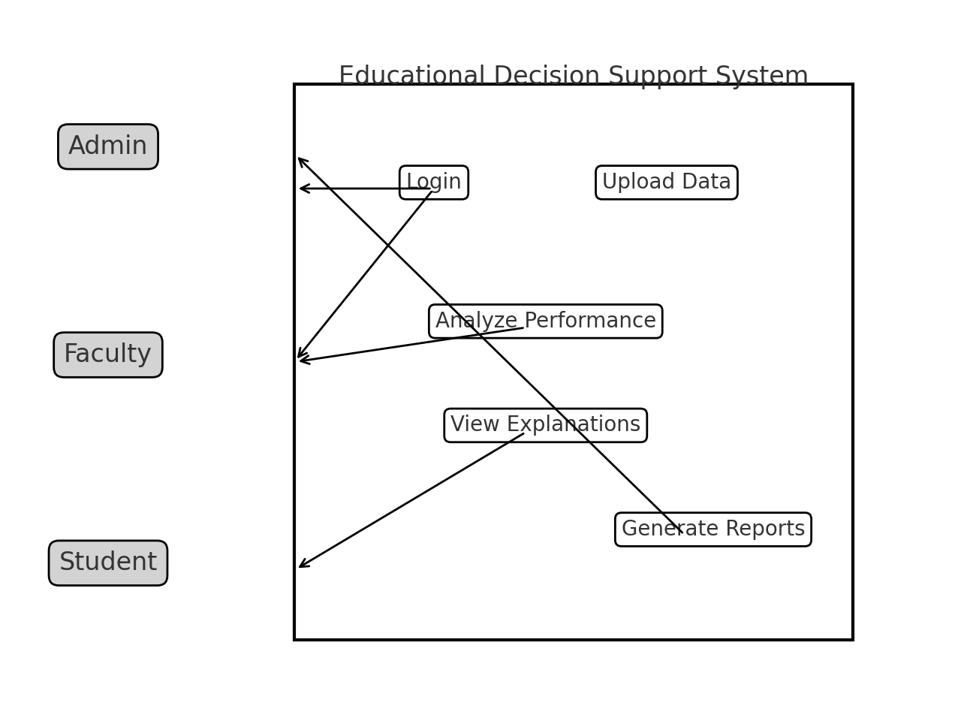
THE ISLAMIA UNIVERSITY OF BAHAWALPUR
Integrating Explainable AI for Transparent Educational Decision Support
Student Name: Zohaib Asif
Roll No: F22BINFT1M01201
Department: Information Technology
Supervisor: Dr. Mustafa Hameed
Date: November 10, 2025

1. Introduction

1.1 Purpose
The purpose of this Software Requirements Specification (SRS) document is to define the functional and non-functional requirements for the system 'Integrating Explainable AI for Transparent Educational Decision Support'. The system aims to support educational institutions with transparent, data-driven decisions on student performance and academic support.

1.2 Scope
The system will provide data-driven recommendations and visual explanations for decisions such as student evaluations, performance analysis, and resource allocation. The Explainable AI (XAI) module will provide human-understandable explanations for predictions.

1.3 Definitions, Acronyms, and Abbreviations
AI – Artificial Intelligence
XAI – Explainable Artificial Intelligence
SRS – Software Requirements Specification
ML – Machine Learning

2. Overall Description

2.1 Product Perspective
Web-based application built with Python that connects to a database and uses AI models to predict and explain student outcomes.

2.2 Product Functions
- Predict student performance and risk of failure.
- Explain predictions with visualized feature importance.
- Generate reports for teachers and administrators.
- Role-based dashboards (Admin, Faculty, Student).

3. Specific Requirements

3.1 Functional Requirements
ID | Requirement Description
FR1 | Allow users to log in and access dashboards based on roles.
FR2 | Analyze student performance data using AI models.
FR3 | Generate explainable outputs (reasoning, graphs, heatmaps).
FR4 | Allow administrators to upload or update student data.
FR5 | Display key metrics like attendance, grades, and progress.
FR6 | Generate reports summarizing AI-based recommendations.

3.2 Non-Functional Requirements
Performance: Response time under 3 seconds for predictions.
Usability: Intuitive interface for all roles.
Reliability: 99% uptime.
Security: Data encryption and role-based access control.
Scalability: Handle increasing numbers of students and records.

4. System Design Description

4.1 Use Case Diagram
The Use Case diagram is shown below:

4.2 System Architecture (High-Level)
Frontend: Flask templates and HTML/CSS.
Backend: Python-based API and ML engine.
Explainability Layer: SHAP/LIME for feature explanations.
Database: MySQL or SQLite.
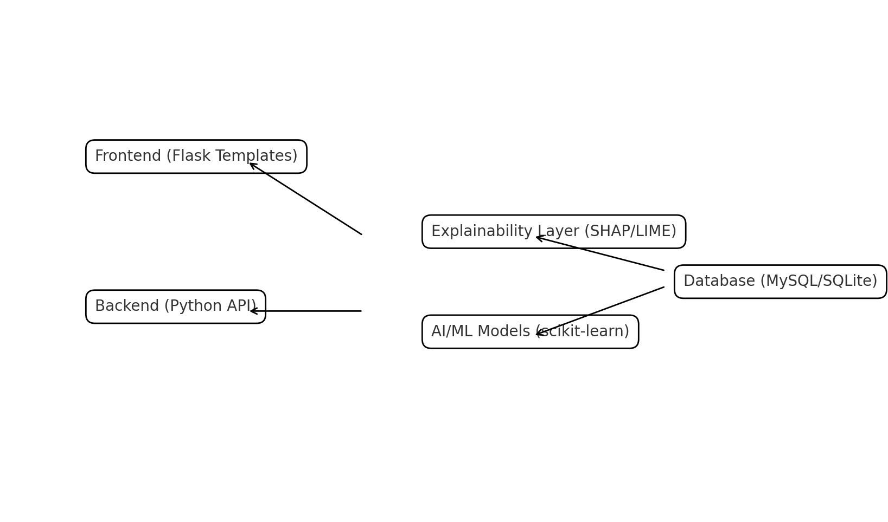

5. External Interface Requirements
User Interface: Dashboards with charts and tables.
Hardware: Server with minimum 8GB RAM recommended.
Software: Python 3.10+, Flask/Django, scikit-learn, pandas, SHAP, LIME.
Communication: HTTP/HTTPS, REST API.

6. Other Requirements
Regular backup, documentation of AI models, and compliance with data privacy policies.

7. Appendix
Future Enhancements: LMS integration, deep learning models, mobile app interface.

