Project to create Star wars movie platform using SWAPI API

Tech used for building this project.

* Javascript
* TypeScript
* MaterialUi
* Third party libraries :- react-pro-sidebar, react-router-dom, materialUi icons.
* SWAPI API.

I followd the flattened and nested folder structure

I extensively used material ui for responsive layout.

Following are the screenshots of the project .

Features:

dark and light theme,

responsive side bar.

Grid and list view of movies

Displayed all the information present in swapi api

Dark theme film Screenshot

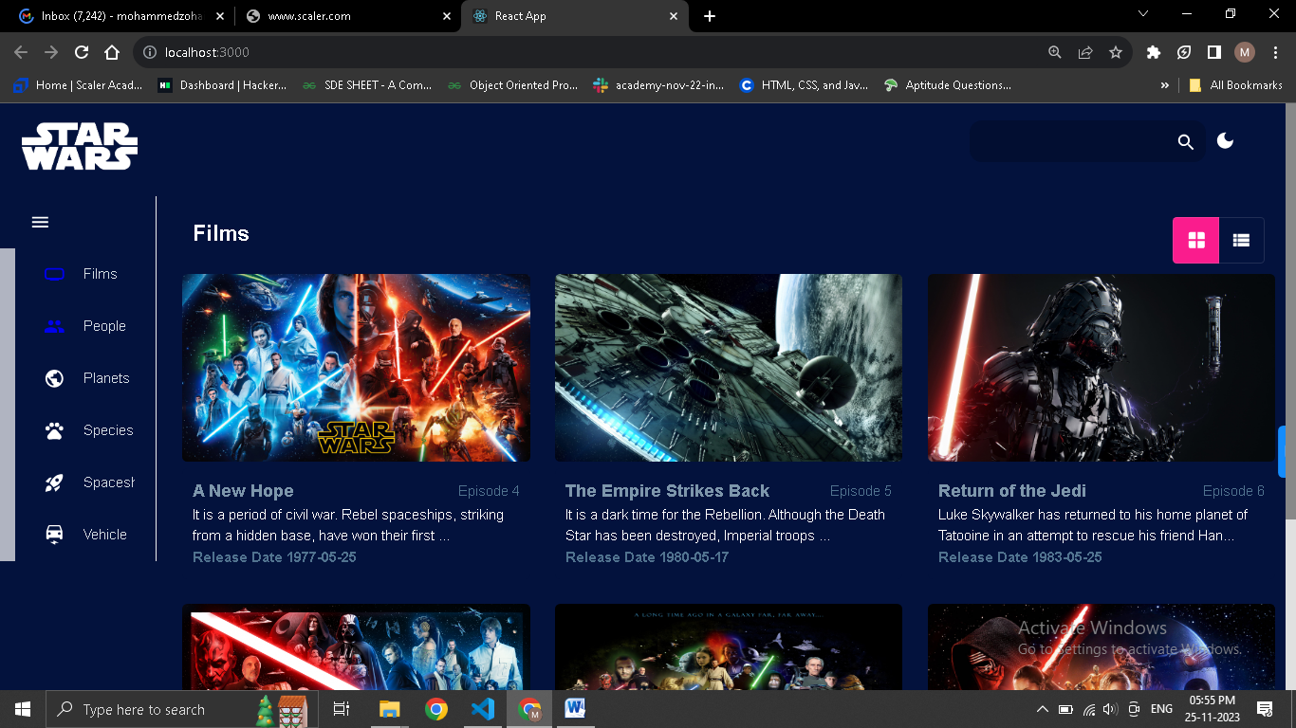

Light Theme Film Grid view

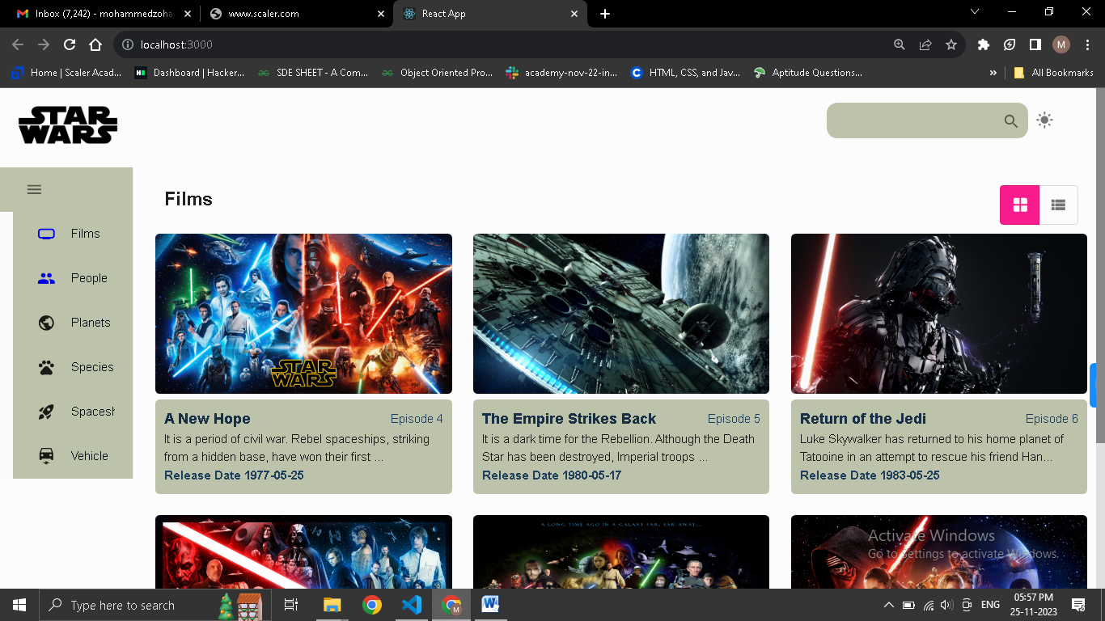

Dark Theme Film List view

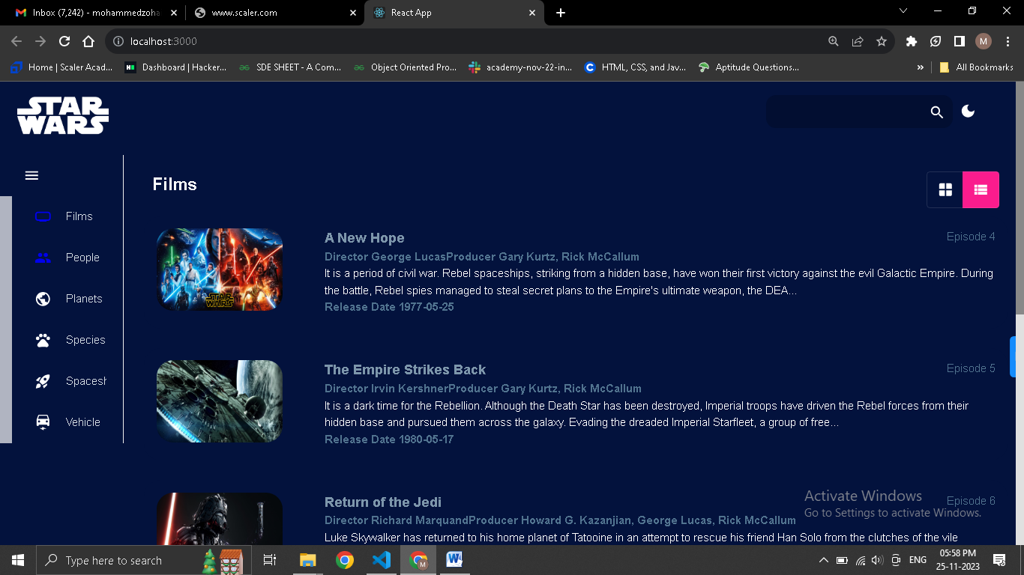

For theme I created a proper theme js file in which I declared my primary and secondary colors, when user hits the theme button it toggles from dark to light theme.

Light theme list view

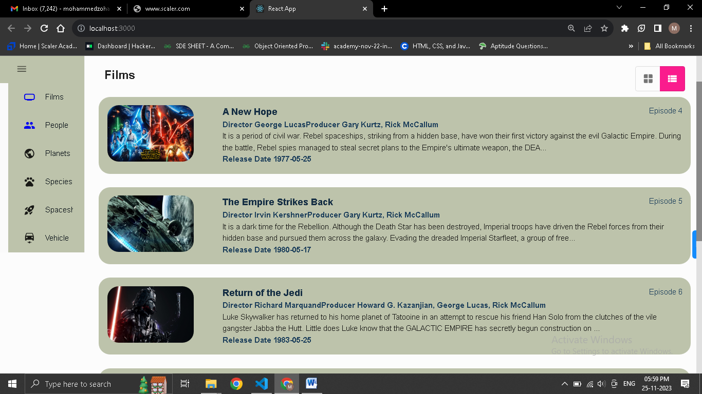

I used react-pro-sidebar library for creating sidebar component which is very easy to implement and have feature for collapsing and displaying only icons of side bar. For example:-

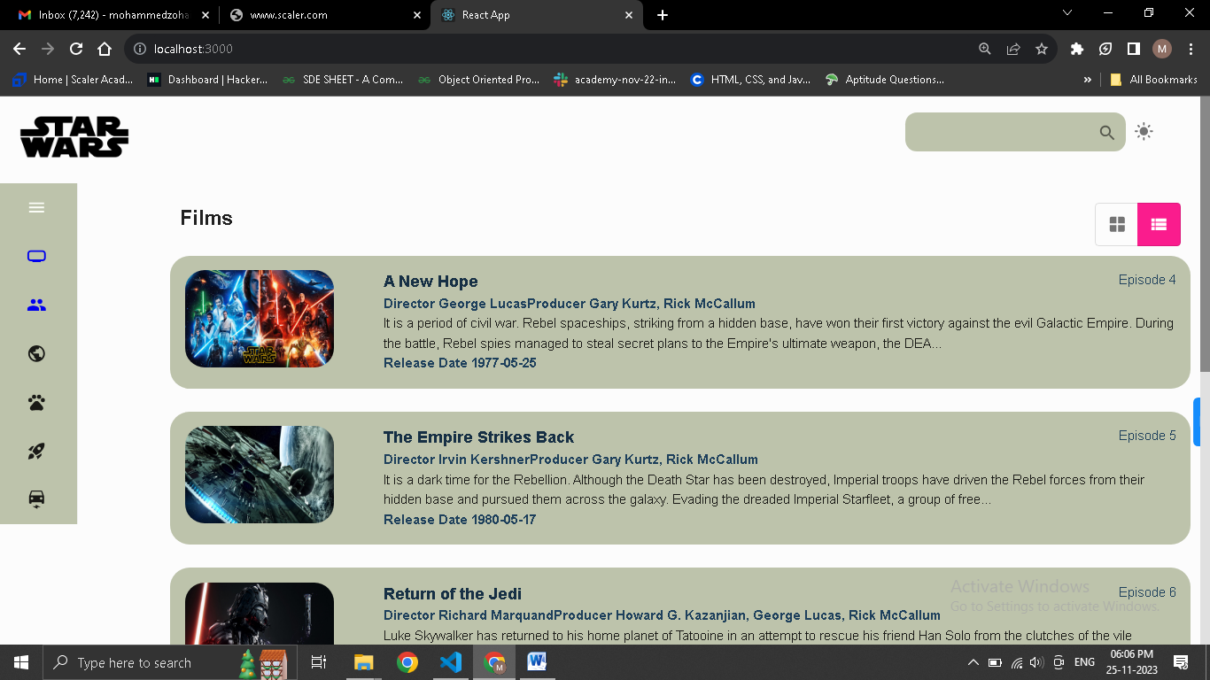

For the main page which is right side of the side bar and main content I used Material UI library for grid view and list view user has a option to view the content as list or grid as shown in screenshots.

People page

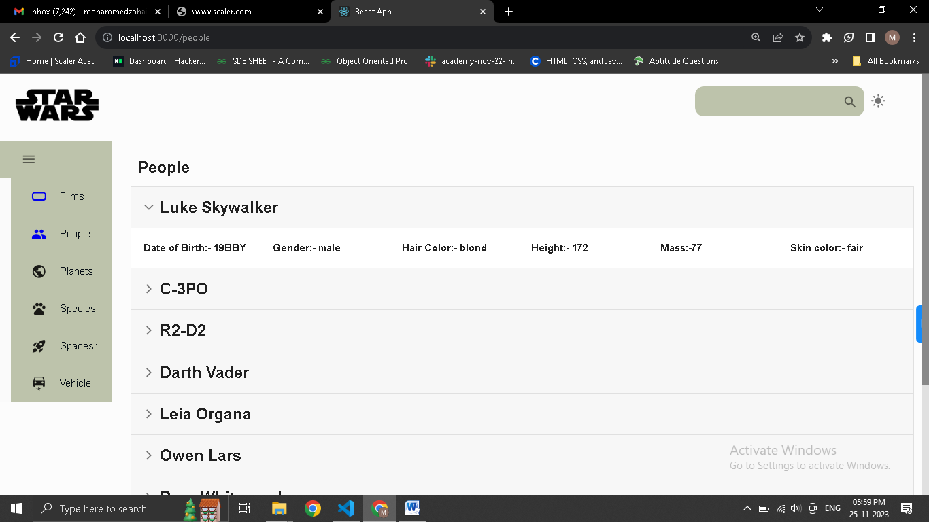

For people view I used Material Ui Accordians to view the details of people.

Git hub repository: <https://github.com/zohaib954/assignment>