**Project Report**

**On**

**“o**nline Shopping Cart**”**



**Aptech Computer Education – MSG-Karachi**

**Submitted By: Guided By**

1. Zohaib khan Sir Amjad

2. Muhammad Shah Fahad Teacher, Aptech-MSG-Karachi

**CERTIFICATE**



**This is to certify that Web Application for**

**Online Shopping Cart has been completed with all functionality by the students of**

**PR-201811E.**

Zohaib khan, Muhammad Shah fahad ,

**INTRODUCTION**

Arts is a stationary shop that sells arts, gift articles, greeting cards, dolls, files, hand bags, wallets, and as well some of the beauty products, etc…. As there is a lot of demand for the greeting cards, gift articles, hand bags, etc…. and in this busy world where one can hardly find time to go out for shopping and with the emerging new technologies where one can purchase products by placing an order through online by sitting at home/office either by credit cards or by VPP or through Cheque or through DD

**SYSTEM ANALYSIS**

EXISTING SYSTEM:

Our client is a retail dealer of various products like gift articles, dolls, files, etc…. The customers usually visit the shop in order to purchase the products. He has a huge variety of products at his shop. Also as there is an increase in the demand of these products and as well as there is a huge variety of combinations and products available, and as the number of retail dealers are increasing day by day, it has become difficult to withheld in the market and as well to retain the customers.

Also as they don’t keep track of the products, it is hard to find how many products are available in the shop.

**Proposed Solution :**

In order to cope up in this competitive world, and to retain the customers, to automate the process, our client wants an application to be built meeting the current technology trend where the customers can place their order through online by sitting at their office/home, and providing the products as per the orders received by the dealer at the door steps of the customer.

He says that he wants that the application should hold the details of the products in detail like price, description of the product and each product is allocated with a unique 7 digit product id which includes 2 digit product code and 5 digit product number. Also he says that for fetching the details of the products, the customer need not be the registered one, but for placing an order one has to be the registered user of the site.

After placing an order, the dealer would dispatch the order as per the type of delivery that the customer has chosen. He says that the application should generate a unique 16 digit order number (includes the type of the delivery (1 digit) that the user has opted for, Product id (7 digit), and the order number (8 digit)) as soon as the order is placed by the customer.

For the order which is placed through the credit card payment or through cheque, the payment should be cleared first and then only the product will be dispatched to the customer’s premises. Also he has provided an option like if the customer is not satisfied by the product then the customer can either replace it (new product will not be sent) or he can return it back with in a week days time, so that he can get back his money which he has paid for that product. Also the warranty card will also be provided for the products which have some warranty.

The dealer alone should be able to update the details of the employees, products and their details, and he can check the orders that are received based on the date, order type (delivery) and he alone has the right to create an employee profile like username or login id and the password. The employee should only be able to change his password, and he can check the details of the orders so that the products can be dispatched as per the customer’s request and that they can be delivered in time.

Also he says that there should be an option on the web site where the customer can send their feedbacks regarding the services that they attain from them.

**Hardware & Software Requirments**

**Hardware**

* A minimum computer system that will help you access all the tools in the courses is a Pentium 166 or better
* 128 Megabytes of RAM or better

**Operating System**

* LINUX / Windows 2000 Server (or higher if possible)

**Software**

* PHP
* MySQL
* PERL
* Apache

**Problem Statement:**

Our client is a retail dealer of various products like gift articles, dolls, files, etc…. The customers usually visit the shop in order to purchase the products. He has a huge variety of products at his shop. Also as there is an increase in the demand of these products and as well as there is a huge variety of combinations and products available, and as the number of retail dealers are increasing day by day, it has become difficult to withheld in the market and as well to retain the customers.

Also as they don’t keep track of the products, it is hard to find how many products are available in the shop.

**Customer Requirement Specification:**

* Maintaining the details of the Employees, product details, stock details, order, and delivery details of the products and that of the customers are to be maintained with the help of the database.
* There should be separate login for Admin, Employees and for the customer.

**Project plan:**

* At first we analyzed the project, took ideas from an institute scenarios.
* We decided to start the work with the formation of database because a strong database is the key of good Application.
* We tried to make out Application’s User Inter face friendlier by which the teacher can easily handle all the situations.
* We also had to make a User guide of our Application.

**Algorithms:**

Algorithms which we used in this program are given below:

* OOP’s.
* MYSQL.
* PHP.
* javascript.

We used full capabilities of MYSQL Server in conjunction with PHP.

Task Sheet

|  |  |  |  |  |
| --- | --- | --- | --- | --- |
| Sr. # | Task | Actual Starting Date | Team Member Name | Status |
| 1. | Problem Review | 1st June | Zohaib khan | Done |
| 2. | Template / Layout of Website | 5th June | Zohaib khan | Done |
| 3. | Use Cases | 10th June | Zohaib khan | Done |
| 4. | ERD Diagram | 12th June | Zohaib khan | Done |
| 5. | Main Page Layout | 12th June | Zohaib khan | Done |
| 6. | Other Pages | 15th June | Rida khan | Done |
| 7. | Functions | 20th June | Zohaib khan, Shah fahad | Done |
| 8. | Checking Links | 24th June | Zohaib khan, | Done |
| 9. | Login/Register | 25th June | Zohaib khan | Done |
| 10. | Admin Panel | 26th June | Zohaib khan Shah fahad | Done |
| 11. | Documentation | 30th June | Zohaib khan | Done |

Unit Check List

|  |  |
| --- | --- |
| **Option** | **Validations** |
| Fields in from should not be null | Yes |
| Input marks are consistent | Yes |
| All numeric fields have a default value | Yes |
| Hyperlink have tooltip texts | Yes |
| All pages have either forward link or backward to home page | Yes |
| Have all modules been proper integrated and are they completely functional? | Yes |
| Does each unit meet its object and purpose? Are all the validations happening as  Specific in process design ? | Yes |
| Are the code working as per specifications ? | Yes |
| Does application functionality resolve the client problem and satisfy his need completely ? | Yes |
| Has the hardware and software been correctly chosen? | Yes |
| Additional features and utilities that give value addition to the entire project | Yes |

Final Check List

|  |  |  |
| --- | --- | --- |
| **Particulars** | **Check** | **Comment** |
| Do all pages open | Yes |  |
| Are all Hyperlink working | Yes | Colors change when you click on the link |
| Are the web page contents devoid of spelling mistakes ? | Yes |  |
| Are the page color as per common guidelines? | Yes |  |
| Is the site browser compatible ? | Yes | Tested with IE 9,10,Firefox and Chrome |

**ER-Diagram**

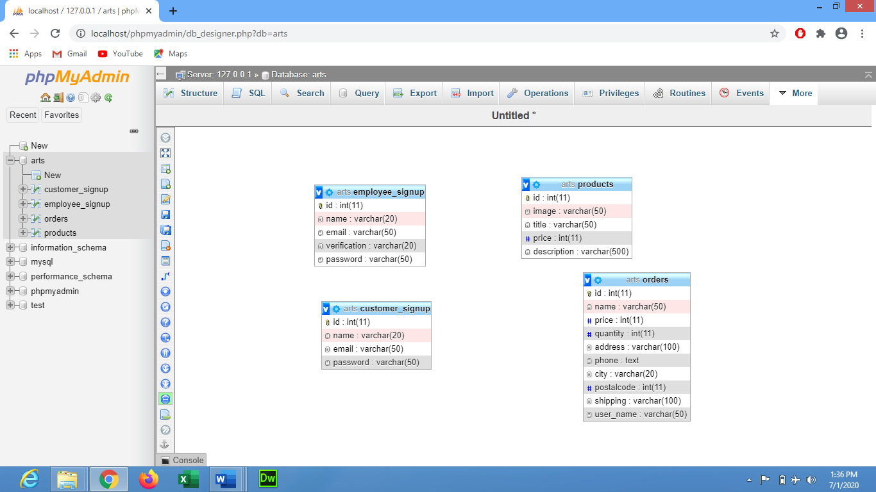

**SOFTWARE INTERFACE**

**Homepage**

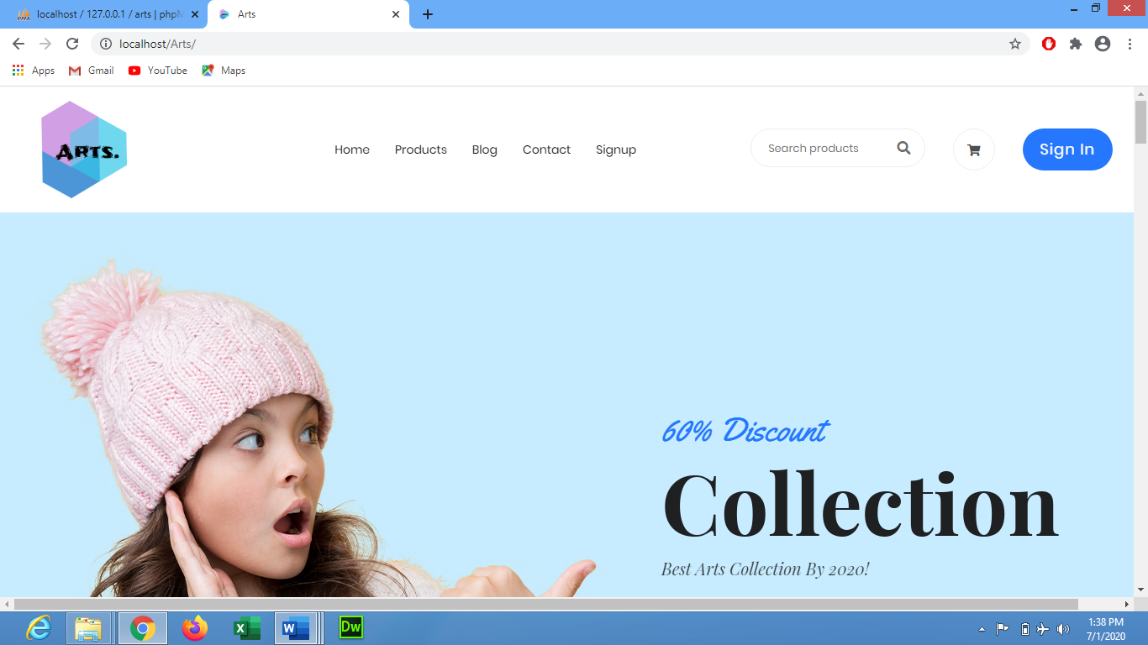

**Login**

**User Name: zohaib (admin) Password(12345),**

**ali(employee) Password(123),**

**fahad(customer) Password(123456)**

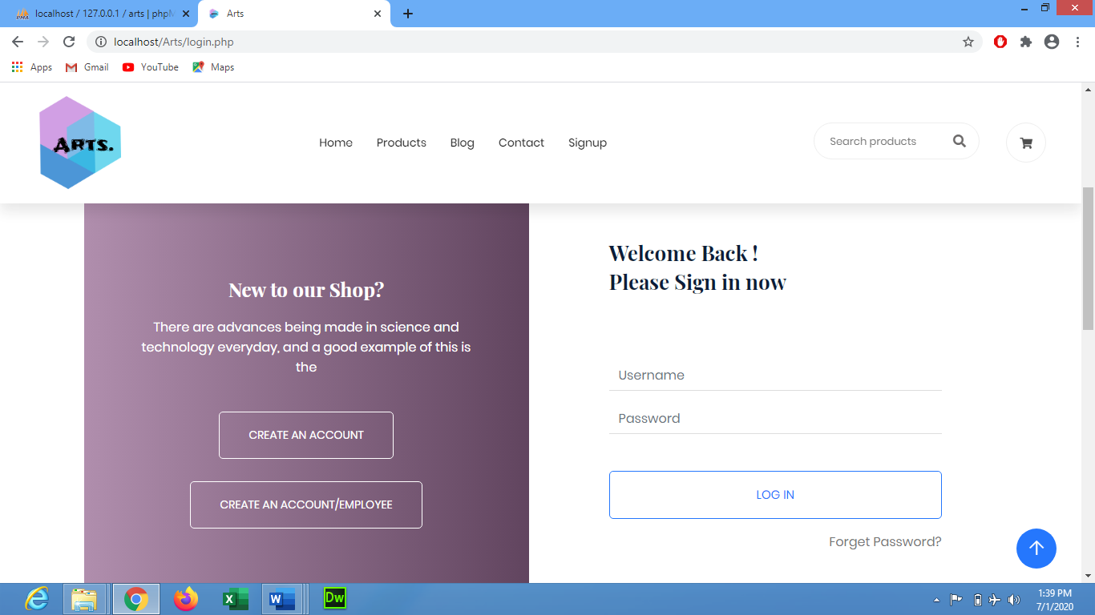

**Signup**

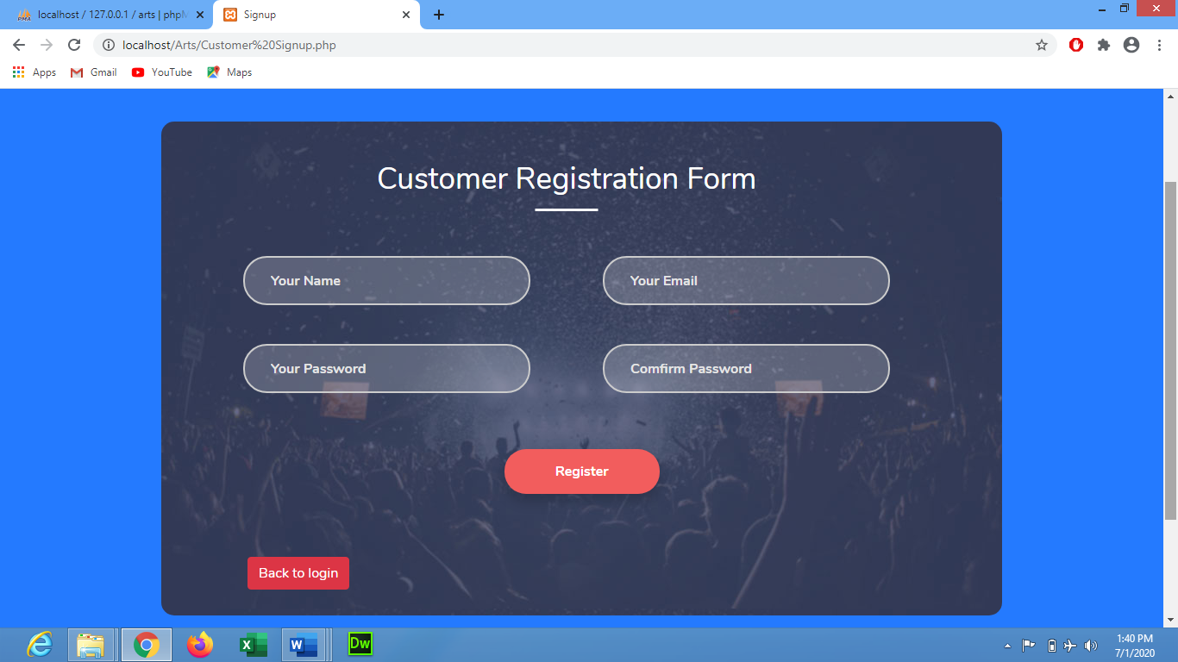

**Dashboard**

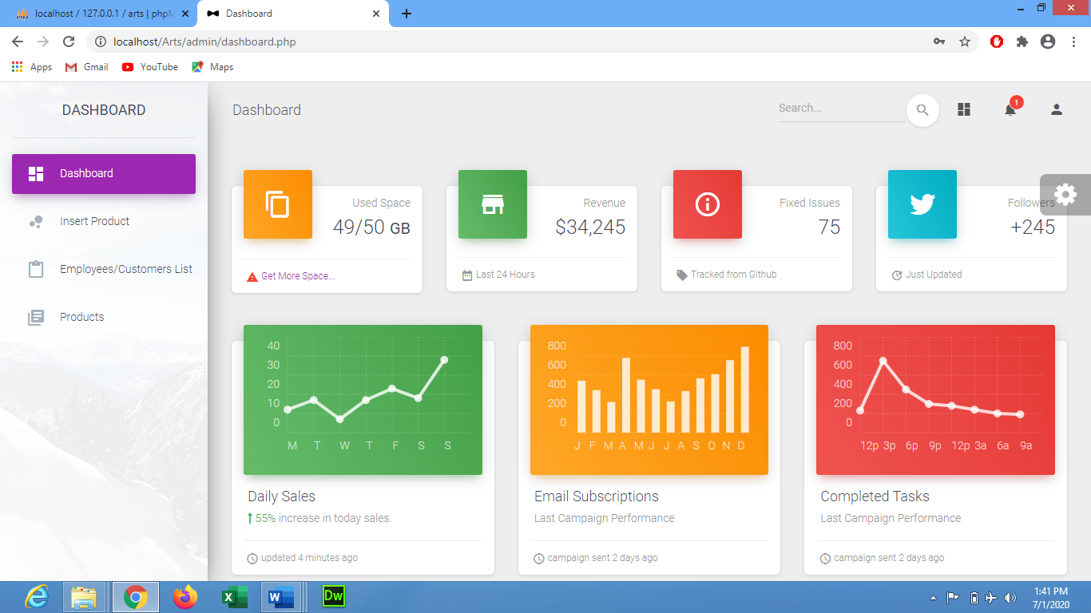**Employee Data**

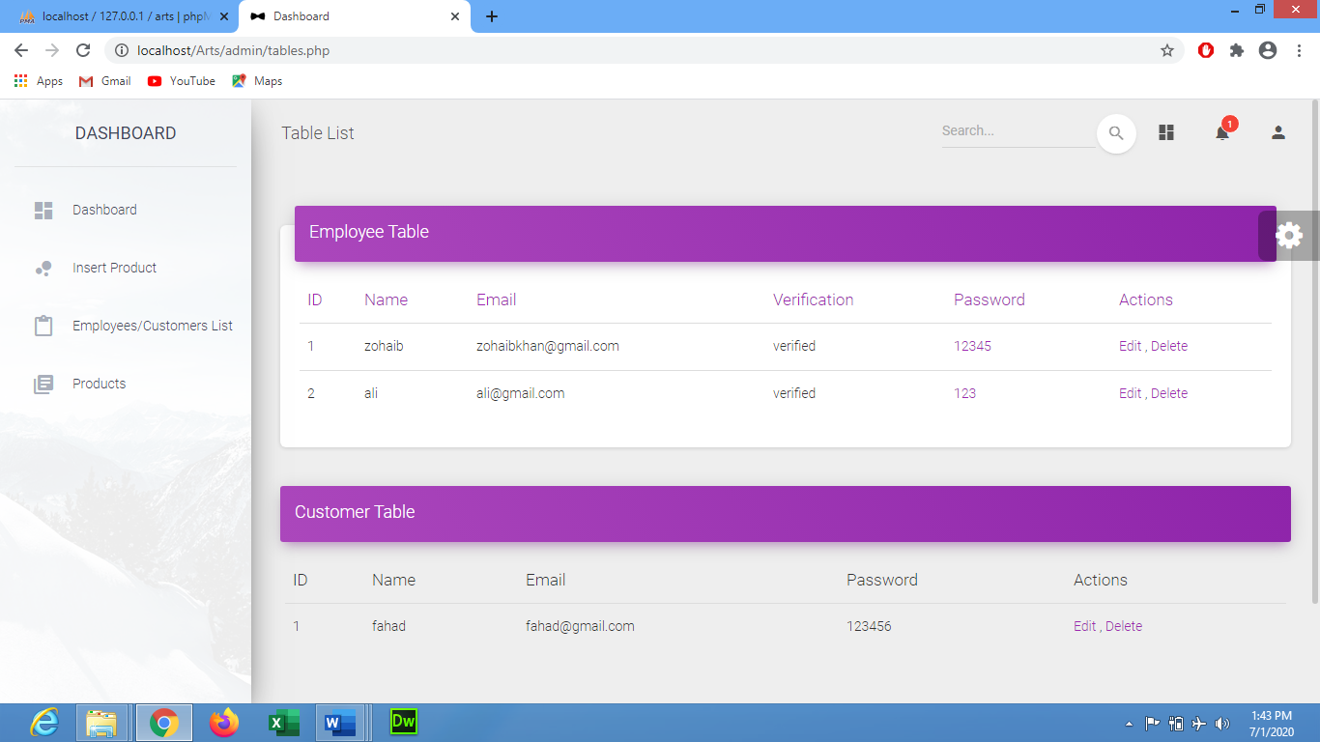**Customer and Employee Data**



**Cart**

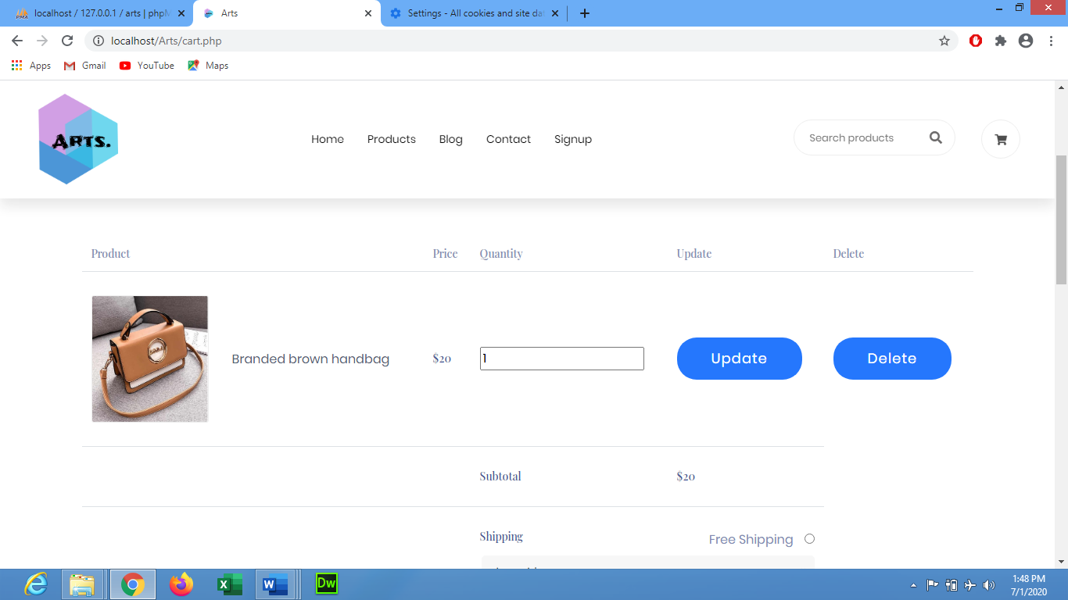

**CONCLUSION :**

Our project is only a humble venture to satisfy the needs in a Online Shopping cart. Several user friendly coding have also adopted. This package shall prove to be a powerful package in satisfying all the requirements of the organization.

The objective of application planning is to provide a frame work that enables the manger to make reasonable estimates made within a limited time frame at the beginning of the software project and should be updated regularly as the project progresses. Last but not least it is no the work that played the ways to success but ALMIGHTY.