**TITLE PAGE**

**Course:** CS1073

**Section:** FR03B

**Assignment number:** 4

**Name:** Zohaib Hassan Khan

**UNB student number:** 3740572

Box.java:

/**

This class represents a box.

@author Zohaib Khan 3740572.

*/

public class Box {

/**

This is the length l of the box.

*/

private double l;

/**

This is the width w of the box.

*/

private double w;

/**

This is the height h of the box.

*/

private double h;

/**

This is the constructor method to initialize the instance

variables.

@param l the length of the box.

@param w the width of the box.

@param h the height of the box.

*/

public Box (double l, double w, double h) {

this.l = l;

this.w = w;

this.h = h;

}

/**

This method retrieves the length of the box.

@return l the length of the box.

*/

public double getLength() {

return l;

}

/**

This method retrieves the width of the box.

@return w the width of the box.

*/

public double getWidth() {

return w;

}

/**

This method retrieves the height of the box.

@return h the height of the box.

*/

public double getHeight() {

return h;

}

/**

This method retrieves the volume of the box.

@return the volume of the box.

*/

public double getVolume() {

return l * w * h;

}

/**

This method retrieves the surface area of the box.

@return the surface area of the box.

*/

public double getSurfaceArea() {

return (2 * l * w) + (2 * l * h) + (2 * w * h);

}

}

Tube.java:

/**

This class represents a tube.

@author Zohaib Khan 3740572.

*/

public class Tube {

/**

This is the radius r of the tube.

*/

private double r;

/**

This is the height h of the tube.

*/

private double h;

/**

This is the constructor method to initialize the instance

variables.

@param r the radius of the tube.

@param h the height of the tube.

*/

public Tube (double r, double h) {

this.r = r;

this.h = h;

}

/**

This method retrieves the radius r.

@return r the radius of the tube.

*/

public double getRadius() {

return r;

}

/**

This method retrieves the height h.

@return h the height of the tube.

*/

public double getHeight() {

return h;

}

/**

This method retrieves the volume of the tube.

@return the volume of the tube.

*/

public double getVolume() {

return Math.PI * r * r * h;

}

/**

This method retrieves the surface area of the tube.

@return the surface area of the tube.

*/

public double getSurfaceArea() {

return (2 * Math.PI * r * h) + (2 * Math.PI * r * r);

}

}

ContainerTest.java:

/**

This is a driver program for the Box and Tube classes.

@author Zohaib Khan 3740572.

*/

import java.util.Scanner;

import java.text.NumberFormat;

public class ContainerTest {

public static void main (String[] args) {

NumberFormat formatter = NumberFormat.getNumberInstance();

formatter.setMaximumFractionDigits(3);

formatter.setMinimumFractionDigits(3);

Scanner sc = new Scanner(System.in);

int choice = 0;

double largestBVolume = Double.NEGATIVE_INFINITY;

double largestTVolume = Double.NEGATIVE_INFINITY;

double smallestBArea = Double.POSITIVE_INFINITY;

double smallestTArea = Double.POSITIVE_INFINITY;

while (choice != 3) {

System.out.println("\nWhat would you like to do?"

+ "\n1 - Get info for a box"

+ "\n2 - Get info for a tube"

+ "\n3 - Quit");

System.out.print("Enter your choice: ");

choice = sc.nextInt();

if (choice == 1) {

System.out.print("Length (in cm): ");

double l = sc.nextDouble();

System.out.print("Width (in cm): ");

double w = sc.nextDouble();

System.out.print("Height (in cm): ");

double h = sc.nextDouble();

Box box = new Box (l, w, h);

System.out.println("The volume is: "

+ formatter.format(box.getVolume())

+ " cubic centimeters.");

System.out.println("The surface area is: "

+ formatter.format(box.getSurfaceArea())

+ " square centimeters.");

if (box.getVolume() > largestBVolume) {

largestBVolume = box.getVolume();

}

if (box.getSurfaceArea() < smallestBArea) {

smallestBArea = box.getSurfaceArea();

}

}

else if (choice == 2) {

System.out.print("Radius (in cm): ");

double r = sc.nextDouble();

System.out.print("Height (in cm): ");

double h = sc.nextDouble();

Tube tube = new Tube (r, h);

System.out.println("The volume is: "

+

formatter.format(tube.getVolume())

+ " cubic centimeters.");

System.out.println("The surface area is: "

+ formatter.format(tube.getSurfaceArea())

+ " square centimeters.");

if (tube.getVolume() > largestTVolume) {

largestTVolume = tube.getVolume();

}

if (tube.getSurfaceArea() < smallestTArea) {

smallestTArea = tube.getSurfaceArea();

}

}

else if (choice > 3 || choice < 1) {

System.out.println("Invalid choice. Please choose from the

options provided.");

}

}

if (largestTVolume > largestBVolume) {

System.out.println("The container with the largest volume

is a tube."

+ "\nThe volume is: "

+ formatter.format(largestTVolume)

+ " cubic centimeters.");

}

else {

System.out.println("The container with the largest volume

is a box."

+ "\nThe volume is: "

+ formatter.format(largestBVolume)

+ " cubic centimeters.");

}

if (smallestBArea < smallestTArea) {

System.out.println("The container with the smallest

surface area is a box."

+ "\nThe surface area is: "

+ formatter.format(smallestBArea)

+ " square centimeters." );

}

else {

System.out.println("The container with the smallest

surface area is a tube."

+ "\nThe surface area is: "

+ formatter.format(smallestTArea)

+ " square centimeters.");

}

}

}

Q1Output:

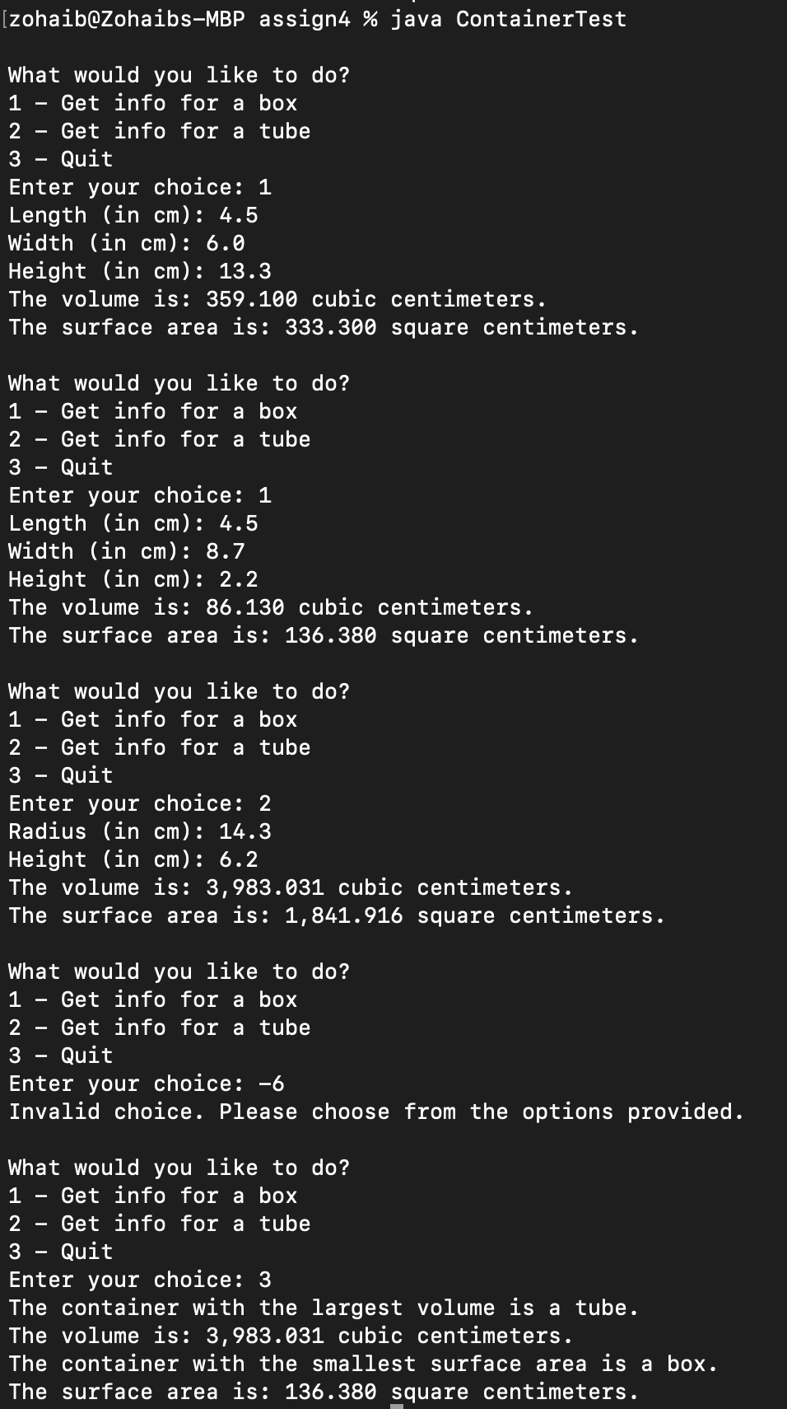

NumberSystem.java:

/**

This is a class for a number conversion system from Arabic to Mayan.

@author Zohaib Khan 3740572.

*/

import java.util.Scanner;

public class NumberSystem {

public static void main (String[] args){

Scanner sc = new Scanner (System.in);

System.out.print("Enter an arabic number: ");

int userInput = sc.nextInt();

String str = "";

int remainder = 0;

int quotient = 0;

String final_str = "";

while (userInput < 0) {

System.out.println("Invalid input. You must enter a non-

negative number.");

System.out.print("Please enter another Arabic number now: ");

userInput = sc.nextInt();

}

int originalInput = userInput;

while (userInput > 0) {

remainder = userInput%20;

quotient = (userInput - remainder ) / 20;

while (remainder > 5) {

str += "_ ";

remainder = remainder - 5;

}

if (remainder == 0) {

str += "U";

}

else if (remainder == 1) {

str += "O";

}

else if (remainder == 2) {

str += "O O";

}

else if (remainder == 3) {

str += "O O O";

}

else if (remainder == 4) {

str += "O O O O";

}

else if (remainder == 5) {

str += "_ ";

}

userInput = quotient;

final_str = str+"\n"+final_str;

str = "";

}

System.out.print("The Mayan output for "

+ originalInput + " is: \n"

+ final_str);

}

}

Q2Output:

