

Name: Muhammad Zohaib khan

Reg# BSE203003
Subject: OOP LAB
LAB:14(Friend Functions)
Instructor: Sir Qaisar Manzoor
Date:2 -7-2021

Practice Task 1
#include<iostream>
#include<string>
using namespace std;
class Area;
class Circle {
friend class Area;
int radius;
public:
Circle(int r) :radius(r) {}
};
class square {
friend class Area;
int length;
public:
square(int l) :length(l) {}
friend void parametre(square);
};
void parametre(square obj)
{
cout << obj.length * 4 << endl;;
}
class Area {
public:
void area_square(square obj)
{
int area = obj.length * 4;
cout << area << endl;
}
void area_circle(Circle obj1)
{
int carea = 3.14*obj1.radius*obj1.radius;
cout << carea << endl;

}
};
int main()
{
Circle obj(12);
square obj2(10);
Area a;
parametre(obj2);
a.area_circle(obj);
a.area_square(obj2);
system("pause");

}

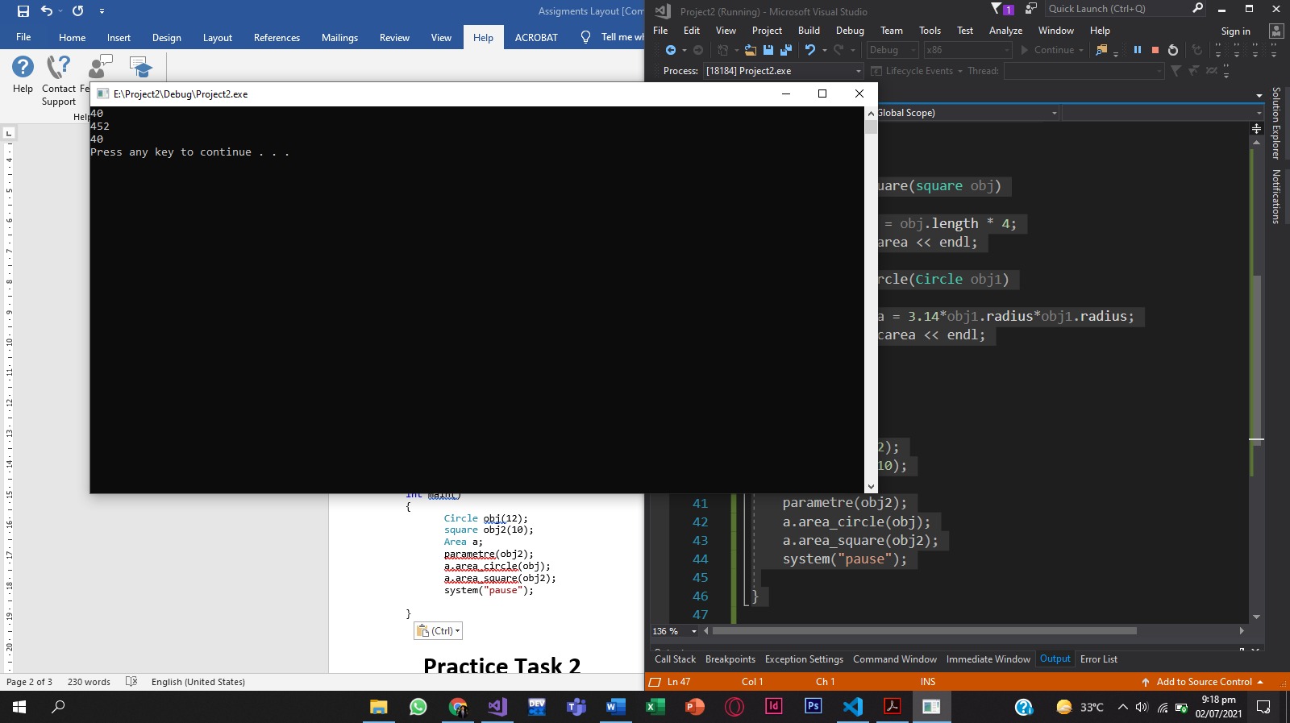

Practice Task 2
#include<iostream>
#include<string>
using namespace std;
class Data {
friend class calculation;
float a, b;
public:
Data(float A, float B) :a(A), b(B) {}
friend void display(Data);
};
class calculation {
public:
void square_sum(Data &obj)
{
int sum = (obj.a*obj.a) + (obj.b*obj.b) + 2 * obj.a*obj.b;
cout << "(a+b)^2=" << sum << endl;

}
void square_differnce(Data obj)
{
int difference = (obj.a*obj.a) + (obj.b*obj.b) - 2 * obj.a*obj.b;
cout << "(a-b)^2=" << difference << endl;
}

};
void display(Data obj)
{
cout << "a= " << obj.a << endl;
cout << "b= " << obj.b << endl;
}
int main()
{
Data obj1(2, 2);
calculation obj;
display(obj1);
obj.square_differnce(obj1);
obj.square_sum(obj1);

}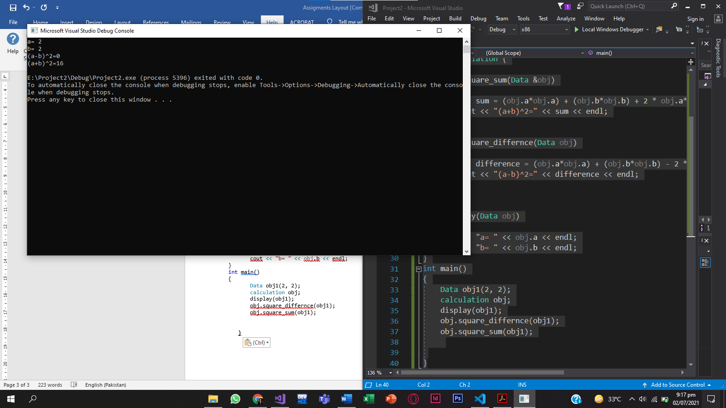

Practice Task 3
#include<iostream>
#include<string>
using namespace std;
class equation {
int a, b;
int result1, result2, result3;
public:
equation(int A, int B) :a(A), b(B) {}
int set_result1(int r1)
{
result1 = r1;
return result1;

}
int get_result1()
{
return result1;
}
int set_result2(int r2)
{
result2=r2;
return result2;

}
int get_result2()
{
return result2;
}
int set_result3(int r3)
{
result3=r3;
return result3;
}
int get_result3()
{
return result3;
}

friend void compute(equation &);
friend void display(equation &);
};
void compute(equation &obj)
{
int t1 = (obj.a*obj.a*obj.a*obj.a) + 4 * (obj.a*obj.a*obj.a*obj.b) + 6 * (obj.a*obj.a*obj.b*obj.b) + 4 * (obj.a*obj.b*obj.b*obj.b) + (obj.b*obj.b*obj.b*obj.b);
obj.set_result1(t1);
int t2= (obj.a*obj.a*obj.a*obj.a) - 4 * (obj.a*obj.a*obj.a*obj.b) + 6 * (obj.a*obj.a*obj.b*obj.b) - 4 * (obj.a*obj.b*obj.b*obj.b) + (obj.b*obj.b*obj.b*obj.b);
obj.set_result2(t2);
int t3 = (obj.a - obj.b)*(obj.a + obj.b)*(obj.a*obj.a + obj.a*obj.b);
obj.set_result3(t3);
}
void display(equation &obj)
{
cout << "a=" << obj.a << endl;
cout << "b=" << obj.b << endl;
cout<<"result1= "<<obj.result1;
cout<<"result2= "<<obj.result2;
cout<<"result3= "<<obj.result3;
}
int main()
{
equation obj(2, 2);
compute(obj);
display(obj);

}