

Name: Muhammad Zohaib khan

Reg# BSE203003
Subject: OOP LAB
Instructor: Sir Qaisar Manzoor
Date:24 -6-2021

Practice Task 1
#include<iostream>
using namespace std;
template <class t>
void common()
{
int s;
cout << "Enter size ";
cin >> s;
t arr[s];
for (int l = 0; l < s; l++)
{
cout << "Enter value ";
cin >> arr[l];
}
int i = 0, j = 0, count = 0, max = 0;
t value = 0;

cout << "Double of each element in an array: " << endl;
for (t l = 0; l < s; l++)
{
cout << arr[l] * arr[l] << " ";
}
cout << "most common number is: " << endl;
for (int c = 0; c < s; c++)
{

for (int i = 0; i < s; i++)
{

if (arr[i] == arr[i])
{
count++;

}

}
if (count > max)
{
max = count;
count = 0;
value = arr[i];
}
else
{
count = 0;
}
}
cout << value;
}

int main()
{
common<float>();
return 0;
}
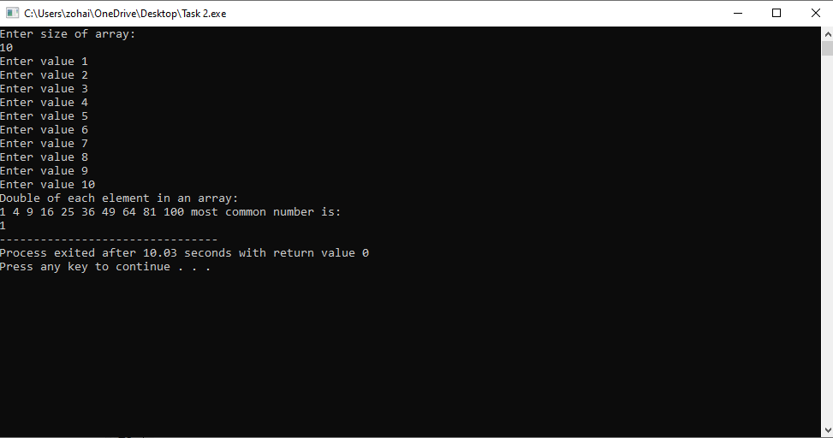

Practice Task 2
#include<iostream>
#include<string>
using namespace std;
template<class t>
t area(t radius)
{
int parametre = 2 * 3.16*radius;
t area = 3.16*(radius*radius);

return area / 2;

}
template<class t>
t area(t length,t width )
{
t area = length * width;
return 3 * area;
}
int main() {
int r, l, w;
cout << "enter area of radius";
cin >> r;
cout<<area(r);
cout << "enter lendth ";
cin >> l;
cout << "enter width ";
cin >> w;
cout<<area(l, w);

}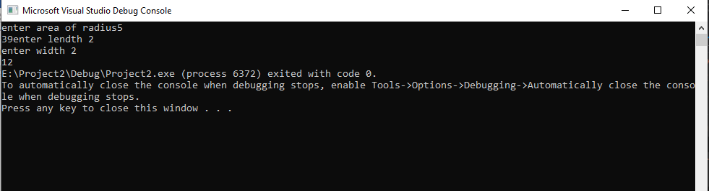

Practice Task 3
#include<iostream>
#include<string>
using namespace std;
template<class t>
class queue {

public:
t arr[10];
queue()
{
for (int i = 0; i < 10; i++)
{
arr[i] = 0;
}
}
t sort()
{
int i, j, temp;
for (i = 0; i < 10; ++i)
{
for (j = i + 1; j < 10; ++j) {
if(arr[i]>arr[j])
{
temp=arr[i];
arr[i]=arr[j];
arr[j]=temp;
}
}
}
for (int k = 0; k < 10; k++)
{
cout << arr[k] << endl;
}
return 0;
}
t max()
{
int m = arr[0];
for (int k = 0; k < 10; k++)
{
if (arr[k] > m)
{
m = arr[k];
}
}
cout << m << endl;
return 0;
}
t min()
{
int mn = arr[0];
for (int k = 0; k < 10; k++)
{
if (arr[k] < mn)
{
mn = arr[k];
}
}
cout << mn << endl;
return 0;
}
};
int main()
{
queue<int> obj;
queue<float>a;
queue<char>c;
cout << "enter value iin array" << endl;

for (int i = 0; i < 10; i++)
{
cin >> obj.arr[i];
}
obj.sort();
obj.max();
obj.min();
//for float
cout << "Enter float valies";
for (int i = 0; i < 10; i++)
{
cin >> a.arr[i];
}
a.sort();
a.max();
a.min();
//for char values
cout << "Enter char values";
for (int i = 0; i < 10; i++)
{
cin >> c.arr[i];
}
c.sort();
c.max();
c.min();
}

