Abstract

As one of the popular social media platform, a very big number of tweets on Twitter and are continually growing so that the regeneration of applicable knowledge is getting difficult by every passing day. From semantics of each Twitter activity and modelling the content of Tweets would allow personalization and counteract the flood of information. As the diversity and reign of topics and trends discussed on Twitter, semantic linking of Twitter posts also promises benefits for other applications on the social web and machine learning application. However, automatically determining the semantic meaning of Twitter posts is a still vital problem due the casual language used by the user and non-meaningful things in the posts.

In this article, we provide worked for linking Twitter posts to related events and analyse them to contextualize Events. Next, we propose strategies that evaluate the semantics of tweets and related events to semantically make individual Twitter activities meaningful. A large-scale evaluation with lot of different machine learning methods confirms the benefits of our approach and shows that our way of addressing the issue of relating tweets with high precision and reach to related event, significantly enrich tweeting semantics, and have a strong impact on creating semantic user profiles for the social web.

For semantic analysis there are number of extractors available that can help you to analyse your data semantically. There is the long list that I cannot show here but the most popular are

* [AlchemyAPI](http://www.alchemyapi.com/)
* [Dandelion API](https://dandelion.eu/)
* [DBpedia Spotlight](http://dbpedia.org/spotlight)
* [Lupedia](http://lupedia.ontotext.com/)
* [OpenCalais](http://www.opencalais.com/)
* [Saplo](http://www.saplo.com/)
* [SemiTags](http://ner2.lmcloud.vse.cz/SemiTags/app/index)
* [TextRazor](http://www.textrazor.com/)
* [THD](https://ner.vse.cz/thd/)
* [Wikimeta](http://www.wikimeta.com/)
* [Yahoo! Content Analysis](http://developer.yahoo.com/search/content/V2/contentAnalysis.html)
* [Zemanta](http://www.zemanta.com/)

1http://wiki.dbpedia.org/Ontology

2http://www.mpi-inf.mpg.de/yago-naga/ yago

3http://www.alchemyapi.com

4http://dbpedia.org/spotlight

5http://www.evri.com/developer

6http://extractiv.com

7http://lupedia.ontotext.com/

8http://www.opencalais.com

9http://www.saplo.com/

10http://www.wikimeta.com

11http://developer.yahoo.com/search/content/V2/contentAnalysis.html 12http://www.zemanta.com

Popular ontologies are of N.E.R.D (named entity Recognition and Disambiguation), IBM Watson and YAGO.

The NERD ontology consists of two building blocks: the NERD core and the derived NERD axioms. The list of NERD core classes is defined as:

**NERD core** Thing, Amount, Animal, Event, Function, Location, Organization, Person, Product and Time. NERD also provides the framework that standardizes the output of 10 different NLP (Natural Language Processors) extractors, which are publicly available on the Internet provide us the wide range of options to choose the among the extractors also the option to combining the output of all the given ones and take one entity one time. Our approach was mainly based on the development by the NERD ontology, which provides a common interface for annotation elements, and interface by the mean of REST API, which could be used to access the single output of these tools alltogether. We compare 3 different systems with NERD and discuss some with the detailed analysis of linking the semantic feature to the data. The NERD application is available online at <http://nerd.eurecom.fr> also with the NERD API libraries for different plateforms. While working on NERD also there were few problems we faced. Some of it’s extractor were in active or just not working or occupied by some other companies, Like the AlchemyAPI were acquired by IBM Watson, saplo was acquired by strossle. But still many of its extractor that are using the ontology of N.E.R.D are still in working form.NERD response look like

e n t i t i e s : [{ ” e n t i t y ” : ” Tim B e r n e r s−Lee ” , ” t y p e ” : ” P e r s o n ” , ” u r i ” : ” h t t p : / / d b p e di a . o r g / r e s o u r c e / T i m b e r n e r s l e e ” , ” ne r dT y pe ” : ” h t t p : / / n e r d . eu recom . f r / o n t ol o g y # P e r s o n ” , ” s t a r t C h a r ” : 3 0 , ” e n dC ha r ” : 4 5 , ” c o n f i d e n c e ” : 1 , ” r e l e v a n c e ” : 0 . 5 }]

IBM Watson is one of the most popular and biggest application of machine learning we took some help for the verification of our work by comparing or entities result and there ontologies. Which was really helpful for the cross validation of our results. Watson gives you a verity of option tp play with. We use there discovery API, which provide you the deep sentiment and semantic linking of your data like “enriched_text.entities.type”

“enriched_text.entities.relevance” from all over the data you feed them.

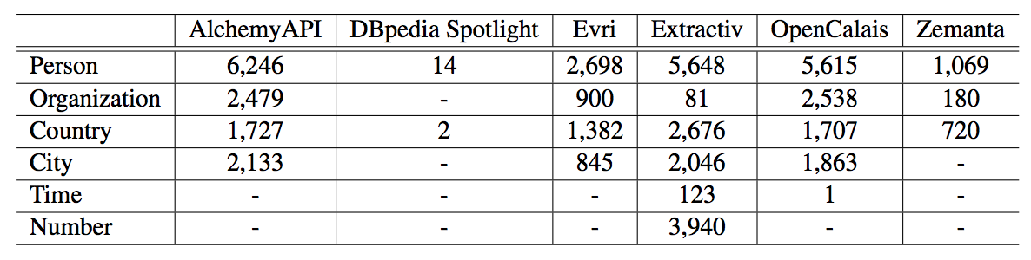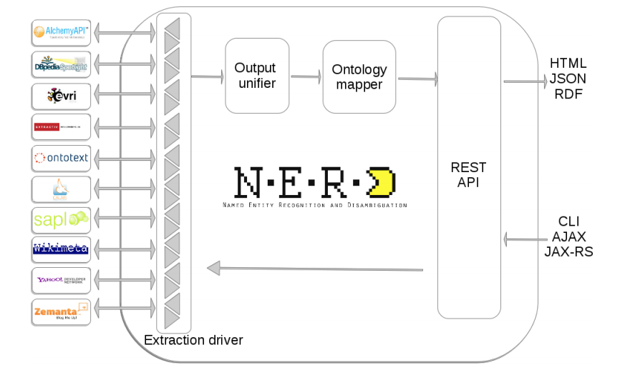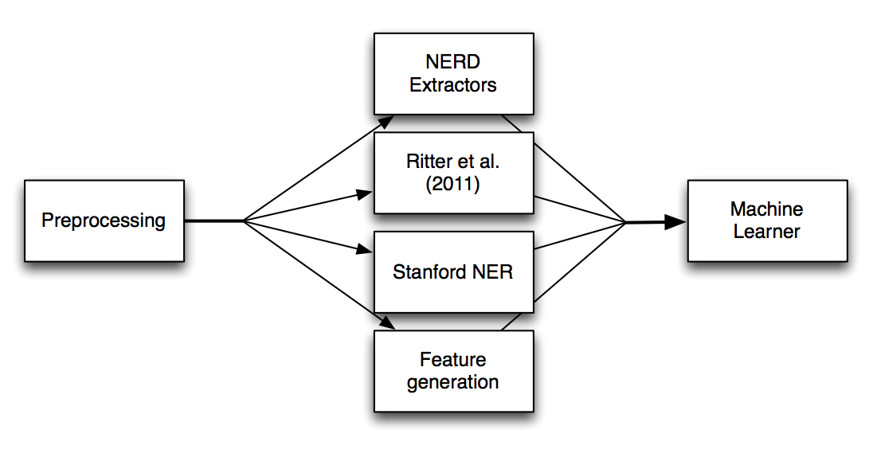

Marieke van Erp, Giuseppe Rizzo and Raphaël Troncy. [Learning with the Web: Spotting Named Entities on the intersection of NERD and Machine Learning](http://nerd.eurecom.fr/ui/paper/vanErp_Rizzo_Troncy-msm2013.pdf). In ( [WWW'13](http://www2013.org/)) [3rd International Workshop on Making Sense of Microposts (#MSM'13)](http://oak.dcs.shef.ac.uk/msm2013/),

Concept Extraction Challenge, Rio de Janeiro, Brazil, May 13, 2013.

Giuseppe Rizzo and Raphaël Troncy. [NERD: A Framework for Unifying Named Entity Recognition and Disambiguation Web Extraction Tools](http://nerd.eurecom.fr/ui/paper/Rizzo_Troncy-eacl2012demo.pdf) ( [poster](http://nerd.eurecom.fr/ui/paper/Rizzo_Troncy-eacl2012demoposter.pdf)). In [13th Conference of the European Chapter of the Association for computational Linguistics (EACL'12)](http://www.eacl2012.org/), Demo Session, Avignon, France, April 23-27, 2012.

Giuseppe Rizzo, Raphaël Troncy, Sebastian Hellmann and Martin Bruemmer. [NERD meets NIF: Lifting NLP Extraction Results to the Linked Data Cloud](http://nerd.eurecom.fr/ui/paper/Rizzo_Troncy_Hellmann_Bruemmer-ldow2012.pdf) ( [slides](http://www.slideshare.net/giusepperizzo/nerd-meets-nif-lifting-nlp-extraction-results-to-the-linked-data-cloud)). In ( [WWW'12](http://www2012.org/)) [5th Workshop on Linked Data on the Web (LDOW'12)](http://events.linkeddata.org/ldow2012/), Lyon, France, April 16, 2012.

Abel F., Gao Q., Houben GJ., Tao K. (2011) Semantic Enrichment of Twitter Posts for User Profile Construction on the Social Web. In: Antoniou G. et al. (eds) The Semanic Web: Research and Applications. ESWC 2011