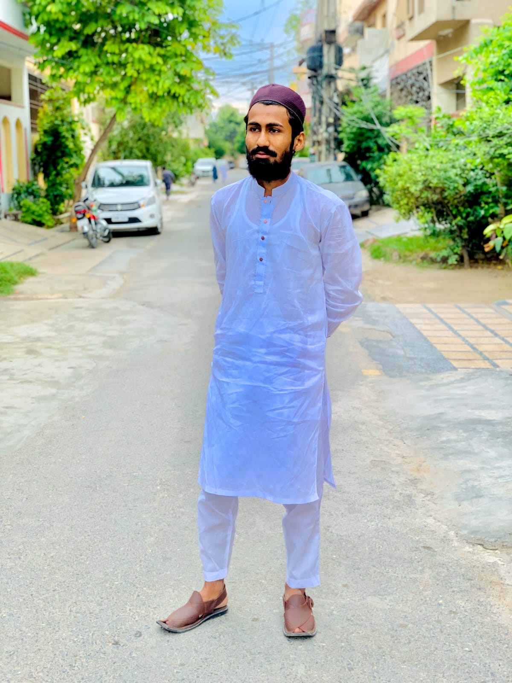
PERONAL RESUME

Zohaib sadiq

Contact
Education
03214292280

Pak arab housing scheme
cs from llu
▪1
▪2

Work Experience
beginner
Skill certificate
▪

Evaluation

