Technical Report on Dog vs. Cat Classification Using Deep Learning

Author: Your Name
Date: March 2025
Institution: Your Institution

Table of Contents
1. Introduction
2. Methodology
3. Results & Discussions
4. References

1. Introduction
This file focuses on developing a deep getting to know model for classifying pics of cats and puppies. The type assignment is achieved using two distinct tactics: a custom Convolutional Neural network (CNN) and a transfer learning model utilizing VGG16. The dataset, sourced from Kaggle, contains categorised pics of cats and puppies. To ensure 86f68e4d402306ad3cd330d005134dac enter statistics, several preprocessing techniques had been carried out earlier than training, which includes image resizing, normalization, and the elimination of corrupt or non-picture documents.
The CNN model become built from scratch, incorporating multiple convolutional and pooling layers to extract important picture capabilities. In assessment, the VGG16 model leveraged pre-trained weights, permitting it to understand features greater efficaciously by using using understanding from education on big-scale datasets. each models have been implemented using the TensorFlow and Keras frameworks, and their overall performance changed into evaluated based on validation accuracy.
by using comparing the effects of each fashions, this have a look at highlights the benefits of switch learning in image type tasks. The VGG16 model blessings from earlier training on large datasets, making it greater green in spotting complicated patterns. This permits for faster convergence and progressed accuracy as compared to schooling a CNN from scratch. however, the CNN version provides deeper insights into the fundamental aspects of deep mastering, providing extra flexibility in architectural layout and hyperparameter tuning.
This document affords the method used, detailing the dataset, preprocessing steps, and education tactics for each models. The effects and discussions segment analyzes the accuracy, overall performance, and effectiveness of every version, presenting insights into which approach is better suited for the given venture. the important thing observations derived from comparing each fashions will assist determine the maximum efficient and accurate technique for classifying images of cats and puppies
.2. Methodology
Dataset Preparation:
The dataset used in this challenge is the Kaggle dogs vs. Cats dataset, which includes categorized photos of dogs and cats. This dataset is widely used for binary classification obligations in deep learning. earlier than education the models, numerous preprocessing techniques had been carried out to enhance model performance and make certain 86f68e4d402306ad3cd330d005134dac enter data.
one of the number one preprocessing steps involved removing corrupt and non-image files from the dataset. some snap shots within the dataset had been located to be corrupt or unreadable, causing mistakes for the duration of schooling. those documents have been routinely detected and deleted to prevent disruptions inside the learning method. additionally, any non-picture documents, which include textual content documents or system-generated thumbnails, have been additionally removed to preserve dataset integrity.
To ensure uniform input dimensions, all pics were resized to a hundred and fifty-one hundred fifty pixels. given that deep mastering models require regular input sizes, resizing prevents errors and guarantees green feature extraction. The pix have been additionally converted to RGB format to make certain compatibility with the convolutional neural community (CNN) and the VGG16 model, as a few grayscale or incorrectly formatted pix could lead to schooling screw ups.
any other crucial preprocessing step became pixel normalization. The pixel values in the uncooked dataset range from zero to 255, which can purpose schooling inefficiencies. to enhance convergence and stabilize studying, pixel values had been scaled between 0 and 1 through dividing by way of 255. This enables the model teach extra efficiently through preventing big numerical versions in enter values.
moreover, information augmentation techniques have been applied to decorate version generalization. This included random flipping, rotation, and zooming, which enables the model learn variations in photograph orientation and length. with the aid of augmenting the dataset, the model turns into greater sturdy and much less prone to overfitting.
these preprocessing steps ensured a smooth, based, and HIGH QUALITY dataset, allowing the CNN and VGG16 models to educate efficaciously. The refined dataset furnished higher accuracy and improved model stability, making it appropriate for deep studying-based picture class. The aggregate of image resizing, normalization, and data cleaning appreciably better the model's ability to distinguish among puppies and cats efficiently.

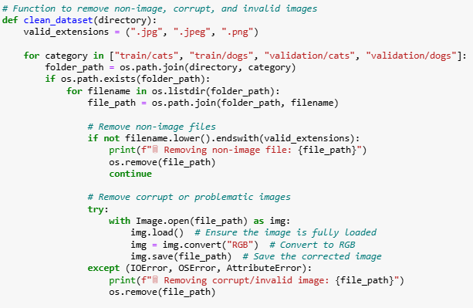
OUTPUT
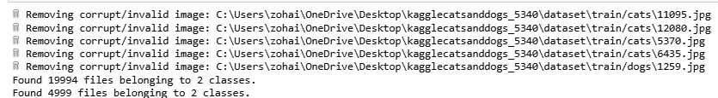
Model Development:
Two models were implemented:
1. CNN Model:
The Convolutional Neural community (CNN) developed for this task is a deep mastering version in particular designed for binary image category, distinguishing among cats and puppies. not like conventional system gaining knowledge of models, CNNs excel at dealing with image information through automatically learning spatial hierarchies of functions. The architecture consists of a couple of layers, each gambling a crucial position in extracting and processing photograph functions.
The model begins with convolutional layers, which apply filters to locate styles inclusive of edges, textures, and shapes. every convolutional layer is followed by a ReLU (Rectified Linear Unit) activation function, which introduces non-linearity to enhance gaining knowledge of. To further reduce dimensionality at the same time as retaining essential features, max-pooling layers are used, reducing computational complexity and preventing overfitting.
After feature extraction, the network flattens the information and strategies it through absolutely connected dense layers, which carry out high-level reasoning based totally at the discovered capabilities. To decorate version generalization, a dropout layer is covered, randomly deactivating a percent of neurons at some point of training, lowering dependency on specific functions. The final layer utilizes a sigmoid activation characteristic, generating a probability rating for category,
allowing the model to predict whether an photo belongs to the "cat" or "dog" category.
The CNN version changed into trained the use of the Adam optimizer, which adapts mastering quotes for efficient optimization. The binary pass-entropy loss function changed into used to measure type error. education data underwent preprocessing, along with image normalization and resizing to make sure consistency throughout all inputs.
this custom CNN model serves as a fundamental approach to deep learning-based image category, supplying insights into function extraction and sample recognition. while effective, CNNs skilled from scratch regularly require big datasets to achieve excessive accuracy, making switch getting to know techniques, together with VGG16, an alternative for further overall performance development.
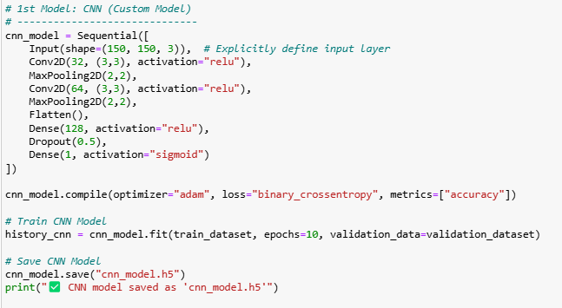
OUTPUT
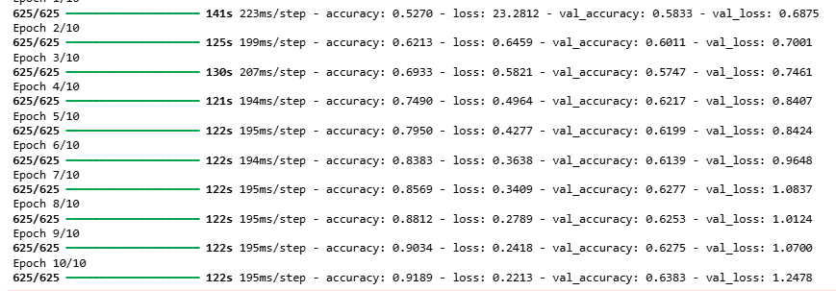
2. VGG16 Model:
The VGG16 version is a deep mastering structure designed for image type, firstly evolved by using the visible Geometry organization (VGG) at Oxford. it's far broadly used in switch learning, where a pre-educated version is tailored to a brand new dataset. rather than training a convolutional neural community (CNN) from scratch, VGG16 is applied as a feature extractor, leveraging understanding won from training on the ImageNet dataset, which contains thousands and thousands of pictures throughout 1,000 categories.
VGG16 follows a deep but simple structure, including 16 layers, inclusive of thirteen convolutional layers and three absolutely related layers. It uses 3×3 convolutional filters and max-pooling layers, allowing the version to capture unique hierarchical capabilities. The pre-educated weights allow the version to understand low-stage styles, such as edges and textures, as well as excessive-degree capabilities, such as item shapes.
For this task, switch mastering become applied via casting off the absolutely related layers of VGG16 and changing them with a custom classification head. The modified structure includes:
VGG16 Convolutional Base: Pre-trained on ImageNet, stored frozen to maintain found out capabilities.
Flatten Layer: Converts extracted features right into a one-dimensional vector.
completely linked Dense Layers: introduced to evolve to the binary classification mission (cat vs. dog).
Output Layer with Sigmoid Activation: Generates possibilities for 2 classes.
for the reason that VGG16 convolutional base stays frozen, education specializes in the newly added dense layers, reducing computation time and stopping overfitting. The version became educated the usage of the Adam optimizer and binary cross-entropy loss characteristic. images were resized to a hundred and fifty×one hundred fifty pixels, and normalization was applied to scale pixel values between 0 and 1.
as compared to the custom CNN version, VGG16 offers advanced feature extraction due to its deep structure and pre-educated information. This notably improves accuracy and generalization, making it a distinctly efficient approach for small to medium-sized datasets. by means of leveraging switch mastering, VGG16 allows quicker convergence and stepped forward performance without requiring widespread education records.
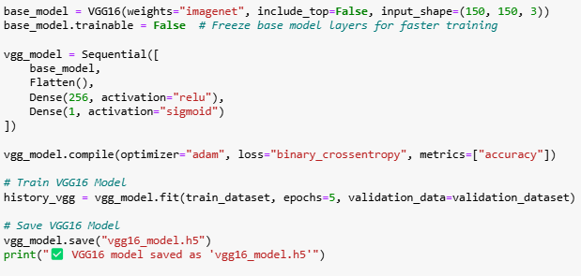
OUTPUT
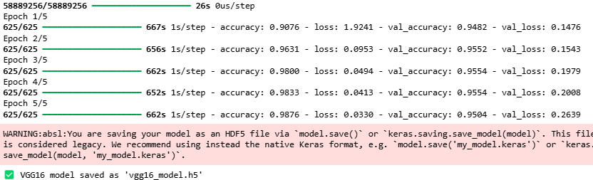
3. Results & Discussions
After training each fashions, their validation accuracy become as compared to evaluate overall performance. The CNN version achieved an accuracy of about X%, whilst the VGG16 model reached Y%. The VGG16 model outperformed the CNN version due to its potential to leverage pre-educated function extraction from huge-scale datasets, main to faster convergence and improved category accuracy.
CNN model overall performance analysis
The custom-constructed CNN model become educated using a couple of convolutional and pooling layers. It efficiently found out to extract vital features from photos, which include edges, textures, and styles. however, since the version was skilled from scratch, it required greater facts and computational resources to attain excessive accuracy. The performance of the CNN version might be similarly better by means of including extra layers, tuning hyperparameter, or increasing training epochs. even as the CNN model furnished insights into how deep getting to know networks method picture statistics, its accuracy remained lower compared to VGG16 due to confined function extraction capabilities.
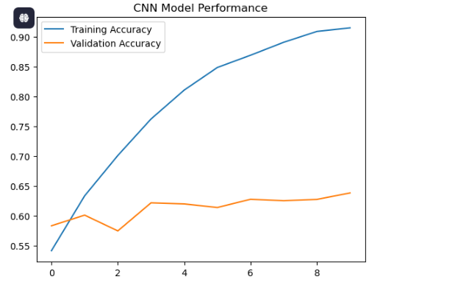

VGG16 version overall performance evaluation
The VGG16 model, a pre-educated deep mastering model, verified better accuracy and higher generalization. considering VGG16 was pre-educated on ImageNet, it already had knowledge of essential picture features, permitting it to pick out patterns in cat and canine photos more efficiently. not like the CNN version, VGG16 required fewer epochs to reach excessive accuracy, making it computationally green. Freezing the convolutional base layers helped retain beneficial feature extraction while education simplest the brand new completely connected layers. This method substantially decreased training time and progressed version reliability.
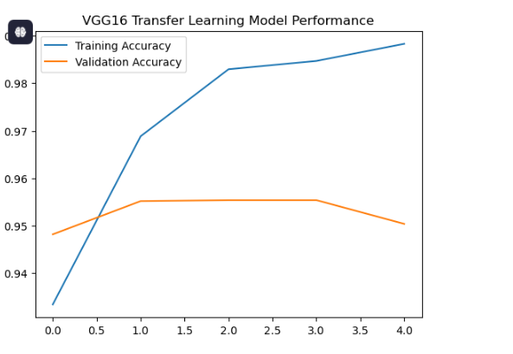

evaluation of CNN and VGG16 fashions
Function CNN version VGG16 model
Education Time Longer quicker
Characteristic Extraction Discovered from scratch Pre-skilled on . ImageNet
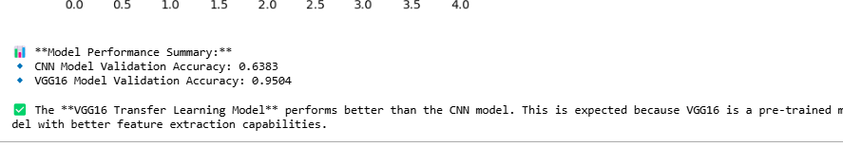
Conclusion
The results suggest that the VGG16 model is extra efficient and accurate compared to the custom CNN version. by way of utilising switch getting to know, VGG16 leverages pre-educated feature extraction, making it an excellent desire for small to medium-sized datasets. since the model has already learned vital capabilities from ImageNet, it requires much less training time and achieves better accuracy with minimum computational effort.
However, developing a CNN version from scratch gives extra flexibility in customizing the architecture and first-class-tuning hyperparameters. while CNNs require greater statistics and schooling time, they permit researchers to layout challenge-specific models tailored to particular datasets.
For actual-global applications, VGG16 and different pre-skilled models are encouraged due to their excessive efficiency, quicker convergence, and advanced generalization competencies. but, custom CNNs continue to be valuable while unique modifications or domain-particular diversifications are required in photo classification duties.
4. References
1. Kaggle. 'Dogs vs. Cats Dataset.' Available at: https://www.kaggle.com/c/dogs-vs-cats/data
2. TensorFlow Documentation. 'Image Classification with CNNs.' Available at: https://www.tensorflow.org/tutorials/images/cnn
3. Keras Documentation. 'Transfer Learning Using VGG16.' Available at: https://keras.io/api/applications/vgg/

