**BUILT IN DATA TYPES IN C#**

* **INTEGRAL TYPE**
  + **SIGNED INTEGERS (WHICH TAKES NEGATIVE AND POSITIVE VALUES)**
  + **UNSIGNED INTEGERS (WHICH ONLY TAKES POSITIVE VALUES)**
    - **SBYTE**
    - **BYTE**
    - **SHORT**
    - **USHORT**
    - **INT**
    - **UINT**
    - **LONG**
    - **ULONG**

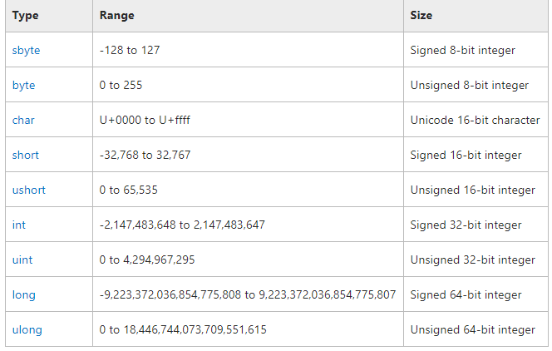

* **MINVALUE()** METHOD
* **MAXVALUE()** METHOD

**BOOLEAN DATA TYPE**

**Bool** keyword is used for Boolean data type which only stores TRUE or FALSE.

**FLOAT DOUBLE AND DECIMAL DATA TYPE**

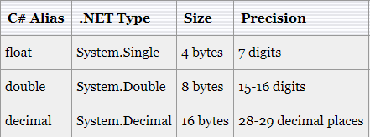

**STRING AND CHARACTER DATA TYPE**

* **STRING** STORES MULTIPLE CHARACTERS IN A SINGLE VARIABLE.
* DOUBLE QUOTES WILL BE USED WITH STRING DATA TYPE.
* **CHAR** STORES SINGLE CHARACTER AT A TIME IN A VARIABLE.
* SINGLE QUOTES WILL BE USED FOR CHAR DATA TYPE.
* **ESCAPE SEQUENCE**
* **VERBATIM LITERAL**
  + VERBATIM LITERAL IS A STRING WITH AN **@** SYMBOL.
  + VERBATIM LITERAL MAKE ESCAPE SEQUENCES TRANSLATE AS NORMAL PRINTABLE CHARACTERS TO ENHANCE READABILITY.

**PRACTICAL EXAMPLE:**

* WITHOUT VERBATIM LITERAL: "D:\\Adil\\Csharp\\Tutorials" – Less readable
* WITH VERBATIM LITERAL: **@**"D:\Adil\Csharp\Tutorials" – More readable