**BOXING AND UNBOXING IN C#**

**BOXING:**

IMPLICIT CONVERSION OF A VALUE TYPE TO A REFERENCE TYPE IS CALLED **BOXING**.

**Example:**

int num1 = 10; // **int** is value type

object obj1 = num1; // Implicit conversion of value type into reference type.

* In Boxing process, a value type is being allocated on the heap rather than the stack.

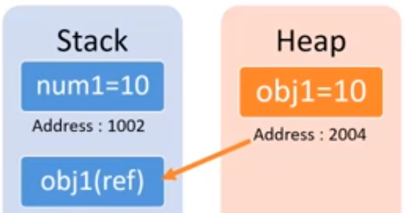

**UNBOXING:**

EXPLICIT CONVERSION OF THE SAME REFERENCE TYPE (WHICH IS BEING CREATED BY BOXING), BACK TO A VALUE TYPE.

**Example:**

int num1 = 10; // int is value type

object obj1 = num1; // Implicit conversion of value type into reference type (Boxing)

int num2 = (int) obj1; // Explicit conversion of reference type into value type (Unboxing)

* IN UNBOXING PROCESS, AN UNBOXED VALUE IS BEING ALLOCATED TO A VARIABLE ON THE STACK RATHER THAN THE HEAP.

