**INHERITANCE IN C# PROGRAMMING**

* The similarity in physical features of a child to that of its parents is due to the child having inherited these features from its parents.
* Similarly, in C#, inheritance allows you to create a class by deriving the common attributes and methods of an existing class.
* Inheritance provides reusability by allowing us to extend an existing class.
* The reason behind OOP programming is to promote the reusability of code and to reduce complexity in code and it is possible by using inheritance.

**PERMANENT EMPLOYEES**

**Int EmpId;**

**String EmpName;**

**Int EmpAge;**

**Int EmpContactNo;**

**Int permanentSalary;**

**Int permanentHours;**

**VISITING EMPLOYEES**

**Int EmpId;**

**String EmpName;**

**Int EmpAge;**

**Int EmpContactNo;**

**Int visitingSalary;**

**Int visitingHours;**

**EMPLOYEE**

**Int EmpId;**

**String EmpName;**

**Int EmpAge;**

**Int EmpContactNo;**

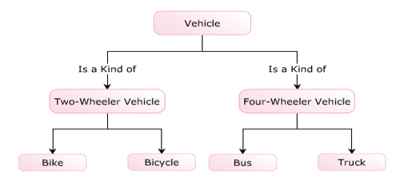

* 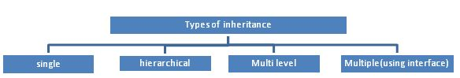The following are the types of inheritance in C#.

The inheritance concept is based on a base class and derived class. Let us see the definition of a base and derived class.

* **BASE CLASS** - is the class from which features are to be inherited into another class.
* **DERIVED CLASS** - it is the class in which the base class features are inherited.

**SINGLE INHERITANCE**

It is the type of inheritance in which there is one base class and one derived class.

