**DIFFERENCE BETWEEN METHOD HIDING AND METHOD OVERRIDING IN C#**

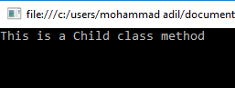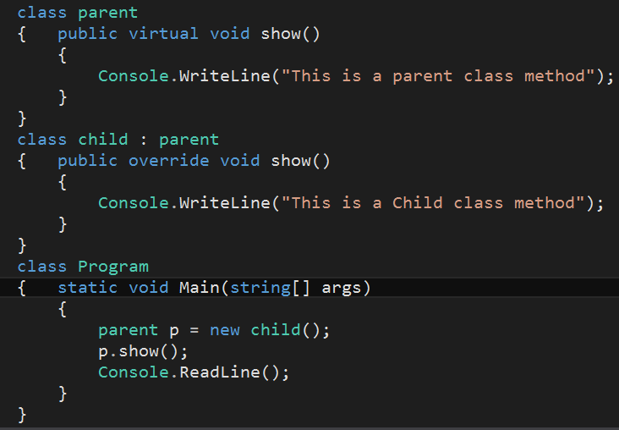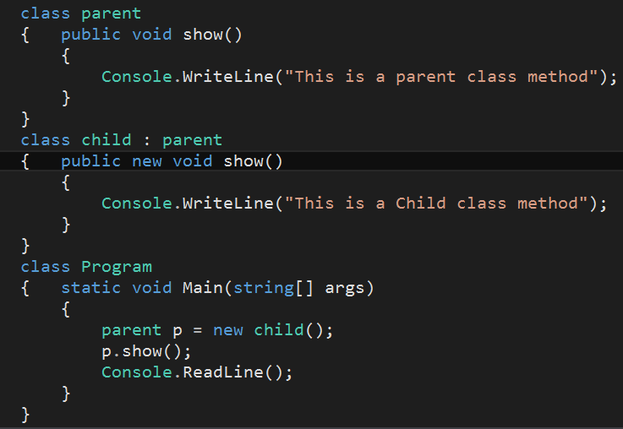

IN **METHOD OVERRIDING**, A BASE CLASS REFERENCE VARIABLE POINTING TO A CHILD CLASS OBJECT, WILL INVOKE THE OVERRIDDEN METHOD Of THE CHILD CLASS.

IN **METHOD HIDING**, A BASE CLASS REFERENCE VARIABLE POINTING TO A CHILD CLASS OBJECT, WILL INVOKE THE HIDDEN METHOD OF THE BASE CLASS.

**METHOD OVERRIDING OUTPUT**

**METHOD HIDING OUTPUT**

**METHOD OVERRIDING**

**METHOD HIDING**