**CLASSES AND OBJECTS IN C#**

* C# programs are composed of classes that represent the entities of the program which also include code to instantiate the classes as objects.
* When the program runs, objects are created for the classes and they may interact with each other to provide the functionalities of the program.
* An object is a tangible entity such as a car, a table, or a briefcase. Every object has some characteristics and is capable of performing certain actions.
* The concept of objects in the real world can also be extended to the programming world. An object in a programming language has a unique identity, state, and behavior.
* The state of the object refers to its characteristics or attributes whereas the behavior of the object comprises its actions.
* An object has various features that can describe it which could be the company name, model, price, mileage, and so on.

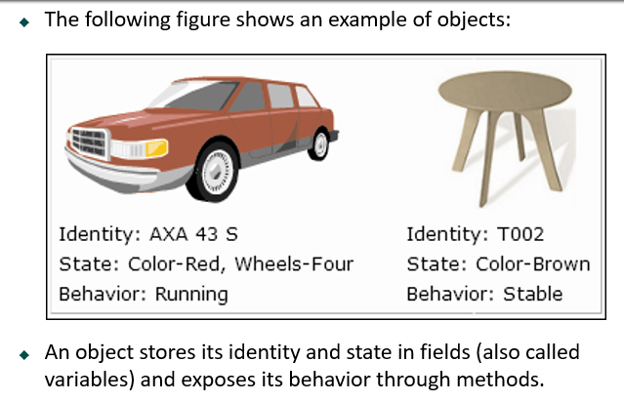

* The concept of classes in the real world can be extended to the programming world, similar to the concept of objects.
* In object-oriented programming languages like C#, a class is a template or blueprint which defines the state and behavior of all objects belonging to that class.
* A class comprises fields, properties, methods, and so on, collectively called data members of the class. In C#, the class declaration starts with the class keyword followed by the name of the class.