**Software Design Specification**

**1. Introduction**

**1.1 Purpose of this document**

The aim of this document is to a specify a high-level view of the architecture of our system, and the interaction between the user and the system. It also focuses on detailing a low-level view of each component of the software and how the components interact with each other.

**1.2 Scope of the development project**

Aliments is a specialized business that provides healthy, hygienic yet savory meals to students in school. The purpose of this process is to both relieve the parents from the hassle of preparing lunch boxes every morning and to make sure students receive proper nutrition for the body along with knowledge for the world.

**1.3 Definitions, acronyms, and abbreviations**

N/A

**1.4 References**

N/A

**1.5 Overview of document**

System architecture section provides an overview of the system's major components and architecture, as well as specifications on the interaction between the system and the user. The Detailed description of components section will be the main focus.  It will describe lower-level classes, components, and functions, as well as the interaction between these internal components. The user interface section will provide the GUI’s of the actual product and the appendices section will contain all the UML diagrams of the system.

**2. System architecture description**

* 1. **Section Overview**  
     -------------------------------------------------------------------------------------
  2. **General Constraints**  
     -------------------------------------------------------------------------------------
  3. **Data Design**  
     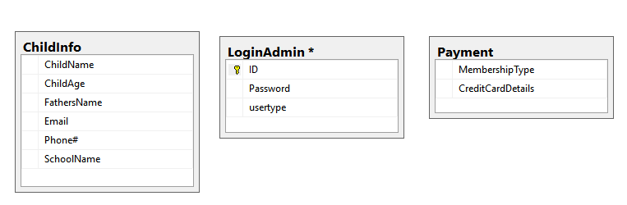
  4. **Program Structure**  
     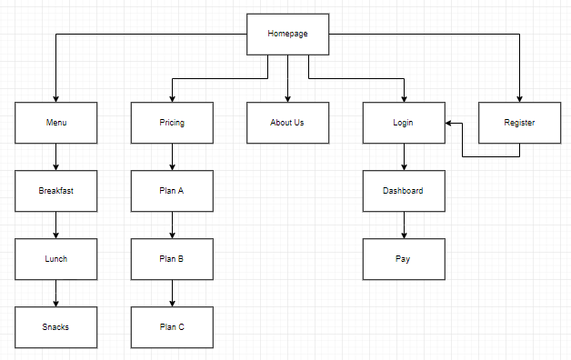

1. **Detailed description of components**

|  |  |
| --- | --- |
| Identification | Menu Selection |
| Type | Webpage |
| Purpose | select menu and redirect to register or login page |
| Function | Allow users to select Menu plan |
| Subordinates | ---------------------------------------------------------- |
| Dependencies | Dependent on login and register page |
| Interfaces | ---------------------------------------------------------- |
| Resources | ---------------------------------------------------------- |
| Processing | ---------------------------------------------------------- |
| Data | Store as a string |

|  |  |
| --- | --- |
| Identification | Login And Register |
| Type | Webpage |
| Purpose | Login and Register to website |
| Function | Allows user to Login and register to avail our services. |
| Subordinates | ---------------------------------------------------------- |
| Dependencies | Dependent on Home Page |
| Interfaces | ---------------------------------------------------------- |
| Resources | ---------------------------------------------------------- |
| Processing | ---------------------------------------------------------- |
| Data | Store as a string |

|  |  |
| --- | --- |
| Identification | Payment |
| Type | Webpage |
| Purpose | Pay for the services |
| Function | Allows user to pay fee of our services using Credit Card |
| Subordinates | ---------------------------------------------------------- |
| Dependencies | Payment api |
| Interfaces | ---------------------------------------------------------- |
| Resources | ---------------------------------------------------------- |
| Processing | ---------------------------------------------------------- |
| Data | Store as a Number |

1. **User Interface Design**
   1. **Section Overview**  
      ----------------------------------------------------------------------------
   2. **Interface Design Rules**  
      ----------------------------------------------------------------------------
   3. **GUI Components**  
      ----------------------------------------------------------------------------
   4. **Detailed Description**

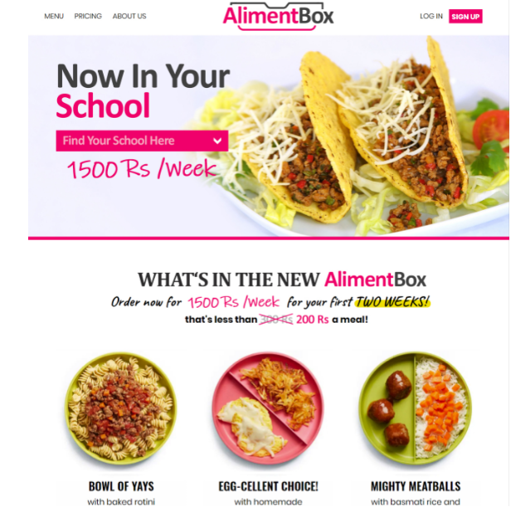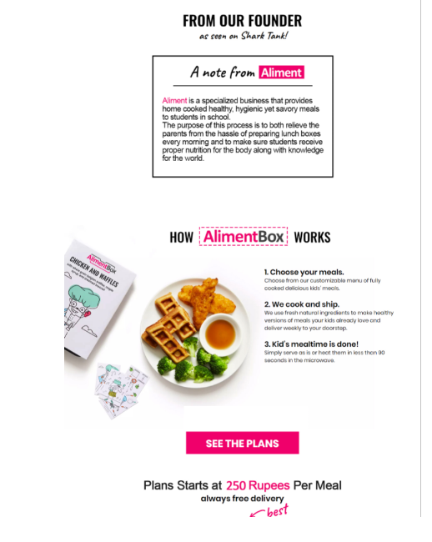

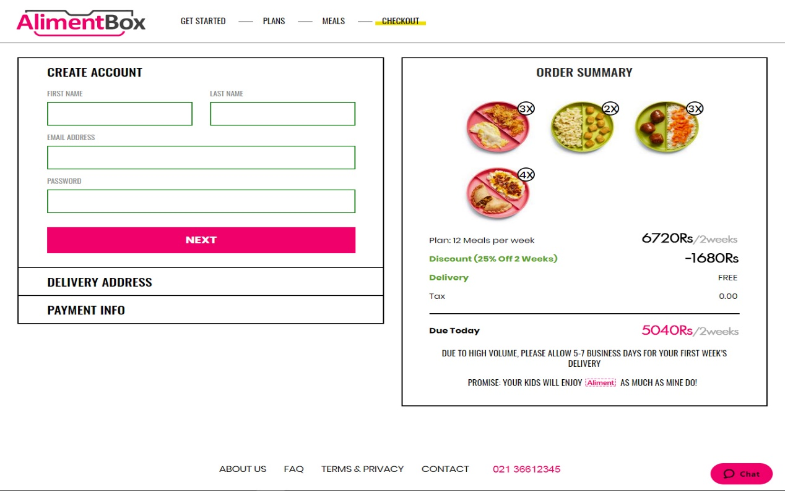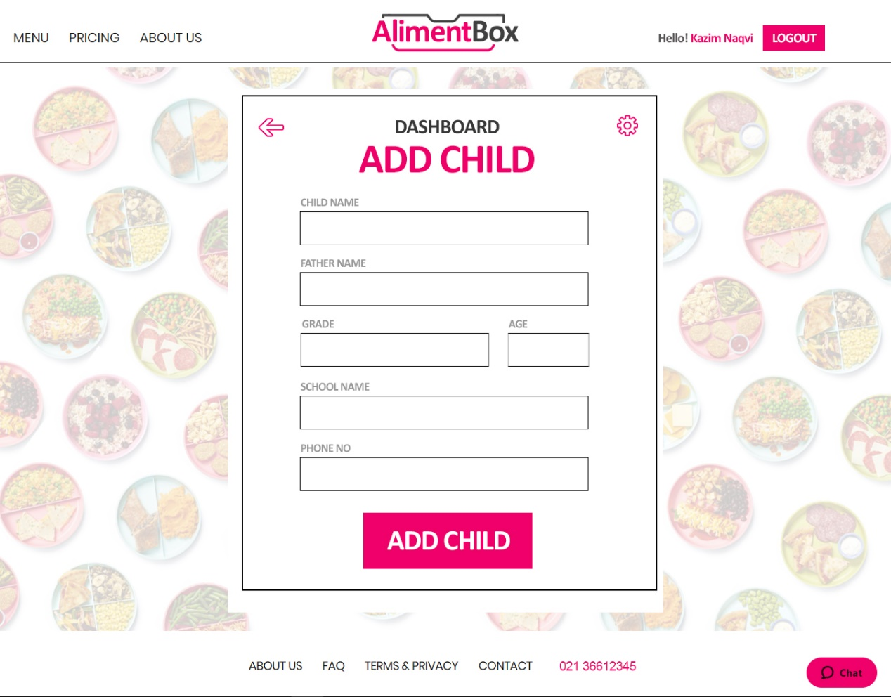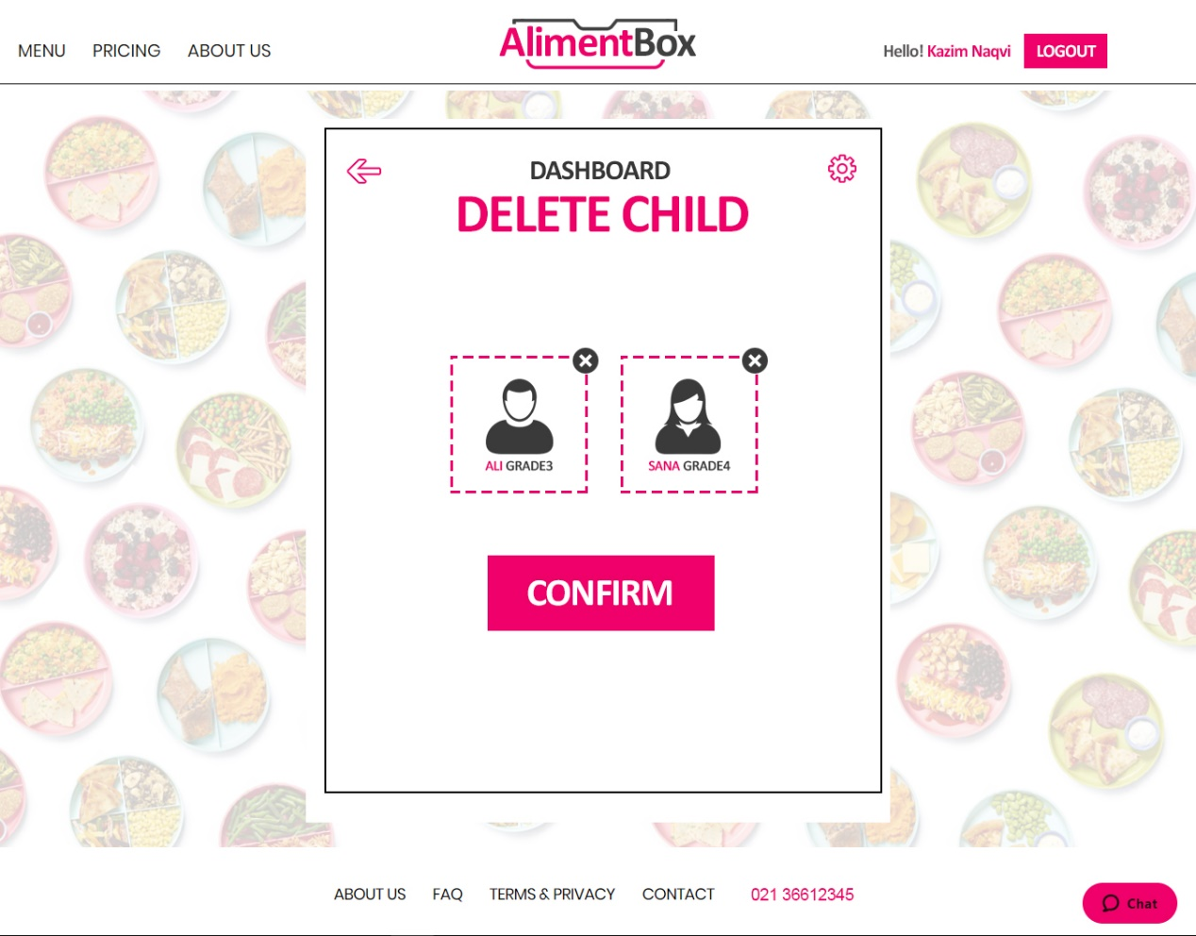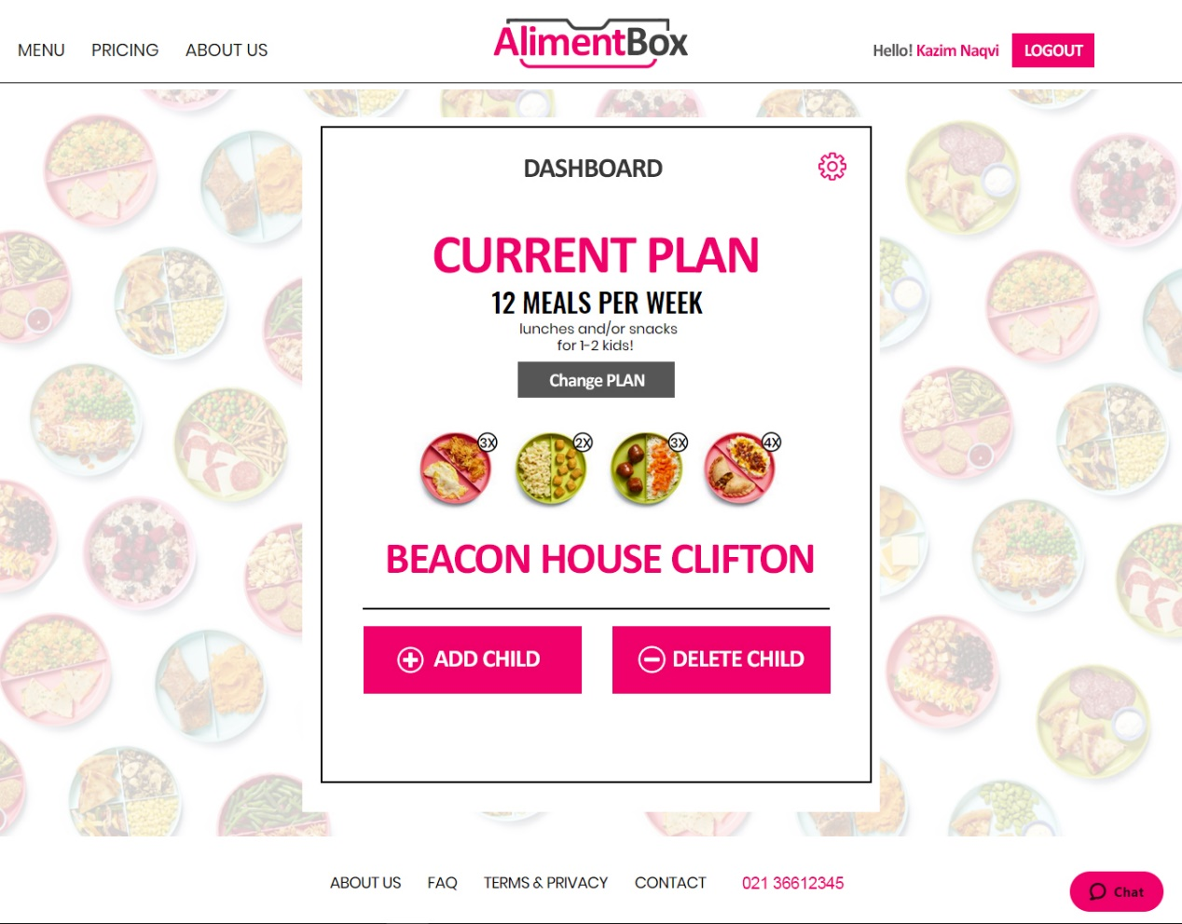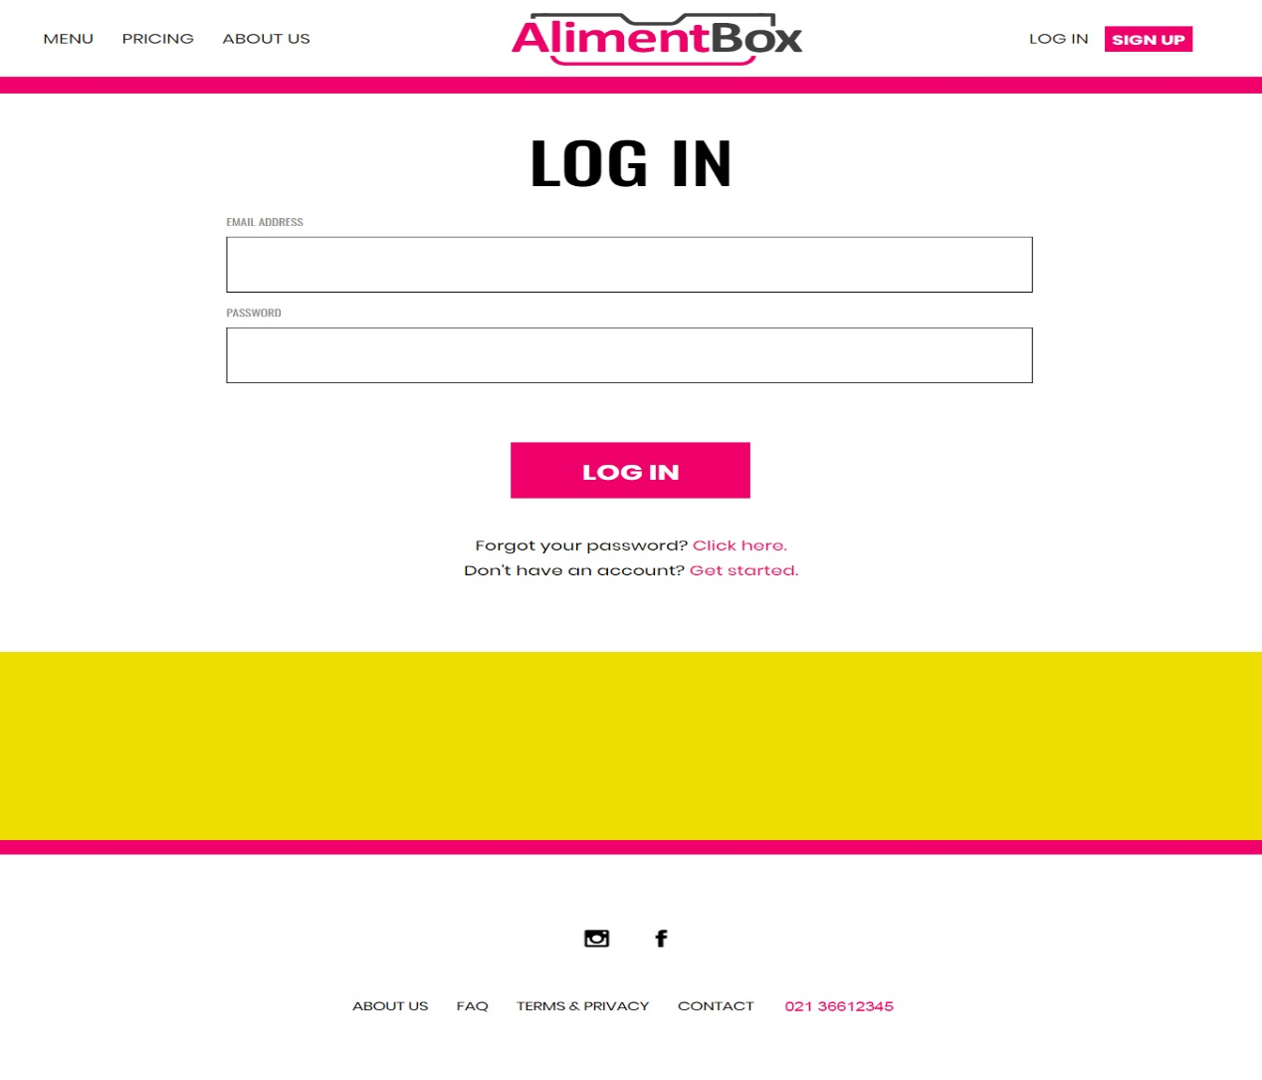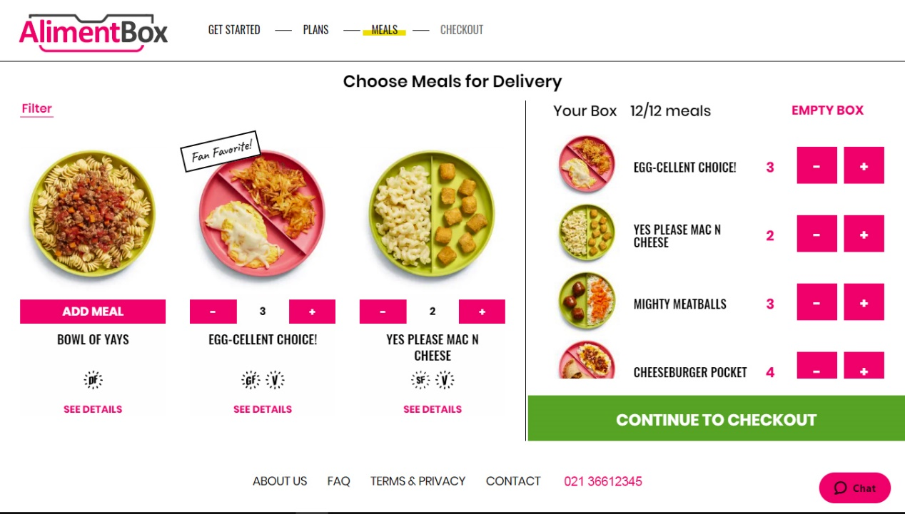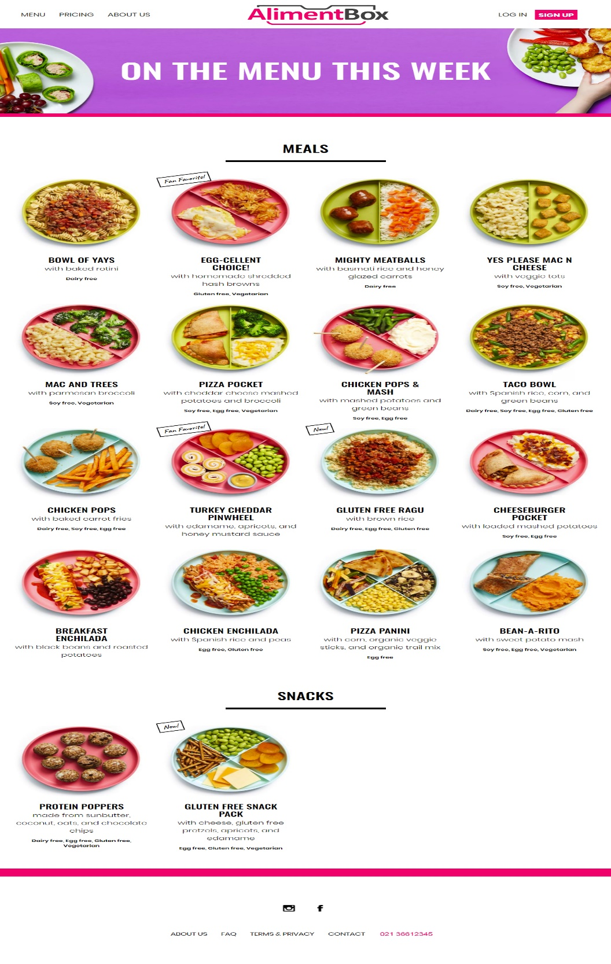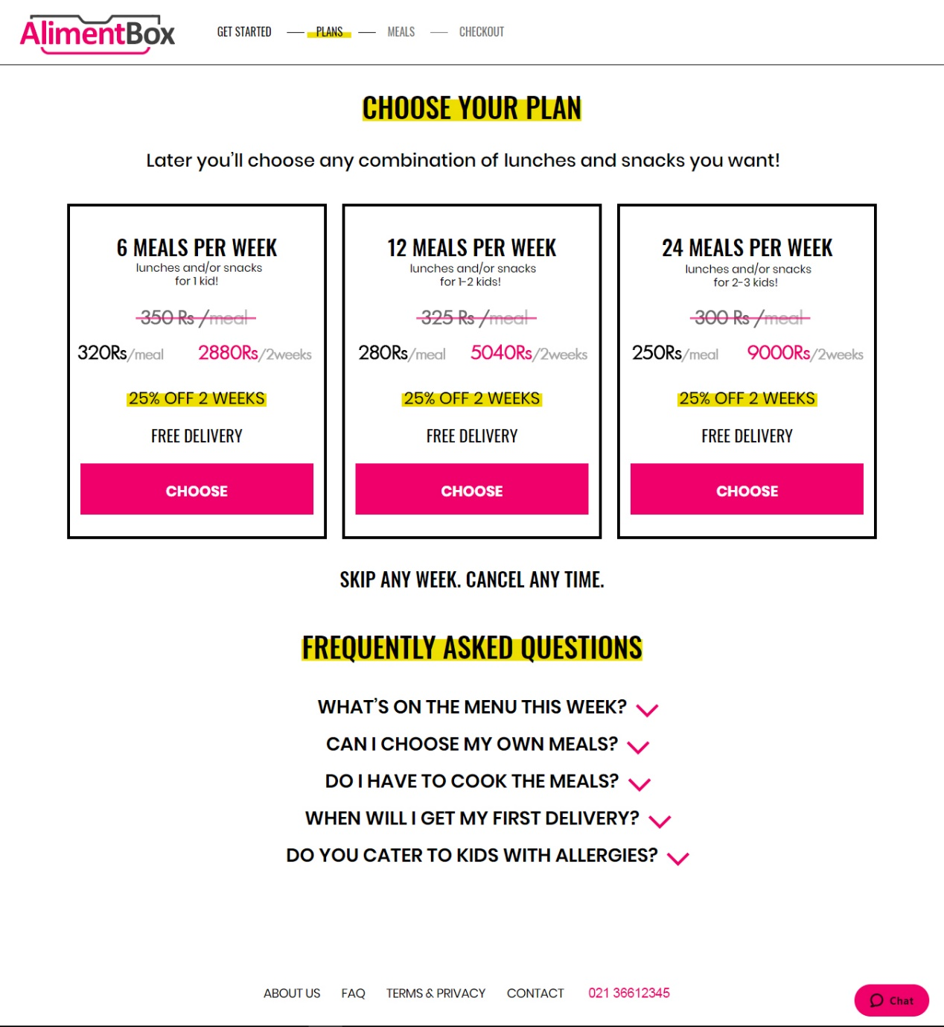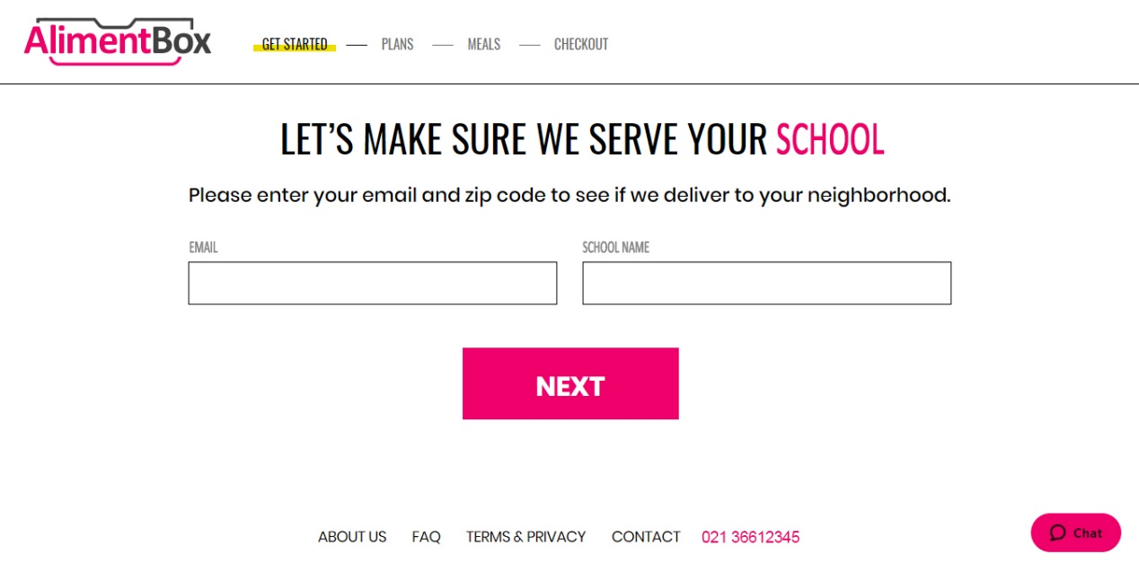

**5.0 Reuse and relationships to other products**

----------------------------------------------------------------------------

**6.0 Design decisions and tradeoffs**

----------------------------------------------------------------------------

**7.0 Pseudocode for components**

----------------------------------------------------------------------------

**8.0 Appendices**

OBJECT DIAGRAM:

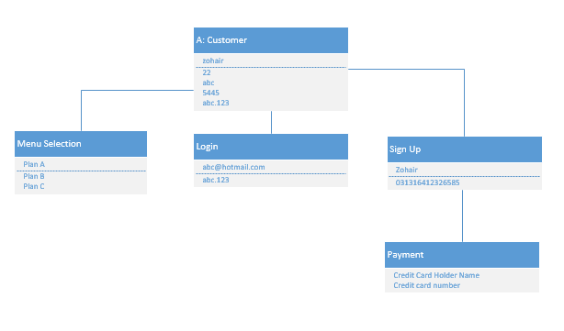

CLASS DIAGRAM:

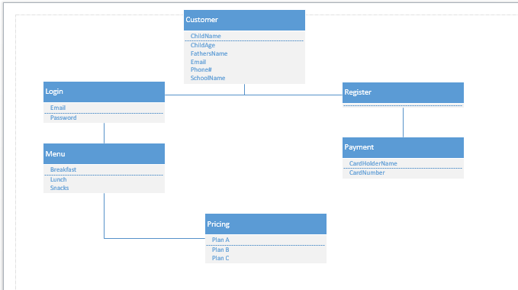

DEPLOYMENT DIAGRAM:

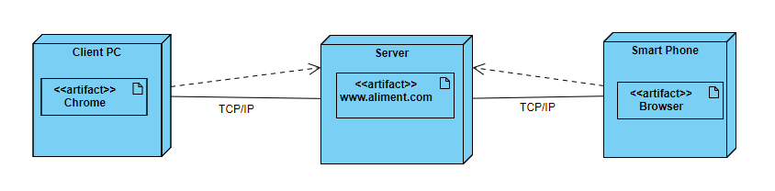

COMPONENT DIAGRAM:

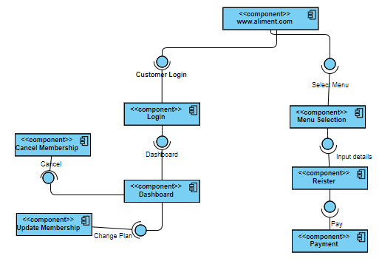

ACTIVITY DIAGRAM:

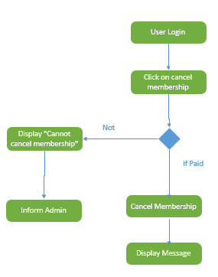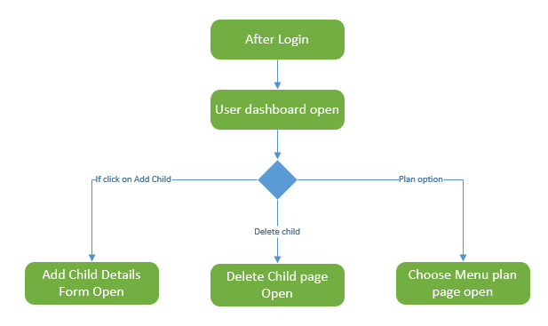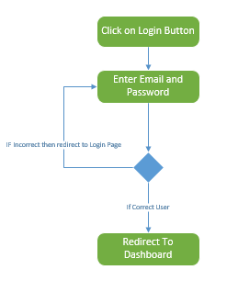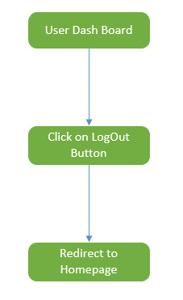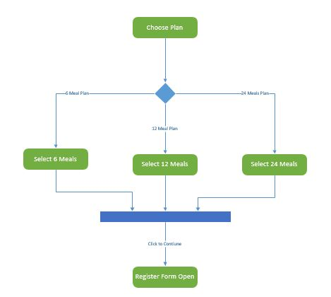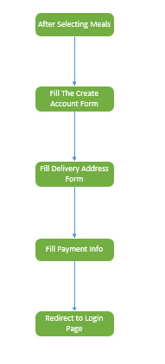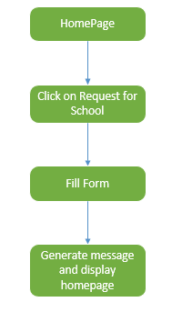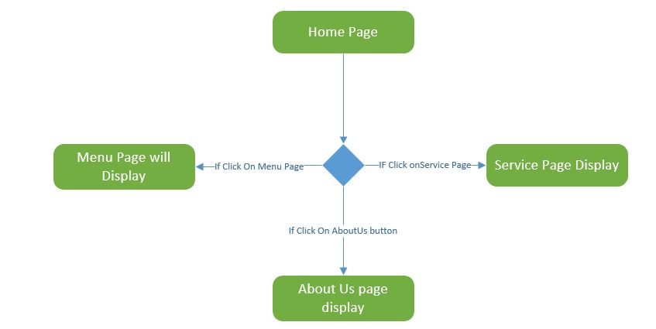

SEQUENCE DIAGRAM:

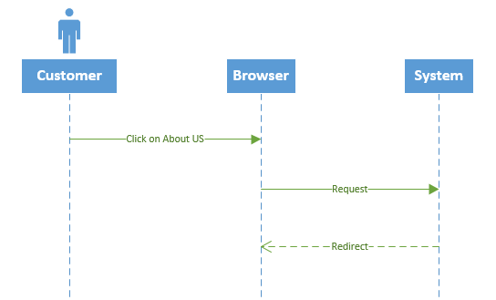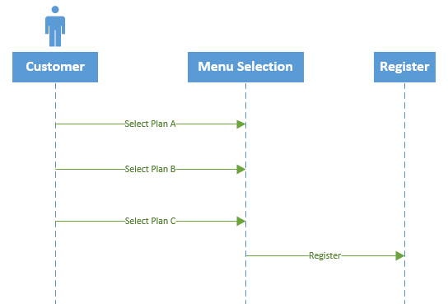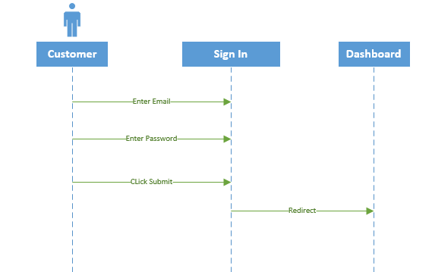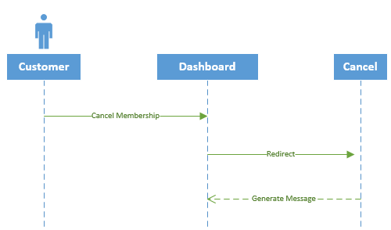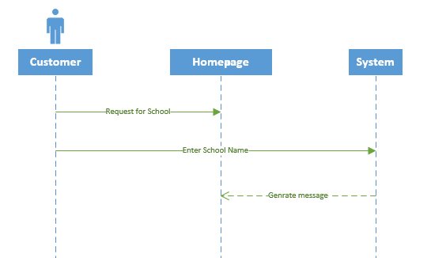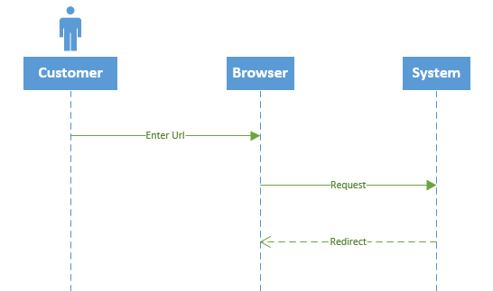

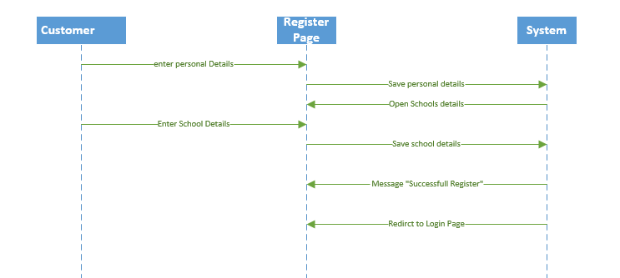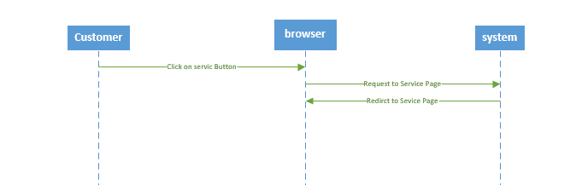

COLLABORATION DIAGRAM:

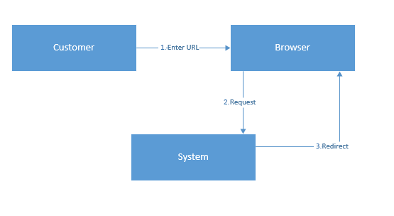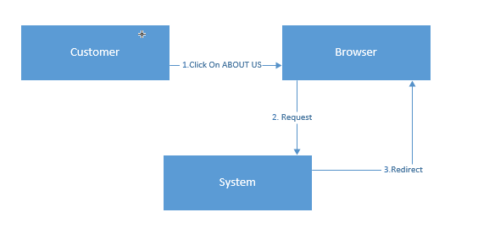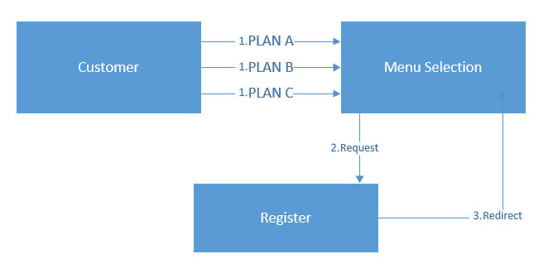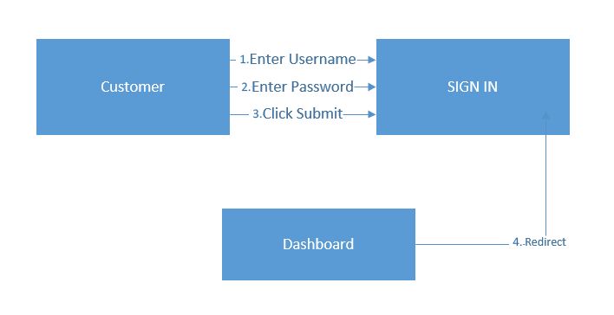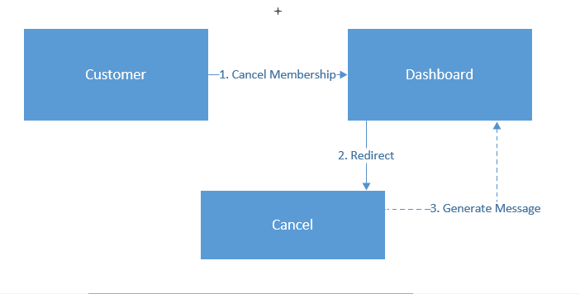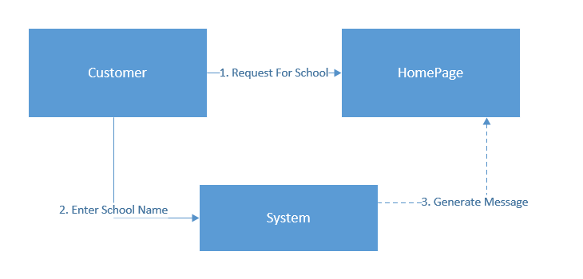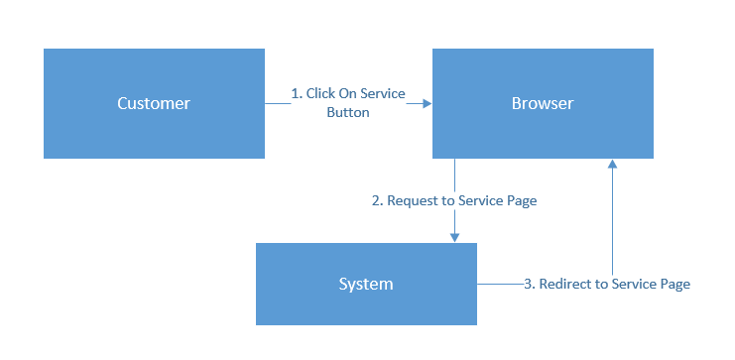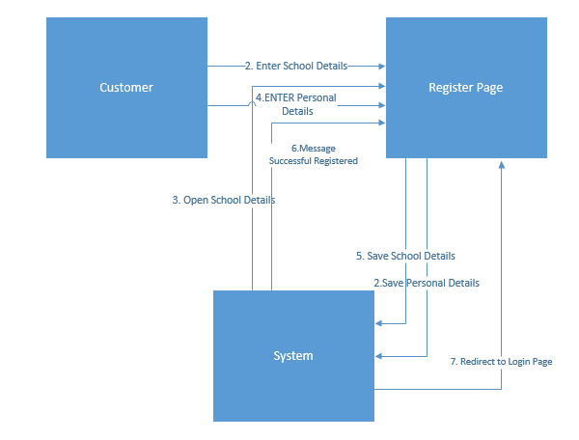

USE-CASE DIAGRAM:

