Quality Analysis using Image Processing of Real Time Data in Industry 4.0

Project Proposal

Supervisor
Dr. Faraz Junejo

Submitted by

Zohair Lokhandwala
{1612258}
Sibte Abbas
{1612135}

Faculty of Computing and Engineering Sciences
Shaheed Zulfiqar Ali Bhutto Institute of Science and Technology, Karachi.

[1st Oct 2019]

Introduction
All gear manufacturing industries aim to produce various competitive products. The competition enhancement depends mainly on productivity and quality of the Gears produced by each industry. In this sector, there have been an enlarge amount of losses due to defective products. Most defects arising in the production process are still detected by human inspection. The work of inspectors is very tedious and time consuming. The identification rate is about 70%. In addition, the effectiveness of visual inspection decreases quickly with fatigue. Digital image processing techniques have been increasingly applied to gear samples for analyzing the product. Therefore, we suggest a fully robust system taking advantage of image processing techniques must be explored to build an economical solution to provide Total Quality Management in manufacturing units which would allow an eco-system of continuous monitoring and improvement there by reducing the cost.

Objective

To design a system that will detect defects and check the overall quality of the automotive gears in industries using Digital Image Processing.

Problem Description
The Proposed System will eliminate majority of the problem of the current framework and improve the overall quality of the gears. It was will be much faster and accurate then a human manually checking for defects., for example:

People will in general commit errors while analyzing the quality of the Gears which is also a tedious procedure which costs a great deal of labor to an industry. A great deal of time is squandered in the clarification of quality. There comes a need in each industry for effective information catch which can spare a ton of time.
A staff is constantly required to perform tasks, Automated framework enables you to screen your procedures continuously and recognize issues as they arrive, empowering fast changes en route.

Additional use for the staff contracted, this framework deals with the human and different assets so that cost of conveyance of every transfer diminishes and help the organization to get more benefit.

Methodology

The first step is to obtain an image from the camera. 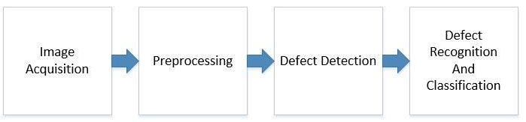Noise may be present in the obtained image due to external disturbances such as variation in illumination level, presence of shadow etc. Hence pre-processing is required to increase the accuracy. The resized image is converted to grey scale image with its intensity values. Smoothing is done by Gaussian filter to reduce noise in the image. Adaptive thresholding is applied to obtain a binary image where all the pixels are distinguished as foreground or background pixels. This localizes the defect in the binary image.

Defect detection in gears After pre-processing, edge detection is applied to preserve boundary information in an image. There are many edge detection techniques such as Sobel, Prewet and Canny operator. Canny operation is an optimal edge detector as it has goo localization and minimal response. This detection technique is applied for the obtained binary image to obtain contours of the gear. The largest contour consisting of teeth profile is obtained and thus number of end points in this largest contour is determined. Thus, determining the gear is defective or not.

Defect classification Decision tree is implemented to classify whether a given test image is defective or not. Geometric features like number of teeth, diameter of gears are considered. It classifies the image as defective or not. If defective, it determines the type of defect present in the test image.

Project Scope
The following system will be developed to make this whole process to be made automated, accurate and fast image processing system which could identify surface defects of gear, select gear with required dimensions (Gold plating) and count the number of teeth.

Feasibility Study
    - Risks Involved:
- Image is blur
- System crash
- System not able to detect minor defects
    - Resource Requirement:
- Laptop/Desktop Computer
- Camera
- Cloud Server

Solution Application Areas
Our goal is to target automotive gear manufacturing industries as it will automate their process. The industry will be benefited in lot of terms as it will be an innovative step towards the automated digital world. In addition, with that it can enhance their services and increase their profits by subtracting expenditure on the staff hired.

Tools/Technology
- Python
- Database

Expertise of the Team Members
- Java
- C#
- Python
- Asp.NET
- Html
- CSS

10. Milestones
- Milestone-1(Requirement and structure)
Research, Planning
Gantt Chart
Proposal Submission

Structure
Analyzing Features
Gather Asset
Finalizing features
- Milestone-2(Diagram and Document)
Use Case Diagrams
Use Cases
System Diagram
Sequence
Class Diagram
ERD diagram
SRS 100%
- Milestone-3 (Development and Document)
Development 35%
SRS revised
Class diagram
SDS 100%
- Milestone-4
Development 25%
Testing

11.ProjectSchedule
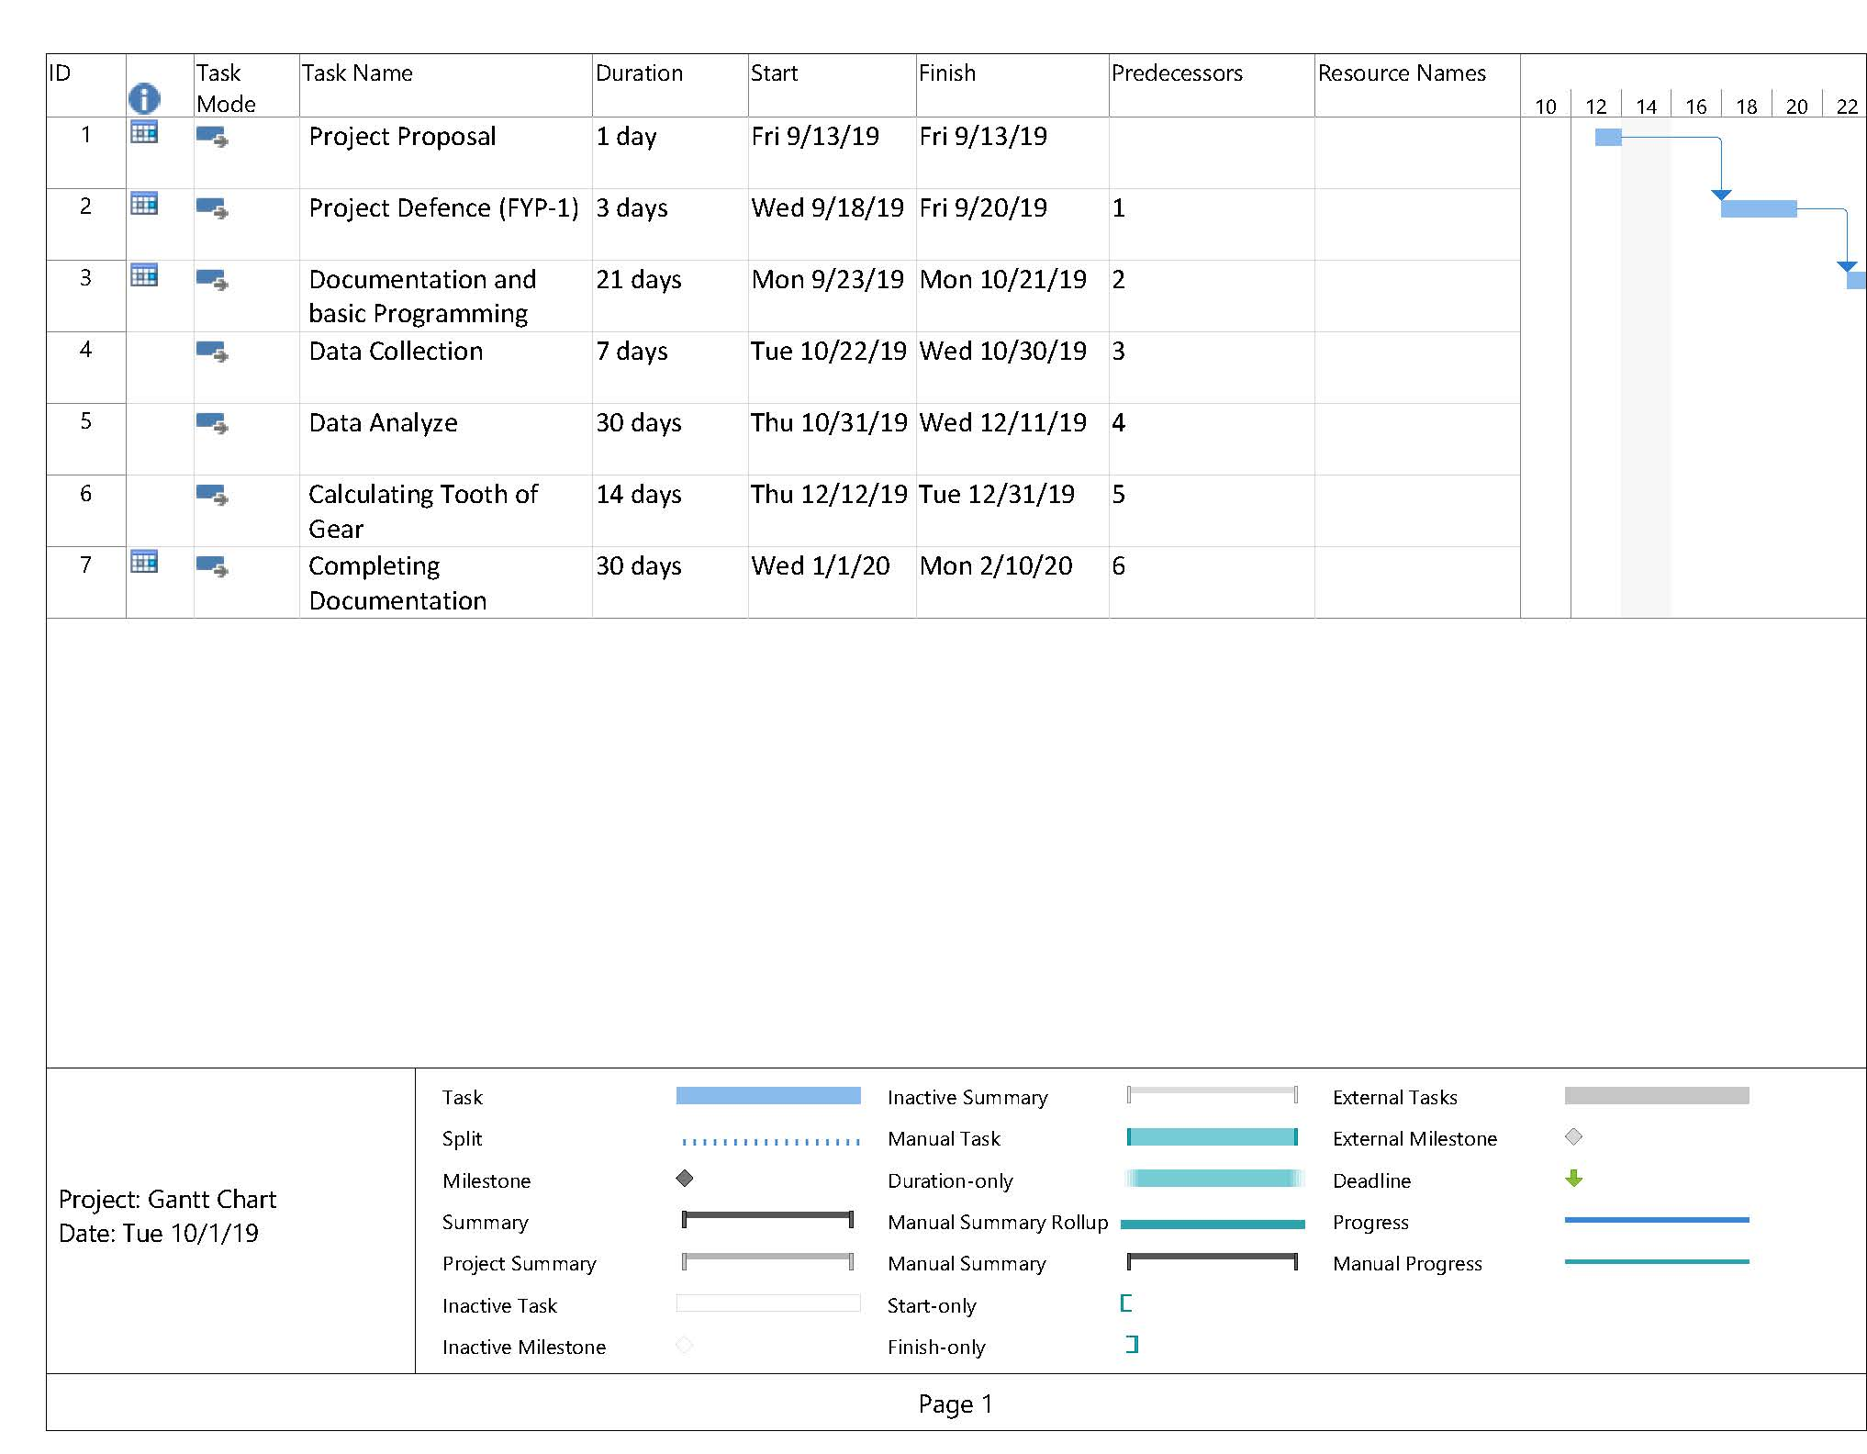
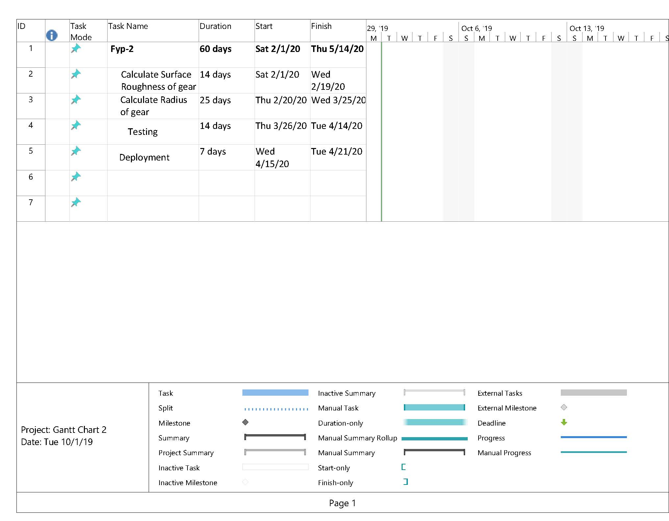

12. Work Breakdown Structure
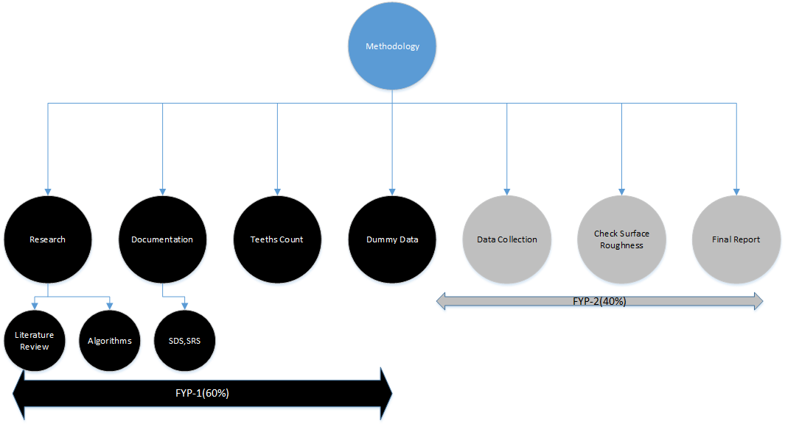

13. References
http://citeseerx.ist.psu.edu/viewdoc/download?doi=10.1.1.300.2999&rep=rep1&type=pdf
https://www.academia.edu/10500793/Analyze_Gear_Failures_and_Identify_Defects_in_Gear_System_for_Vehicles_Using_Digital_Image_Processing
http://www.ijcta.com/documents/volumes/vol8issue2/ijcta2017080224.pdf?fbclid=IwAR1W4iBieYDCMpf5YfblNbpzVsSOqtQpoFyBPYXKe7vJeCN1bOygGgqbvNc
http://ijariie.com/AdminUploadPdf/Geometric_Verification_of_Gears_Using_Image_Processing_Technique_ijariie7818.pdf?fbclid=IwAR2R4YGlvLmh66CBtb9jc5PqrdoImBNUaSrQiHpZtgW-7lqHYVihERG51vI
http://oaji.net/articles/2017/1992-1514710168.pdf?fbclid=IwAR3OOsy-Mv-_yPaGw0AHO8uF9YU2scOtfPw2OaBN9Cq3Pu-SwQ7qxyBzwZI
https://www.ncbi.nlm.nih.gov/pmc/articles/PMC5038642/?fbclid=IwAR3iYd8ev6j2kFrHX_ZVC3WD1Fez6W2vwghzYQfC1CJNtbGqCQfK6esit6c

