Table of Contents
Type chapter title (level 1) 1
Type chapter title (level 2) 2
Type chapter title (level 3) 3
Type chapter title (level 1) 4
Type chapter title (level 2) 5
Type chapter title (level 3) 6
Software Design Specification

1. Introduction

1.1 Purpose of this document
The aim of this document is to a specify a high-level view of the architecture of our system, and the interaction between the user and the system. It also focuses on detailing a low-level view of each component of the software and how the components interact with each other.

1.2 Scope of the development project
The following system will be developed to make this whole process to be made automated, accurate and fast image processing system which could identify surface defects of gear, select gear with required dimensions (Gold plating) and count the number of teeth.

1.3 Definitions, acronyms, and abbreviations
N/A

1.4 References
N/A

1.5 Overview of document
System architecture section provides an overview of the system's major components and architecture, as well as specifications on the interaction between the system and the user. The Detailed description of components section will be the main focus. It will describe lower-level classes, components, and functions, as well as the interaction between these internal components. The user interface section will provide the GUI’s of the actual product and the appendices section will contain all the UML diagrams of the system.

2. System architecture description

  - Section Overview
This section provides the overall summary of our system architecture.
  - General Constraints
This system will be used by the operator of the gear hobbing machine to check the quality of each gear in real-time. This system will be developed on Python using the OpenCV library. It will require a computer and an internet connection to operate. The functionality of our system is constrained by data provided via the cameras on the machine. The internet should be up and running all the time so the data can be uploaded to the sever. Our System relies on the cameras functioning properly and would shut down if that were not the case.

  - Data Design
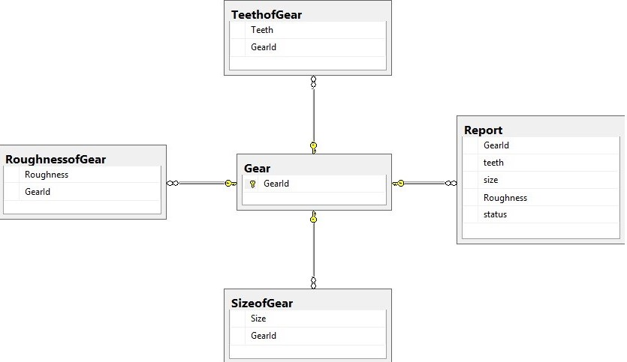
  - Program Structure
Describe the architectural model chosen and the major components. Include a pictorial representation (or reference to an appendix block or class diagram) of the major components.

- Detailed description of components

Identification | Camera
Type | Hardware
Purpose | Capture Images of the Gear
Function | Capture and store images in raspberry pi
Subordinates | ------------------------------------------------------------------------------------------------
Dependencies | The camera should be connected to the power and the raspberry pi to store the captured images.
Interfaces | ------------------------------------------------------------------------------------------------
Resources | Camera and the Raspberry Pi
Processing | ------------------------------------------------------------------------------------------------
Data | Image Files

Identification | Raspberry Pi
Type | Hardware
Purpose | Store Images of the Gear
Function | Store the captured images received from the camera
Subordinates | ------------------------------------------------------------------------------------------------
Dependencies | It should be connected to the power and the camera to store the captured images and also to the server to send image files to the system.
Interfaces | ------------------------------------------------------------------------------------------------
Resources | Camera, Raspberry Pi, Server
Processing | ------------------------------------------------------------------------------------------------
Data | Image Files

Identification | Server
Type | Hardware
Purpose | Send Data
Function | Receive the data from the raspberry pi and send it to the system through server
Subordinates | ------------------------------------------------------------------------------------------------
Dependencies | It should be connected to the power and the raspberry pi
Interfaces | ------------------------------------------------------------------------------------------------
Resources | System, Raspberry Pi, Server
Processing | ------------------------------------------------------------------------------------------------
Data | Image Files

Identification | System
Type | Hardware, Desktop Application
Purpose | Process the images
Function | The images received from the server will be processed
Subordinates | ------------------------------------------------------------------------------------------------
Dependencies | It should be connected to the power and the server to receive the images of the gear.
Interfaces | ------------------------------------------------------------------------------------------------
Resources | System, Server
Processing | ------------------------------------------------------------------------------------------------
Data | Image Files

- User Interface Design
  - Section Overview
Provide a summary of the contents of this section.
  - Interface Design Rules
N/A
  - GUI Components
N/A

  - Detailed Description
We have chosen Python language with PyCharm IDE and SQL database to implement our project because of its more interactive support and save the reports. The user will interact with a keyboard and a mouse if he is using a computer to type information and move the cursor. User can also interact using a touch screen if he/she is using a tablet or a mobile phone. Camera will be used for capturing images. Raspberry Pi acts as an intermediate device for sending the data collected from these units to the server for further processing.

5.0 Reuse and relationships to other products
N/A

6.0 Design decisions and tradeoffs
N/A

7.0 Pseudocode for components
N/A

8.0 Appendices

Class Diagram | Describes the structure of a system
Object Diagram | Expresses possible object combinations of a specific Class Diagram
Statechart Diagram | Expresses possible states of a class (or a system)
Activity Diagram | Describes activities and actions taking place in a system
Sequence Diagram | Shows one or several sequences of messages sent among a set of objects
Collaboration Diagram | Describes a complete collaboration among a set of objects
Use-case Diagrams | Illustrates the relationships between use cases
Component Diagram | A special case of a Class Diagram used to describe components within a software system
Deployment Diagram | A special case of a Class Diagram used to describe hardware within the overall system architecture
System Block diagram | A diagram showing the major components of the system with its interconnections and external interfaces

