Outline for Project_1

Energy Consumption Analysis for Buildings in San Francisco

By: Zohair Zulfiqar, Devanshi Mathur, Tekabe Fanta, Joy Mickle, Andrew Brannon, and Sehajmeet Sohal

Background

The Existing Buildings Energy Performance Ordinance in the City of San Francisco requires commercial and non-residential buildings that meet certain square footage requirements to report energy use and greenhouse gas emission data to the City.

Project Overview

GOAL ACTION

GOAL: Our goal was to identify energy usage and greenhouse gas emission trends, patterns, and relationships for commercial and residential buildings in San Francisco

ACTION ITEMS: Using the insights from the data, we can advise and modify policies for reducing energy use and greenhouse gas emissions

RESOURCE: Open Source Data from the City of San Francisco through the Existing Buildings Energy Performance Ordinance Report

Property Type Counts

Total number of commercial buildings 604

Total number of mixed residential 83

Question #1: What property subcategory type has the highest source energy use intensity and greenhouse gas emissions per square footage in the year 2022? Need to create two bar charts X-Axis (property subcategory), Y-Axis (Greenhouse gas emission intensity 2022) X-Axis (property subcategory), Y-Axis (Source energy use intensity 2022)

**PROCEDURE**: Used groupby function in pandas to create bar charts broken down by property subcategory.

**FINDINGS**: Highest Source EUI and GHG Emitters are buildings that are continuously in use in the tech industry.

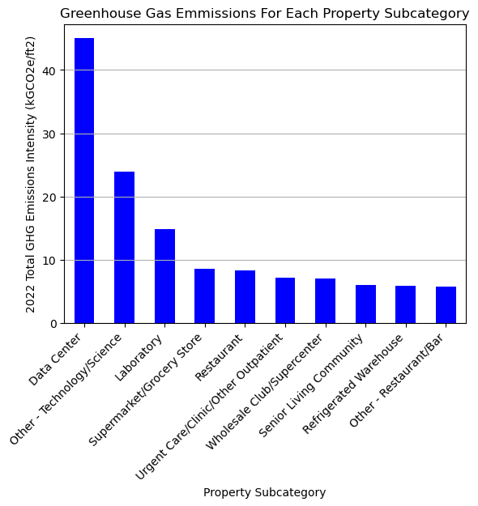

Correlation between GHG and Source EU

The r-value is 0.948 PROCEDURE: Used

linregress function in pandas to obtain parameters for a regression analysis

**FINDINGS**: There is a strong correlation between Source EUI and GHG Emissions. Due to the high demand of energy used by certain types of buildings e.g. buildings used in the tech industry we see an increase in emissions of GHG by these buildings. 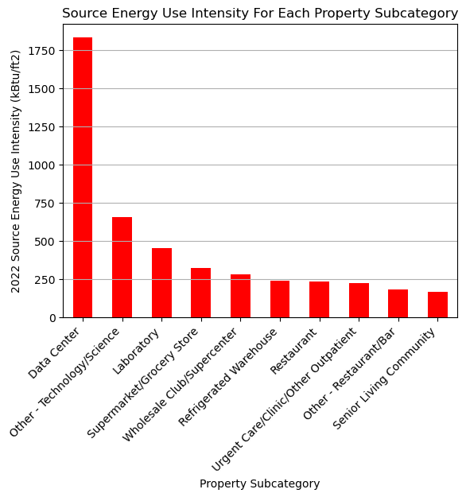

**Question #2**

For commercial and residential buildings, is there a relationship between year built and greenhouse gas emission intensity?

**Residential Buildings**

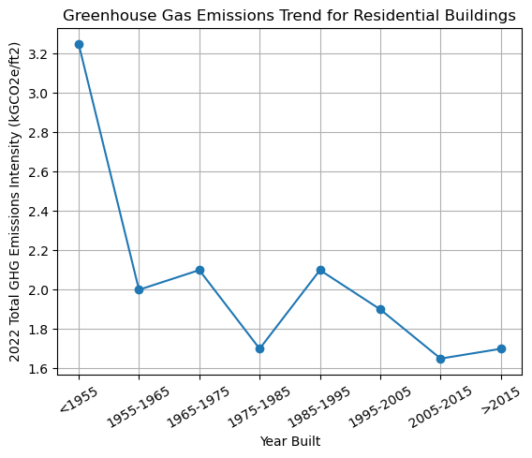

**Commercial Buildings**

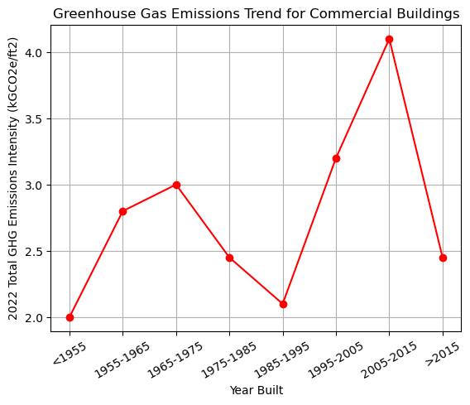

**PROCEDURE**: Created bins and used the groupby function to plot the 2022 GHG emissions based on the year the building was built.

**FINDINGS**: Newer residential buildings are emitting less GHG. There was an uptick for GHG emissions for commercial buildings built in the new millennia – this is due to high emitting property types such as tech centers.

**Question #3**

Has the greenhouse gas emission intensity for commercial and residential buildings decreased since 2018? Create boxplots for the 2022 GHG Emissions to calculate the quartiles and IQR and list the potential outlying properties for commercial and residential buildings.

**Commercial Buildings**

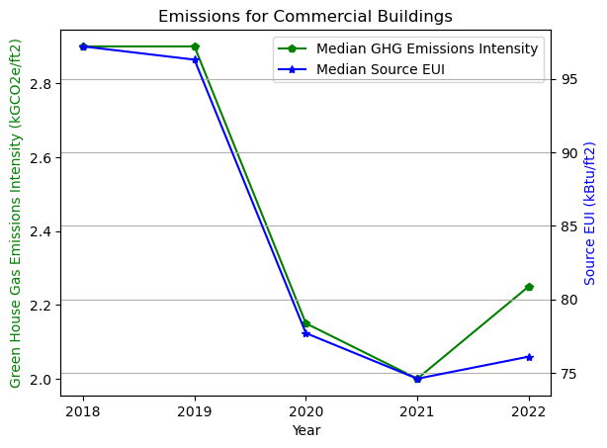

**Residential Buildings**

PROCEDURE: Used median for statistical analysis of GHG emissions and EUI since there are potential outliers in the data.

FINDINGS: The GHG emissions and EUI consumption has reduced after 2018 as expected since the ordinance went in place.

GHG Emissions boxplots Source EUI boxplots

FINDINGS and CONCLUSION:

The Boxplot and IQR analysis for year 2022 shows that:  
 • 33.33% of commercial properties are outliers for GHG emission and 31.25% of commercial properties are outliers for Energy

consumption with the Data Center being the top for both.  
 • 14.29% of residential properties are outliers for GHG emission and 14.29% of residential properties are outliers for Energy

consumption with Multifamily Housing being the top for both.  
 • This analysis solidfies the correlation between energy consumption and greenhouse gases emission, the properties with highest energy consumption seems to have the highest GHG emission as well

**Question #4** Is there a correlation between energy use and building floor area?

Residential Buildings Commercial Buildings

Mean correlation of commercial buildings (floor area vs energy use) from 2018 to 2022 is: 0.0805832669848815 Mean p-value of commercial buildings (floor area vs energy use) from 2018 to 2022 is: 0.05119773066264244

Mean correlation of mixed residential buildings(floor area vs energy use)from 2018 to 2022 s: -0.07641699519445266 Mean p-value of mixed residential buildings (floor area vs energy use) from 2018 to 2022 is: 0.5112473898708946

The mean correlation of commercial buildings (floor area vs energy use) from 2018 to 2022 indicates a weak positive correlation between the variables being analyzed. It shows that floor area has somewhat little impact on energy use in commercial buildings.

On the other hand, A weak negative correlation between energy use and floor area in mixed residential property types suggests that larger floor areas in such buildings are associated with lower energy consumption. This finding can have several potential explanations. It could be due to more efficient building designs, the use of energy-saving technologies, or a higher adoption of sustainable practices in larger mixed residential properties. These buildings might have implemented energy-efficient systems, insulation, or renewable energy sources, resulting in reduced energy consumption.

These findings underscore the significance of implementing energy management strategies and sustainable practices in commercial buildings, while highlighting the potential for energy-efficient designs and technologies in larger mixed residential properties.

Next Steps

1. The data highlights the vigorous energy consumption and GHG emission by data centers, our next steps would be to find sustainable ways to run data centers.
   1. Consolidate Servers: Turn off any dead servers and optimize your existing servers.   
      Upgrade Servers: Move to energy efficient servers
   2. Change To High-Efficiency Power: This removes inefficiencies with multiple AC/DC conversions.
   3. Implement natural cooling and use optimal locations for data centers that have natural cooling effect
   4. Improve Air Management to prevent recirculation of hot air from IT systems
2. Simple ways of saving energy could be implemented in Labs/Grocery stores/Supermarkets like adding motion detector or light sensor that sense heat in background to analyze movement or presence of people to reduce energy consumption
3. To reduce GHG emissions from refrigeration systems from supermarkets/Restaurant/Warehouses
4. Replace refrigerants with low-warming HFCs/new cooling agents/non-HFC substances
5. increase the refrigeration efficiency in appliances.
6. Control leakages of refrigerants from existing appliances.
7. Ensure recovery, reclaiming /recycling, and destruction of refrigerants at end of life

Conclusion

* REVIEW:   
   GOAL: Our goal was to identify energy usage and greenhouse gas emission trends, patterns, and relationships for commercial and residential buildings in San Francisco   
   ACTION ITEMS: Using the insights from the data, we can advise and modify policies for reducing energy use and greenhouse gas emissions  
     
   WHAT WE LEARNED: Findings and Final Analysis: It shows that floor area has negligible impact on energy use in commercial buildings. On the other hand, A weak negative correlation between energy use and floor area in mixed residential property types suggests that larger floor areas in such buildings are associated with lower energy consumption. And the properties with highest energy consumption seem to have the highest GHG emission as well.
* NEXT STEPS: Identify ways to change policy and equipment to reduce emissions in the cases found like data centers and supermarkets and large GHG emission buildings

References

https://rahi.io/green-data-centers/

https://drawdown.org/solutions/refrigerant-management

https://data.sfgov.org/Energy-and-Environment/Existing-Buildings-Energy- Performance-Ordinance-Re/j2j3-acqj