Review Functions
Give yourself a pat on the back, you just navigated through functions!
In this lesson, we covered some important concepts about functions:
- A function is a reusable block of code that groups together a sequence of statements to perform a specific task.
- A function declaration :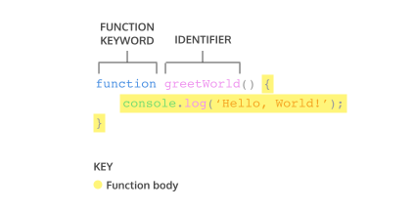
- A parameter is a named variable inside a function's block which will be assigned the value of the argument passed in when the function is invoked:
- To call a function in your code:
- ES6 introduces new ways of handling arbitrary parameters through default parameters which allow us to assign a default value to a parameter in case no argument is passed into the function.
- To return a value from a function, we use a return statement.
- To define a function using function expressions: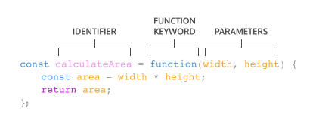
- To define a function using arrow function notation: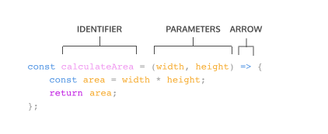
- Function definition can be made concise using concise arrow notation: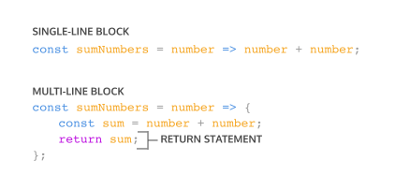
It's good to be aware of the differences between function expressions, arrow functions, and function declarations. As you program more in JavaScript, you'll see a wide variety of how these function types are used.

