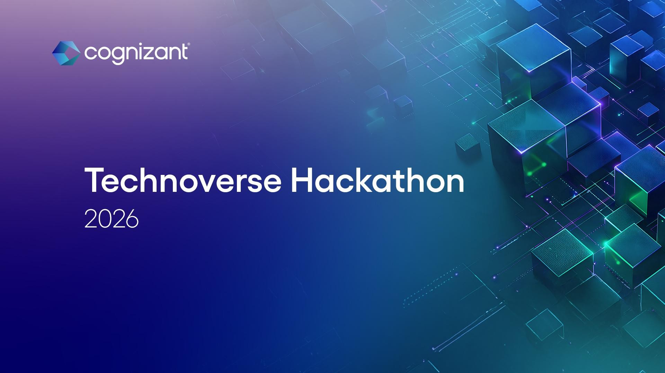


1 © 2025–2027 Cognizant | Private




Instructions for idea submission (step 02)
- All teams must submit ideas as per the guidelines outlined in this document (refer slides 4 & 5).
- Ideas must be submitted only in PDF format, using the prescribed template (refer slides 7 & 8).
- Teams may include additional supporting details within the same PDF, as applicable.
- The idea submission platform (PDF upload) will be open from 7th April
to 12th April.
- Ensure your idea is submitted before the deadline(12th April).

2 © 2026–2027 Cognizant | Private




Idea submission guidelines

3 © 2026-2027 Cognizant | Private


Structure for submitting ideas

WHY
Explain the Problem
Problem Description & Business Scenario : Include relevant background information, data or context that helps to understand the problem significance and impact. Talk about the Industry and business trends, needs & scenario


Problem Scope: Define the boundary and scope of the problem, specify any limitations or specific requirement.
Target Users/Stakeholders: Identify the target users or stakeholders who would benefit from the solution. Describe their needs, pain points that solution addresses.

Solution Overview: Provide high level overview of the solution, explaining its core concepts and how it addresses the problem. Describe solution features, functionalities and main components of the solution. Technical Details: Provide technical information around the solution, this may include underlying technologies, platforms, programming languages, frameworks, algorithms, libraries used. Explain the data sources and integration/interoperability considerations with systems.
Innovation: Highlight unique or innovative aspects of the solution, emphasize any novel technologies, methodology or strategies employed.
Market Potential: Provide approx. Market potential, bring in facts and figures from research & analyst reports (if possible).
Why are the technologies you used are appealing for the solution: Explain why technologies used for the use case are relevant for the use case.

How
Explain the Solve

WHAT
Value proposition
Enumerate the primary benefits or advantages of the solution with specific metrics or data points to quantify the benefits in terms of user experience, efficiency, time and cost savings, flexibility, scalability, social and environmental impact.

© 2026–2027 Cognizant | Private
4


Additional Context (please provide additional details as applicable in your case)

Investments

What does it take & How much does it cost to solve?

Cloud Process Re-engg Modernization AI

Tools

Returns

ROI Revenue Growth
Happy Customer
Margin improvement
Employee Experience
Quantify the benefits &
What if I don’t solve?

Timelines

Time to realize benefits
Time to
solve
Milestones















© 2026–2027 Cognizant | Private
5




Idea submission template

6 © 2026-2027 Cognizant | Private

<idea description> | Business Plan (1/2)



WHY
Problem Description & Business Scenario :
Problem Scope:
Target Users/Stakeholders:
Explain the Problem

How
Solution Overview: Technical Details: Innovation:
Market Potential:
Explain the Solve

WHAT
Primary benefits : Efficiency and flexibility : Time and cost saving : Scalability:
Social Impact:
Value proposition

© 2026–2027 Cognizant | Private
7




Financials & Timelines | Business Plan (2/2)

Investments
What does it take & How much does it cost to solve?

Returns
Quantify the benefits &
What if I don’t solve?

Timelines
Time to realize benefits

© 2026–2027 Cognizant | Private
8

Idea evaluation criteria

Will the idea deliver business value?
Is the idea unique?
Is the idea implementable?
Is the idea scalable?






9 © 2026–2027 Cognizant | Private





Thank you

10 © 2026–2027 Cognizant | Private

