PROJECT DESIGN PHASE – II
Data Flow Diagram & User Stories
Date: 29 September 2026

1. Project & Team Details
Team ID | SWTID-2026-3350
Project Name | FitBuddy – AI Fitness Plan Generator using Gemini Models
Team Size | 4
Team Leader | Zohoorunnisa R
Team Members | Thanzeela Begum T; Yasmeen G; Yuva Sree S

2. Data Flow Diagram (DFD)
The DFD below represents the main information flow in FitBuddy: user details are validated, sent to the Gemini AI layer for personalized workout and nutrition generation, stored in SQLite, and later used for feedback-based plan updates and administrator/coach viewing.
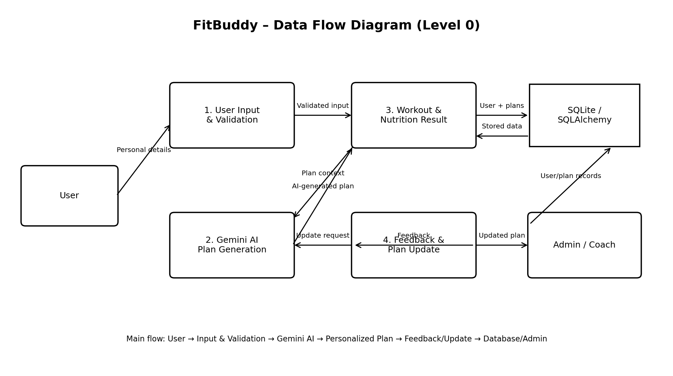

3. DFD Components
DFD Element | Description
User | Provides name, user ID, age, weight, fitness goal and workout intensity; can submit feedback.
User Input & Validation | Receives form data and validates the structure before processing.
Gemini AI | Generates a structured 7-day workout plan and supports feedback-based plan updates.
Workout & Nutrition Result | Displays the personalized workout plan and nutrition/recovery tip.
Feedback & Plan Update | Processes user feedback and regenerates an updated workout plan.
SQLite / SQLAlchemy | Stores user information, original plans and updated plans.
Admin / Coach | Can view registered users and their original and updated workout plans.

4. User Stories
The following user stories are prepared for FitBuddy using the supplied template structure: User Type, Functional Requirement (Epic), User Story Number, User Story / Task, Acceptance Criteria, Priority and Release.
User Type | Functional Requirement (Epic) | User Story Number | User Story / Task | Acceptance Criteria | Priority | Release
Customer (Web User) | Profile & Input | USN-1 | As a user, I can enter my name, user ID, age, weight, fitness goal and workout intensity. | All required inputs are captured and validated. | High | Sprint-1
Customer (Web User) | Workout Plan Generation | USN-2 | As a user, I can generate a personalized 7-day workout plan based on my fitness goal and intensity. | A day-wise workout plan is generated and displayed. | High | Sprint-2
Customer (Web User) | Nutrition / Recovery | USN-3 | As a user, I can receive a nutrition or recovery tip related to my selected fitness goal. | A relevant tip is displayed with the workout result. | Medium | Sprint-2
Customer (Web User) | Plan Storage | USN-4 | As a user, I can have my details and generated plan stored for later access. | User details and plan are stored in the SQLite database. | High | Sprint-2
Customer (Web User) | Feedback | USN-5 | As a user, I can submit feedback such as 'add more cardio' or 'include more rest days'. | Feedback is accepted and linked to the user's plan. | High | Sprint-3
Customer (Web User) | Plan Update | USN-6 | As a user, I can receive an updated workout plan based on my feedback. | The original plan and feedback are processed and an updated plan is displayed. | High | Sprint-3
Customer (Web User) | Plan History | USN-7 | As a user, I can preserve my original plan while an updated version is stored separately. | Original and updated plans remain available in the database. | Medium | Sprint-3
Administrator / Coach | Admin Dashboard | USN-8 | As an administrator or coach, I can view all registered users and their workout plans. | User records and plan information are shown in a structured view. | Medium | Sprint-3
Administrator / Coach | Plan Monitoring | USN-9 | As an administrator or coach, I can compare original and updated workout plans. | Both plan versions are displayed clearly for each user. | Medium | Sprint-3
Developer | FastAPI Backend | USN-10 | As a developer, I can implement routes for the homepage, workout generation, feedback and admin view. | Required FastAPI routes process requests and return the correct templates. | High | Sprint-3
Developer | Frontend | USN-11 | As a developer, I can provide responsive Jinja2 pages for input, results and admin viewing. | index.html, result.html and all_users.html render correctly. | High | Sprint-4
Developer | Deployment & Testing | USN-12 | As a developer, I can run and verify FitBuddy locally using Uvicorn. | Application loads locally and API documentation is accessible. | High | Sprint-4

5. User Story Acceptance Summary
A user story is considered complete when its acceptance criteria are satisfied, the relevant FitBuddy functionality works as intended, and the feature is verified during the assigned sprint.

6. Main FitBuddy Functional Epics
• Profile & User Input
• Personalized Workout Plan Generation
• Nutrition / Recovery Tip
• Database & Plan Storage
• Feedback-Based Plan Update
• FastAPI Routing & Backend
• Frontend / Jinja2 Interface
• Administrator / Coach Dashboard
• Deployment & Testing

