PROJECT PLANNING PHASE
Project Planning Template
(Product Backlog, Sprint Planning, User Stories & Estimation)
Planning Date: 29 September 2026

1. Project & Team Details
Team ID | SWTID-2026-3350
Project Name | FitBuddy – AI Fitness Plan Generator using Gemini Models
Team Size | 4
Team Leader | Zohoorunnisa R
Team Members | Thanzeela Begum T; Yasmeen G; Yuva Sree S
Project scope: FitBuddy uses FastAPI, Google Gemini models, Jinja2/HTML, and SQLite with SQLAlchemy to generate personalized 7-day workout plans, nutrition/recovery tips, feedback-based plan updates, and an admin view of users and plans.

2. Product Backlog, Sprint Schedule & Estimation
The backlog below is adapted to the FitBuddy project workflow described in the project document. Story points are estimated effort points; priorities are High or Medium.
Sprint | Functional Requirement (Epic) | Story No. | User Story / Task | Story Points | Priority | Team Member(s)
Sprint-1 | Model Selection & Architecture | USN-1 | As a team, we can research and select the Gemini model for workout generation and feedback-based updates. | 4 | High | Zohoorunnisa R; Yasmeen G
Sprint-1 | Model Selection & Architecture | USN-2 | As a developer, I can define the FitBuddy architecture covering frontend, FastAPI backend, AI layer and SQLite database. | 4 | High | Zohoorunnisa R; Yuva Sree S
Sprint-1 | Development Environment | USN-3 | As a developer, I can set up Python, virtual environment, required libraries and Uvicorn for local development. | 4 | High | Thanzeela Begum T; Yuva Sree S
Sprint-1 | Project Structure | USN-4 | As a team, we can create the app, templates and static asset structure needed for FitBuddy. | 3 | Medium | Yasmeen G; Yuva Sree S
Sprint-1 | AI Integration Preparation | USN-5 | As a developer, I can prepare secure configuration for the Gemini API key and basic AI integration. | 5 | High | Zohoorunnisa R; Thanzeela Begum T
Sprint-2 | Core Functionality | USN-6 | As a user, I can enter name, user ID, age, weight, fitness goal and workout intensity. | 3 | High | Thanzeela Begum T; Yasmeen G
Sprint-2 | Workout Plan Generation | USN-7 | As a user, I can receive a personalized 7-day workout plan using Gemini Pro. | 5 | High | Zohoorunnisa R; Thanzeela Begum T
Sprint-2 | Nutrition / Recovery Tip | USN-8 | As a user, I can receive a concise nutrition or recovery tip using Gemini Flash. | 3 | Medium | Yasmeen G
Sprint-2 | Database | USN-9 | As a system, I can store user details and generated plans in SQLite using SQLAlchemy. | 4 | High | Yuva Sree S; Zohoorunnisa R
Sprint-2 | Backend Input Validation | USN-10 | As a system, I can validate user inputs using FastAPI forms and Pydantic schemas. | 5 | High | Thanzeela Begum T; Yuva Sree S
Sprint-3 | Routing & Feedback | USN-11 | As a user, I can submit feedback such as adding cardio, yoga or more rest days. | 3 | High | Yasmeen G
Sprint-3 | Feedback-Based Update | USN-12 | As a user, I can receive an updated workout plan generated from my original plan and feedback. | 5 | High | Zohoorunnisa R; Thanzeela Begum T
Sprint-3 | FastAPI Routes | USN-13 | As a developer, I can implement /, /generate-workout, /submit-feedback and /view-all-users routes. | 5 | High | Zohoorunnisa R; Yuva Sree S
Sprint-3 | Admin Dashboard | USN-14 | As an admin/coach, I can view registered users and their original and updated plans. | 4 | Medium | Yasmeen G; Yuva Sree S
Sprint-3 | Dynamic Rendering | USN-15 | As a developer, I can pass AI-generated results and user data dynamically to Jinja2 templates. | 3 | High | Thanzeela Begum T
Sprint-4 | Frontend Development | USN-16 | As a user, I can use a clean and responsive homepage to enter my fitness information. | 4 | High | Yasmeen G; Thanzeela Begum T
Sprint-4 | Result Page | USN-17 | As a user, I can view my personalized workout plan and nutrition tip clearly. | 4 | High | Yuva Sree S; Yasmeen G
Sprint-4 | Deployment | USN-18 | As a developer, I can run FitBuddy locally with Uvicorn and access the application and /docs. | 4 | High | Zohoorunnisa R; Yuva Sree S
Sprint-4 | Testing | USN-19 | As a team, we can test workout generation, nutrition tips, feedback updates, database storage and admin view. | 5 | High | All Members
Sprint-4 | Documentation & Demo | USN-20 | As a team, we can prepare phase-wise documentation, GitHub files and a project demonstration. | 3 | Medium | All Members

3. Sprint Tracker, Velocity & Burndown
Sprint | Total Story Points | Duration | Planned Start | Planned End | Planned Points Completed | Release / Review
Sprint-1 | 20 | 6 Days | 30 Sep 2026 | 05 Oct 2026 | 20 | 05 Oct 2026
Sprint-2 | 20 | 6 Days | 07 Oct 2026 | 12 Oct 2026 | 20 | 12 Oct 2026
Sprint-3 | 20 | 6 Days | 14 Oct 2026 | 19 Oct 2026 | 20 | 19 Oct 2026
Sprint-4 | 20 | 6 Days | 21 Oct 2026 | 26 Oct 2026 | 20 | 26 Oct 2026

Velocity Calculation
Planned team velocity = 20 story points per 6-day sprint. Average velocity per day = 20 ÷ 6 ≈ 3.33 story points/day.

Burndown Data
For each 20-point sprint, the ideal remaining work is shown below. Actual completed points can be updated after each review.
Day | Ideal Remaining Story Points | Actual Remaining Story Points
0 | 20 | 20
1 | 16.7
2 | 13.3
3 | 10
4 | 6.7
5 | 3.3
6 | 0
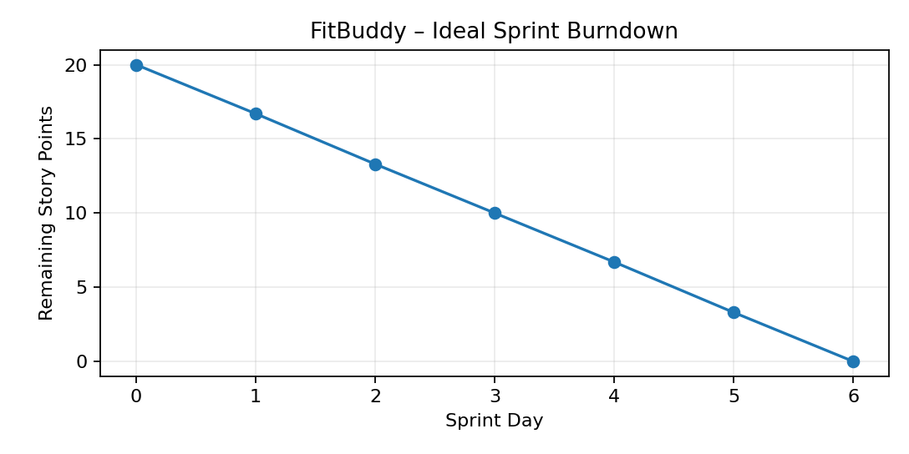

4. FitBuddy Project Milestones
Milestone | Area | Planned Activities
Milestone 1 | Model Selection & Architecture | Select Gemini models, define architecture, set up development environment.
Milestone 2 | Core Functionality Development | Develop workout generation, nutrition tips, database storage and FastAPI input processing.
Milestone 3 | routes.py Development | Implement home, workout generation, feedback update and admin routes.
Milestone 4 | Frontend Development | Develop index.html, result.html and all_users.html with responsive Jinja2 templates.
Milestone 5 | Deployment & Verification | Prepare local deployment, configure API key, run Uvicorn and verify application behaviour.

5. Team Responsibilities
Team Member | Planned Responsibility
Zohoorunnisa R | Team coordination, Gemini integration, backend architecture, routes and review.
Thanzeela Begum T | Backend input processing, workout generation support, frontend forms and testing.
Yasmeen G | UI design, nutrition tip module, feedback interface and documentation support.
Yuva Sree S | Database/SQLAlchemy, project structure, deployment support, admin view and testing.

6. Project Phase Submission Checklist
☐ Brainstorming & Ideation Phase
☐ Requirement Analysis Phase
☐ Project Design Phase
☐ Project Planning Phase
☐ Project Development Phase
☐ Project Testing Phase
☐ Project Documentation Phase
☐ Project Demonstration Phase

7. Notes
This planning document follows the supplied Project Planning Template structure: product backlog, sprint schedule, story points, velocity and burndown planning. The FitBuddy-specific stories are based on the supplied project document's workflow and functionality.

