PROJECT DESIGN PHASE – II
Technology Stack (Architecture & Stack)
Date: 29 September 2026

1. Project Details
Team ID | SWTID-2026-3350
Project Name | FitBuddy – AI Fitness Plan Generator using Gemini Models
Team Size / Members | 4 – Zohoorunnisa R; Thanzeela Begum T; Yasmeen G; Yuva Sree S

2. Technical Architecture
The architecture follows the template guidance by showing application logic, infrastructure demarcation, external interfaces, data storage and the machine-learning model interface.
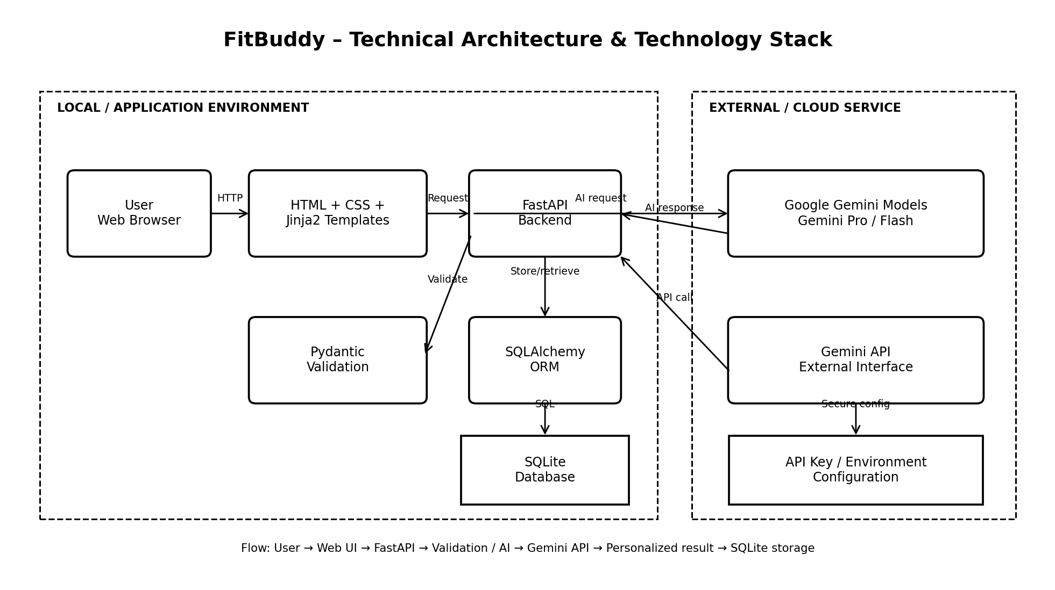

3. Table-1: Components & Technologies
S.No | Component | Description | Technology
1 | User Interface | How the user interacts with the FitBuddy application. | HTML, CSS, Jinja2 Templates
2 | Application Logic-1 | Logic for receiving and processing user fitness information. | Python + FastAPI
3 | Application Logic-2 | Input validation and request schema processing. | Pydantic
4 | Application Logic-3 | Database access and object-relational mapping. | SQLAlchemy
5 | Database | Stores user details, original plans and updated plans. | SQLite
6 | Cloud Database | Cloud database service used by the current solution. | Not specified / Not used in current local architecture
7 | File Storage | Files and project assets required by the application. | Local Filesystem
8 | External API-1 | External interface used to request AI-generated workout and nutrition content. | Google Gemini API
9 | External API-2 | Additional external API in the current solution. | Not specified / Not used
10 | Machine Learning Model | Generates personalized workout plans, nutrition/recovery tips and feedback-based updates. | Google Gemini Models – Gemini Pro / Gemini Flash
11 | Infrastructure (Server / Cloud) | Application deployment and runtime environment. | Local Server / Uvicorn; cloud deployment not specified

4. Infrastructure Demarcation
Area | Components | Purpose
Local | Browser, Jinja2, FastAPI, Pydantic, SQLAlchemy, SQLite, local filesystem | Application interface, business logic, validation and local data storage.
External / Cloud | Google Gemini API and Gemini models | AI-powered workout, nutrition and feedback-based plan generation.

5. Table-2: Application Characteristics
S.No | Characteristics | Description | Technology
1 | Open-Source Frameworks | Frameworks and libraries used to build the application. | FastAPI, Pydantic, SQLAlchemy, Jinja2
2 | Security | API credentials should be kept in environment configuration and should not be exposed in source code or UI. Input validation is applied through Pydantic/FastAPI. | Environment variables / secure API-key configuration; Pydantic validation
3 | Scalable Architecture | The application separates presentation, backend logic, AI integration and database access, allowing individual components to be extended. | FastAPI + Jinja2 + SQLAlchemy + modular Python structure
4 | Availability | The current project is designed to run while the configured local Uvicorn service is active. Distributed servers/load balancers are not specified in the current solution. | Uvicorn / local server
5 | Performance | FastAPI provides lightweight request handling; Gemini model selection separates plan-generation and concise-tip workloads; SQLite supports the current local project scope. | FastAPI + Gemini Pro/Flash + SQLite

6. Technology Stack Summary
• Frontend: HTML, CSS and Jinja2 templates
• Backend: Python and FastAPI
• Validation: Pydantic
• Database layer: SQLAlchemy
• Database: SQLite
• AI / Machine Learning: Google Gemini models
• External interface: Google Gemini API
• Local server: Uvicorn
• File storage: Local filesystem

7. References from the Provided Template
C4 Model – https://c4model.com/
IBM online order processing architecture – https://developer.ibm.com/patterns/online-order-processing-system-during-pandemic/
IBM Cloud Architecture – https://www.ibm.com/cloud/architecture
AWS Architecture – https://aws.amazon.com/architecture
How to draw useful technical architecture diagrams – Medium

