EXP 1:
CODE:
private void btnCHECK_Click(object sender, EventArgs e)
{
int n;
n = Convert.ToInt32(txtNUM.Text);
if (n % 2 == 0)
{
lblRES.Text = "Even Number";
}
else
{
lblRES.Text = "Odd Number";
}
}
OUTPUT:
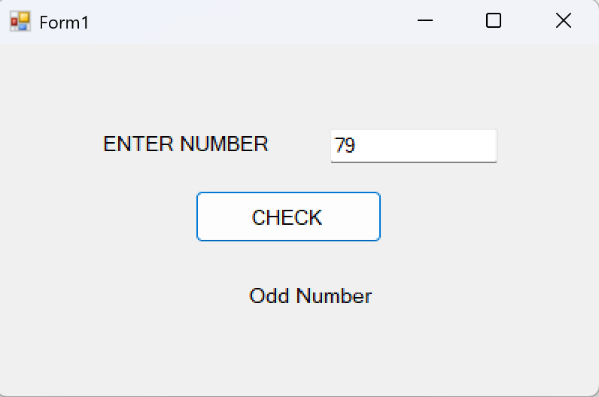

EXP 2:
CODE:
private void btnDIS_Click(object sender, EventArgs e)
{
int num;
num = Convert.ToInt32(txtNUM.Text);
string result = "Square :\n";
for(int i = 1; i <= num; i++)
{
result += i + "^2 = " + (i * i) + "\n";
}
int sum = 0;
int j = 1;
while (j <= num)
{
sum += j;
j++;
}
result += "\nSum of Natural Numbers =" + sum;
lblRES.Text = result;
}
OUTPUT:
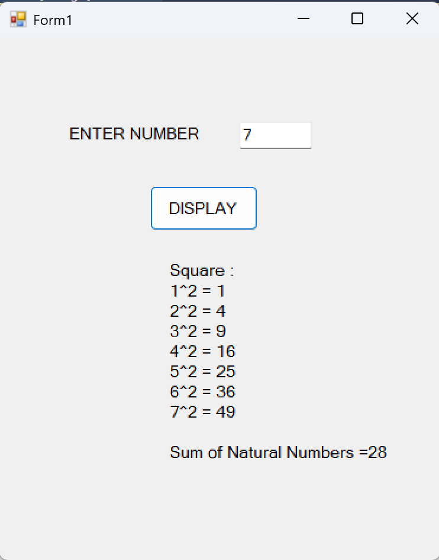

EXP 3:
CODE:
For all digits:
private void no0_Click(object sender, EventArgs e)
{
if (textBox1.Text == "")
{
textBox1.Text = "0";
}
else
{
textBox1.Text = textBox1.Text + "0";
}
}

For all operators:
private void add_Click(object sender, EventArgs e)
{
firstnumber = Convert.ToInt32(textBox1.Text);
textBox1.Text = "";
operation = "+";

}

For equal button:
private void eql_Click(object sender, EventArgs e)
{
int secondnumber;
int result;
secondnumber = Convert.ToInt32(textBox1.Text);
if (operation == "+")
{
result = firstnumber + secondnumber;
textBox1.Text = Convert.ToString(result);
firstnumber = result;
}
if (operation == "-")
{
result = firstnumber - secondnumber;
textBox1.Text = Convert.ToString(result);
firstnumber = result;
}
if (operation == "*")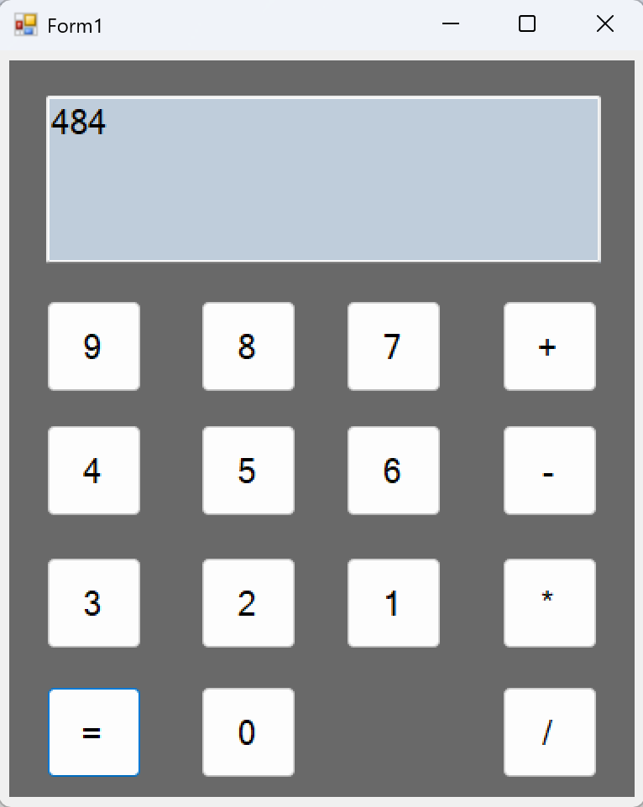
{
result = firstnumber * secondnumber;
textBox1.Text = Convert.ToString(result);
firstnumber = result;
}
if (operation == "/")
{
result = firstnumber / secondnumber;
textBox1.Text = Convert.ToString(result);
firstnumber = result;
}
}
OUTPUT:

EXP 4:
CODE:
private void button1_Click(object sender, EventArgs e)
{
if (openFileDialog1.ShowDialog() == DialogResult.OK)
{
pictureBox1.Image = new Bitmap(openFileDialog1.FileName);
pictureBox1.SizeMode = PictureBoxSizeMode.StretchImage;
}
}

private void button2_Click(object sender, EventArgs e)
{
string name = textBox1.Text;
decimal age = numericUpDown1.Value;
string gender = "";
string hobbies = "";
string bloodgroup = "";
if (radioButton1.Checked)
gender = "Male";
else if (radioButton2.Checked)
gender = "Female";
if (checkBox1.Checked)
hobbies += "Reading ";
if (checkBox2.Checked)
hobbies += "Singing ";
if (checkBox3.Checked)
hobbies += "Dancing ";
bloodgroup = comboBox1.SelectedItem.ToString();
MessageBox.Show("Name : " + name + "\nAge : " + age + "\n Gender : " + gender +
"\nBlood Group : " + bloodgroup + "\nHobbies : " + hobbies);
}

OUTPUT:
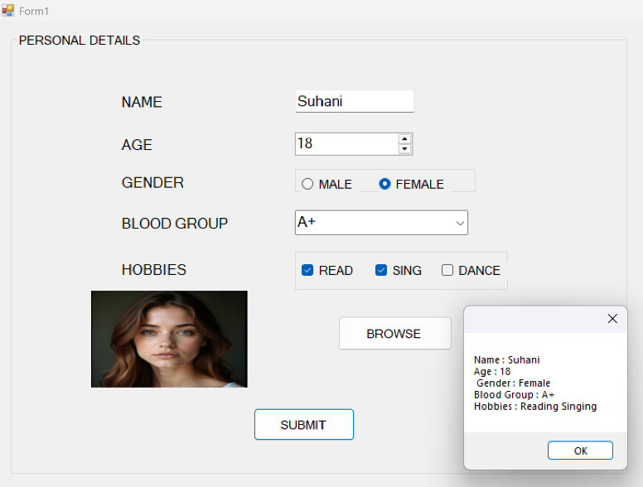

EXP 5:
CODE:
FORM 1:
private void textBox1_KeyPress(object sender, KeyPressEventArgs e)
{
if (!char.IsControl(e.KeyChar) && !char.IsDigit(e.KeyChar))
e.Handled = true;
}

For all text box validating:
private void textBox1_Validating(object sender, CancelEventArgs e)
{
if (textBox1.Text.Trim() == "")
{
errorProvider1.SetError(textBox1, "Enter Mark");
e.Cancel = true;
return;
}
int mark = Convert.ToInt32(textBox1.Text);
if (mark < 0 || mark > 100)
{
errorProvider1.SetError(textBox1, "Mark should be " +
"between 0 and 100");
e.Cancel = true;
}
else
{
errorProvider1.SetError(textBox1, "");
}
}
private void button1_Click(object sender, EventArgs e)
{
int m1 = Convert.ToInt32(textBox1.Text);
int m2 = Convert.ToInt32(textBox2.Text);
int m3 = Convert.ToInt32(textBox3.Text);
int total = m1 + m2 + m3;
double average = total / 3.0;
string result;
if (m1 >= 35 && m2 >= 35 && m3 >= 35)
result = "Pass";
else
result = "Fail";
this.Hide();
Form2 frm = new Form2(total, average, result);
frm.ShowDialog();
Application.Exit();

OUTPUT:
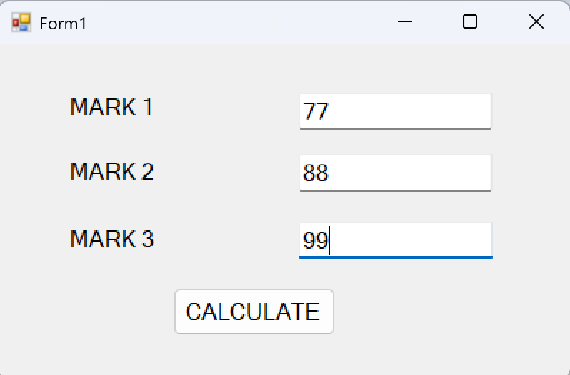

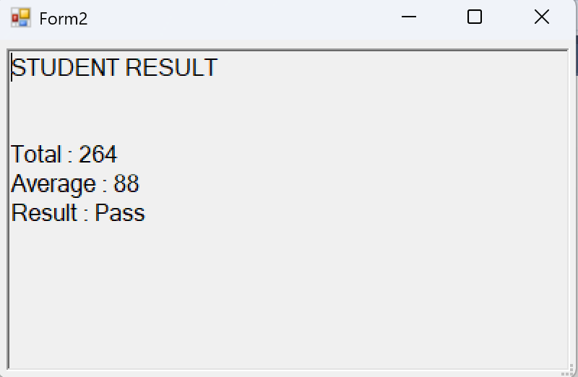

EXP 6:
CODE:
private void nEWToolStripMenuItem_Click(object sender, EventArgs e)
{
richTextBox1.Clear();
}

private void oPENToolStripMenuItem_Click(object sender, EventArgs e)
{

if (openFileDialog1.ShowDialog() == DialogResult.OK)
richTextBox1.Text = System.IO.File.ReadAllText(openFileDialog1.FileName);
}

private void sAVEToolStripMenuItem_Click(object sender, EventArgs e)
{
saveFileDialog1.Filter = "Text files|*.txt";
if (saveFileDialog1.ShowDialog() == DialogResult.OK)
System.IO.File.WriteAllText(saveFileDialog1.FileName, richTextBox1.Text);
}

private void eXITToolStripMenuItem_Click(object sender, EventArgs e)
{
Close();
}

private void cUTToolStripMenuItem_Click(object sender, EventArgs e)
{
richTextBox1.Cut();
}

private void cOPYToolStripMenuItem_Click(object sender, EventArgs e)
{
richTextBox1.Copy();
}

private void pASTEToolStripMenuItem_Click(object sender, EventArgs e)
{
richTextBox1.Paste();
}

private void sELECTALLToolStripMenuItem_Click(object sender, EventArgs e)
{
richTextBox1.SelectAll();
}

private void uNDOToolStripMenuItem_Click(object sender, EventArgs e)
{
richTextBox1.Undo();
}

private void rEDOToolStripMenuItem_Click(object sender, EventArgs e)
{
richTextBox1.Redo();
}

private void fONTSTYLEToolStripMenuItem_Click(object sender, EventArgs e)
{
if (fontDialog1.ShowDialog() == DialogResult.OK)
richTextBox1.Font = fontDialog1.Font;
}

private void fONTCOLORToolStripMenuItem_Click(object sender, EventArgs e)
{
if (colorDialog1.ShowDialog() == DialogResult.OK)
richTextBox1.ForeColor = colorDialog1.Color;
}

OUTPUT:
