**PROJECT 2: BASIC SORTING**

**-----o-----**

***Name: Trần Gia Bảo***

***ID: 22127034***

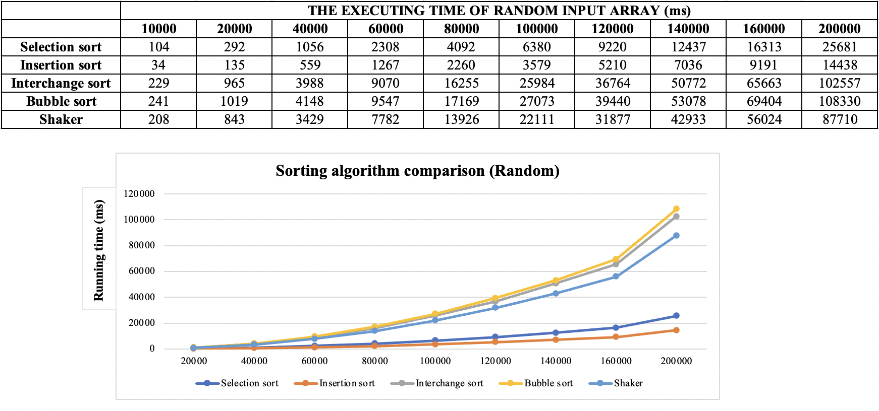

**🡪 Comment:** With random input, as the number of elements increases, the Interchange sort and Bubble sort algorithms take longer to execute. In contrast, Insertion sort and Selection sort algorithms take less time to execute.

**🡪 Comment:** With ordered input, the Selection sort, Interchange sort, Bubble sort, and Shaker sort algorithms all have equal execution time (It isn’t too slow as the number of elements increases). Especially, Insertion sort algorithm always has an execution time of 0.

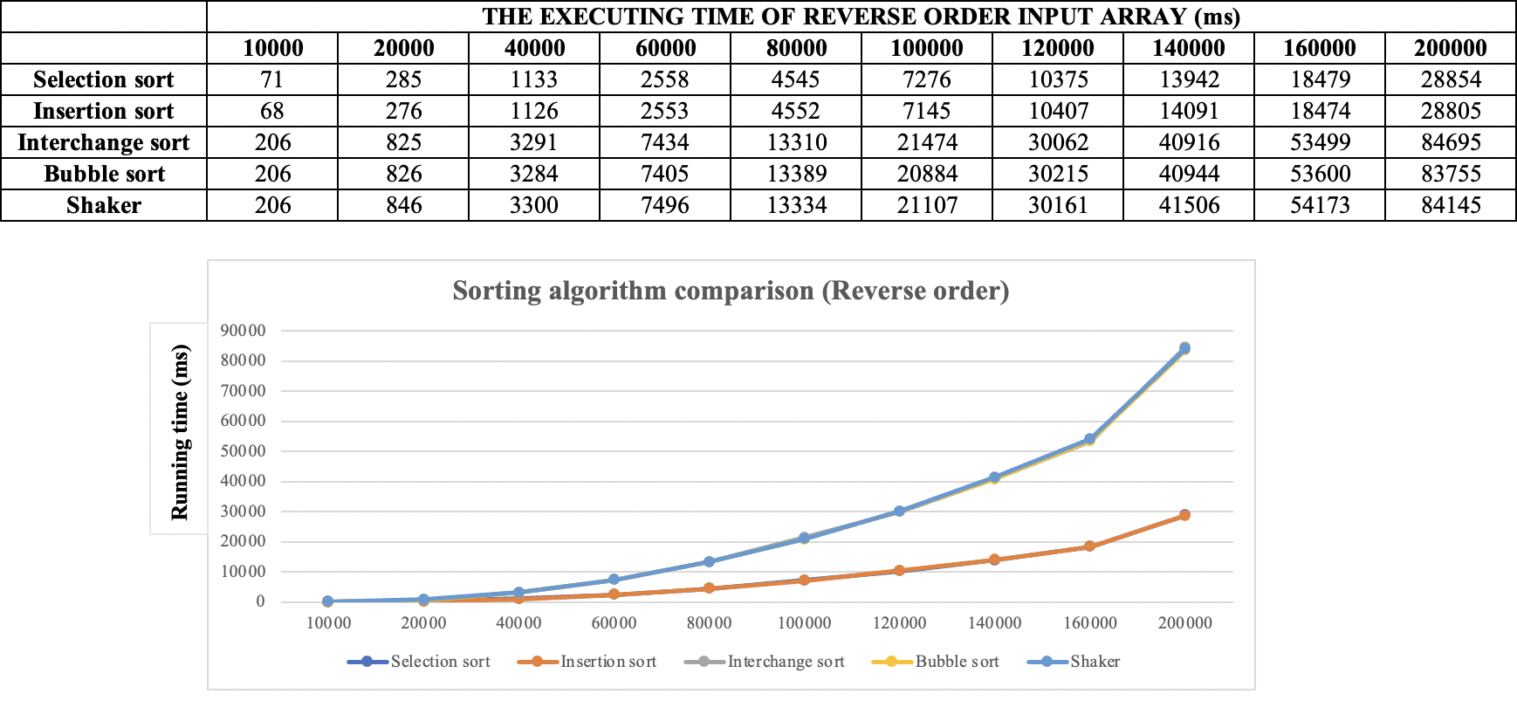

**🡪 Comment:** With input in reverse order, the execution time of the Selection sort and Insertion sort algorithms is not too slow as the number of elements in the array increases. In contrast, the Interchange sort, Bubble sort and Shaker sort algorithms are 3 times slower.

**🡪 Comment:** With a quasi-ordered input (5% of elements out of position), the execution time of the Insertion sort algorithm is very fast compared to the other 4 algorithms.

**🡪 Summary:** Each algorithm has its own strengths and weaknesses. However, with almost ordered input data, the Insertion sort algorithm has an advantage.