**CHUYẾN BAY:**

**ĐẶT CHỖ:**

**KHÁCH HÀNG:**

**KHẢ NĂNG:**

**LỊCH BAY:**

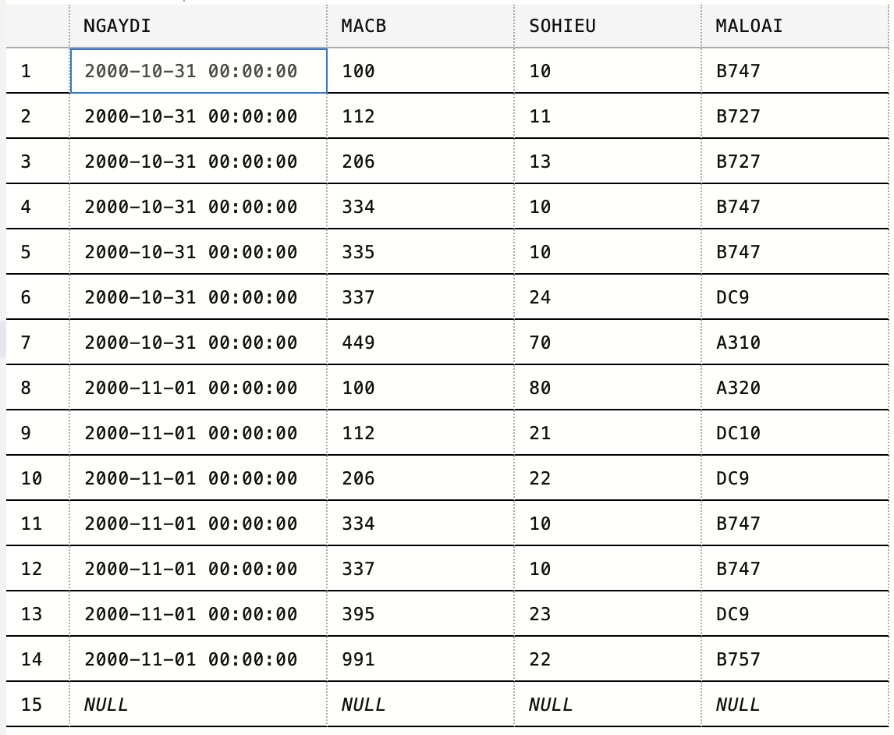

**LOẠI MB:**

**MÁY BAY:**

**NHÂN VIÊN:**

**PHÂN CÔNG:**

