MAGNA FOODSERVICE
VOLUME 2 OF 4
Technical Architecture
System Design, Data Pipeline & Schema
How the system is built — for CTO review and engineering handover
Lead Intelligence System — Complete Project Document Set
July 2026 · Owner: Zoeb

Contents
1. Architecture Overview 3
2. Technology Stack 4
3. Data Sources 5
4. The Lead Discovery Pipeline (Full Flow) 6
5. The Platform-First MVP Flow 9
6. Deduplication Logic 11
7. FSA Matching by Address 12
8. Company Enrichment (In-House, Zero Cost) 13
9. Data Schema Reference 14
10. Scoring Model 15
11. Design Decisions and Changes Log 17

1. Architecture Overview
The system is a deterministic, serverless data pipeline — not an AI agent framework. Intelligence lives in the calibrated scoring model and matching logic, both derived from real customer data, not in a language model making runtime decisions. This is a deliberate choice: it keeps the system auditable, cheap to run, and maintainable by a single technical owner.

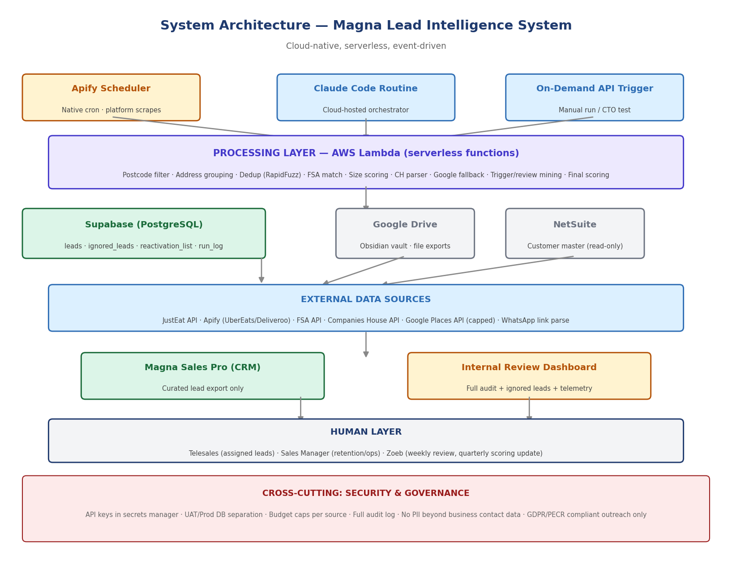

Three trigger paths feed the processing layer: a native Apify schedule for platform scraping, a Claude Code cloud routine for orchestration and scoring, and an on-demand API trigger for manual testing. All processing runs as serverless AWS Lambda functions — no server to provision, patch, or maintain.

2. Technology Stack
Layer | Technology | Role
Frontend / UI | Next.js on Vercel | Internal dashboard for non-technical staff; staging preview per branch
Database | Supabase (PostgreSQL) | Replaces Google Sheets, which broke at scale in a previous project. UAT and production strictly separate.
Pipeline processing | AWS Lambda (serverless) | Batch execution of pipeline stages — pay only when running
Orchestration | Claude Code cloud routine | Scheduled, cloud-hosted, no local machine dependency
Scraping (2 of 3 platforms) | Apify with built-in proxy rotation | Pre-built community actors for Uber Eats / Deliveroo
Scraping (JustEat) | Public JSON endpoint | No scraping required — structured data, zero proxy risk
Deduplication | RapidFuzz (Python) | Multi-field composite fuzzy matching
Version control / CI | GitHub + GitHub Actions | Automated deployment pipeline
CRM | Magna Sales Pro (existing) | Lead assignment and conversion tracking
ERP | NetSuite (existing, read-only) | Source of truth for customer master data

Why no LLM at runtime
No vector databases, no agent frameworks, no LLM calls in the core pipeline. This keeps cost near-zero (pennies per run, see Volume 4) and keeps every decision traceable to a rule, not a model inference. An LLM is used only optionally, later, for menu classification — a Phase 2 enrichment, not a Phase 1 dependency.

3. Data Sources
Source | Cost | What It Provides
JustEat public endpoint | Free | Primary discovery — structured JSON, no scraping needed
Apify (Uber Eats + Deliveroo) | Low, per result | Secondary discovery via pre-built actors + proxy rotation
FSA Food Hygiene Rating API | Free, no key | Legitimacy check, hygiene rating, lat/long, matched BY ADDRESS
Companies House API | Free, key required | Company status, directors, PSC, red flags, filed accounts (parsed in-house for financials)
Google Places API | Capped £5/day | Fallback only — phone/address gap-filling on named businesses, never bulk discovery
WhatsApp click-to-chat links | Free | Phone number extracted directly from wa.me links on Google/Facebook business pages — highest-confidence mobile source

DataLedger (third-party financial data provider) was evaluated and rejected — see Section 8. All financial enrichment is produced in-house from the same public Companies House filings at zero marginal cost.

4. The Lead Discovery Pipeline — Full Flow
The reference architecture. All 10 stages, all decision gates, all exit routes.

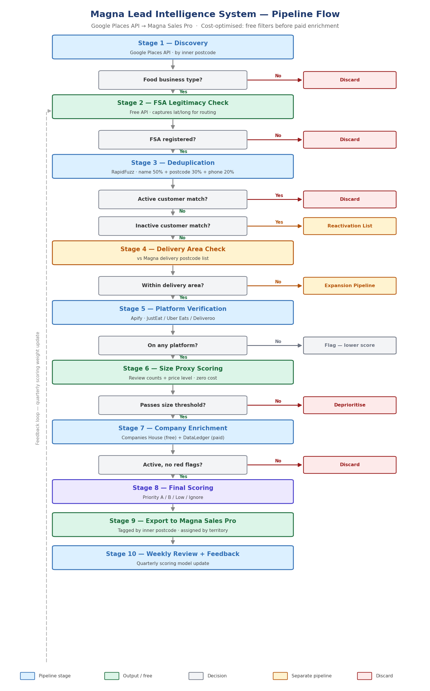

4.1 Stage-by-stage detail
Stage | What Happens | Cost
1 — Discovery | Search one postcode area across delivery platforms and/or Google Places | Low/free
2 — FSA Check | Match by address. Captures lat/long, hygiene rating. No match = discard. | Free
3 — Deduplication | RapidFuzz vs Magna customers. 80%+ match auto-ignored to internal log, not shown to CRM. Active = discard, Inactive = Reactivation List. | Free
4 — Delivery Area Check | Only searches postcodes already delivered to — filter is implicit in search scope, not a separate stage in MVP | Free
5 — Platform Verification | Confirms live trading status; captures reviews, ratings, cuisine, phone numbers | Low
6 — Size Proxy Scoring | Review counts (with Google fallback where platform reviews are thin) substitute for unavailable turnover data | Free
7 — Company Enrichment | Companies House matched by address; financials parsed in-house from filed accounts | Free
8 — Trigger + Review Mining | New-business and ownership-change flags; public review scanning for competitor-failure signals | Free
9 — Final Scoring | Calibrated model applied — see Section 10 | Free
10 — Export + Feedback | Curated fields to Magna Sales Pro; full record retained internally; quarterly recalibration | Free

5. The Platform-First MVP Flow
The build sequence starts here — not with the full architecture above. Delivery platforms replace Google Places as the primary discovery source for the MVP phase, because every result is provably live and trading today, directly solving the failure mode of the earlier Google-Places-only attempt.

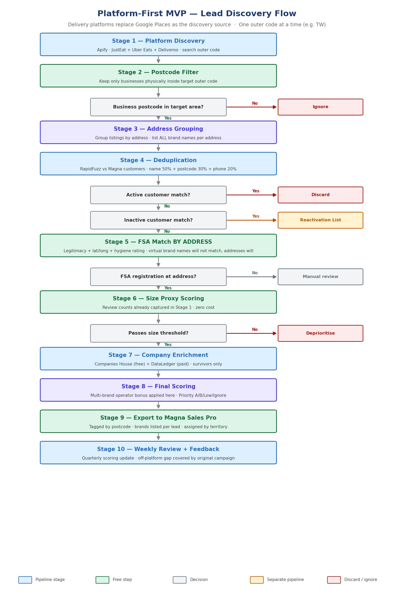

5.1 Owner decisions locked into this flow
# | Decision | Rule
1 | Out-of-area businesses are ignored | Platforms return businesses delivering INTO an area from outside it — filtered out by address, not delivery radius
2 | Virtual brands are wanted leads | One kitchen running six brands from one address = one lead, all brands listed, scoring bonus applied
3 | Multi-tenant buildings are split correctly | Differentiated from single-kitchen multi-brand via FSA registration count at the address — multiple FSA registrations = separate tenants, separate leads
4 | Off-platform businesses are deferred, not forgotten | Reached later via the original outbound campaign — logged as a known Phase 2 item, not a gap
5 | FSA and Companies House matching is by ADDRESS, not brand name | Prevents the exact false-positive error caught during a live audit of an experimental run (see Volume 3, Appendix)

6. Deduplication Logic
Field | Weight | Method
Business name | 50% | Token sort ratio (RapidFuzz) — handles word order variation, stripped of Ltd/Limited/The
Postcode district | 30% | Exact match on first characters
Phone number | 20% | Exact match after normalisation (strip non-digits, +44 → 0 prefix)

Simplified threshold rule (owner-directed)
80% or higher composite score = automatic ignore. The lead is logged in a separate internal Ignored Leads table with the reason, matched account, match percentage and which fields matched — but is NOT surfaced for manual review. This removes review burden while preserving a full audit trail for management to query later.
Below 80% but above a lower floor: the lead still enters the main lead file, colour-flagged, showing the partial match percentage and matched account — scored lower but not discarded.

7. FSA Matching by Address
The single most important correction to the original design. Matching by business/brand name fails for virtual brands — a dark kitchen trading as six different names on delivery platforms will never appear under any of those names in the FSA register, because FSA registration is tied to the physical premises and its operating company, not the marketing brand.

Matching by address instead: the FSA record at the premises typically names the actual operator. When this operator name correlates with a Companies House record at the same address, that is treated as a verified match. Brand name is used only as a last-resort, low-confidence fallback — never as the primary key.

The number of distinct FSA registrations found at one address is also the mechanism used to distinguish a single multi-brand kitchen (one registration, several brand names) from a subleased multi-tenant building (multiple registrations, one per tenant) — see Section 5.1, Decision 3.

8. Company Enrichment — In-House, Zero Cost

8.1 Why DataLedger was evaluated and rejected
DataLedger (a third-party UK company financial data provider) was tested against the free-credit tier. Its core service is parsing Companies House iXBRL filings into structured JSON — balance sheet, and profit & loss where a company has chosen to disclose it. Critically: the underlying data is entirely public. Companies House filings are freely accessible; DataLedger’s value-add is the parsing convenience, not the information itself.

Given the volume required and the fact that most target businesses are micro-entities that never disclose turnover in the first place, the decision was made to build an equivalent in-house parser rather than pay per record indefinitely.

8.2 What the in-house parser produces
The same field format used by commercial providers is replicated (c_ prefix for current year, p_ for prior year) so the schema is portable and familiar:
- Total assets, fixed assets, current assets, cash at bank, debtors, creditors, current liabilities, net assets, equity
- Turnover and profit fields — populated only where a company has voluntarily filed full accounts (a minority of small limited companies)
- Employee count where disclosed
- A derived Financial_Label field using an in-house formula: Solvent-Growing / Solvent-Stable / Thin / Insolvency-Flag / No-Data / Dormant

Important limitation, stated plainly
Net assets is a solvency signal, not a size signal. A high-turnover takeaway can show low net assets due to leased premises, director loans, or profit taken as salary. It answers “is this company financially stable”, not “how big is this business.” Business size continues to be estimated from platform review volume and rating (Section 4.1, Stage 6), not from financial filings.

9. Data Schema Reference
The full field schema (102 fields across 9 groups) is maintained as a separate, actively-versioned Excel workbook shared directly with the CTO for CRM field mapping. It is referenced here rather than reproduced in full, since it changes independently of this document as CRM constraints are confirmed.

Field Group | Field Count | Purpose
Identity | 11 | Business identity, address, postcode hierarchy, lat/long
Contact | 14 | All phone numbers across all sources — WhatsApp link, Google, Facebook, website, landlines
FSA Verification | 6 | Legitimacy, hygiene rating, registration count at address
Company Profile | 16 | Companies House data, directors, PSC, director trace for phoenix detection
CH Financials (in-house) | 18 | Balance sheet data parsed from filed accounts, zero external cost
Platform | 9 | Ratings, review counts, cuisine, multi-brand flag
Trigger + Review Mining | 9 | Timing-based buying signals — new business, ownership change, competitor-failure review flags
Scoring | 9 | Final score, tier, uniqueness/legitimacy percentages, match detail
Pipeline | 4 | Run tracking, search code, assignment, status

Reference document: Magna_Lead_Field_Schema_v4.xlsx — current version shared with CTO for field validation against the Magna Sales Pro API.

10. Scoring Model
All weights below are derived from analysis of real customer data — see Volume 1, Section 3 — not estimated.

Factor | Points | Basis
Fast Casual Restaurant | +28 | Lowest churn (28.6%), £611/wk average
Fried Chicken Shop | +25 | Highest count in ICP top quartile
Piri Piri Shop | +24 | Highest spend of top types (£734/wk)
Burger Restaurant | +18 | High volume, tempered by 64.4% churn
Café / Coffee Shop | -10 | 80.5% churn
Other / unclassified | -20 | 93.9% churn
Core territory (UB, W, HA, TW, SW, SL) | +20 | Highest concentration of best customers
Mobile number captured | +15 | Primary contact channel for demographic
New business (FSA reg < 60 days) | + (trigger bonus) | No incumbent supplier — timing signal
Recent ownership change detected | + (trigger bonus) | Buyer actively reviewing suppliers
Review complaint about current supplier | + (trigger bonus) | Live signal of switching intent
Matches inactive customer (80%+ dedup) | Auto-ignored | Routed to Reactivation List, not scored as new

Priority Tier | Score | Action
Priority A | 70+ | Contact within 24 hours — SAME-DAY if trigger-flagged
Priority B | 40–69 | Work within the week
Low | 20–39 | One call or email only
Ignore | Under 20 | No sales time allocated

11. Design Decisions and Changes Log
A running record of material design changes made during project development, with rationale, so the reasoning is never lost.

Change | From → To | Why
Discovery source | Google Places only → Delivery platforms primary, Google fallback | Every platform result is provably trading today; Google alone previously produced dead/invalid data
Enrichment sequencing | Paid checks mid-pipeline → All free filters before any paid call | Minimises paid API spend to genuinely surviving leads only
Out-of-area handling | Score penalty, kept in pipeline → Removed to separate Expansion Pipeline | Preserves the data for future route growth instead of discarding it
Financial data source | DataLedger (paid, per-record) → In-house Companies House parser (free) | Same public source data; removes ongoing per-record cost entirely
Business size proxy | Assumed turnover data → Platform + Google review volume | ~50% of small companies never disclose turnover; review data is free and always available
Dedup handling | Full manual review queue → 80%+ auto-ignore with full audit log | Reduces review burden while preserving traceability
FSA and CH matching key | Business/brand name → Physical address | Brand name matching produced false positives on multi-brand virtual kitchens — caught during a live audit
Scoring inputs | Static business profile only → Profile + timing triggers (new business, ownership change, review complaints) | Conversion is a timing problem as much as a targeting problem
Lead routing | Uniform weekly batch → Trigger-flagged leads get same-day routing | Buying signals decay fast; delay destroys the value of a trigger

Magna Foodservice — Volume 2 of 4 — Technical Architecture — July 2026

