MAGNA FOODSERVICE
VOLUME 3 OF 4
Process & Operations
Automation, Triggers & Actionable Intelligence
How the system runs day to day, how leads become calls, and how the data becomes revenue
Lead Intelligence System — Complete Project Document Set
July 2026 · Owner: Zoeb

Contents
1. Operating Philosophy 3
2. Automation — Minimal Human Intervention 4
3. Trigger-Based Routing 6
4. From Data to Actionable Intelligence 8
5. The Weekly and Quarterly Cadence 10
6. Cost Funnel and Run Economics 11
7. Manual Testing Protocol 12
8. Appendix — Live Audit Findings 13

1. Operating Philosophy
This is not a build-once, run-forever system. It is designed around three operating principles that determine every process decision in this volume:
- Automate the repeatable, verify the uncertain. Discovery, matching, and scoring run without human input. Anything genuinely ambiguous is logged for review, never silently guessed.
- Speed matters as much as accuracy. A perfectly scored lead delivered a week late converts worse than a good lead delivered same-day. Section 3 covers this in detail.
- The system must justify its own existence continuously. Every run is logged with cost, duration, and volume at each stage — not as bureaucracy, but so the economics can be proven and defended at any time.

2. Automation — Minimal Human Intervention

2.1 What runs without a human
- Platform discovery — Apify native scheduler, runs on a fixed cadence with no manual trigger
- Postcode filtering, address grouping, deduplication — fully automated Python logic
- FSA and Companies House matching — automated API calls, address-keyed
- Scoring, tiering, and trigger flagging — automated calculation against the calibrated model
- Internal database logging — every lead, every ignored record, every run’s telemetry, written automatically

2.2 What deliberately stays manual
The one gate that stays human — by design, not by limitation
The Magna Sales Pro CRM upload is a manual, reviewed step, even once the system is fully proven. Automating the write into the CRM that telesales works from is exactly the kind of irreversible action that turns one bad batch into twenty embarrassing calls to real customers. Five minutes of review before upload is the cheapest quality control the business will ever buy. This can be revisited after six months of proven reliability — not before.

2.3 Where the automation actually lives
Component | Where It Runs | Why
Platform scraping | Apify native scheduler | Purpose-built for this exact job — not reinvented inside an AI orchestrator
Processing, matching, scoring | Claude Code cloud routine, scheduled weekly | Runs on Anthropic-managed cloud infrastructure — no dependency on a local machine being switched on
CRM upload | Manual, by Zoeb, after review | Deliberate human checkpoint — see 2.2
DataLedger / Google Places calls | Fallback-only, cost-capped | Never the primary path — only fires when free sources are insufficient

3. Trigger-Based Routing
Not every lead deserves the same urgency. The scoring model in Volume 2 tells you how good a lead is. Trigger detection tells you when to act on it — and timing is, in practice, as important as quality.

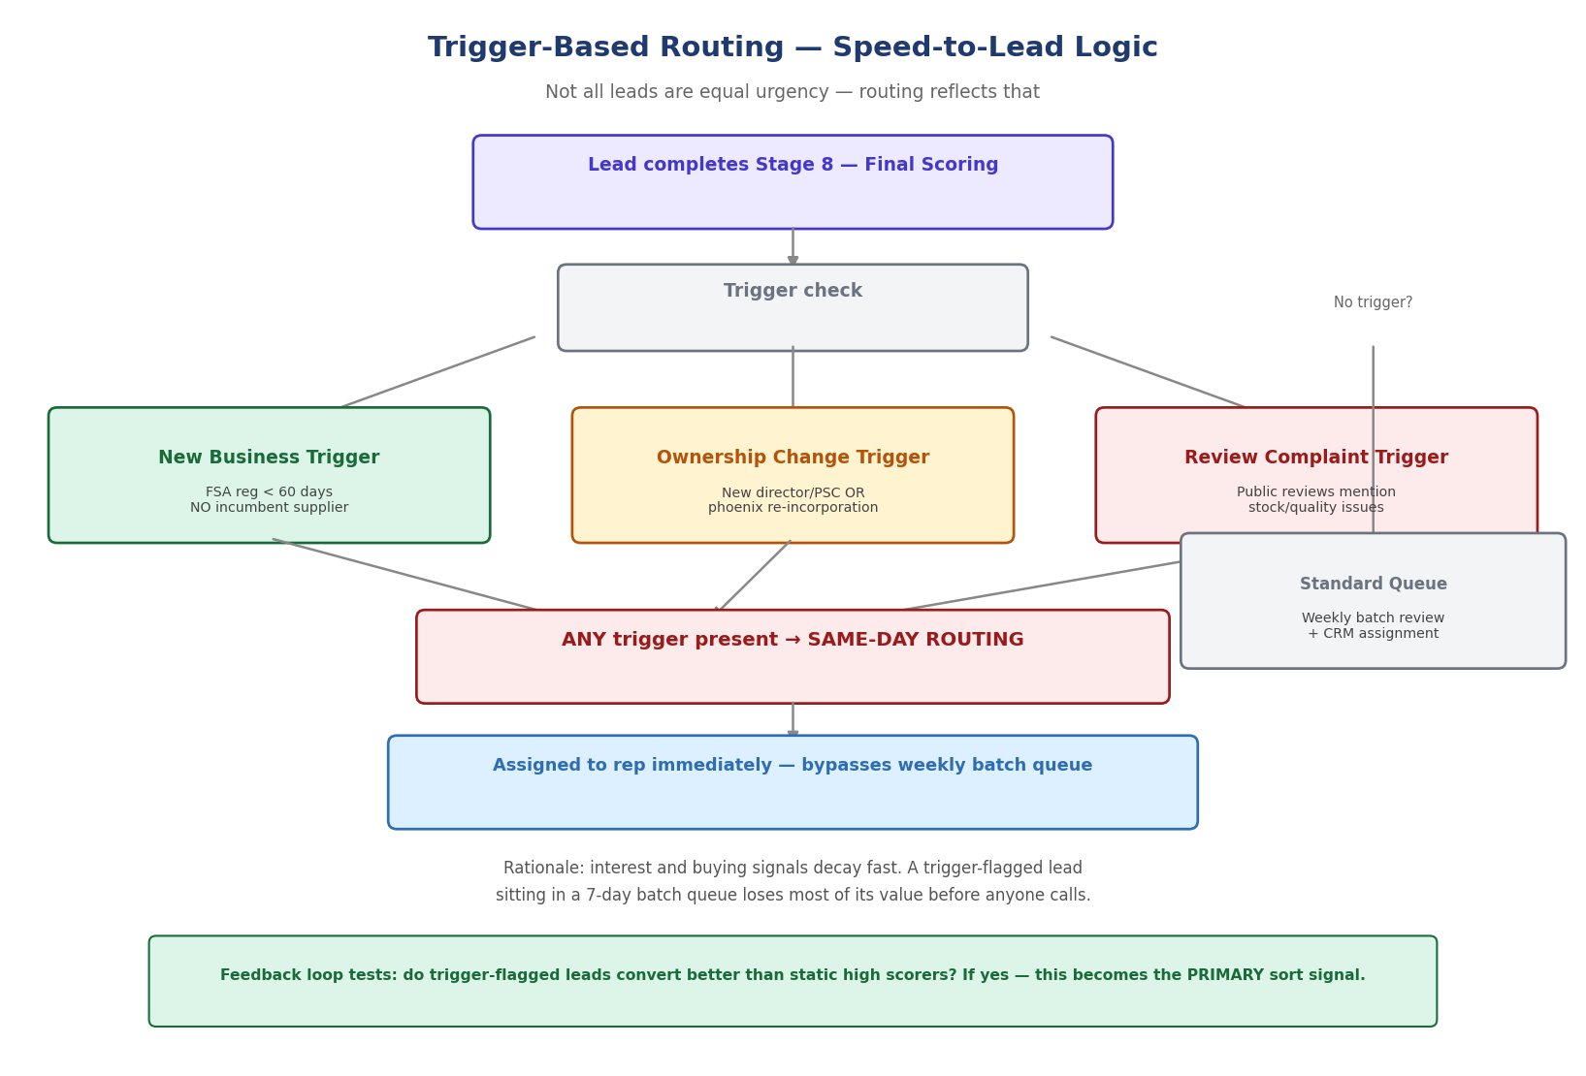

3.1 The three triggers
- New Business — FSA registration under 60 days old. No incumbent supplier relationship exists to break.
- Ownership Change — a new director or PSC appointment, or a dissolved company re-incorporated at the same address (phoenix pattern). A new owner is actively reviewing every supplier relationship.
- Review Complaint — public reviews on Google or delivery platforms mentioning stock shortages, inconsistency, or quality drops. A live signal that the current supplier is failing that business right now.

3.2 The routing rule
Any trigger present — the lead bypasses the standard weekly batch and is assigned to a rep the same day. No trigger — it enters the normal weekly review queue. This is enforced automatically at export, not left to manual judgement.

4. From Data to Actionable Intelligence
Data alone does not close deals. This section defines exactly how the pipeline’s output is meant to be used by a human being on the phone.

4.1 What the rep sees, and why each field matters
Field the Rep Sees | How It Changes the Call
Director/PSC name | Ask for the person by name at the gatekeeper stage — measurably improves call-through rate versus asking for “the owner”
Mobile number (WhatsApp-sourced preferred) | Matches the channel this demographic actually uses — higher answer rate than a cold landline call
Multi-brand flag + all brand names | One call can open a relationship covering several product ranges at once — reframes the pitch entirely
Trigger flag + reason | Gives the rep an opening line grounded in fact: “I saw you’ve recently opened / recently taken over / [issue] — we can help with that”
Review trigger snippet | A specific, honest hook — not a script, a genuine observation that shows the call is not random
Financial label (Solvent-Growing etc.) | Internal-only — informs prioritisation, never spoken to the prospect

4.2 What management sees, and why it matters
- The Ignored Leads log — held internally, never exported — is searchable so management can spot patterns: territories with unusually high existing-customer density, business types consistently filtered out, data quality gaps
- Run telemetry — duration, cost, volume at each stage — proves the economics of the system continuously rather than as a one-off business case
- Quarterly conversion data feeds back into the scoring model — the system should get measurably better at picking winners every quarter, not stay static

5. The Weekly and Quarterly Cadence
Cadence | Activity | Owner
Continuous / scheduled | Platform discovery, processing, scoring runs automatically | System (Apify + Claude Code routine)
Weekly | Review of scored lead batch before CRM upload | Zoeb
Weekly | Conversion review in Magna Sales Pro — what converted, what didn’t | Sales Manager + reps
Same-day (event-driven) | Trigger-flagged leads assigned immediately, outside the weekly cycle | System → Rep, automatic
Quarterly | Scoring model weights recalibrated against real conversion outcomes | Zoeb
Quarterly | Review of Ignored Leads log for patterns worth management attention | Zoeb + Sales Manager
Ongoing | Manual verification test on any new data source or stage before it goes live | Zoeb

6. Cost Funnel and Run Economics
Every stage of the pipeline exists partly to reduce the volume reaching the next — and therefore the cost of the next. This is not accidental; it is the core cost-control mechanism of the entire design.

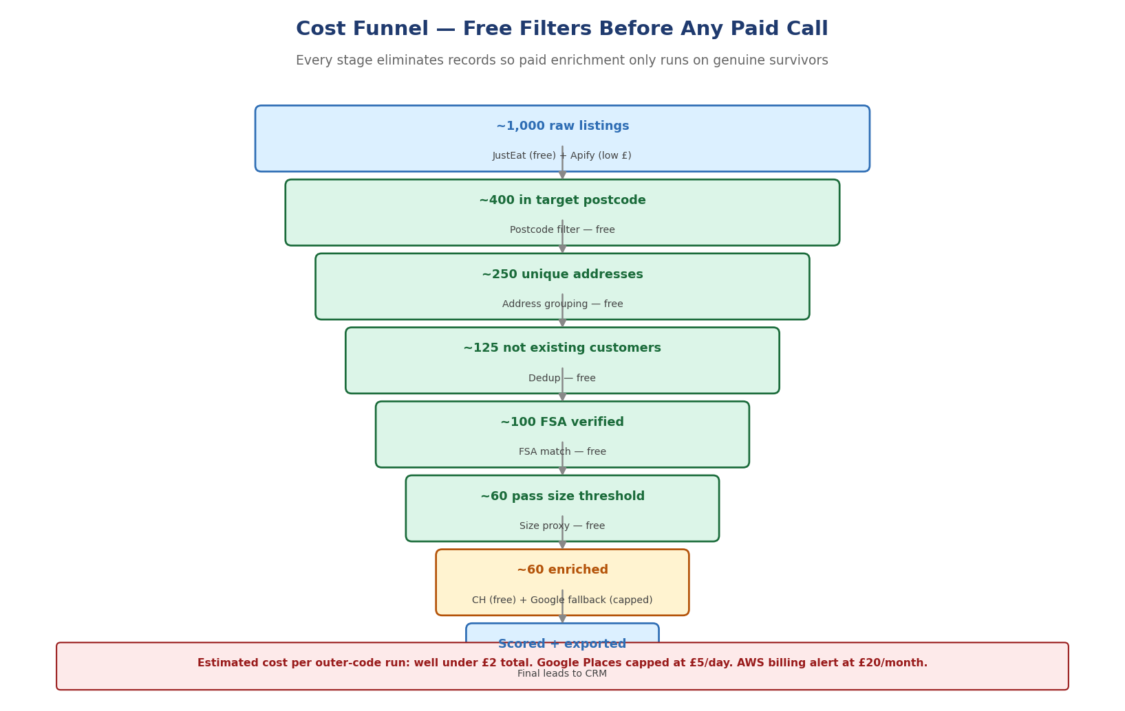

Full budget framework, per-source pricing, and hard caps are detailed in Volume 4, Section 3.

7. Manual Testing Protocol
The single business rule that gates every new stage or source
Before any new data source, matching rule, or scoring change goes live at volume, one business is run through the entire flow by hand — find it on the platform, check its postcode, check it against the customer list, find its FSA record by address, look it up on Companies House. If this cannot be done manually in under 10 minutes per business, the automated design has a flaw that must be fixed before scaling, not after.

This protocol applies permanently, not just at initial launch — every material change to the pipeline is tested this way before it touches live lead volume.

8. Appendix — Live Audit Findings
An early experimental run was independently audited against live public records (Companies House, FSA) before this architecture was finalised. The findings materially shaped the design decisions recorded in Volume 2, Section 11, and are preserved here as evidence.

Finding | Verified Outcome | Design Change Made
Business-to-company name matching | Confirmed cases of correct-looking but wrong company matches (e.g. a fish and chip shop matched to an unrelated company sharing one word in its name) | Matching rule changed to address-based, name dropped to last-resort fallback — see Volume 2, Section 7
Dissolved company handling | A dissolved company was found still trading under the same brand at the same premises, with recent live customer reviews | Rule added: dissolved + live platform listing = keep lead, void company data, flag for new-entity/director trace — not auto-discard
Discovery via public platform endpoint | A public, unauthenticated JustEat endpoint returned genuine, structured, verifiable business listings with no scraping required | Adopted as the primary Stage 1 discovery source, replacing planned reliance on Apify for all three platforms
Financial enrichment necessity | Manual review confirmed that most small companies in the target segment disclose no turnover, and that net assets alone can be a misleading size signal for a leasehold takeaway | DataLedger dropped; in-house parser built; review volume retained as the primary size proxy — see Volume 2, Section 8

Magna Foodservice — Volume 3 of 4 — Process & Operations — July 2026

