## Usage

On the command line, run

python test_model_run.py

After executing, a series of figures will be displayed for A and P including: the minimum and maximum CDF for each alpha-level, the combined minimum and maximum (figure 1 and 2), and an interactive 3D plot of the combinied minimum and maximum. The file test_model_run_uq results also contains the console output of the run used to create these figures

## Explanation

Let A and P be two models,

A = PA + FA + XF + YG + c P = (PP + FP)X^2+ cY + F + G

where PA , FA , PP , FP are the total area and total perimeter of all probabilistic and fuzzy shapes respectively, X and Y are probabilistic random variables, F and G are fuzzy numbers[1], and c is a constant.

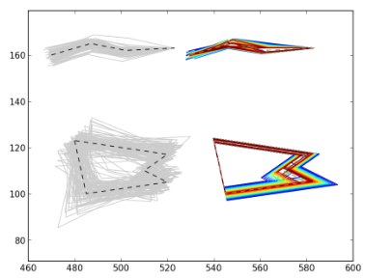

Figure

For this example, let the inputs to A and P consist of 4 shapes (figure 1). The definition of the shapes as well as the remaining parameters are shown in the tables below.

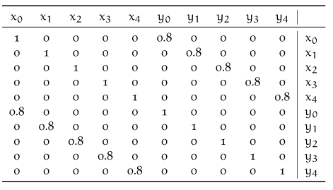

Table 4.8

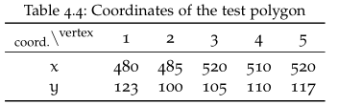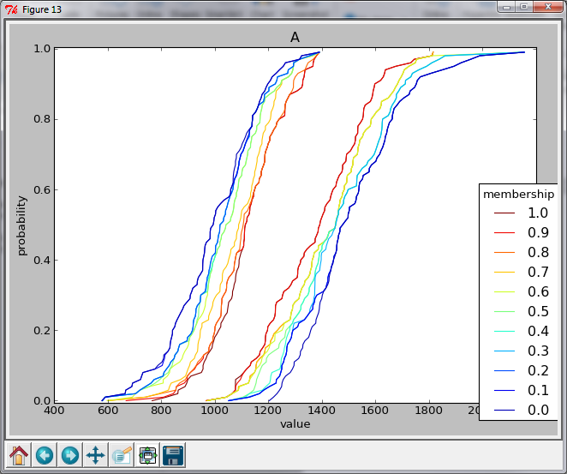

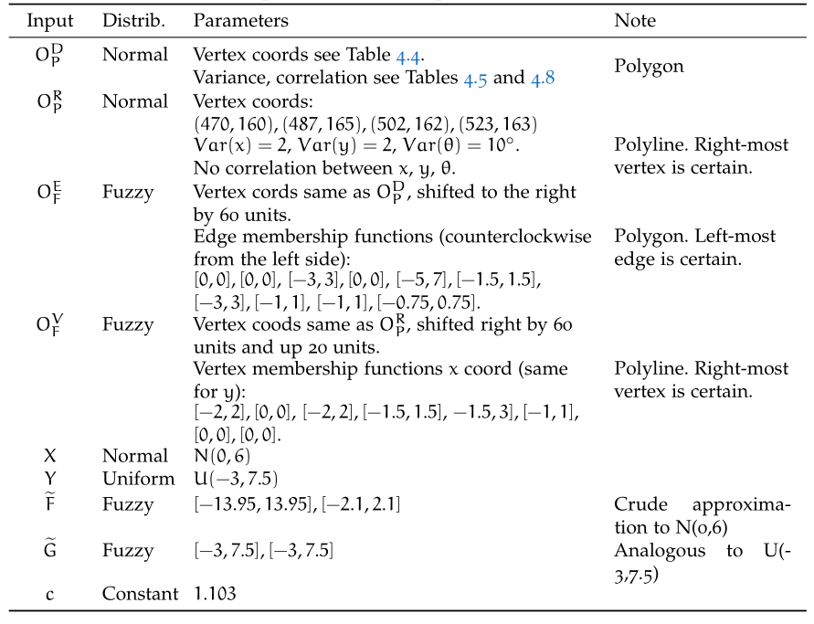

Table 1

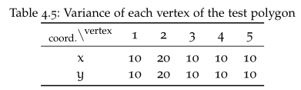

Table 4.5

Figure 2: Fuzzy CDF for A

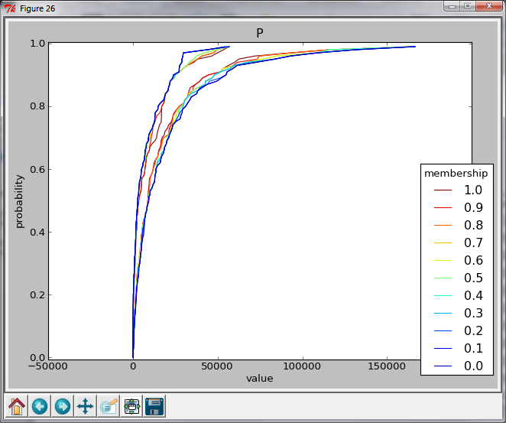

Figure 3: Fuzzy CDF for P

1. In table 1, fuzzy numbers are defined as [sl, su], [kl, ku] where sl, and su are the lower and upper bounds of the support and kl and ku are the same for the kernel.