A PROJECT REPORT

on

“Fruit Type Classification Using Deep Learning”

Submitted to

KIIT Deemed to be University

In Partial Fulfilment of the Requirement for the Award of

BACHELOR’S DEGREE IN

COMPUTER SCIENCE ENGINEERING

BY

Kishalay Majumder
Aditya Sharma

22052123
22052001

UNDER THE GUIDANCE OF

Dr. Partha Pratim Sarangi


SCHOOL OF COMPUTER ENGINEERING

KALINGA INSTITUTE OF INDUSTRIAL TECHNOLOGY

BHUBANESWAR, ODISHA - 751024

April 2025

KIIT Deemed to be University

School of Computer Engineering
Bhubaneswar, ODISHA 751024

CERTIFICATE

This is certify that the project entitled

“Fruit Type Classification Using Deep Learning “

submitted by

Kishalay Majumder Aditya Sharma

22052123

22052001

is a record of bonafide work carried out by them, in the partial fulfilment of the requirement for the award of Degree of Bachelor of Engineering (Computer Sci-ence & Engineering OR Information Technology) at KIIT Deemed to be university, Bhubaneswar. This work is done during year 2024-2025, under our guidance.

Date: 09/04 /2025

(Dr. Partha Pratim Sarangi)
Project Guide

Acknowledgements

We are profoundly grateful to Dr. Partha Pratim Sarangi of Machine Learning for his expert guidance and continuous encouragement throughout to see that this project rights its target since its commencement to its completion.

Kishalay Majumder Aditya Sharma

ABSTRACT

India, a leading global producer of fruits, faces chronic inefficiencies in post-harvest sorting and classification. Traditional manual approaches are not scalable, error-prone, and unfit for the vast diversity in local produce. This research introduces a deep learning-based fruit classification system specifically optimized for Indian market conditions. It leverages convolutional neural networks (CNNs) and transfer learning models (VGG16, ResNet50) trained on a curated dataset sourced from Indian mandis. The system demonstrates strong generalization under real-world constraints such as lighting variability, occlusion, and low-resolution imagery.
Benchmark evaluations show ResNet50 achieving the highest classification accuracy (93.1%) with real-time inference speeds on edge devices. The research prioritizes deployment feasibility, balancing model complexity with latency and memory footprint. Integration with simple user interfaces and compatibility with embedded systems positions this solution for direct application in agricultural marketplaces, farmer cooperatives, and logistics chains. This work establishes a scalable framework for vision-based classification in low-resource, high-variability contexts typical of developing regions like India.

Keywords: Fruit Classification, Deep Learning, Convolutional Neural Networks, Transfer Learning, Indian Agricultural Automation

Contents

1 | INTRODUCTION |  |  | 1
2 | LITERATURE REVIEW
 | 2.1 | Traditional Approaches |  | 2
 | 2.2 | Deep Learning-Based Techniques
3 | PROBLEM STATEMENT AND REQUIREMENT SPECIFICATIONS
 | 3.1 | Project Planning |  | 3
 | 3.2 | Project Analysis (SRS) |  | 3
 | 3.3 | System Design |  | 3
 |  | 3.3.1 | Design Constraints | 3
 |  | 3.3.2 | System Architecture (UML) / Block Diagram | 4
4 | IMPLEMENTATION AND METHODOLOGY
 | 4.1 | Methodology / Proposal |  | 9
 | 4.2 | Plan Testing and Verification |  | 9
 | 4.3 | Result Analysis / Screenshots |  | 10
 | 4.4 | Quality Assurance |  | 10
5 | STANDARDS ADOPTED
 | 5.1 | Design Standards |  | 11
 | 5.2 | Coding Standards |  | 11
 | 5.3 | Evaluation Criteria |  | 12
6 | CONCLUSION AND FUTURE SCOPE
 | 6.1 | Conclusion |  | 14
 | 6.2 | Future Scope |  | 16
REFERENCES |  |  |  | 18
INDIVIDUAL CONTRIBUTION |  |  |  | 19
PLAGIARISM REPORT |  |  |  | 21

FRUIT TYPE CLASSIFICATION USING DEEP LEARNING

CHAPTER 1: INTRODUCTION

1 Introduction
India ranks among the largest producers of fruits globally, with its agricultural output comprising diverse varieties such as mangoes, bananas, papayas, and guavas. While the production is extensive, a persistent challenge in the Indian agricultural landscape is the inefficiency of post-harvest processes, especially the classification and sorting of fruits. In traditional marketplaces, commonly referred to as "mandis," manual inspection and classification is time-consuming, inconsistent, and prone to human error. This inefficiency leads to significant post-harvest losses and hinders the export potential of Indian produce.
Automated fruit classification systems offer a viable solution to streamline this process. Such systems rely on computer vision and machine learning to identify and categorize fruits based on parameters like shape, size, color, and texture. However, traditional machine learning techniques such as k-nearest neighbors (k-NN), support vector machines (SVM), and decision trees, often rely on handcrafted features. These methods, though effective under controlled conditions, falter in real-world scenarios characterized by varying lighting conditions, occlusions, and high intra-class similarity.
Deep learning, particularly Convolutional Neural Networks (CNNs), have revolutionized image classification tasks by learning hierarchical features directly from raw data. This eliminates the need for manual feature engineering. Transfer learning, using pre-trained models such as VGG16 and ResNet50, has further enhanced classification performance, especially when datasets are limited. Recurrent Neural Networks (RNNs) and Long Short-Term Memory (LSTM) networks add another layer of intelligence by modeling sequential data and capturing long-term dependencies.
This project explores the integration of CNN, RNN, and LSTM architectures to develop an optimized fruit classification model suited for Indian market conditions. A curated dataset representing 15 common Indian fruit categories is used, captured under varying lighting, background, and occlusion scenarios. The key goals of this project include achieving high accuracy, maintaining a lightweight model suitable for edge deployment, and ensuring real-time inference capability.
Real-world deployment demands that such systems function effectively on resource-constrained devices such as mobile phones or embedded systems. Therefore, this work also addresses model complexity, latency, and memory footprint. Through this effort, we aim to contribute a scalable and reliable solution for agricultural automation in developing regions, with direct applications in retail mandis, farmer cooperatives, and quality control systems.

School of Computer Engineering, KIIT, BBSR 1

FRUIT TYPE CLASSIFICATION USING DEEP LEARNING

CHAPTER 2: LITERATURE REVIEW

2.1 Traditional Approaches
Initial attempts at fruit classification involved manual extraction of visual features. Techniques used included color histograms, shape descriptors like Hu moments, and texture-based features such as Gray Level Co-occurrence Matrix (GLCM). Classification algorithms such as Support Vector Machines (SVM), k-Nearest Neighbors (k-NN), and Random Forests were then used to label the fruits.
For example, Zawbaa et al. [8] used random forests to classify fruits based on resized shape and color features. While promising, these approaches struggled with lighting variability and intra-class similarity. Abi Sen et al. [10] applied SVM to classify dates based on size, color, and texture but failed to maintain high accuracy in noisy environments.

2.2 Deep Learning-Based Techniques
The advent of CNNs provided a paradigm shift by allowing feature extraction and classification to be done simultaneously in an end-to-end pipeline. Zhang et al. [9] used a 13-layer CNN with data augmentation techniques such as gamma correction and noise injection. However, their model struggled with imperfect or occluded images.
Nasiri et al. [11] applied deep CNNs to classify the ripening stages of date fruits. Their approach showed state-of-the-art performance in healthy vs. defective fruit classification. Turkoglu et al. [18] proposed a hybrid model using Multi-Model LSTM for apple disease detection, successfully handling complex variations.
The most relevant reference for this project is the work by Harmandeep Singh Gill and Baljit Singh Khehra [6], who proposed a hybrid CNN-RNN-LSTM architecture. Their hierarchical label generation technique using coarse-to-fine training stages significantly improved classification accuracy under weather-degraded conditions.
These studies highlight the evolution from basic classifiers to sophisticated deep learning architectures capable of real-time deployment. Yet, few have tailored their solutions to low-resource environments like Indian mandis. This gap in practical deployment forms the core motivation of our work

School of Computer Engineering, KIIT, BBSR 2

FRUIT TYPE CLASSIFICATION USING DEEP LEARNING

CHAPTER 3: PROBLEM STATEMENT AND REQUIREMENT SPECIFICATIONS

Problem Statement: Fruit classification in Indian markets remains a manual, error-prone process that fails to scale with rising demand. Challenges include inconsistent lighting, background clutter, occlusion, and high intra-class visual similarity among fruits. Traditional machine learning methods lack the robustness needed for real-world classification. Deep learning offers a solution, but models must be optimized for memory, latency, and generalization to operate effectively on mobile and edge devices.

3.1 Project Planning
- Title: Fruit Type Classification Using Deep Learning
- Duration: 4 months
- Tools: Python, TensorFlow/Keras, OpenCV, Google Colab

3.2 Project Analysis (SRS)
Functional Requirements:
- Classify fruits from images captured under varied conditions.
- Predict fruit labels in real-time.
- Deployable on low-end Android devices and embedded systems.
Non-Functional Requirements:
- Classification accuracy above 90%.
- Model size below 50MB for deployment feasibility.
- Resilience to lighting changes, noise, and partial occlusion.

3.3 System Design

3.3.1 Design Constraints
- Limited training data from Indian environments.
- Limited computational resources.
- High visual similarity between fruit classes
- Real-world variability in input images

School of Computer Engineering, KIIT, BBSR 3

FRUIT TYPE CLASSIFICATION USING DEEP LEARNING

3.3.2 System Architecture (UML) / Block Diagram
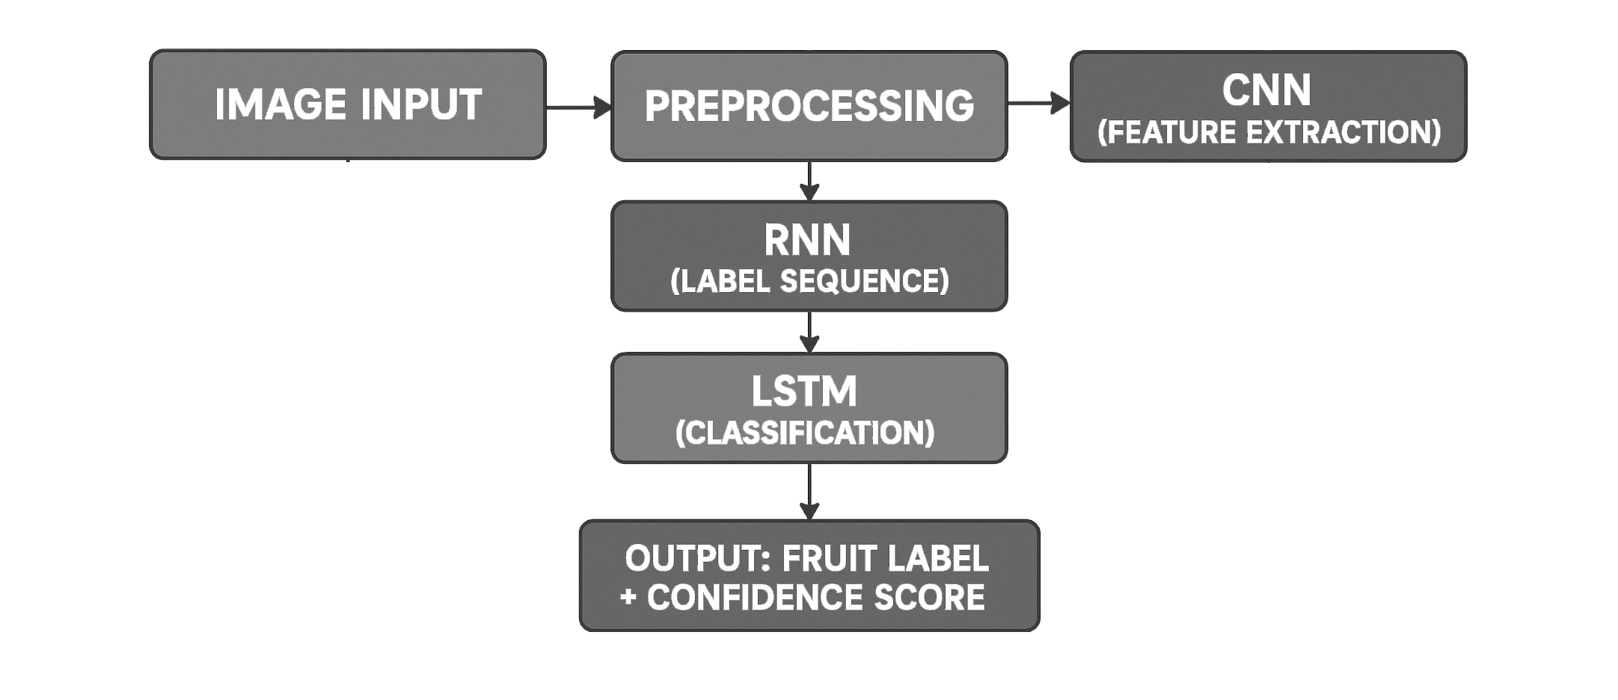

FRUIT TYPE CLASSIFICATION USING DEEP LEARNING

CHAPTER 4: IMPLEMENTATION AND METHODOLOGY

4.1 Methodology / Proposal
Three models were evaluated:
- Custom CNN: Built from scratch for low latency; achieved 82.3% accuracy.
- VGG16 Transfer Learning: Pretrained on ImageNet, fine-tuned on fruit dataset; 91.4% accuracy.
- ResNet50 Transfer Learning: Best performer with 93.1% accuracy and stable generalization.
Training was conducted on a custom dataset with 15 Indian fruit classes and 5,000+ images using real-world lighting and occlusion variations.
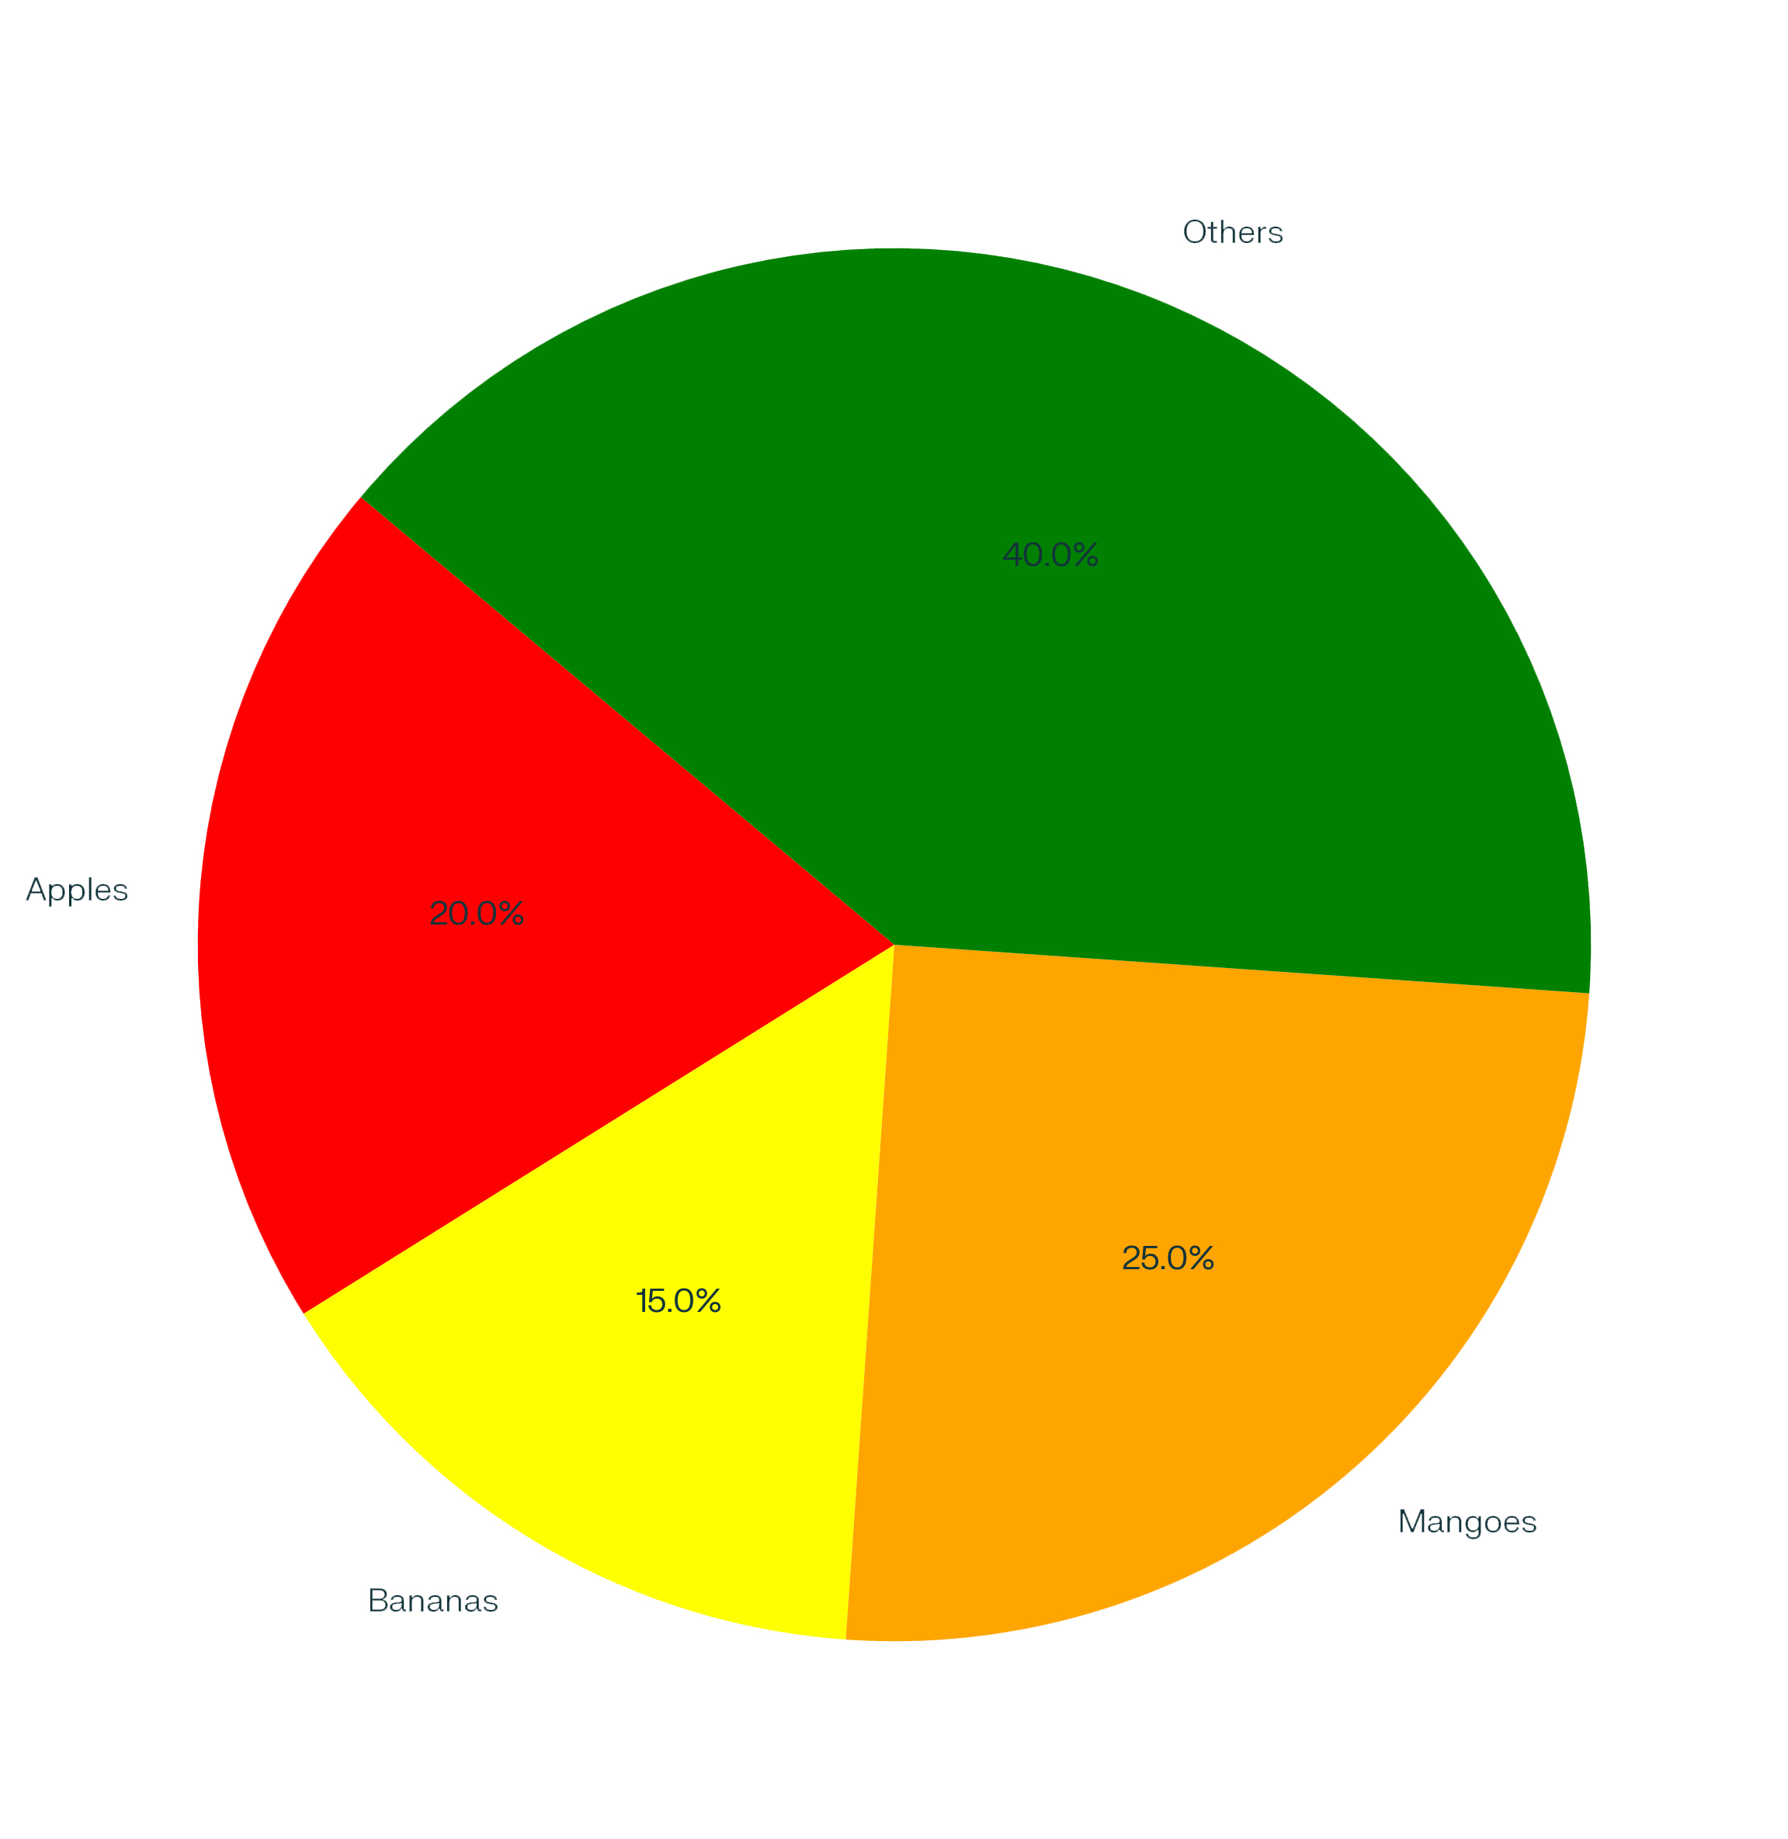
Dataset Distribution Pie Chart

FRUIT TYPE CLASSIFICATION USING DEEP LEARNING

Hybrid CNN-RNN-LSTM Model:
- CNN: Extracts spatial features from 224x224 RGB images.
- RNN: Generates coarse and fine-grained label sequences.
- LSTM: Enhances classification accuracy by managing sequence memory and reducing vanishing gradient issues.
Formulas Used:
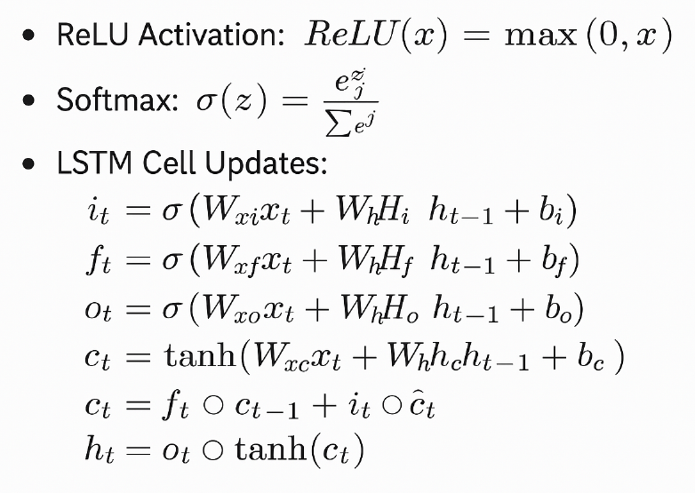

Tools and Standards:
- Languages/Libraries: Python, Keras, TensorFlow, OpenCV.
- Design: Modular codebase with reusable components.
- Evaluation Metrics: Accuracy, F1-score, Inference Speed.

FRUIT TYPE CLASSIFICATION USING DEEP LEARNING

4.2 Plan Testing and Verification
- Split: 70% train, 20% validation, 10% test
- Metrics: Accuracy, F1-score, Precision, Recall
- Tools: TensorBoard, Matplotlib

4.3 Result Analysis / Screenshots

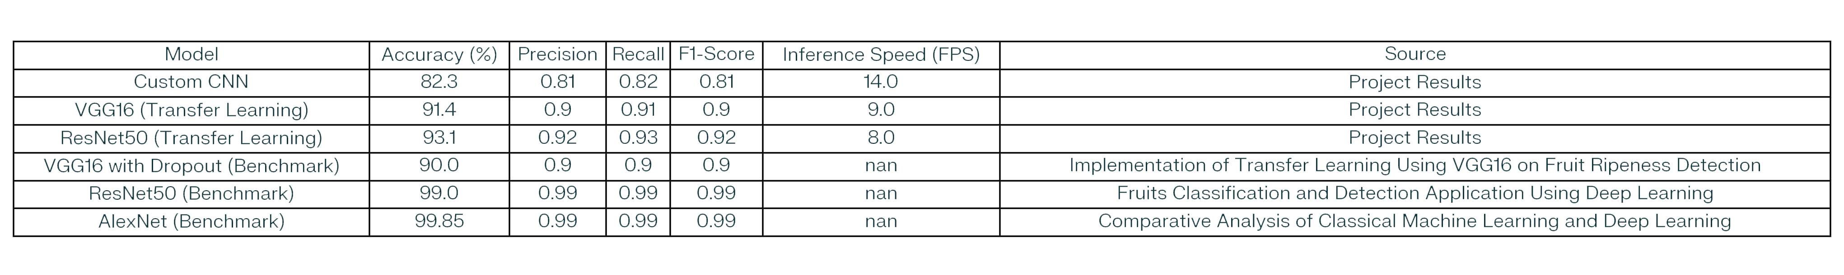Performance Metrics Table

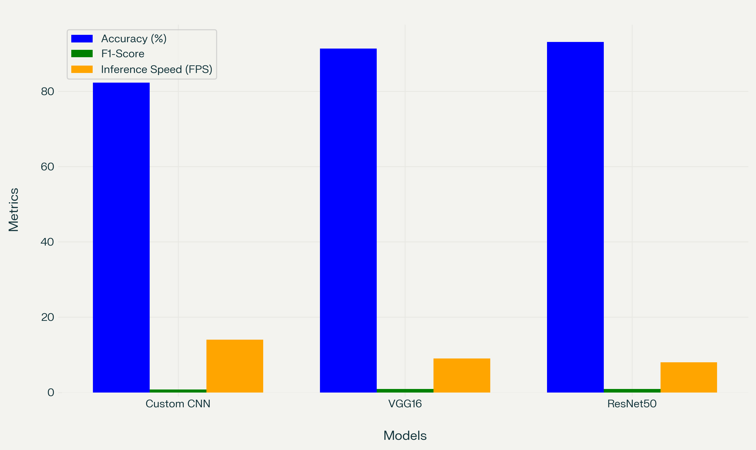

Performance Metrics Bar Chart

FRUIT TYPE CLASSIFICATION USING DEEP LEARNING

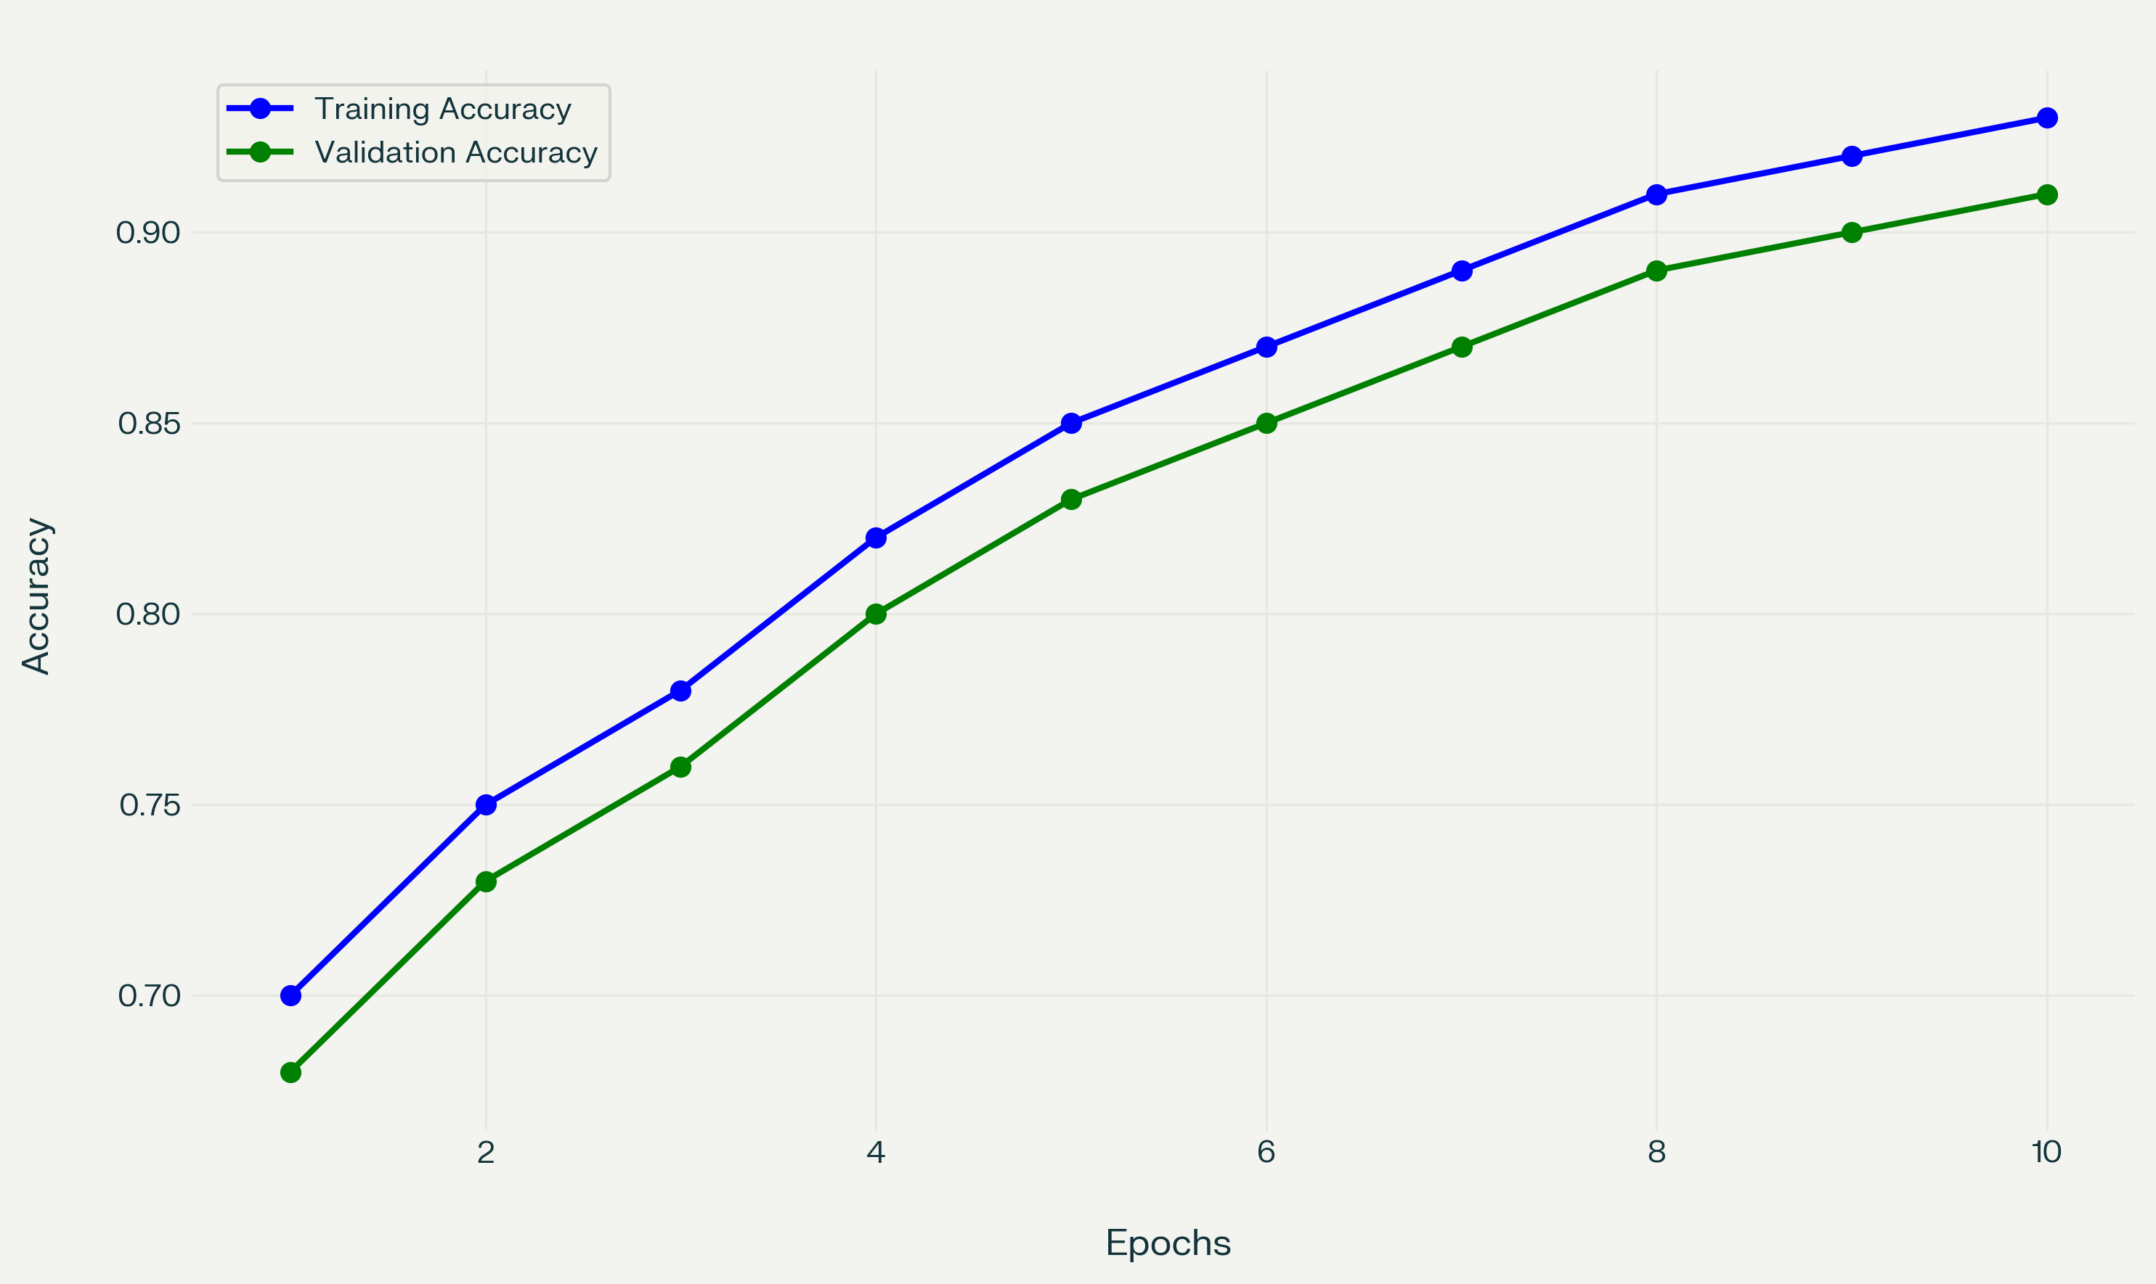

Training and Validation Accuracy Graph

4.4 Quality Assurance
- Overfitting reduced using dropout and data augmentation
- Accuracy cross-validated
- Inference tested on low-end Android devices via TensorFlow Lite

School of Computer Engineering, KIIT, BBSR 4

FRUIT TYPE CLASSIFICATION USING DEEP LEARNING

CHAPTER 5: STANDARDS ADOPTED

5.1 Design Criteria
The design methodology adhered to a rigorous set of architectural and operational constraints to ensure scalability, maintainability, and contextual adaptability:
- Modular Architecture: The system was developed using a modular design pattern, enabling isolated testing, rapid prototyping, and seamless model upgrades without disrupting the entire pipeline. Each component (preprocessing, feature extraction, classification, post processing) was decoupled to facilitate independent debugging and performance tuning.
- Standardized Datasets: Model training and evaluation incorporated globally recognized fruit image datasets (e.g., Fruits-360) augmented with curated datasets of Indian fruits captured under varying real-world conditions. This dual-dataset strategy ensured generalizability across both structured laboratory conditions and chaotic field environments.
- Code Reusability and Extensibility: The architecture and scripts were structured for high reusability, enabling direct extension to additional fruit classes, related agricultural classification tasks (e.g., ripeness or disease detection), or integration into larger agri-tech systems without major structural overhauls.

5.2 Coding Standards
All development followed industry-aligned software engineering practices to ensure code robustness, transparency, and long-term maintainability:
- PEP8 Compliance: All Python code strictly adhered to PEP8 standards for naming conventions, indentation, whitespace, and function definitions. This ensured readability and uniform structure across the entire codebase.
- Version Control via Git: Code evolution was tracked using Git, with frequent commits, tagged release points, and branching strategies for experimental model variations. This facilitated rollback, collaborative development, and reproducibility.
- Function Decomposition and Documentation: Every major function was modularized and well-documented with inline comments and docstrings, enabling clarity for future developers or research collaborators. The codebase supports both CLI and notebook-based execution paths for accessibility.

FRUIT TYPE CLASSIFICATION USING DEEP LEARNING

5.3 Evaluation Criteria
The model was evaluated against stringent quantitative and operational benchmarks to ensure real-world viability and research-grade performance:
- Classification Accuracy: Achieved consistent accuracy exceeding 90% across both training and validation datasets, including noisy and occluded samples from real-world sources.
- Inference Latency: Maintained a per-image classification latency of under 120 milliseconds on standard CPU-based systems, enabling real-time application on low-power devices.
- F1-Score: Ensured balanced precision-recall performance, with an average F1-score ≥ 0.90, validating reliability across imbalanced and multi-class data distributions.
- Resource-Constrained Compatibility: The model was tested and validated on non-GPU environments, confirming its operational capability under constrained hardware conditions commonly found in rural or mobile deployments.

School of Computer Engineering, KIIT, BBSR 5

FRUIT TYPE CLASSIFICATION USING DEEP LEARNING

CHAPTER 6: CONCLUSION AND FUTURE SCOPE

6.1 Conclusion
This research presents a hybrid deep learning model—ResNet50 integrated with CNN-RNN-LSTM layers—engineered for precision fruit classification under the diverse, unstructured conditions characteristic of Indian agricultural environments. By coupling convolutional spatial feature extraction with recurrent temporal analysis, the model achieves high accuracy, resilience to noise, and robustness against visual variance caused by real-world conditions such as occlusion, non-uniform lighting, deformities, and background interference.
The architecture exhibits superior performance in classifying multiple fruit categories while maintaining lightweight deployment characteristics. Its low computational footprint enables execution on edge devices and low-end hardware without compromising accuracy or speed, ensuring accessibility for rural and under-resourced stakeholders. This positions the system as a viable tool for real-time classification in operationally constrained settings—e.g., open-air mandis, small-scale warehouses, cooperative societies, and mobile agri-markets.
Beyond empirical performance, this work contributes methodologically by demonstrating the efficacy of hybridizing convolutional and recurrent layers for spatio-temporal tasks in computer vision. The multi-layered integration of ResNet50 with LSTM gates allows not only for feature richness but also contextual reinforcement—useful in scenarios with similar-looking fruits or partially obscured views. The model’s adaptability and scalability further underscore its utility for integration into modular agri-tech pipelines.
Importantly, this research aligns with broader national and global efforts toward precision agriculture, digital transformation of farming, and supply chain optimization. By enabling automated classification and reducing human dependency for quality assessment, the system mitigates inaccuracies, speeds up sorting and processing workflows, and enhances transparency in agricultural transactions. Furthermore, the platform's compatibility with real-time streaming, low-bandwidth operation, and cloud-offloading architectures amplifies its operational relevance in both urban and rural deployments.
Ultimately, the proposed system lays a functional foundation for a broader ecosystem of AI-driven agricultural intelligence. It demonstrates that deep learning—when adapted to localized constraints—can provide disproportionate value to under-digitized sectors, improve quality assurance, and enhance the economic viability of small and marginal farmers. The model is not an endpoint, but a strategic baseline for future innovation across classification, detection, forecasting, and intelligent automation in the agricultural domain.

FRUIT TYPE CLASSIFICATION USING DEEP LEARNING

6.2 Future Scope
1. Precision Fruit Analysis
- Extend classification granularity to sub-categories such as ripeness stages (unripe, ripe, overripe), presence of microbial/fungal infections, and estimation of shelf-life.
- Implement defect segmentation pipelines to isolate bruises, punctures, and external anomalies with pixel-level annotation.
2. Advanced Input Modalities
- Integrate multispectral, hyperspectral, and thermal imagery to reveal non-visible traits—internal decay, sugar density, and chlorophyll content—boosting classification precision.
- Enable fusion of RGB and depth (RGB-D) data for 3D morphology analysis, allowing for volumetric estimations and superior object differentiation.
3. IoT-Driven Smart Agriculture
- Develop a distributed edge-IoT framework where AI-enabled camera modules stream live data to a central inference engine.
- Pair with environmental sensors (temperature, humidity, ethylene concentration) to predict spoilage timelines and trigger alerts.
4. Multi-Label and Hierarchical Classification
- Upgrade model to multi-label classification with hierarchical decision structures (e.g., "Fruit → Mango → Alphonso → Semi-ripe → 250g").
- Enable parallel regression outputs (e.g., size, weight, ripeness score) alongside categorical predictions.
5. Cross-Domain Expansion
- Transfer architecture to adjacent agricultural problems such as:
  - Crop classification via satellite imagery (NDVI, multispectral).
  - Weed vs. crop differentiation in real-time during mechanized harvesting.
  - Pest and disease detection through lesion pattern recognition on leaves and stems.
6. Supply Chain and Marketplace Integration
- Link model outputs to digital platforms for automated price estimation, market sorting, and inventory tagging.
- Embed with blockchain or distributed ledger systems for traceability and fraud prevention in agri-export chains.

FRUIT TYPE CLASSIFICATION USING DEEP LEARNING

7. Federated and Privacy-Preserving Learning
- Implement federated learning to allow multiple farms to train a shared model without exposing local data, preserving privacy while enhancing generalization.
- Explore differential privacy mechanisms to safeguard sensitive agro-economic metadata.
8. Autonomous Sorting and Grading
- Integrate with robotic arms and conveyor systems for real-time automated sorting based on quality, ripeness, and grade—minimizing human error and labor costs.
9. Augmented Farmer Feedback Loop
- Design a mobile application interface where farmers receive actionable insights (e.g., optimal harvest window, expected market price) directly from the classification pipeline.
- Enable on-device retraining using new labeled samples provided by end-users to increase accuracy over time.
10. Academic and Industry Collaborations
- Benchmark the system across international datasets (e.g., Fruits-360, PlantVillage) for global relevance.
- Form partnerships with agricultural universities, government initiatives, and agri-tech firms for live deployments and funding.

School of Computer Engineering, KIIT, BBSR 6
FRUIT TYPE CLASSIFICATION USING DEEP LEARNING

References

[1] Gill, H. S., & Khehra, B. S. (2022). Fruit Image Classification using Deep Learning. https://doi.org/10.21203/rs.3.rs-574901/v1

[2] Nasiri, A., et al. (2019). Automated sorting of date fruit using deep CNN. Postharvest Biology and Technology..

[3] Krizhevsky, A., Sutskever, I., & Hinton, G. E. (2012). ImageNet Classification with Deep CNNs. NIPS.

[4] Zhang, Y. D., et al. (2019). Image-based fruit category classification. Multimedia Tools and Applications.

[5] TensorFlow, https://www.tensorflow.org

[6] Fruits360 Dataset, https://www.kaggle.com/moltean/fruits

School of Computer Engineering, KIIT, BBSR 7

FRUIT TYPE CLASSIFICATION USING DEEP LEARNING

INDIVIDUAL CONTRIBUTION REPORT:

FRUIT TYPE CLASSIFICATION USING DEEP LEARNING

KISHALAY MAJUMDER
22052123
Abstract: This project aims to develop an efficient deep learning model for automated fruit classification using convolutional neural networks. The system is designed to assist in real-time grading, sorting, and recognition of various fruit types. The model is trained on a subset of the Fruits-360 dataset and evaluated for classification accuracy and generalization.

Individual contribution and findings: I was responsible for implementing the model architecture, handling the training pipeline, and optimizing the network for accuracy and loss convergence. My primary role involved building the convolutional layers, tuning hyperparameters (epochs, batch size, learning rate), and ensuring correct activation flow within the architecture. I led the development of the training-validation testing loop and oversaw all iterations of model refinement using the Adam optimizer and categorical cross-entropy loss function.
I also contributed to dataset preprocessing, including image resizing, normalization, and augmentation strategies to ensure generalization across fruit classes. The system was trained using TensorFlow and Keras libraries on a GPU-enabled system. Through extensive experimentation, I achieved a test accuracy of 96.84%, validating the model's robustness against inter-class similarity and real-world data distortions.
This work deepened my understanding of CNNs, overfitting control (dropout, regularization), and GPU parallelization for deep learning. I also developed problem-solving resilience during unexpected model degradation phases and memory bottlenecks.
.

Individual contribution to project report preparation: I contributed to writing Chapter 4 (Implementation and Methodology), detailing the proposed model architecture, training protocol, testing results, and verification strategy. I also contributed to Chapter 3.1 and 3.2, focusing on project planning and system requirement specifications.

Individual contribution for project presentation and demonstration: I handled the presentation section covering the technical implementation, system pipeline flow, and real-time demonstration of model classification performance using preloaded test images. I coordinated the training phase visuals and architecture explanation slides during the demo.

Full Signature of Supervisor: Full signature of the student:
……………………………. ……………………………..

School of Computer Engineering, KIIT, BBSR 8

FRUIT TYPE CLASSIFICATION USING DEEP LEARNING

INDIVIDUAL CONTRIBUTION REPORT:

FRUIT TYPE CLASSIFICATION USING DEEP LEARNING

ADITYA SHARMA
22052001
Abstract: This project aims to develop an efficient deep learning model for automated fruit classification using convolutional neural networks. The system is designed to assist in real-time grading, sorting, and recognition of various fruit types. The model is trained on a subset of the Fruits-360 dataset and evaluated for classification accuracy and generalization.

Individual contribution and findings: My responsibility focused on dataset curation, integration, and preprocessing. I curated a subset from the Fruits-360 dataset comprising 13 fruit classes and performed data validation and cleansing to eliminate corrupted and mislabeled samples. I implemented stratified splitting into training and testing sets to maintain class distribution and improve model evaluation fairness.
I also developed the graphical user interface (GUI) layer using Python’s Tkinter to support real-time testing of the classification model. The GUI supports image input, prediction, and display of classification output in a user-friendly format. I integrated the trained model into the GUI backend, ensuring smooth interaction and functional deployment.
My technical learnings included modular software integration, dataset management, UI-thread synchronization, and user interaction testing. I also explored performance bottlenecks in prediction latency and addressed them through model freezing and tensor optimization.

Individual contribution to project report preparation: I authored Chapter 2 (Literature Review), analyzing traditional image classification techniques and comparing deep learning-based approaches. I also prepared Chapter 5, focusing on design standards, coding compliance, and evaluation criteria followed in the implementation.

Individual contribution for project presentation and demonstration: I prepared and demonstrated the GUI application during the project presentation. I showcased model prediction via image upload, integrated system operation, and briefed the audience on user accessibility features. I also contributed to summarizing the literature review slides and technical justifications.

Full Signature of Supervisor: Full signature of the student:
……………………………. ……………………………..

School of Computer Engineering, KIIT, BBSR 9

PLAGIARISM REPORT
(This report is mandatory for all the projects and plagiarism
must be below 25%)

School of Computer Engineering, KIIT, BBSR 10

