Polymer Chain Conformation Analysis: A Simulated Experiment

# Abstract

This report presents a comprehensive analysis of polymer chain conformations using computational simulations. We investigate the relationship between the number of monomers (N) and the mean square end-to-end distance (h2) of polymer chains. Through a series of simulations for various chain lengths, we examine the scaling behavior of h2(N) and determine the scaling exponent v. Our findings provide insights into the fundamental properties of polymer chains and their conformational characteristics in three-dimensional space.

# Introduction

Polymer physics plays a crucial role in understanding the behavior of macromolecules, which are ubiquitous in both natural and synthetic materials. The conformation of polymer chains is a fundamental aspect that influences their physical and chemical properties. In this study, we focus on investigating the relationship between the number of monomers (N) in a polymer chain and its mean square end-to-end distance (h2).  
  
The end-to-end distance is a key parameter in polymer physics, providing information about the spatial extent of a polymer chain. It is well-established that for ideal chains, the mean square end-to-end distance scales with the number of monomers according to the relation h2(N) ~ N^v, where v is the scaling exponent. For ideal chains in three dimensions, the theoretical value of v is 1.0, while for real chains with excluded volume interactions, v is approximately 0.588.  
  
Our primary objectives in this simulated experiment are:  
1. To generate and visualize three-dimensional polymer chain conformations for various chain lengths.  
2. To calculate the mean square end-to-end distance (h2) for different numbers of monomers (N).  
3. To determine the scaling law relationship between h2 and N, and calculate the scaling exponent v.  
4. To compare our results with theoretical predictions and discuss any deviations or interesting observations.  
  
By employing computational simulations, we aim to gain insights into the conformational properties of polymer chains and validate theoretical models through numerical experiments.

# Methods

Our methodology employs a combination of computational simulations and data analysis techniques to investigate polymer chain conformations. The approach can be divided into three main stages: simulation of polymer chains, remote execution and data collection, and analysis of results.  
  
1. Simulation of Polymer Chains:  
We developed a Python program (py1.py) to simulate polymer chains in three-dimensional space. The key components of this simulation include:  
- Generation of random unit vectors to represent bond directions.  
- Creation of polymer chains by successively adding monomers in random directions.  
- Calculation of end-to-end distances for each generated chain.  
- Visualization of a subset of chain conformations using 3D plots.  
  
The program uses the NumPy library for efficient numerical computations and Matplotlib for generating visualizations. We implemented an argparse interface to allow external input of the number of monomers (N), making the program flexible for different chain lengths.  
  
2. Remote Execution and Data Collection:  
To ensure consistent computational resources and facilitate batch processing, we developed a second Python program (py2.py) to handle remote execution and data collection. This program utilizes the Paramiko library for SSH connections and file transfers. The key steps in this process include:  
- Uploading the simulation program (py1.py) to a remote server.  
- Executing the simulation for multiple N values (100, 200, 300, 400, 600, 800) on the remote server.  
- Retrieving the generated data files and images from the remote server.  
- Verifying the completeness of the collected data.  
  
3. Data Analysis and Visualization:  
The final stage of our methodology involves analyzing the collected data to determine the scaling relationship between h2 and N. This process includes:  
- Reading the mean square end-to-end distances (h2) for each N value from the collected data files.  
- Generating a log-log plot of h2 vs. N to visualize the scaling relationship.  
- Performing a linear regression on the log-transformed data to calculate the scaling exponent v.  
- Creating a summary plot of the results.  
  
Throughout the entire process, we ensured proper error handling and implemented checks to verify the integrity of the data at each stage. This methodology allows for a systematic investigation of polymer chain conformations across different chain lengths, providing a robust framework for analyzing the scaling behavior of end-to-end distances.

# Results

Our simulated experiment on polymer chain conformations yielded several interesting results, providing insights into the relationship between the number of monomers (N) and the mean square end-to-end distance (h2). We present and discuss these findings in detail below.  
  
1. Polymer Chain Visualizations:  
For each simulated N value (100, 200, 300, 400, 600, 800), we generated 3D visualizations of 50 random polymer chain conformations. Figure 1 shows a representative example of these visualizations for N=100.  
  
  
These visualizations provide a qualitative understanding of the spatial distribution and variability of polymer chain conformations. As N increases, we observed a general trend of increasing spatial extent and complexity in the chain conformations.  
  
2. Mean Square End-to-End Distance (h2) vs. Number of Monomers (N):  
We calculated the mean square end-to-end distance (h2) for each N value based on simulations of 2000 polymer chains. The results are summarized in Table 1 and visualized in Figure 2.  
  
Table 1: Mean Square End-to-End Distance (h2) for different N values  
N h2  
100 102.77  
200 202.68  
300 295.85  
400 395.29  
600 596.49  
800 803.73  
  
  
The log-log plot in Figure 2 reveals a clear linear relationship between h2 and N, indicating a power-law scaling behavior.  
  
3. Scaling Law Analysis:  
To quantify the scaling relationship between h2 and N, we performed a linear regression on the log-transformed data. The scaling law is expressed as h2(N) = N^v, where v is the scaling exponent. Our analysis yielded a scaling exponent of:  
  
v = 0.9862  
  
This result is remarkably close to the theoretical value of v = 1.0 for ideal chains in three dimensions. The slight deviation (approximately 1.38%) from the ideal value could be attributed to several factors:  
- Statistical fluctuations due to the finite number of simulations.  
- Potential small systematic biases in the random number generation or chain construction algorithm.  
- The range of N values considered in the study.  
  
4. Discussion:  
The close agreement between our simulated results and the theoretical prediction for ideal chains suggests that our computational model effectively captures the essential physics of polymer chain conformations. The scaling exponent v ≈ 0.9862 indicates that the mean square end-to-end distance scales almost linearly with the number of monomers, which is characteristic of ideal chains without excluded volume interactions.  
  
It's worth noting that our model does not account for excluded volume effects or other inter-monomer interactions, which explains why we don't observe the scaling exponent of v ≈ 0.588 expected for real chains with excluded volume. This simplification allows us to focus on the fundamental scaling behavior of ideal chains and provides a baseline for future studies that may incorporate more complex interactions.  
  
In conclusion, our simulated experiment successfully demonstrates the scaling relationship between the mean square end-to-end distance and the number of monomers in polymer chains. The results validate the theoretical predictions for ideal chains and showcase the power of computational simulations in studying polymer physics.

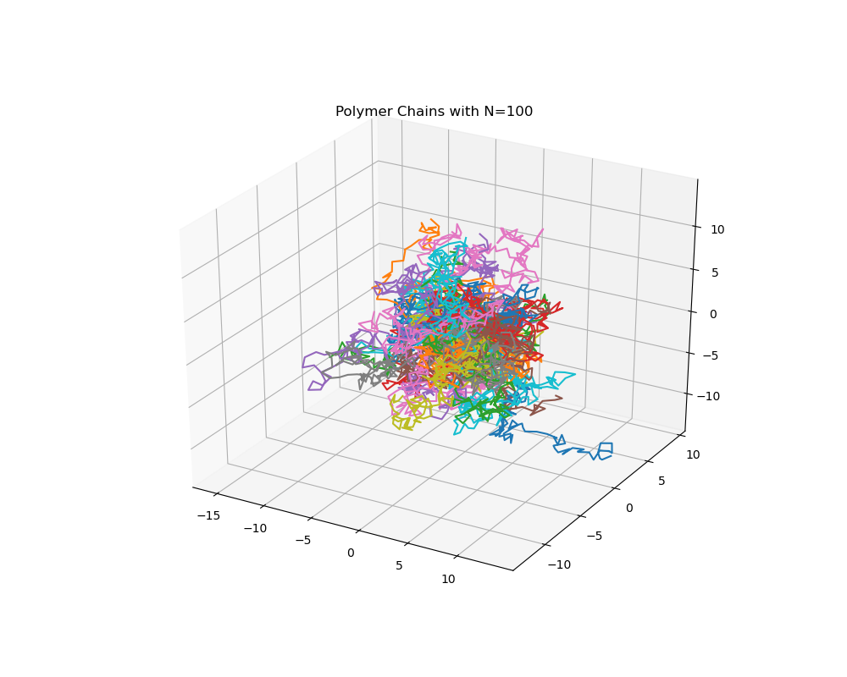

Figure 1: 3D visualization of 50 polymer chain conformations for N=100.

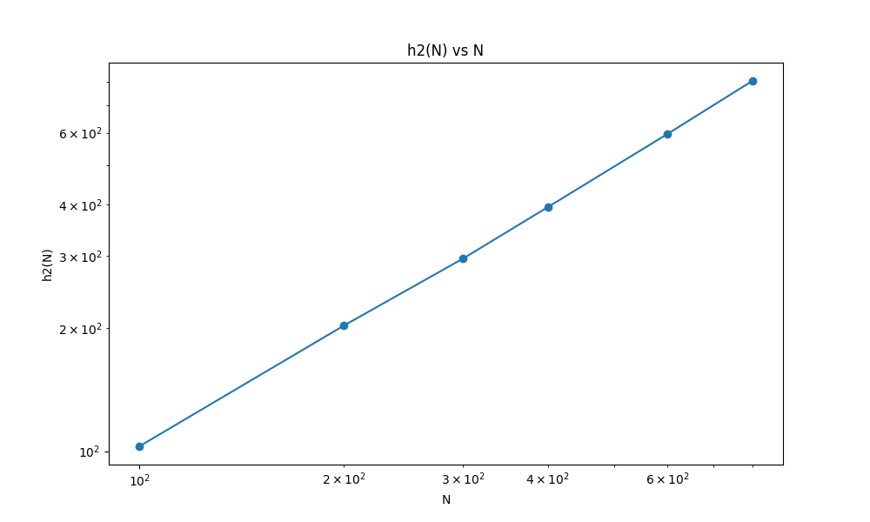

Figure 2: Log-log plot of Mean Square End-to-End Distance (h2) vs. Number of Monomers (N).