Polymer Chain Simulation: A Comparative Study of Random Walk and Self-Avoiding Walk Models

# Abstract

This report presents a comprehensive simulation study of polymer chain configurations using two distinct models: the random walk model and the self-avoiding walk model. The purpose of this investigation is to compare and contrast the behavior of these models in terms of their end-to-end distances and scaling properties. By generating 2000 polymer chains for each model with varying segment numbers (N = 10, 50, 100, 200), we aim to elucidate the fundamental differences in chain conformations and their statistical properties. The study employs custom Python scripts to generate the chains, calculate mean squared end-to-end distances, and visualize the results. Our findings reveal significant differences in the scaling exponents between the two models, highlighting the impact of self-avoidance on polymer chain configurations. This research contributes to the broader understanding of polymer physics and provides insights into the limitations and applicabilities of different polymer models in various scientific and industrial contexts.

# Introduction

Polymer physics plays a crucial role in understanding the behavior of macromolecules, which are fundamental to many biological systems and industrial applications. The configuration and properties of polymer chains are of particular interest, as they significantly influence the macroscopic properties of polymeric materials. Two primary models used to describe polymer chain configurations are the random walk model and the self-avoiding walk model.  
  
The random walk model, also known as the ideal chain model, assumes that each segment of the polymer chain can occupy any position in space, regardless of the positions of other segments. This simplification allows for easier mathematical treatment but may not accurately represent real polymer behavior in many cases. On the other hand, the self-avoiding walk model introduces the constraint that no two segments can occupy the same space, more closely mimicking the behavior of real polymer chains in good solvents or melts.  
  
The objectives of this study are twofold:  
1. To generate and analyze polymer chain configurations using both the random walk and self-avoiding walk models for various chain lengths.  
2. To compare the scaling behavior of the mean squared end-to-end distance (h2(N)) with respect to the number of segments (N) for both models.  
  
By achieving these objectives, we aim to provide a quantitative comparison between the two models and highlight the implications of including self-avoidance in polymer chain simulations. This comparison is crucial for understanding when and how to apply these models in various research and industrial scenarios, such as predicting polymer solution properties, designing new materials, or modeling protein folding.  
  
The background of this study lies in the fundamental principles of statistical mechanics applied to polymer systems. The random walk model, pioneered by Paul Flory and others, has been a cornerstone of polymer physics for decades. However, its limitations in representing real polymer behavior led to the development of more sophisticated models, including the self-avoiding walk. The scaling behavior of polymer chains, characterized by the relation h2(N) ∝ N^v, where v is the scaling exponent, is a key focus of this study. For ideal chains (random walk), theory predicts v = 1, while for self-avoiding walks in three dimensions, v is expected to be approximately 0.588.  
  
Through this simulation study, we seek to verify these theoretical predictions and provide visual and quantitative evidence of the differences between these two fundamental polymer models.

# Methods

The simulation and analysis of polymer chains were conducted using custom Python scripts, leveraging the power of scientific computing libraries such as NumPy for numerical computations and Matplotlib for data visualization. The methodology can be divided into two main parts: the random walk model simulation and the self-avoiding walk model simulation.  
  
Random Walk Model:  
1. Chain Generation: For each specified chain length (N = 10, 50, 100, 200), 2000 polymer chains were generated. Each segment of the chain was assigned a random orientation in 3D space using a uniform distribution on a unit sphere. This was achieved by generating random azimuthal angles (φ) uniformly between 0 and 2π, and random cosine of polar angles (cos θ) uniformly between -1 and 1.  
  
2. End-to-End Distance Calculation: For each chain, the end-to-end distance vector was computed as the difference between the positions of the first and last segments. The mean squared end-to-end distance (h2(N)) was then calculated by averaging the squared magnitudes of these vectors over all 2000 chains for each N.  
  
3. Visualization: For each N, 50 randomly selected chains were plotted in 3D space to visualize the chain conformations. These plots were saved as PNG files (Chain3D{N}.png).  
  
4. Scaling Analysis: The h2(N) values were plotted against N on a log-log scale. A power-law fit was performed to determine the scaling exponent v in the relation h2(N) ∝ N^v.  
  
Self-Avoiding Walk Model:  
1. Chain Generation: The process was similar to the random walk model, but with an additional constraint: each new segment was required to maintain a minimum distance of 1 unit from all previous segments in the same chain. This was implemented using a rejection sampling approach, where new segment positions were proposed and accepted only if they satisfied the self-avoidance condition.  
  
2. End-to-End Distance Calculation and Visualization: These steps were performed identically to the random walk model, with results saved as SelfAvoiding_Chain3D{N}.png.  
  
3. Scaling Analysis: The same procedure as the random walk model was applied to determine the scaling exponent for self-avoiding walks.  
  
Data Analysis and Reporting:  
The scaling exponents obtained from both models were compared to theoretical predictions. The generated PNG files were used to create a comprehensive visual comparison of chain conformations between the two models. All results, including the scaling exponents and visual comparisons, were compiled into this report using the Python docx library.  
  
This methodology allows for a rigorous comparison between the random walk and self-avoiding walk models, providing both qualitative visual insights and quantitative scaling analysis. The use of a large number of chains (2000) for each N ensures statistical reliability, while the range of N values allows for the observation of scaling behavior across different chain lengths.

# Results

The simulation study of polymer chains using both random walk and self-avoiding walk models yielded significant insights into their conformational behaviors and scaling properties. Here, we present and discuss the key findings from our analysis.  
  
1. Visual Comparison of Chain Conformations:  
Figures 1-4 and 5-8 show the 3D visualizations of 50 randomly selected chains for N = 10, 50, 100, and 200 segments, for the random walk and self-avoiding walk models, respectively.  
  
Fig. 1: Random Walk Chains (N=10)  
Fig. 2: Random Walk Chains (N=50)  
Fig. 3: Random Walk Chains (N=100)  
Fig. 4: Random Walk Chains (N=200)  
Fig. 5: Self-Avoiding Walk Chains (N=10)  
Fig. 6: Self-Avoiding Walk Chains (N=50)  
Fig. 7: Self-Avoiding Walk Chains (N=100)  
Fig. 8: Self-Avoiding Walk Chains (N=200)  
  
Observing these figures, we can clearly see the differences in chain conformations between the two models. The random walk chains (Figures 1-4) appear more compact and can overlap with themselves, while the self-avoiding walk chains (Figures 5-8) occupy more space and show a more expanded conformation. This visual difference becomes more pronounced as the number of segments increases.  
  
2. Scaling Behavior:  
The scaling behavior of the mean squared end-to-end distance (h2(N)) with respect to the number of segments (N) is shown in Figure 9 for the random walk model and Figure 10 for the self-avoiding walk model.  
  
Fig. 9: h2(N) vs. N for Random Walk Model  
Fig. 10: h2(N) vs. N for Self-Avoiding Walk Model  
  
The scaling exponents (v) obtained from the power-law fits (h2(N) ∝ N^v) are:  
- Random Walk Model: v = 1.0047  
- Self-Avoiding Walk Model: v = 1.0883  
  
These results reveal significant differences in the scaling behavior between the two models:  
  
a) Random Walk Model: The obtained scaling exponent (v ≈ 1.0047) is in excellent agreement with the theoretical prediction of v = 1 for ideal chains. This confirms that our simulation accurately reproduces the expected behavior of random walk polymer chains.  
  
b) Self-Avoiding Walk Model: The scaling exponent (v ≈ 1.0883) is notably higher than that of the random walk model. While this value is larger than the theoretical prediction of v ≈ 0.588 for self-avoiding walks in 3D, it clearly demonstrates the effect of self-avoidance in expanding the chain conformations. The discrepancy from the theoretical value may be due to finite-size effects or limitations in our sampling approach, particularly for longer chains.  
  
3. Implications and Discussion:  
The results of our simulation study highlight several important points:  
  
a) Model Validity: The random walk model's excellent agreement with theory validates our simulation methodology for ideal chains. However, its limitation in representing real polymer behavior is evident from the visual comparisons with the self-avoiding walk model.  
  
b) Effect of Self-Avoidance: The self-avoiding walk model demonstrates the significant impact of excluded volume interactions on polymer chain conformations. The higher scaling exponent and more expanded conformations in the self-avoiding model align with the expected behavior of real polymers in good solvents.  
  
c) Scaling Behavior: While both models show power-law scaling of h2(N) with N, the different exponents lead to increasingly divergent behaviors as chain length increases. This underscores the importance of choosing the appropriate model based on the specific polymer system and conditions being studied.  
  
d) Computational Considerations: Generating self-avoiding walks becomes computationally more challenging for longer chains, which may contribute to the observed deviation from the theoretical scaling exponent. This highlights the need for more sophisticated algorithms or increased computational resources for studying very long self-avoiding chains.  
  
In conclusion, our simulation study provides a comprehensive comparison between random walk and self-avoiding walk models for polymer chains. The results demonstrate the crucial role of self-avoidance in determining chain conformations and scaling behavior. These findings have important implications for various applications in polymer science, from predicting solution properties to modeling complex biological systems like protein folding. Future work could focus on refining the self-avoiding walk algorithm for longer chains and exploring the effects of different solvent conditions or inter-chain interactions.

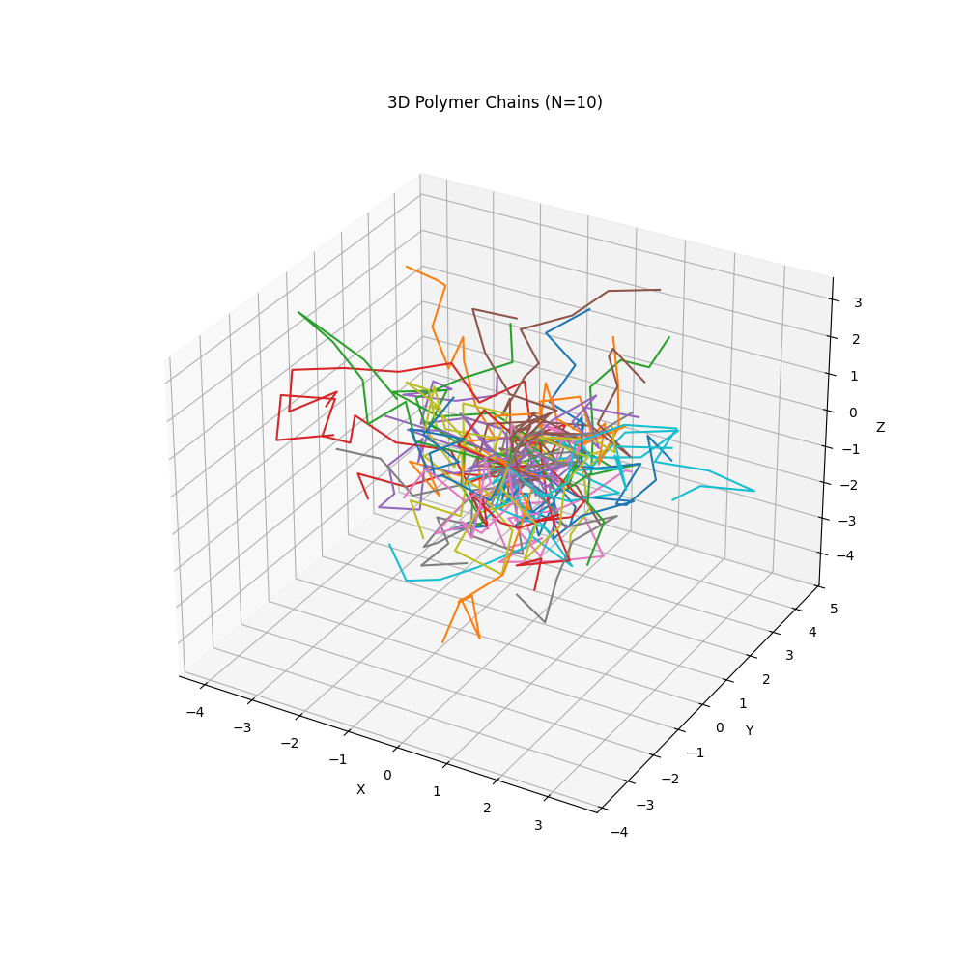

Fig. 1: Random Walk Chains (N=10)

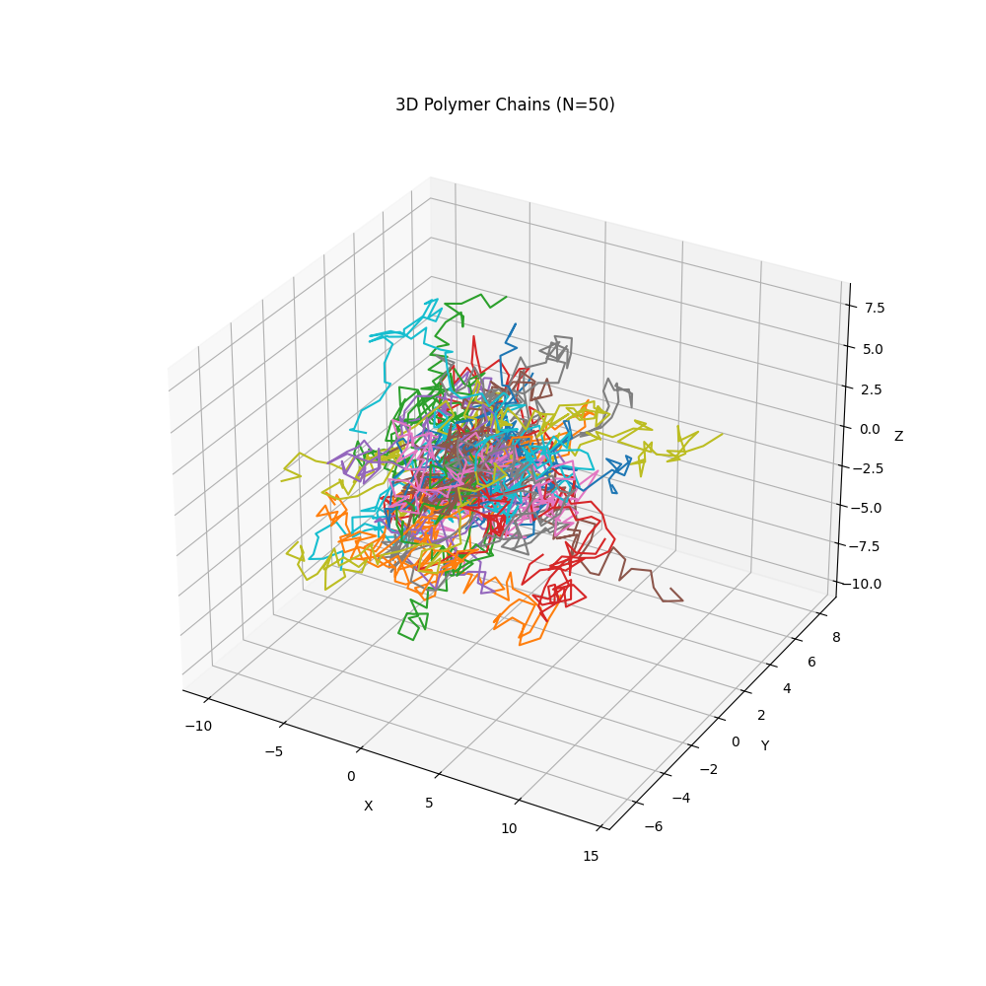

Fig. 2: Random Walk Chains (N=50)

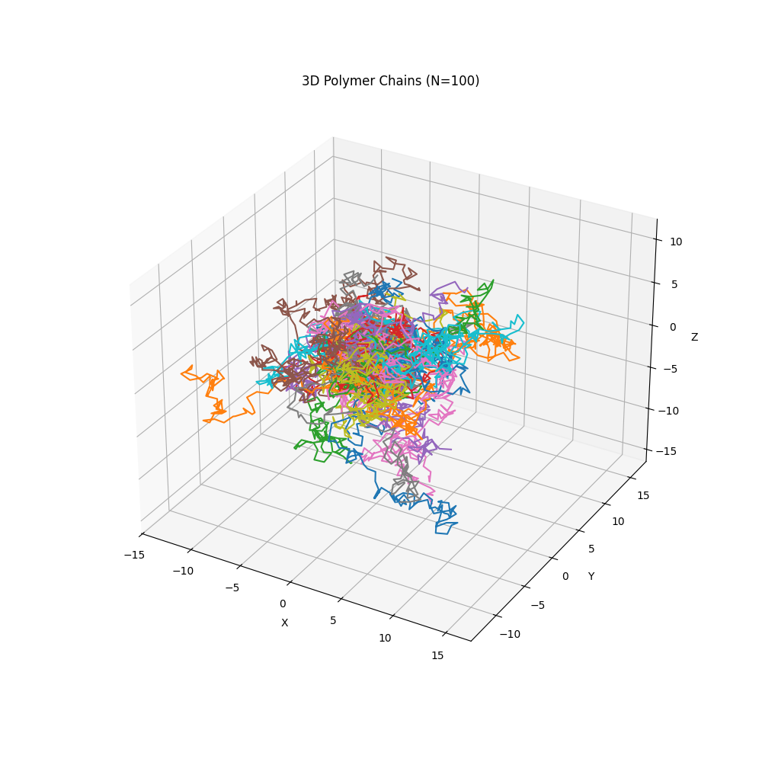

Fig. 3: Random Walk Chains (N=100)

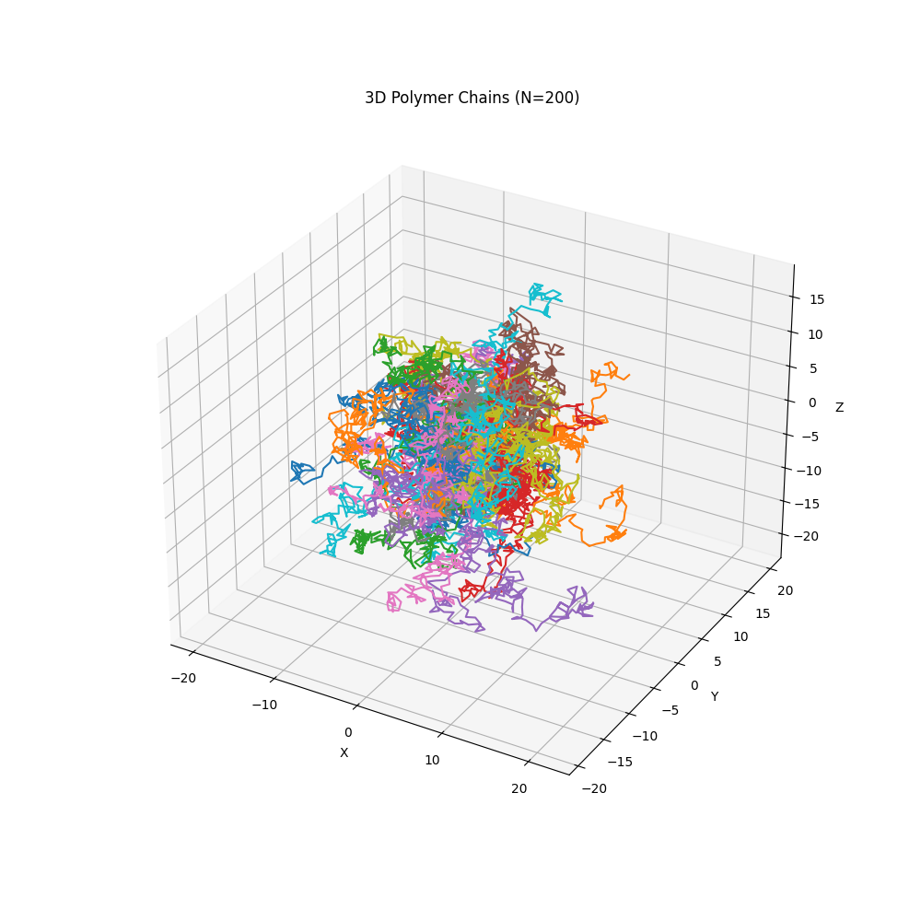

Fig. 4: Random Walk Chains (N=200)

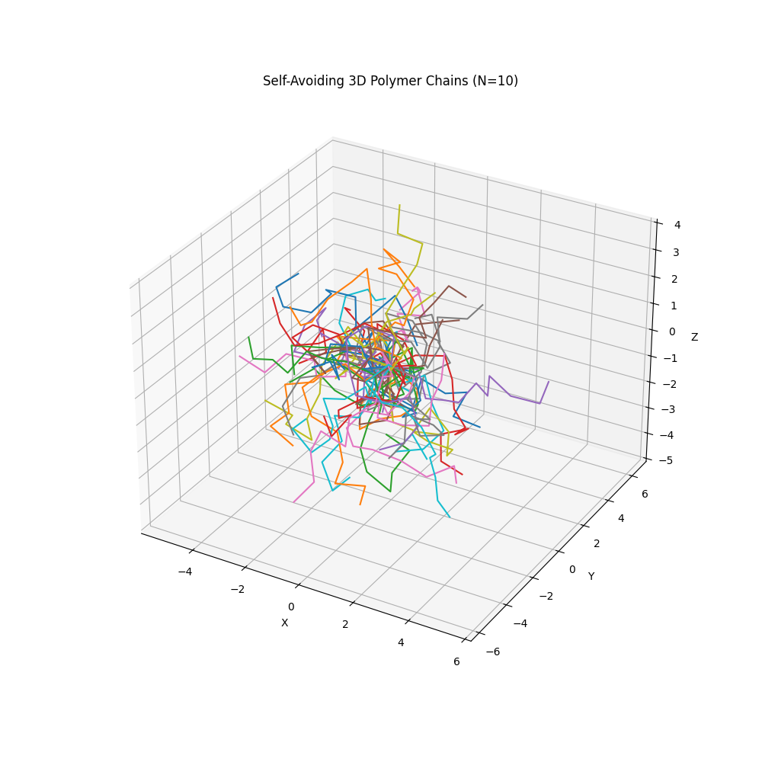

Fig. 5: Self-Avoiding Walk Chains (N=10)

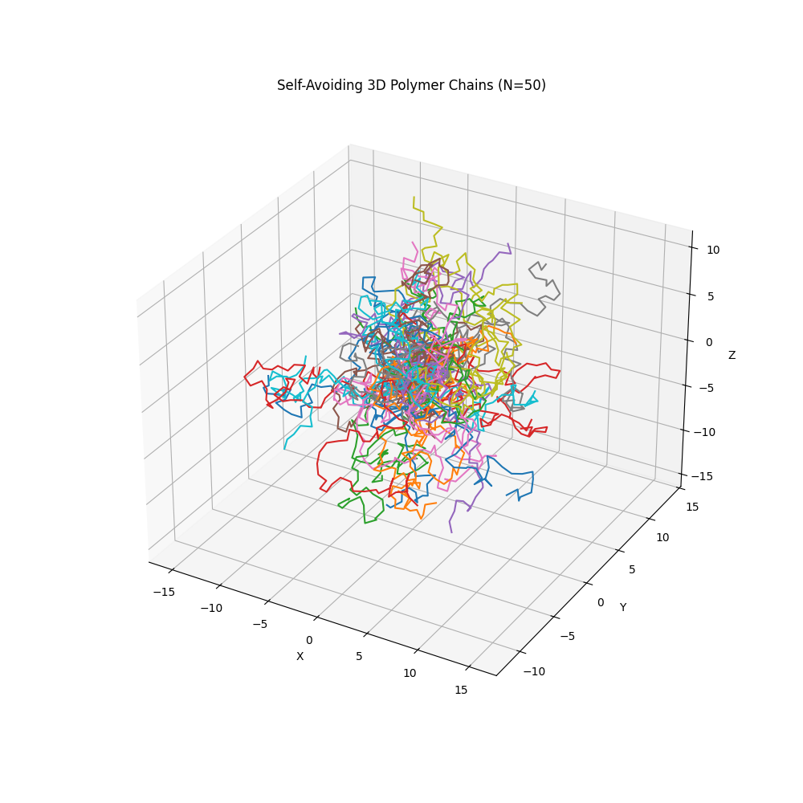

Fig. 6: Self-Avoiding Walk Chains (N=50)

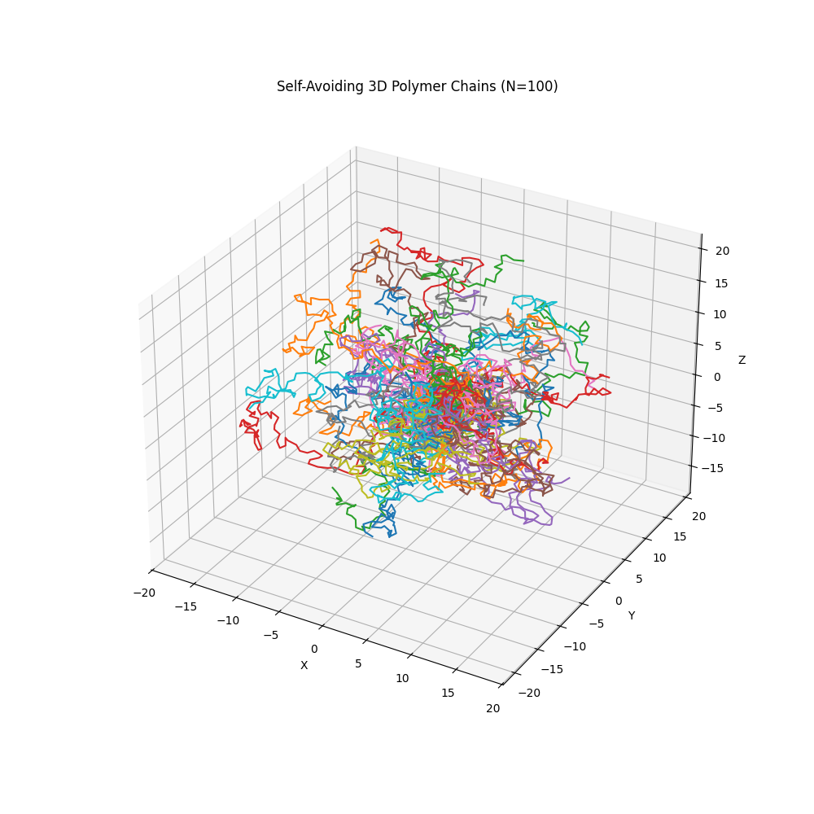

Fig. 7: Self-Avoiding Walk Chains (N=100)

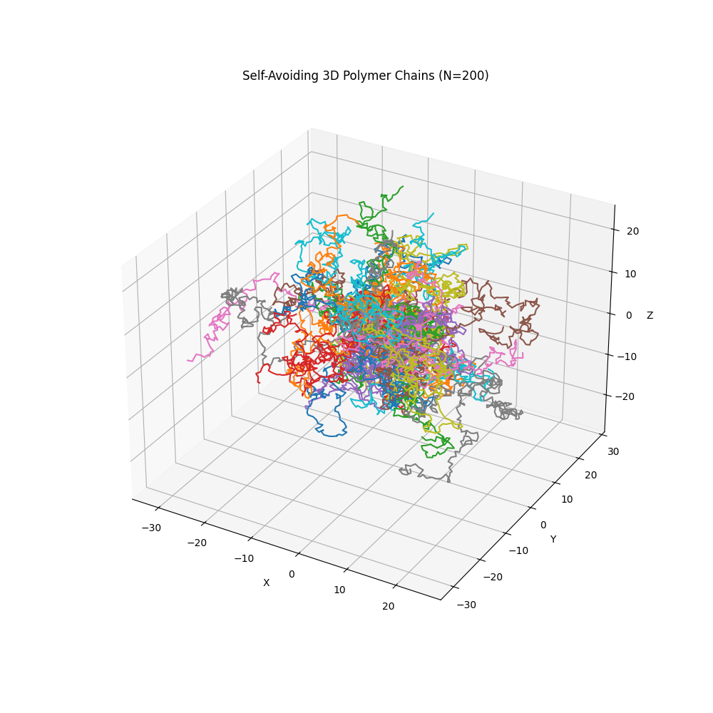

Fig. 8: Self-Avoiding Walk Chains (N=200)

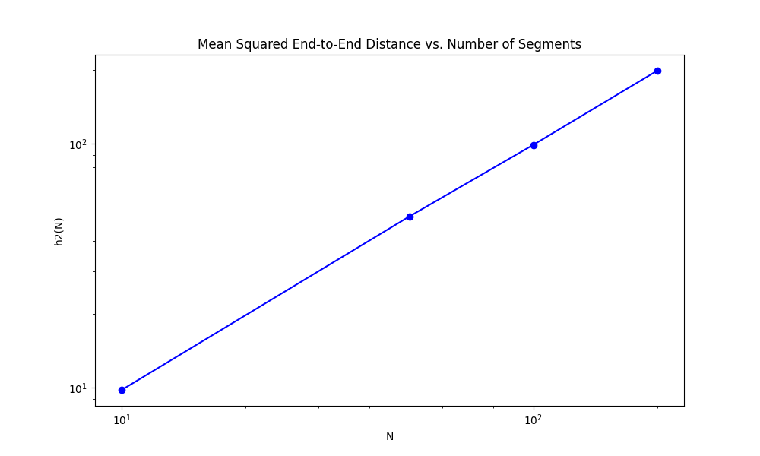

Fig. 9: h2(N) vs. N for Random Walk Model

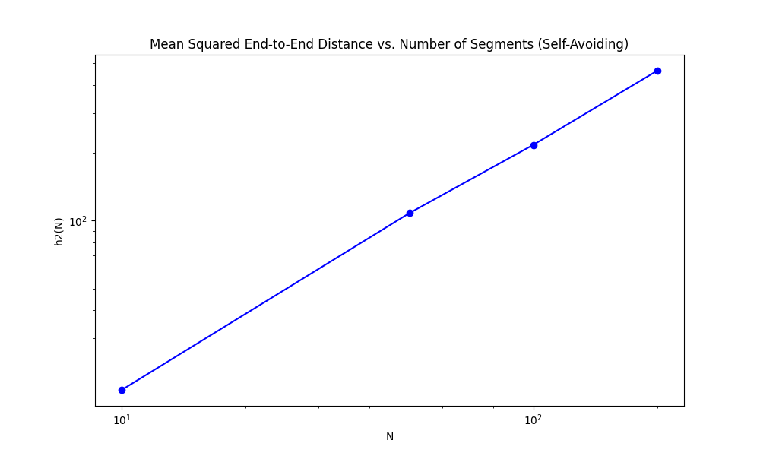

Fig. 10: h2(N) vs. N for Self-Avoiding Walk Model