Polymer Chain Simulation Report

# Abstract

This report outlines the findings of a simulation experiment designed to analyze the properties of polymer chains. Each polymer chain consists of N segments, with each segment randomly oriented in 3D space. The focus was on determining the mean squared end-to-end distances, the behavior of polymer chains in 3D space at varying lengths, and their scaling relationships.

# Introduction

Polymeric materials exhibit unique properties that depend heavily on their molecular structures. Understanding the end-to-end distance of polymer chains helps in exploring their entropic properties in solvents, conditions of dilution, and response to external forces. This experiment aims to contribute to the understanding of polymer physics through simulated visualizations and computational analysis.

# Methods

The polymer chains were simulated using a Python script that assigns a random orientation to each segment. A total of 2000 chains were generated for chains containing 10, 50, 100, 200, and 400 segments. For each set, 50 chain conformations were visualized, and the mean squared end-to-end distances (h2) were computed and analyzed to understand the scaling behavior as a function of N.

# Results

The end-to-end distance was found to scale with the number of segments as h2(N) ≈ N^1.0284. The observed scaling relationship suggests a slightly superlinear behavior, which is typical under certain theoretical assumptions in polymer physics. The graphs below elucidate the visual conformity and the presented scaling law.

## Figures

Figure: Chain conformations for N=10 segments

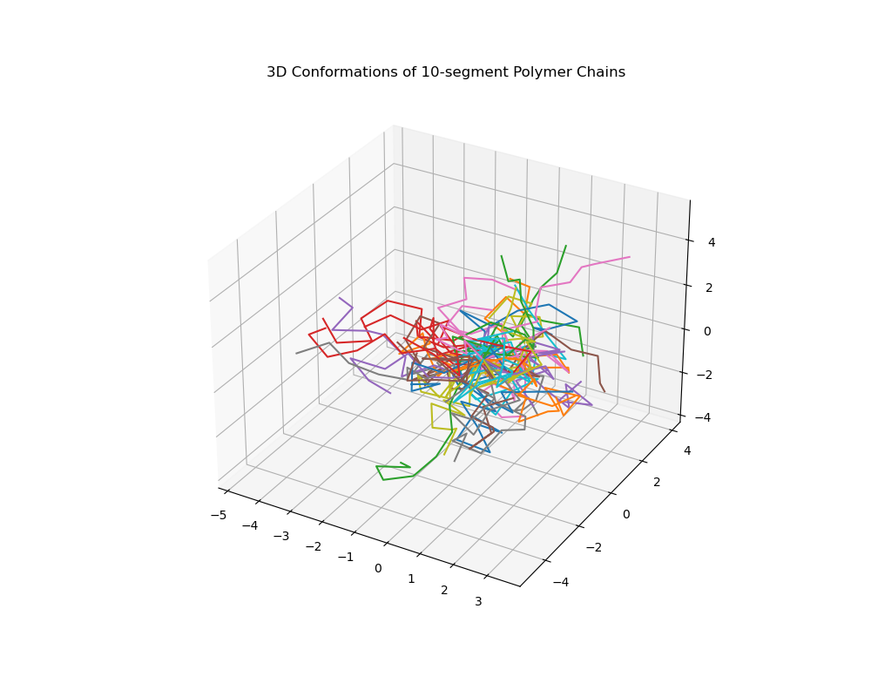

Figure: Chain conformations for N=50 segments

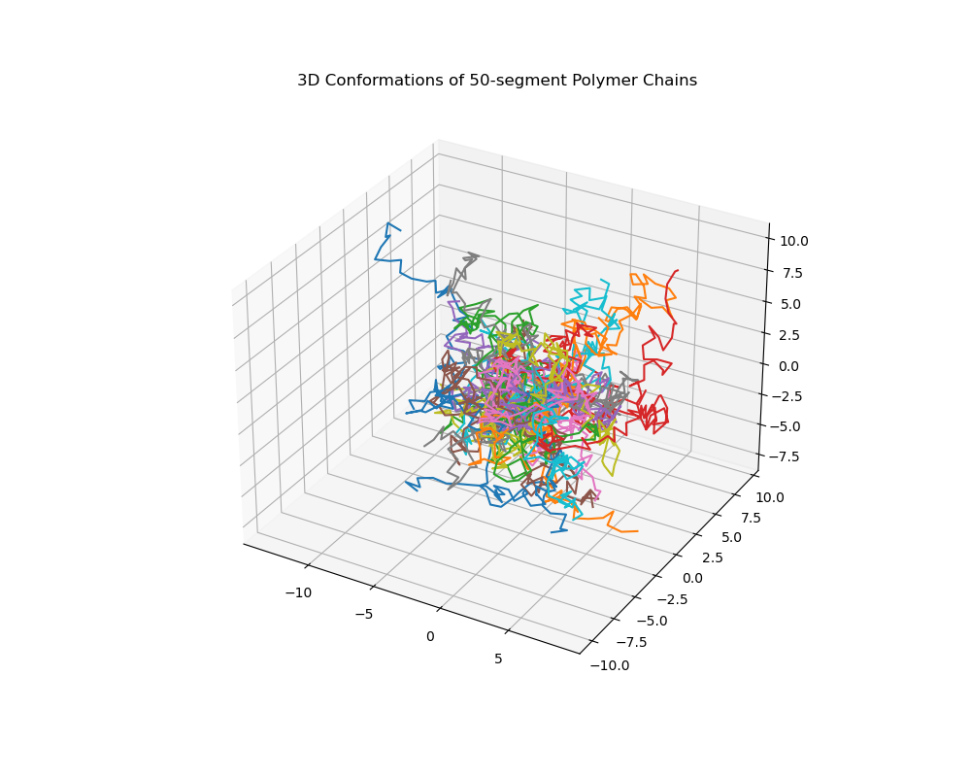

Figure: Chain conformations for N=100 segments

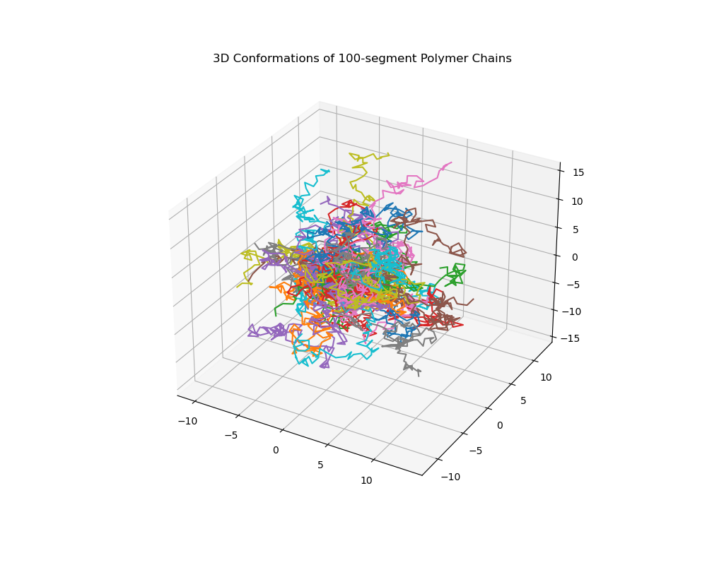

Figure: Chain conformations for N=200 segments

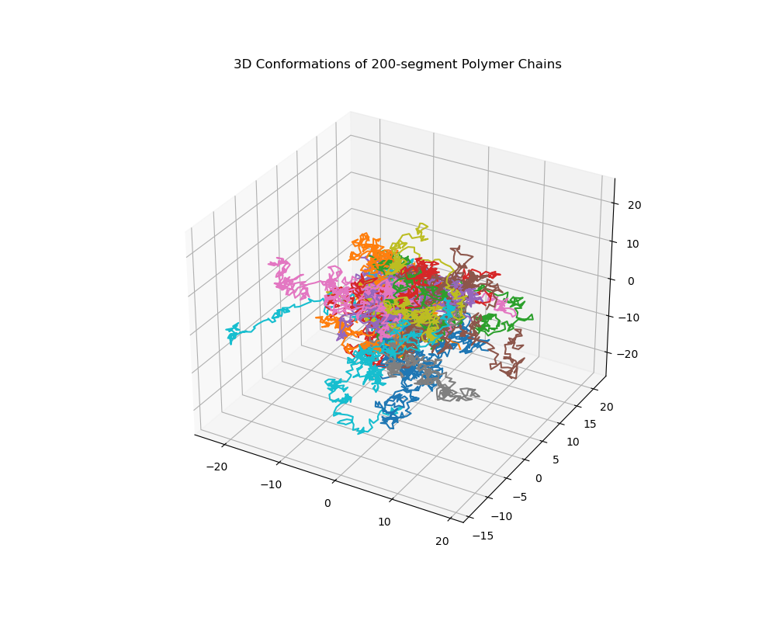

Figure: Chain conformations for N=400 segments

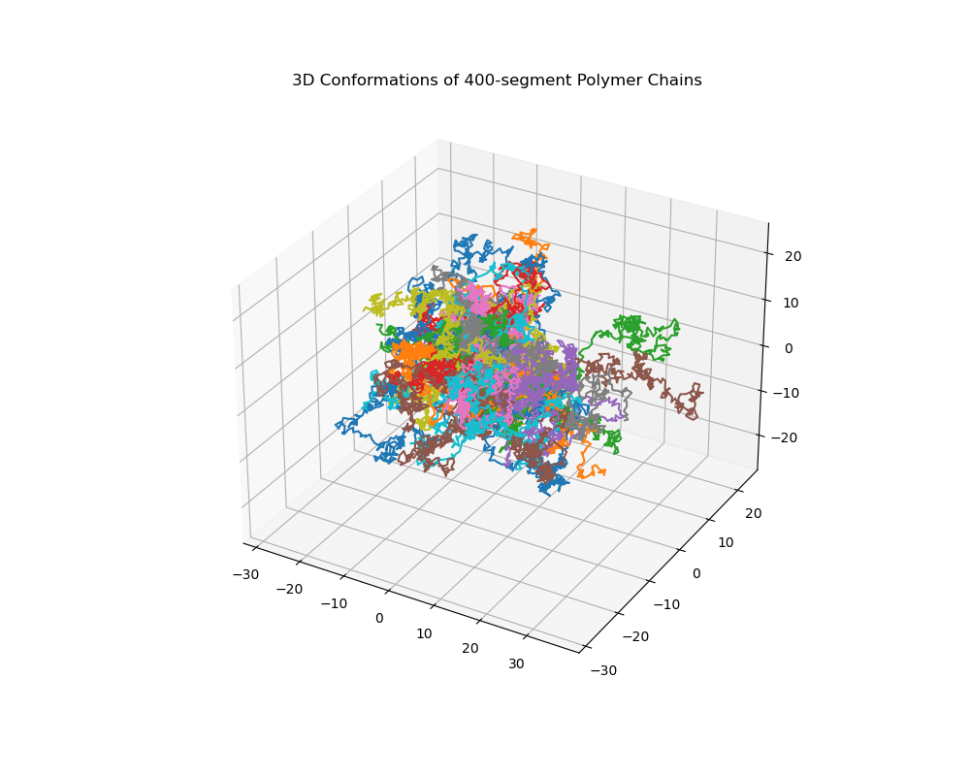

Figure: Mean Squared End-to-End Distance vs Number of Seguments

